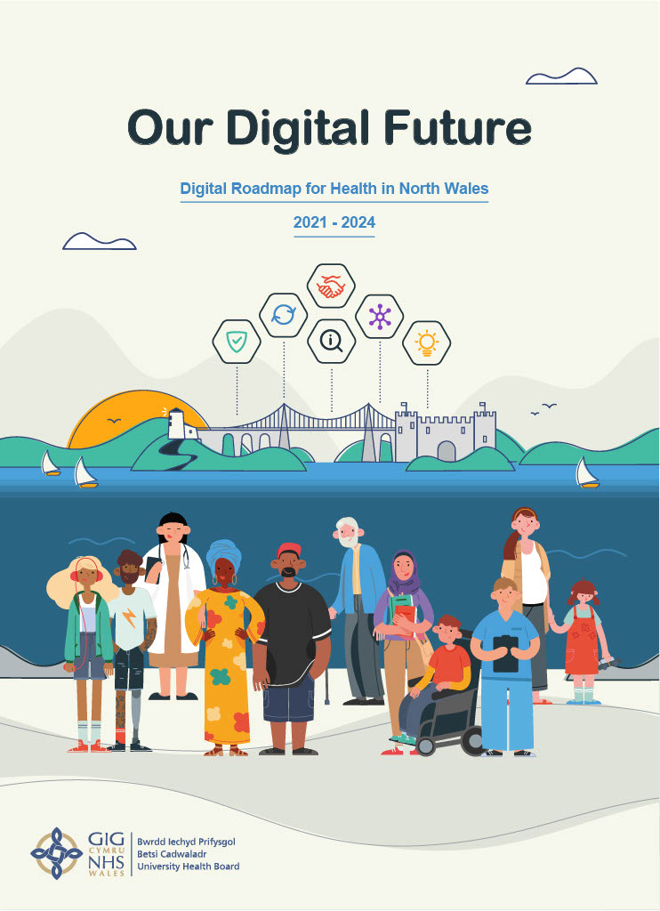
CONTENTS

1. FOREWORD 3
2. INTRODUCTION 4
3. OUR DIGITAL VISION, AMBITIONS & ENABLERS - OVERVIEW 5
4. AMBITION 1 – ENABLED PATIENT & CARERS EXPERIENCE 6
Patient & Carers Experiences 6
How These Experiences Will Feel Different For Patients & Carers 7
Patient & Carers – How You Can Support The Delivery Of This Strategy 8
5. AMBITION 2 – CONNECTED STAFF 9
Staff Experiences 9
How These Experiences Will Feel Different For Staff 10
Staff – How Can You Support The Delivery Of This Strategy 11
6. THE SIX KEY ENABLERS 11
Enabler 1 – Strengthened Digital Foundations 12
Enabler 2 – Information For Improvement 12
Enabler 3 – Digital Organisation “Think Digital” 13
Enabler 4 – Strong Partnerships 13
Enabler 5 – Digital Inclusion 14
Enabler 6 – Embracing Innovation 15
7. NATIONAL & LOCAL CONTEXT 16
National Context 16
Local Context 18
8. WHERE ARE WE NOW? 20
Brief Overview 20
What We Delivered In 2019/20 22
Our Key Challenges 23
Our Risks 24
9. DELIVERING THE AMBITIONS & ENABLERS 24
Delivering Ambition 1 – Enabled Patients & Carers 24
Outpatients Transformation Programme 25
Patient Involvement, Outcomes & Experience 25
Digital Health Record (DHR) Project 26
Digital Services For Public & Patients Programme 26
Delivering Ambition 2 – Connected Staff 27
Welsh Patient Administration System (WelshPAS) Project 27
Patient Record Transition Programme (PRTP) 28
Collaborative, Productivity & Agile Working Programme 28
Service Transformation Programmes & Projects 29
Digital Skills Plan 30
Delivery of Enabler 1 – Strengthened Digital Foundations 31
Our ICT Infrastructure, Systems, Devices & Support Provided Are Suitable For Today & The Future 31
Strong Information Security & Governance 33
To Get The Best Out Of Our Suppliers 34
Delivery of Enabler 2 – Information For Improvement 34
Health Analytics Unit 35
Business Intelligence & Robotics 35
Clinical Coding Standards & Automation 35
National Data Resource Programme (NDR) 35
Delivery of Enabler 3 – Digital Organisation “Think Digital” 36
Increasing Our Digital Maturity 36
Improving Delivery & Increasing Value 37
Planning For Our Current & Future Workforce 38
Continued Engagement With The Public, Patients, Carers & Staff 38
Delivery of Enabler 4 – Strong Partnerships 39
Sharing Information 39
Delivery of Enabler 5 – Digital Inclusion 40
Working Together 40
Embedding Digital Inclusion 40
Delivery of Enabler 6 – Embracing Innovation 41
New Models Of Care 41
Working Together & Best Practice 42
Small Business Research Initiative (SBRI) 42
10. ROADMAP FOR DELIVERY & MEASURING SUCCESS 43
Measuring Success 44
11. MONITORING & REVIEWING THIS STRATEGY 44
12. APPENDICIES 45

FOREWORD

I am delighted to share our Digital Strategy with you, the last year has been a challenge for us all but it also brought us many opportunities and lessons from a digital perspective. We had to quickly accelerate digital ways of supporting our patients and staff. Some examples include introducing virtual consultations, the creation of new data systems to ensure we had access to the latest data, and supporting many staff to work from home.
Digital is the future and we know that we have to increase the pace of delivery, support people through this change, maximise the use of our budgets and additional funding with a clear plan for delivery today and for the future.
This is an ambitious strategy for us as we have previously focused on delivering technology, but our primary focus now is about how we can improve the experiences that our patients, carers and staff have on a day to day basis by working with them.
All our plans are becoming increasingly preventative, we need to provide access to patients and carers to the information they need that can support them to self-manage their care and our staff have to be able to access the right information, in the right place at the right time to be able to provide safe, positive patient experiences and improved outcomes.
Our approach is “Digital First – leaving no-one behind”. This is crucial as some of our patients and their carers may be digitally excluded and we do not want this strategy to have a negative impact on people’s health.
Thank you to everyone who engaged with us on this strategy, we had a great response with over 4,000 comments and you will see that your feedback has shaped this strategy. We will continue to engage, and I look forward to working with you and providing you with an annual update on progress.

Jo Whitehead
Chief Executive of BCUHB

INTRODUCTION
Our Vision is all about “transforming the patient experience, safety and outcomes through digital ways of working”. This means putting the experiences of patient, carers and staff at the heart of what we do. Achieving this involves ensuring we get the basics right.

This strategy supports the delivery of our strategic priorities in Living Healthier, Staying Well and our Population and Organisational Outcomes and is informed by feedback from our engagement. It covers primary care, secondary care, community care and mental health.

Although we have made some investment over the last 3 years, the fact remains that we are still behind where we need to be. The current level of funding has not enabled us to keep up with the increasingly rapid pace of change and sustainable investment is one of our biggest challenges in the implementation of this Strategy which has been highlighted through our engagement.

As a result, we know that our staff feel frustrated by their daily digital experiences: how they access patient data, multiple logins, disjointed systems plus limited or out of date equipment and software. This strategy is aimed at reducing this frustration and providing more efficient ways of working.

Being able to access the right information in the right place at the right time, through a Digital Health Record (DHR) is key to helping our staff deliver the highest quality of service. This strategy details our plans to make this happen, this will also include how we share information across borders as some of our patients receive treatment outside of North Wales.

Our patients deserve the best experiences possible. This means choice in how they can communicate with us, together with providing reassurance they are listened to, they can receive specialist care easily and quickly and that their information is safe and secure. These key experiences and how we will deliver them have been included to ensure we meet the needs of our patients. The engagement has been positive and we will move to an approach that puts the user in the centre, be it a patient, carer or staff.

To finance this strategy we will review how we fund digital, prioritise what we deliver and identify other funding sources. There is a significant amount of service transformation that is happening now and needs to happen in the future and at the moment we don’t have the capacity or capability to deliver all of this.

Cyber security is one of our biggest risks and therefore one of our key priorities. We have a duty to keep our patients, carers, staff and our organisation safe so that we are able to continue to deliver services in the unlikely event our systems are compromised.

Our approach of “Digital First - leaving no-one behind” has been developed to reflect the importance of inclusion and the high level of concern raised about this during the engagement. We know that 10% of our population are digitally excluded, (this figure does not include care homes or hospital settings) and this is even higher in some of our patient groups. It is important that we still have efficient systems and processes in place for those who cannot access services digitally, whilst also working collaboratively to support them to access digital services if they should choose to.

The Welsh language and culture are vitally important and we will work with others to meet the Welsh Language Standards.
We cannot deliver this Strategy on our own, a key enabler for this strategy is about working in partnership. Our key areas for working in partnership are through our community resource and mental health teams, digital inclusion, digital skills, research and developing our workforce for the future.
We know that digital transformation is not easy. It is not just about putting systems in place, it also involves changing our culture and providing a vision for change and supporting staff and all users through the change.
Our longer term vision is to work towards the development of a Digital Health and Social Care Strategy across North Wales, which ensures we are working collaboratively so together we can deliver more technology enabled care, supporting care closer to home and our prevention agenda.
The digital world changes at pace so we will need to review this Strategy annually, especially in line with our clinical strategy and the new Digital Strategy for Wales.

OUR DIGITAL VISION, AMBITIONS & ENABLERS - OVERVIEW

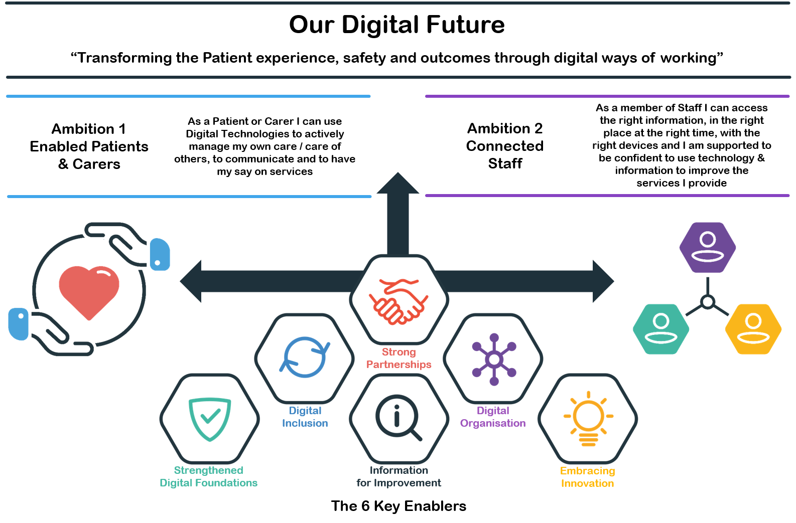

AMBITION 1 – ENABLED PATIENT & CARERS EXPERIENCE

Patient & Carers Experiences
We want our patients and carers to have the following experiences:

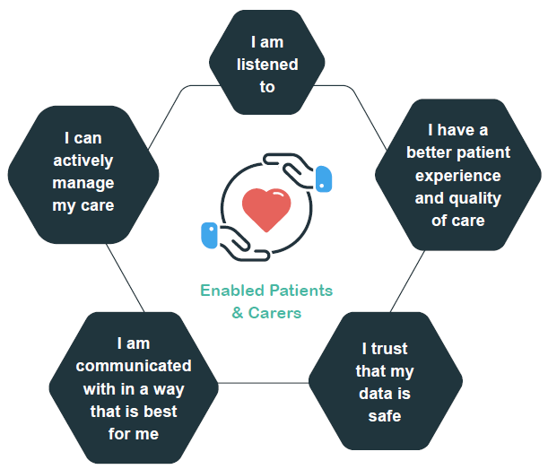

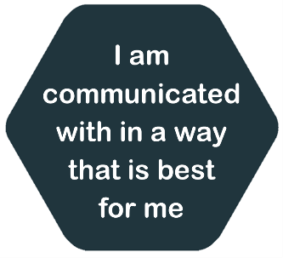 | - I am kept informed about my care  - I have the choice of face to face or video consultations  - I can book some appointments/change my appointments online and receive reminders in a way that suits me  - I can receive my letters digitally and can have access to them more easily for future reference  - I am communicated with in my language/method/format of choice
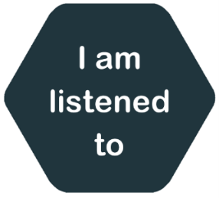 | - I can tell you about my care, experience and my health so I receive the best care for me, and it improves services  - I don’t have to keep repeating my details to different individuals or organisations who provide my care  - My rights are taken into account
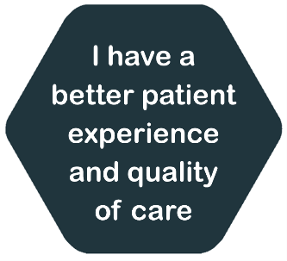 | - There is a single accurate source of information held about me and important information is available to all who treat/support me  - When I am referred, I will get care easier and quicker  - Services I receive are designed around patient needs  - It is easier for me to move between services  - I can receive some of my care closer to home  - I am safe
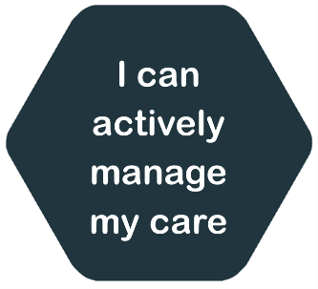 | - I will be able to access my information more easily so I can be more informed about my care and options  - I will be able to update parts of my own health record in the future so the person providing my care knows more about me  - I am signposted to suitable self-help resources and apps  - I know where and how to access information and services digitally
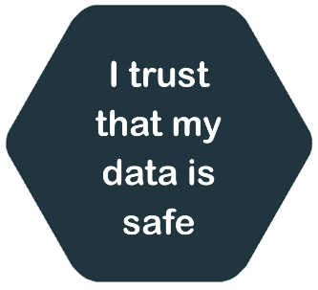 | - When I provide my data, I know that it will only be used to provide my care and improve health care, and that it will be stored safely and kept confidential at all times

How These Experiences Will Feel Different For Patients & Carers
The patient focused stories below show how the experiences will feel different for our patients and carers.
 |  | Dewi is a 73 year old who has diabetes and it has affected his vision, he is currently being treated as an outpatient at the diabetes and ophthalmology departments. Dewi had a fall and was taken into the Emergency Department late one evening. During his time within the Emergency Department, Dewi didn’t have to repeat his details as his real-time patient progression and documents were all on one system. The staff that treated Dewi had access to his Digital Health Record and the real-time monitoring of his diabetes through his wearable device so they had access to vital information which supported their decision on the best treatment for Dewi whilst reducing any clinical risks. Dewi was safely discharged electronically with information sent to the GP electronically with details of the prescription that he has been given. On discharge the information was also shared electronically with the Community Resource Team, a multidisciplinary Health and Social Care Team who then provided his wrap around care in the community
 | Lowri is a 27 year old and has a busy life, working full-time and is a single mum. Due to her kidney condition she needs to attend a large number of outpatient appointments, at some of these appointments she has to be physically seen by a clinician but other times does not. Lowri works with her clinician to develop a plan for using virtual consultations as this saves her 1 hour of travel time per appointment and £30 in child care fees |  | 

 | Elin is a 20 year old asthmatic and she wants to play an active role in her care as this helps her manage her condition better. She likes to see her recent test results and compare them with her last results and she has worked closely with her clinician to be able to do this. She can access this information and some other parts of her digital health record through the patient portal, where she can also find information on her next appointments and if they aren’t suitable she can change them electronically

Patient & Carers – How You Can Support The Delivery Of This Strategy
For this Strategy to be successful we all need to be actively involved. From the engagement, our patients and wider stakeholders thought the following were what they could do deliver the experiences:
- Be positive about new technology which is provided, be willing to test them out, learn how they work and feedback to us areas for improvement via various engagement methods  - Embrace the technology within your households, ask for help when required, so you can get support to develop your digital skills  - Share good experiences with family, friends and networks to help promote the use of our digital solutions | - Take responsibility for your own health by using other, trusted sources of information when required, providing us with the correct information about you, and keeping that information up to date  - Use our services responsibly, use the right services, at the right time, for the right reasons  - Be supportive and patient as sometimes new ways of working go wrong

AMBITION 2 – CONNECTED STAFF

Staff Experiences
We want our Staff to have the following experiences:
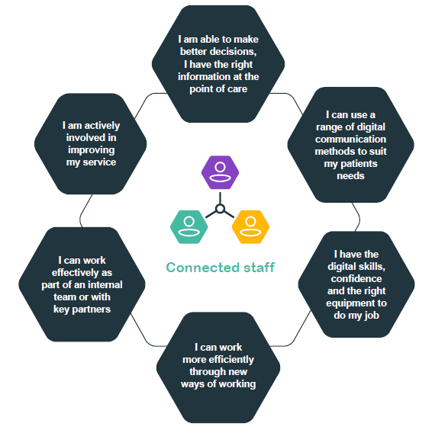

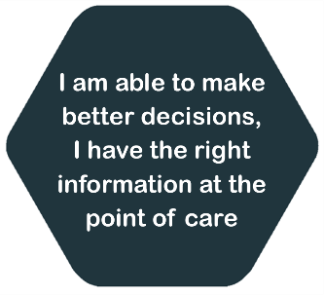 | - I know how to access all the information I need  - I know my patients better as I have listened to the information they have given during and after the care I have provided
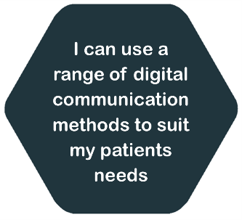 | - I can use virtual consultations where they better suit my patients  - I can run group sessions and work collaboratively with other health care partners where it will benefit my patients
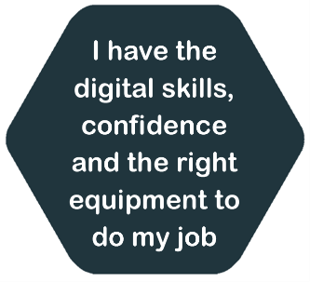 | - I am supported to develop my digital skills and I know where to go to get support  - I have the right equipment to do my job
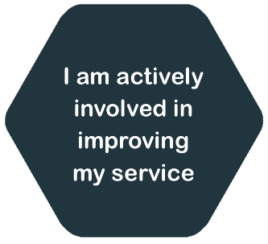 | - I have easy access to the data and information I need to review performance and standards  - I am engaged and can influence improvements in my service and organisation  - I am able to identify when digital solutions can support me to deliver a better service to my patients
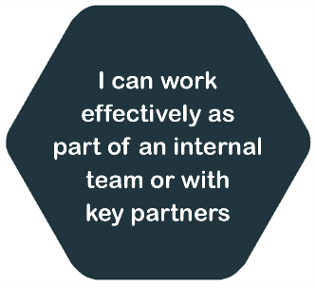 | - I can share and receive information and media securely with key partners  - I can use digital solutions that help me to collaborate
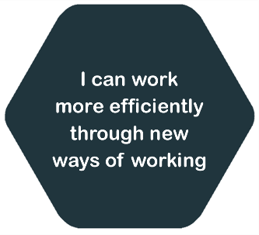 | - I can digitally dictate my letters  - I can make electronic test requests and sign them off electronically  - I can make and receive e-referrals  - I can log on once and have access to all the key systems that I need  - If my role allows, I can work from any location and meet my colleagues virtually which means I spend less time travelling  - I have confidence in the systems that I use, and the information held in them is up to date  - I can manage medicines and prescribe electronically  - I contribute to better communication between Primary and Secondary Care  - I know where my patients are, so that I can ensure their needs are promptly met to minimise time away from home

How These Experiences Will Feel Different For Staff
The staff focused stories below show how the experiences will feel different for our staff.
Kate is a Doctor that works across two of the three acute hospitals. Kate has access to a standard set of the systems that she uses on a daily basis and is able to sign in once for all of these, which saves her a lot of time. Kate also accesses the same systems across both hospitals so she doesn’t have to learn to use two different systems |  | 
 | Meinir, Rob and Lesley all work in the Community Resource Team in Bangor. Meinir is a district nurse, Rob is a Social Worker and Lesley is the local GP. They are able to share information safely with each other which allows them to see in one place the information about the person that they are caring for with a single care plan that they can all access and update. They don’t have to keep asking the same questions and they have everything they need to do their jobs in one place

Staff – How Can You Support The Delivery Of This Strategy
For this Strategy to be successful we all need to be actively involved:
- Be positive about new technology which you have access to, be willing to test them out, learn how they work and feedback to us areas for improvement via various engagement methods  - Promote digital ways of working to colleagues and consider helping others who are less confident, maybe become a Digital Champion for your service  - Be proactive in developing your digital skills to keep up to date with the latest technology, devices and systems | - Use data to make decisions and improve services  - Promote changes to the way services are delivered by having honest conversations with patients and being confident enough to assist patients where required  - Actively engage with the wider organisation when opportunities arise to ensure you are having your say on all things digital  - Support in the identification and realisation of the benefits that are achievable via the use of digital solutions

THE SIX KEY ENABLERS
To enable us to deliver our Vision, Ambitions and Experiences we will focus on the following enablers, please also see the Delivery Plans in Appendix 2.

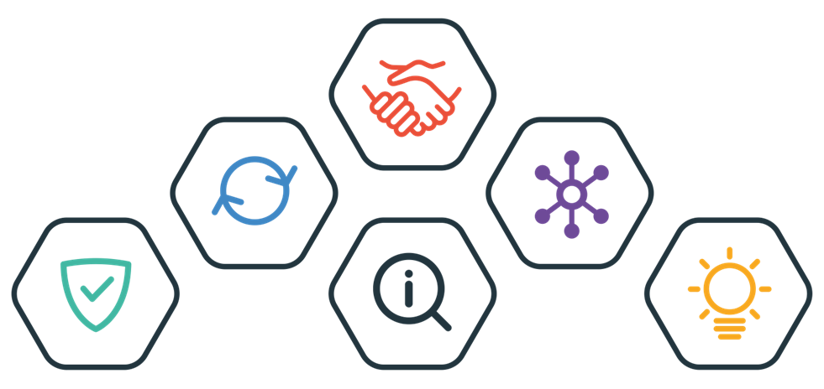

Enabler 1 – Strengthened Digital Foundations

 | “Our ICT infrastructure, systems, devices and support provided are suitable for today and the future, we have strong information security and governance, and we get the best out of our suppliers”

We have to “Invest in and get the basics right”, this is a key message from the engagement with our staff. Laying down strong digital foundations are crucial for us to be the digital organisation we want to be, to enable us to deliver the patient and staff experiences and the changes that are needed, safely at a faster pace.
These basics include our networks, devices, hardware, systems, storage, and telephones.
Cyber-security is one of our biggest risks, daily attacks have become the norm and we work with a large amount of the most sensitive personal data that we have to keep safe. We take this high risk seriously and we will do everything we can to prevent attacks, if we are attacked, we will be resilient in order to minimise the damage and achieve the recovery required.
We have a large number of suppliers and need to ensure we manage what we have well, buy exactly what we need, at the best price/value and develop positive relationships with our suppliers.

Enabler 2 – Information For Improvement

 | “We use quality data to create intelligence to make better decisions,  predict demand and improve services”

Getting the basics right means that our data has to be correct, accessible, usable and robust to provide the most benefit to our staff and improve our services. The amount of data and information we have is growing at a rapid rate. We need to make maximum use of it to deliver quality services now and in the future.
Our business intelligence (BI) technology and skills are essential for operational delivery, enabling the organisation to make immediate and short to medium term decisions. We also need to develop our modelling capability, which will provide us with a pro-active way of understanding the longer-term impact of any changes that we make and predict the supply and demand of our services.
We will continue to increase the use of our BI dashboards across the organisation and we will move towards a self-service approach by equipping the services with the dashboards and interrogation tools, this will help release resources to focus on other important information areas.
A consistent approach to reports is important for staff confidence and uptake. We will review our existing reports and dashboards, ensuring a consistent look and feel.
Robotic Process Automation (RPA) is now a proven tool, with many uses across the NHS. RPA can automate repetitive tasks across applications and systems. We will use the ethnicity and preferred language from the COVID-19 vaccination programme as a pilot for RPA, importing the data into our patient Administration System.
In Clinical Coding SNOMED- CT would provide us with a structured clinical shared language that is readable by computers. It is made up of clinical terms that include procedures, symptoms, clinical measurement, diagnosis and medication. SNOMED will support the sharing of data between systems, and specifically our new Digital Health Record. We will start the automation of Clinical Coding as it allows for real time information about our patients to be available, saving time and resources.
Our work as part of the National Data Resource (NDR), will contribute to the establishment of a national data store making use of Cloud and ‘Big Data’ methodologies. We will establish a real-time messaging framework that enables improved frequency and timeliness of data feeds for reporting.
The NDR will facilitate access to key datasets to enable reporting and provide local insight for improvements to patient care. Advanced analytics will be enabled through access to modern data toolkits.

Enabler 3 – Digital Organisation “Think Digital”

 | “Think Digital” We actively develop our digital culture and maturity through committed and accountable leadership, being integrated throughout our business planning processes with the appropriate investment to improve. Delivering benefits to patients and staff: financial, non-financial, social  and environmental.”

To deliver transformational change we need to be a Digital Organisation which means more than just having systems and processes in place, it is also about people and a way of thinking and acting. We want our staff, patients and carers to “Think Digital.” Thinking digitally across the organisation will be a big change for us but it is what we have to do to make sure we can deliver excellent care now and in the future.
Many transformation projects fail because of organisation culture challenges, we are prioritising and investing time in improving our digital readiness to ensure we will have more success in delivering the changes that are needed.
We have started our journey to become a digital organisation; we have identified that we need to improve our digital readiness and strengthen our governance, service standards, finance, planning and how we deliver our projects. This can only be achieved by continuing to actively develop our staff and learn and grow through meaningful engagement.
Identifying and delivering benefits to show the difference this Strategy makes is important and one of our key measures of success. As well as financial and non-financial (social) benefits we will also assess the environmental benefits digital solutions bring.
From the engagement we know that most of our staff are not familiar with our current digital objectives, our staff have to know what we are aiming to achieve.

Enabler 4 – Strong Partnerships

 | “We can seamlessly share relevant information with our key partners and we work co-productively in developing new ways of working with our Patients, Staff, Key Partners and Suppliers”

One of the key areas of concern from the public and patients from the engagement is the safety of the information that they provide to us so we will ensure data protection and information security is at the forefront of our thinking when designing services. To provide the best services to our patients who receive care from a range of organisations, we want to be able to share and receive information seamlessly with our partners when we need to, so everyone has the right information and the person receiving care does not have to repeat their history.
To meet the needs of our patients and staff we have to work in a more co-productive way (doing things “with” rather than “to”), this is covered more in how we will deliver the experiences for patients and staff and our approach of User Centred Design.
This co-productive approach is what we want to use with our key partners to get the best out of working together for our patients and staff. We will embed this into our ways of working.
Our community resource and mental health teams work as part of integrated teams with our key partners. We have already identified that we need to provide a different digital service support model for all our services and this model for these two services will be different, due the level of integrated working as to make best use of resources and to develop their own longer term digital plans.
We recognise the importance of working in partnership and are committed to achieving a Joint Digital Health and Social Care Strategy across North Wales, to deliver better experiences for our patients/service users and our staff.

We will continue to work with partners on digital opportunities that benefit our patients and staff.

One of the key areas for working in partnership is the digital skills of our patients and staff. This is covered in more detail in Enabler 3 – Digital Organisation and Enabler 5 – Digital Inclusion.

Enabler 5 – Digital Inclusion

 | “We are fully aware of the impact of any new ways of working on our  patients, carers and staff so we can put plans in place to ensure inclusion.”

Concerns regarding digital exclusion was a common theme throughout our engagement. The public/patients thought that digital exclusion was one of the top 3 reasons to the question “what do you think might stop, or get in the way of the above experiences happening’
10% of the population of Wales are not online and 27% of those who do use the internet lack at least one of the five basic digital skills:
- Handling information and content
- Communicating
- Transacting
- Problem solving
- Being safe and legal online

Older people, people with disabilities and people with a limiting long term health condition are less likely to be online, these are the people who are more likely to need health and social care support. Further information about digital inclusion and basic skills can be found here: Digital inclusion and basic skills.
87% of people who said they are in good general health said they are able to find the right information when they are ill, compared with 68% of those in poor health. People who displayed all five digital skills (3 month period in 2019) are more likely to have used the internet to access health information than those with fewer skills. Similar proportions of people said they can find the right information to help them lead a healthy lifestyle.
Our approach is “Digital First - leaving no-one behind.” We will continue to provide and support people to access our services non-digitally e.g. through face to face appointments If we don’t it could impact on existing health inequalities.
This is an important area for us to continue to work in partnership as part of the Digital Communities Initiative, to embed Social Inclusion and form a stronger relationship with Digital Communities Wales and/or other Welsh Government programmes which aim to reduce digital exclusion as to gain additional expertise and experience in this area.

Enabler 6 – Embracing Innovation

 | “We keep up to date with new ideas and ways of working and be involved in and invest in innovative research and development. We learn from and are ready to adopt best practice”

We want to be one step ahead of new and existing technology is out there and how we can use it.
We will keep up to date and review new models of care to improve the care we provide, we will integrate these into our new developing clinical strategy.
Research is an important aspect to becoming more innovative in the digital world. This is particularly important for delivering digital clinical environments where patients and staff can both benefit.
This is an area where we can work in partnership with our own Research and Development Team and the Regional Research, Innovation and Improvement Co-ordination Hub (delivered by the North Wales Social Care and Well-being Services Improvement Collaborative) as well as Higher Education and Colleges locally and nationally.
To ensure we achieve this, we commit to agreeing a protected proportion of our Informatics staff time to do this annually.
We need to review how we manage research and development in Informatics so that services have a direct link in to review opportunities.
We also have some excellent examples of good practice across BCU, from our partners and other health boards, we will create a forum to learn from these.
We will also continue to lead on the Small Business Research Initiative (SBRI), which works with public sector bodies across Wales to develop innovations where no solution on the market exists. This is a co-creation and collaboration approach where we identify unmet needs with our colleagues within health and invite industry and academia to work closely with us to develop a solution together that meets our needs. We also want to advance this further by leading on a UK wide national SBRI working with all the home nations to have a wider impact for health of the UK population.

NATIONAL & LOCAL CONTEXT

National Context
Our Legislative and Strategic Environment
As a Public Sector Organisation, we have a duty to adhere to a number of external acts and legislations. We have taken the following legislation into account when developing this Strategy and will ensure we continue to meet the requirements of them as we deliver:
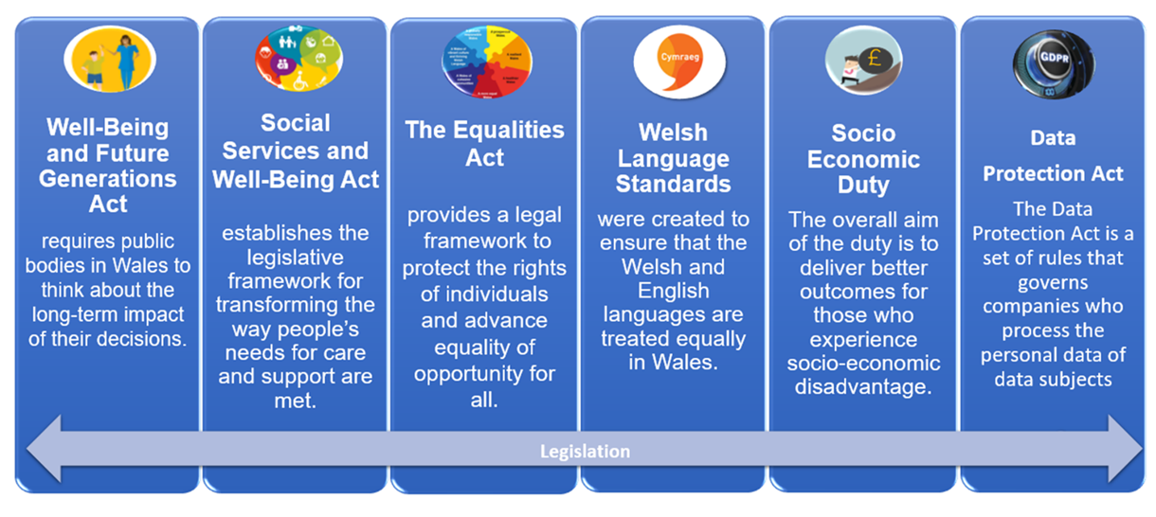

National Strategies, Plans and Programmes
There are also a lot of national strategies, plans and programmes that we need to deliver on and take into account in this Strategy. A full list of these can be found in Appendix 2. The two key ones are:

A Healthier Wales: A Plan for Health and Social Care (2018) recognises digital healthcare technology as a key enabler of transformational change. It also acknowledges the challenges of driving digital change at pace and scale across health and care in Wales. The quadruple aims of this plan are as follows and have been used to develop our population outcomes.
- Improved population health and wellbeing
- Better quality and more accessible health and social care services
- Higher value health and social care
- Motivated and sustainable health and social care workforce

Informed Digital Health - A Digital Health and Social Care Strategy for Wales (2015) set out a vision that included supporting people and professionals to use information whilst being enabled by the NHS Wales Digital Architecture.
Informed Health and Care – A Digital Health and Social Care Strategy for Wales (December 2015):
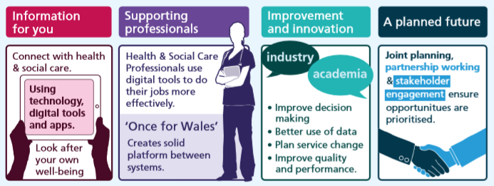
This Strategy, a Healthier Wales and the Informatics Systems in NHS Wales (Public Accounts Committee, 2018) which identified the challenges in delivering digital transformation and at a pace have all set the direction for digital change in Wales. This has resulted in a new body called the Digital Health and Care Wales being developed (Formally NWIS – NHS Wales Informatics Service) and the appointment of a Chief Digital Officer (CDO) for Health and Care who will define national standards and services.
National Delivery
Digital Health Care Wales (DHCW), which is a special health authority leads on the digital transformation of Health and Care in NHS Wales. They have a responsibility to deliver Informatics to Primary Care and some of the ICT Services and Projects nationally by providing us with a range of services and solutions. This Strategy includes some work in relation to Primary Care but a lot of the support and new ways of working is undertaken by DHCW who we will work closer with. DHCW is funded nationally from the Welsh Government to deliver the following on our behalf:

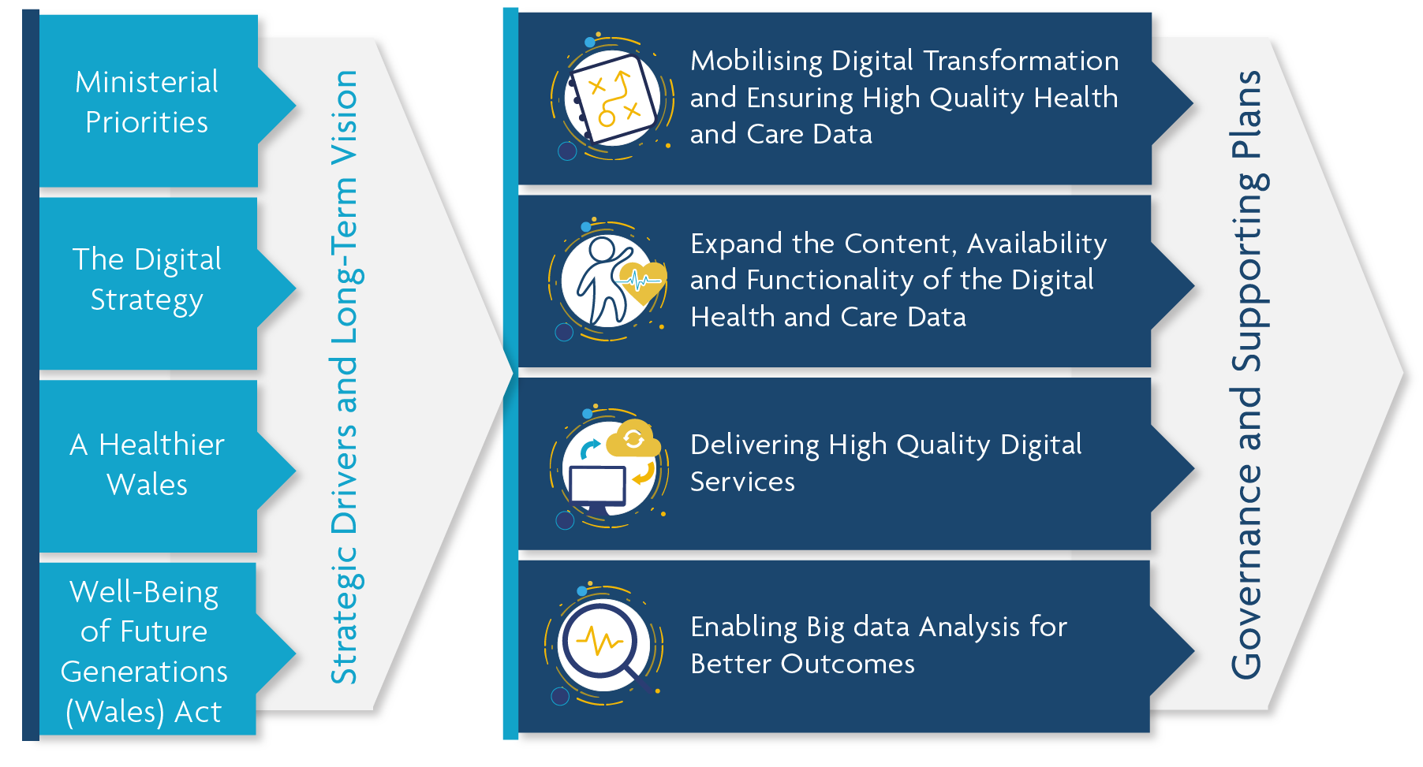
DHCW supports all Health Boards through a “Once for Wales” approach, recognising that Health Boards are at different stages of their digital journey means that sometimes national solutions don’t meet our local needs and could introduce delays.

Local Context
About North Wales
North Wales is a great place to live and work, the following are some key facts and figures about the population of North Wales that provides us with some service delivery challenges. We have taken these into account to develop this Strategy and we will continue to take into account the changing needs of our populations.
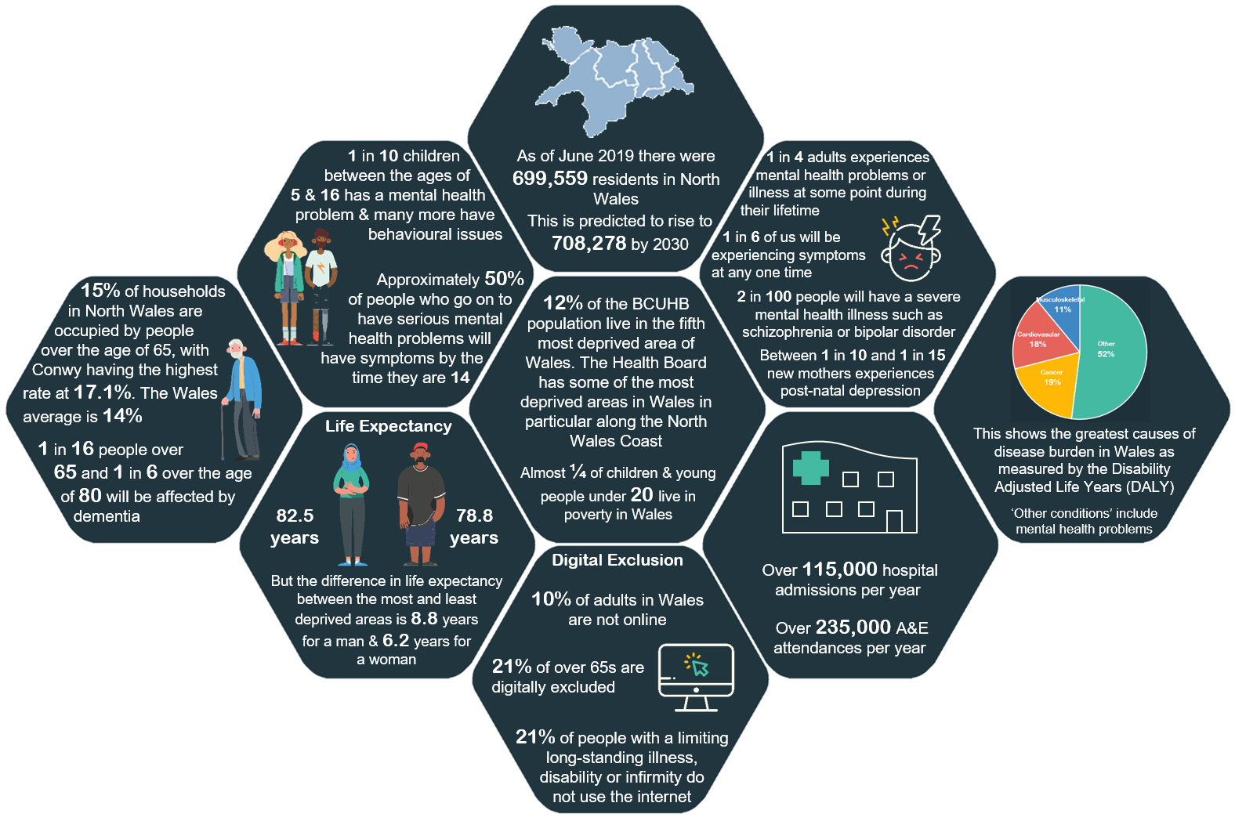

About BCUHB
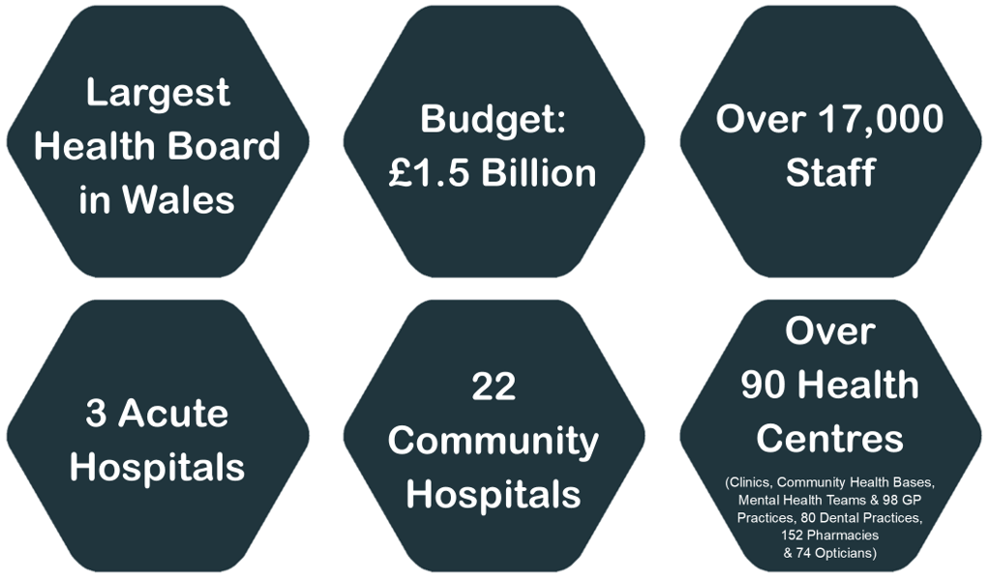
This Strategy supports the delivery of our BCUHB Strategy, “Living Healthier, Staying Well - Working in Partnership to Improve Health and Deliver Excellent Care across North Wales” that defines our future models of care delivery. With respect to providing more care closer to home, services will be provided through local community resource teams, including local authority and the third sector partners, offering a range of advice, assessment and treatment. The local teams will be supported by 14 primary care clusters that provide access to more specialist services without having to attend an acute hospital. The primary care clusters will include mental health services and each will be based upon a population of approximately 50,000.

The Strategy also supports the delivery of our 9 Population and Organisational Outcomes for 2021 – 2024:

Population Outcomes
- Outcome 1 - People in North Wales have improved health and well-being with better prevention and self-management.
- Outcome 2 - Better quality and accessible health and social care services enabled by digital and supported by engagement.
- Outcome 4 - The health and social care workforce is motivated and sustainable.
- Outcome 5 - Higher value health and social care system that has demonstrated rapid improvement and innovation.
- Outcome 6 - Improve health and reduce inequalities.

Organisation Outcomes
- Outcome 7 - Service transformation
- Outcome 8 - Progress against targeted intervention requirements
- Outcome 9 - Long-term quality service and financial sustainability

Informatics at BCUHB
Our Informatics Team supports the delivery across the Health Board and is made up of ICT, Patient Records & Digital Integration, Information and Clinical Coding and Programmes, Assurance and Improvement.
- ICT
Information and Communication Technology (ICT) is the development, management and support of the core ICT infrastructure, including systems and servers, networks, telephony, personal computers, email and collaboration and mobile communications as well as the provision of Service Desk and Customer Support and Engagement.

- Patient Records and Digital Integration
The Patient Records and Digital Integration Department provides a sustainable range of services that are renowned for ensuring the quality and standards of patient records, ensuring the timely availability of records to inform clinical decisions, and meeting our legislative requirements in relation to subject access requests; alongside leading projects to deliver the safe transformation from paper to digital.

- Information and Clinical Coding
The Information Management Services Department is responsible for delivering a complex and diverse service to the Organisation comprising of WPAS Management, Information Development, Information Reporting, Information Standards, Information Analysis and Clinical Coding.
- Programmes, Assurance and Improvement
The Programmes, Assurance and Improvement Service manage national and local digital programmes and projects working across the organisation. Undertaking Businesses Analysis to support services with their processes and systems; Provide business support, assurance and improvement for the Informatics Service and are the guardians for the national Small Business and Research and Innovation Centre.

WHERE ARE WE NOW?

Brief Overview
We are at the point where we know we need to change or we are at risk of being left behind in the digital world. We have also mapped out where we are now in relation to the delivery of the ambitions, enablers and existing systems. Please see Appendix 4.

WHAT IS GOOD ABOUT WHERE WE ARE NOW | WHERE WE NEED TO IMPROVE
- We are ranked No 1 in Wales for our IT Infrastructure in the AWIIR Report March 2020 which shows our planning in this key area is progressive. Please see Appendix 5 for more detail  - Learnt lessons from Covid  - Invested in upgrading equipment as it has become outdated  - Telephone Services have been updated, including new switchboards  - Computer networks have been replaced.  - Implemented Public Wi-Fi at most BCUHB premises  - Improved our data centres with extra-protection from cyber-attacks  - Started the roll out of Symphony which will become the Welsh Emergency Department System  - Started the roll out of Virtual Consultations  - Implementation of better ways of recording care of patients and data is displayed in real-time to support consultants make decisions on a daily basis  - A range of BI Dashboards have been developed to help individuals, services make decisions and improve  - Our Alert Texts notify key services when patients are in hospital to help with continuity of care in the community and allows GP's to track progress of their patients during a hospital stay  - Our Account Management approach in Information is working well  - Text Reminders to patients, with 12,000 appointments being re-used when patients have notified that they are unable to attend. This also captures language choice  - We know what our patients, carers and staff want out of a Digital Strategy  - Work with the Board on digital maturity has started  - We lead on Innovation nationally through the Small Business Research Initiative Centre of Excellence  - We have started our improvement through engagement with our patients, carers and staff  (Please also see what we delivered in 2019/20) | - We are not a digital organisation  - Informatics Service is just seen as the providers of computers and phone and support if things go wrong  - We don’t have the core systems in place across the organisation which delays the implementation of other basic functionality (WPAS & online appointments)  - A lot of staff are frustrated with their digital experience in work  - The public, patients and carers are concerned about digital exclusion  - We have invested but not at the scale that is needed to fully embed or lead the way in digital  - Due to funding arrangements, locally and nationally a lot projects start but are never completed so no benefits are gained  - We don’t deliver at the pace of change needed as we don’t prioritise and lack the staff to deliver  - Costs in our business cases generally do not include lifetime costs of projects through to business as usual  - Our delivery of some projects are dependent on national funding and delivery – this sometimes slows us down, they are not at the right time for us and then funding is limited  - Some staff do not have access to the right equipment to do their job  - Some of our hardware is running on old technology  - Investment in cyber-security is as at a crucial stage to keep our information safe  - The focus previously has been solely on the implementation of technology and not the wider change required.  - The link between digital delivery and meeting our strategic objectives and supporting performance improvement has not been fully developed  - A lot of our services are going through transformation, this transformation is not co-ordinated from a digital perspective resulting in ad-hoc support to services  - We don’t know the digital skill levels of our staff  - We don’t promote our digital achievements internally or externally

What We Delivered In 2019/20
Informatics – Key Achievements
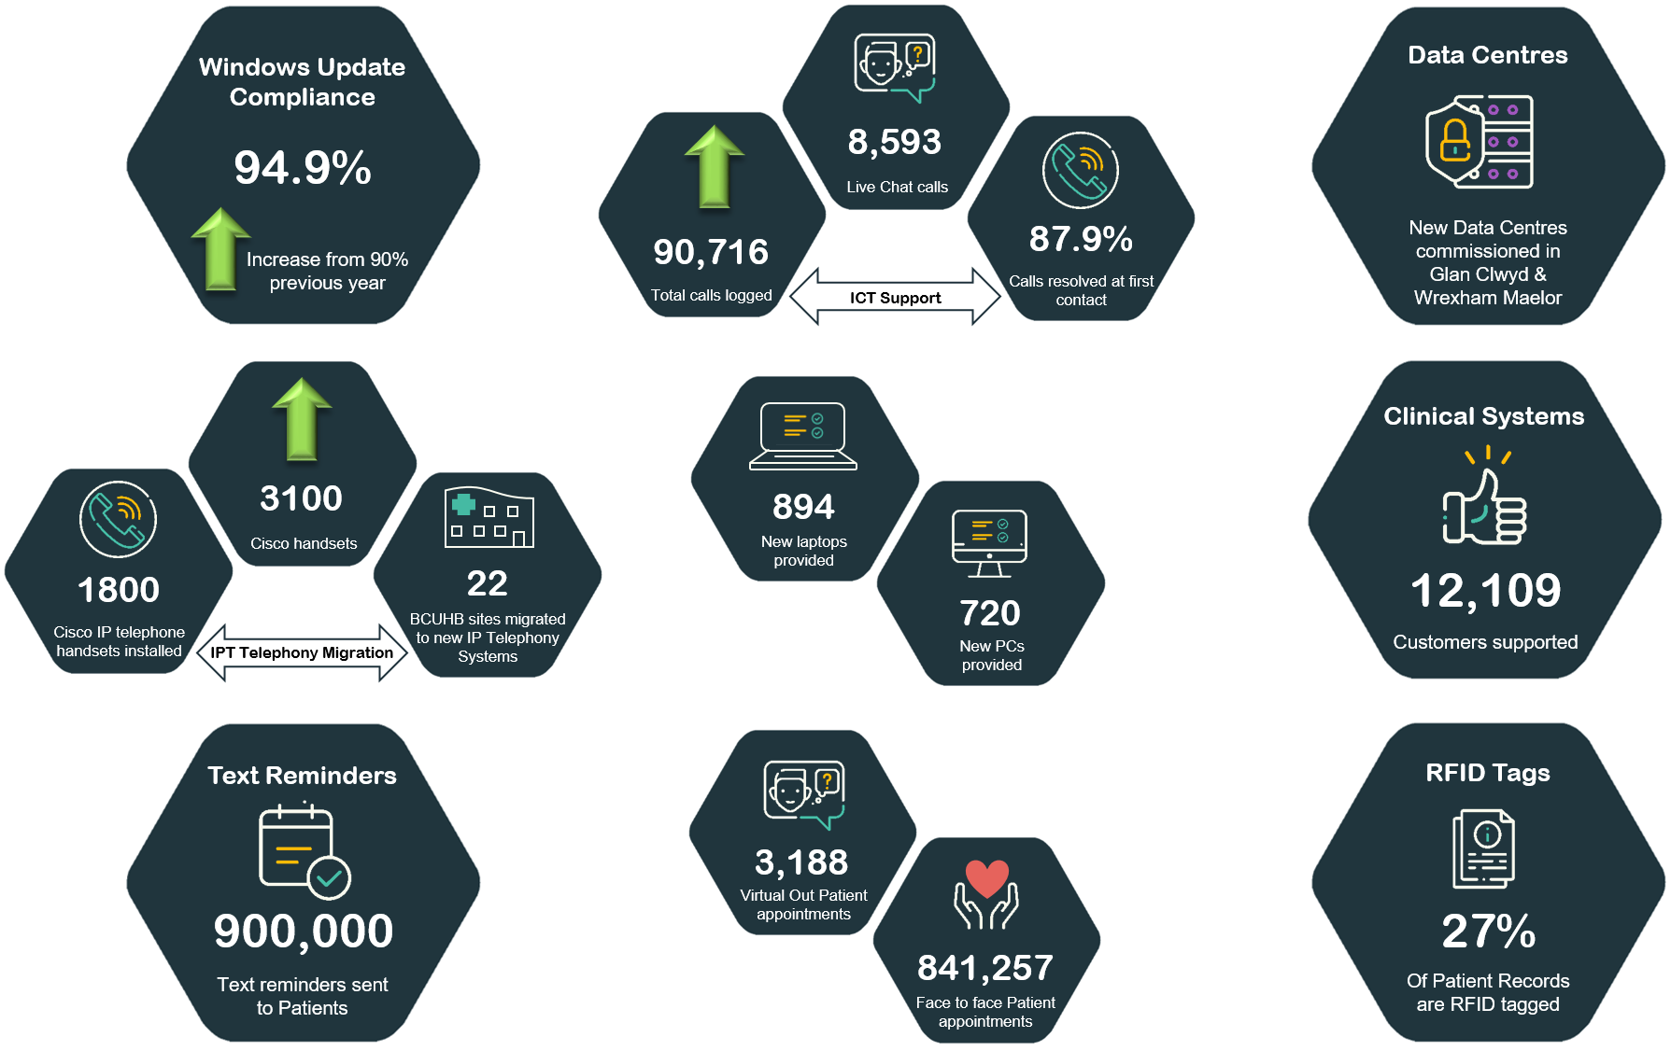

In addition to this we have also responded to Covid, please see Appendix 5- Our Response to Covid.

Our Key Challenges
We have quite a lot of challenges that could impact on our digital transformation, we have taken them into account in developing this Strategy and we will also review them as part of how we manage our risks. The following 4 challenges provides an overall summary:

 | Our Population |  |  | Pace of Change and Increasing Demand
- Increasing demand for services: The population in North Wales will increase due to more babies being born and people living longer – an ageing population will need more care and we have an ageing workforce so there is a risk of a loss of knowledge and experience  - Increasing complexity: There are an increasing number of people who have more than one health need, so health needs are becoming more complex  - Digital inclusion: 10% of people in Wales are digitally excluded, they are likely to be older, less educated and in poorer health  Digitally excluded people do not have access to a range of health and care information so can impact on the amount of referrals  - Increasing awareness about Data Protection legislation: and the greater need to keep their information safe and secure |  |  | - The pace of change: The pace of technological change and innovation moves so fast  - Increasing demand for digital services: Demand for digital services and more flexible ways of working is increasing from both staff and patients  - Digital skill development: Digital skills of staff and patients may not always keep up with the pace of change  - Large amount of legacy systems that are unconnected: We have many unconnected systems and processes across BCU  - Reliance on paper based records: Across BCUHB so difficulties when patients move between sites  - Low level of digital maturity: Our culture has varying levels of digital readiness that will need to mature to achieve the required level of digital change  - National delivery: There are competing national drivers that do not always align with what we want to deliver and sometimes slows down our delivery
 | Reducing Finance and Short Term Funding |  |  |  | Working Together
- Savings: Over the last 3 years we have had to make significant savings and we have to still make more  - Increasing costs for technology: due to increase in demand and complexity  - Short term funding: Increasing short term grant funding and decreasing budgets  - Lack of sustainable funding: Increasing short-term grant funding with a local expectation to sustain and refresh longer-term putting increased pressure on future budgets |  |  | - Different systems and agenda’s: We work together with a range of partners to deliver what is best for our patients and staff as it can bring better results. Working together can take more time and can be more difficult due to the use of different systems  - Once for Wales: We work with other Health Boards facilitated by DHCW to develop solutions for Wales, these national solutions don’t always meet our needs, and are sometimes not timely

Our Risks
To support the successful delivery of this Strategy we have identified the following risks that we will need to manage. A risk is something that could happen which could have a negative impact on the delivery of the Strategy. We will manage these through our Risk Registers and regular review, monitoring and reporting.

These risks have been identified through current delivery, the challenges and engagement:

- Competing priorities with lack of sustainable investment in digital
- National infrastructure and projects may not deliver what is needed and/or at the required pace
- Unable to keep up with the pace of digital change to meet the expectations of our patients, carers and staff
- Information is not safe
- Insufficient staff capability and capacity to deliver the Strategy
- Organisational culture and service planning does not change
- Lack of engagement from staff

DELIVERING THE AMBITIONS & ENABLERS
To deliver our Vision we have developed detailed delivery plans for our Ambitions and Enablers, these can be found in Appendix 2 and we have provided some further details below.

Delivering Ambition 1 – Enabled Patients & Carers
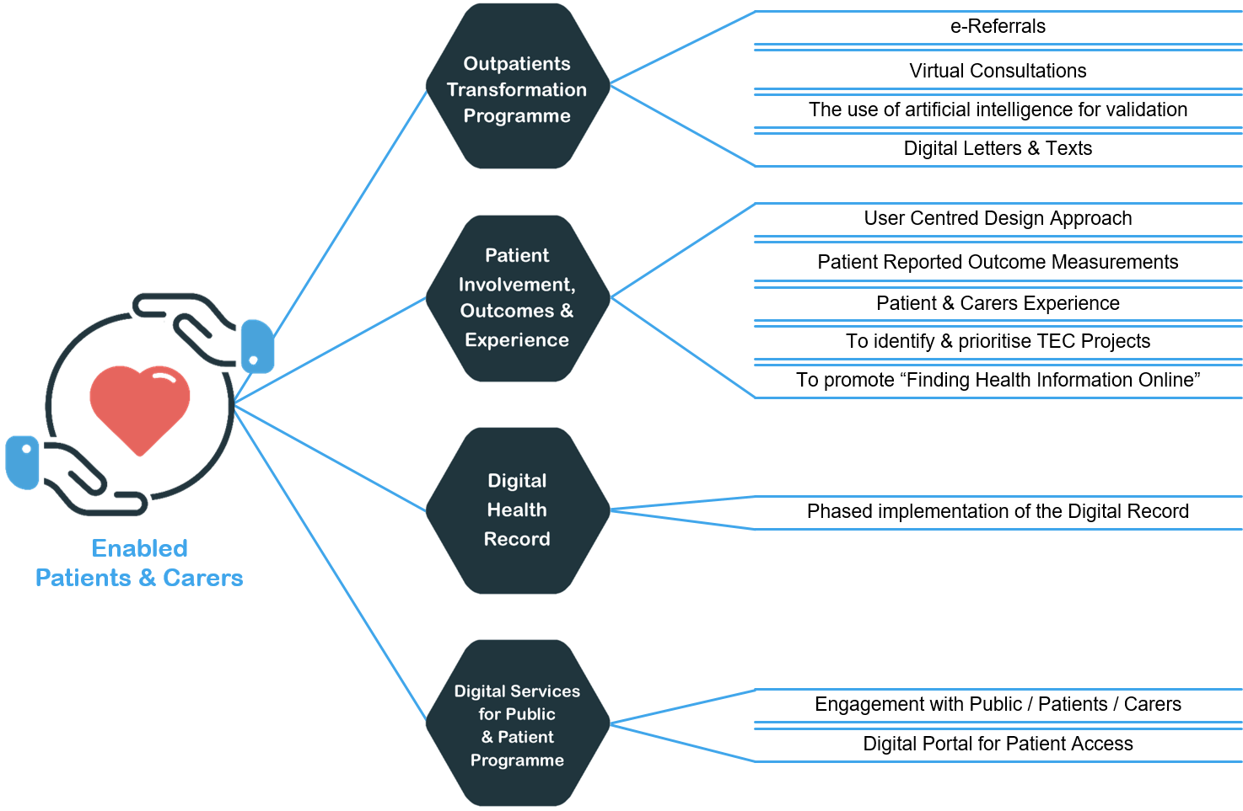
The delivery of the Patient and Carer Experiences will be done through the following Programmes or Projects but some of the Patient Experiences will also be delivered through the Connected Staff Delivery Plan.

Outpatients Transformation Programme
We are just developing our Outpatients Transformation Programme aligned to the National Strategy “Transforming the way we deliver outpatients.” This programme will deliver a lot more than what we have put into this Strategy as these are just the digital aspects. This Programme will include:
- Electronic referral management systems to make getting specialist care easier and quicker;
- Technology to reduce the need to go to hospital for an appointment if it is not needed;
- Alternative ways to support effective self- management of stable long term conditions;
- Alternative approaches to reduce the need for inappropriate outpatient appointments;

The digital priorities that will be delivered will be:
- E-referrals – to deliver this we have to have the same Welsh Patient Administration System (WPAS) in place across the organisation so we will see if there are any other ways to develop this whilst we are putting in the WPAS.
- Continue to roll out of Virtual Consultations
- We want to get the data right first time and we will use Artificial Intelligence to improve the validation of the data that we have
- Improved Communication methods

In the future we also want patients of carers to be able to book their appointments online, before we can progress with this we need to have WPAS in across the organisation.

Digital Appointment Letters and Text Reminders Project
A project has also been set up to deliver digital letters and text reminders under “My Appointment Letters Online”” this has been put in place due to WPAS not being fully implemented.

Patient Involvement, Outcomes & Experience
User Centred Designed Approach (UCD)
We want our patients to be at the centre of when we are changing or developing new digital services which means we will work with people who will be using them. UCD is a process in which the needs, wants and limitations of the end user are taken into account. Through this approach we expect to get an increased user experience plus make implementation more efficient.
Value Based Health Care & Patient Reported Outcome Measurements (PROMS)
We are currently implementing our Value Based Health Care Plan one of the key areas of this plan is the collection of PROMS as a key data set will as this will allow us to assess if we are delivering better outcomes with financial sustainability. We are currently piloting the collection of PROMS with our Orthopaedic Team.
Digital can also support Value Based Health Care through supporting any pathway re-design work and reducing the failure demand.

Patient and Carers Experience (PREMS)
As part of our Patient and Carer Experience Strategic Plan, we are working collaboratively at a national level to have one system that collects patient experience and turns it into real-time insights which will improve the services that our patients receive.
The new bi-lingual system will be able to collect data via multi-channels i.e. online, tablet, SMS, phone, E-mail (survey links), QR Codes and paper to ensure we do not digitally exclude our patients and accommodating sensory loss.
This system will collect that national Patient Reported Experiences Measures. (PREMS)
Finding Health Information Online
There is a lot of fake health information online, believing this information could cause harm to our Patients and their Carers, so we will promote the regionally developed “Finding Health Information Online”
Once the Digital Portal has been developed we can also introduce Chat Bots, so patients can self-care by gaining information and advice.

Digital Health Record (DHR) Project
The development of the Digital Health Record will allow a single view of the patient record, having this in place will support the integration with local and national systems and will provide greater access to systems and information that are safe and reducing the use of paper from the how we work. We will have one system that is capable of gathering patient information from scanned records, new content from e-forms and current and future systems. Part of this project is also to develop digital ways of sharing information across our borders. This project has started and is planned to deliver across the Health Board over 4 years.
A patient’s ability to access this information in the future will be through the Digital Portal to be delivered by the Digital Services for Public and Patients Programme (DSPP). The DHR and the Digital Portal has to be in place, so access to information will grow over the next few years.

Digital Services For Public & Patients Programme
Digital Services for Public and Patients Programme (DSSP) is a national programme which will develop a Digital Portal that will provide access to parts of the digital health record to patients, including for example appointments, prescriptions, test booking and results. Patients will also be able to give their permission for other people to access the digital record such as their carers, people who provide their care and others who they choose.
This is a national project being led by DHCW and we are represented on some of the delivery groups.

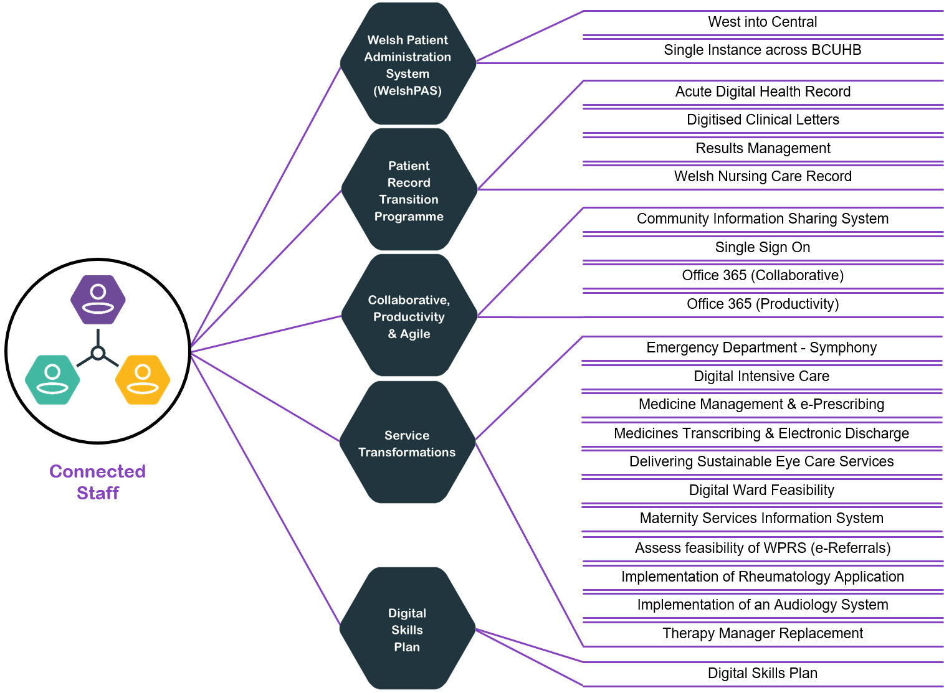
Delivering Ambition 2 – Connected Staff
Some Staff experiences mirror what we will deliver for Enabled Patients and Carers. These are:
- The implementation of the Digital Health Record to support better decision making
- Know more about the patients Outcomes an Experiences through PROMS and PREMS so that improvements can be made.
- Ability to undertake Virtual Consultations
- Ability to make e-Referrals
Delivering the Connected Staff Experiences will be done through the following key Programmes/Projects and Plans plus the delivery of the Enablers.

Welsh Patient Administration System (WelshPAS) Project
This is the basic core administration system in any hospital/community and we don’t have this in place yet across the whole organisation. The PAS documents the patient events and provides support to the basic workflow for case note tracking, referrals, outpatient clinics and inpatient activity. Having a single PAS across all Acute Hospitals will also allow us to fully utilise the PAS and implement new systems that link in with WPAS – we won’t have to implement systems multiple times so will save us time and money.

Patient Record Transition Programme (PRTP)
Our PRTP Programme is an established Programme will continue to work on deliver the following:
- Digital Health Record (DHR), creating a single digital place for the patient record, supporting integration with local and national systems in Wales and beyond.
- Digitised Clinic Letters (Digital Dictation & Speech Recognition), key to achieving the wider move from paper to digital patient records.
- Results Management – to deliver a fit for purpose solution that will be used across our clinical teams that will improve patient safety and support the transition from paper
- Welsh Nursing Care Record (WNCR) – this will transform the nursing documents through standardising the forms, so all our nurses will be using the same forms and they will be digital
- Centralised Teams – providing our staff with the right training and environments to ensure compliance with our legislative responsibilities for appropriately, safely and securely managing and sharing patient information

Collaborative, Productivity & Agile Working Programme
Our staff rated “I can work effectively as part of a multi-disciplinary team” as their highest current experience and “I can work from any location and meet my work colleagues virtually, spending less time travelling” as the 4th highest current experience – we have to continue to deliver and improve these experiences.
This Programme will be new but the projects within are existing projects and will link in with the Corporate Workforce Programme and approach to agile working, it will include:
- Implementation of a Community Information Sharing System
- Implementation of Single Sign on
- Full roll out of Office 365 (Collaborative)
- Roll out of the Office 365 Power Applications and Power Business Intelligence (Productivity)
Some of our teams such as our Community Resource Teams and Mental Health Teams work closely on a daily basis with our key partners such as Social Care and we need to be able to share patient information between partners safely – an Information Sharing Agreement is important and this is covered in Enabler 3 – Stronger Partnerships but we also need the technology to share this information so that they can work more as one team to provide the best care to the patient/service user.
We will implement a Community Information Sharing System, that meets all partner’s needs, we have invested a lot of time and money already into the Welsh Community Care Information System so we will assess if this is the most appropriate solution moving forward.
Due to Covid working from home or any location has become the norm and we expect demand from our staff to continue to increase. Many of our staff have patient facing roles or provide support on site and work across sites, our staff need a seamless service regarding what site they are working from or if they are working from home.
Office 365 also provides us with opportunities for new ways of working and we will maximise our use of these so we work more efficiently.

Service Transformation Programmes & Projects
We have a significant amount of service transformations underway across the organisation and many more being planned, digital is an enabler for these transformations. How they are supported by Informatics varies depending on the project, this is why we have highlighted the need for a different approach to how we support services and that includes digital planning at a service level so the right support can be provided or prioritised. (Please see Strengthened Foundations and Digital Organisation). Through better service planning we will be able to fully view the full range of service transformations, the value and the benefits. Service Transformations have to be led by the Services and supported by Informatics.
The following Programmes and Projects have been identified from what we are currently delivering, through engagement and what external funding we know will be available nationally. They are at different stages of planning and require support. This is not an exhaustive list and many services are changing the way they work. Our Clinical, Estates and Environmental Sustainability Strategies also need to be included as digital will be crucial in supporting them so we know that we will need to add more in and prioritise
- Emergency Department – Symphony
Our Emergency Departments have been under significant pressure due to Covid and staff who work under these conditions need real-time information about the people that are attending, why they are attending, and where they are in their treatment which can speed up discharge.
This is provided by Symphony which we continue to roll out and upgrade in our Hospitals and Minor Injury Units, and then move onto the Welsh Emergency Department System.
This will also support the reduction in waiting times and speed up discharge, so will also improve the patient experience.

- Digital Intensive Care
This is in its early stages and is a National Programme that will transform critical care by automating the collection of data from the monitors and devices used to support patients with life-threatening illnesses.

- Pharmacy - Medicine Management and e-Prescribing
Medicine Management and e-prescribing was a recommendation in the “Pharmacy: Delivering a Healthier Wales”. This national investment will accelerate these plans for a 2021/22 delivery. This Project will result in a digital medicines management system and an e-Prescribing System and will also enable electronic transfer of prescriptions between GP’s and Community Pharmacies.

- Pharmacy - Medicines Transcribing and Electronic Discharge (MTeD)
MTeD has been partially rolled out within 69 ward areas across BCU, we want this to be accessible to the remaining 55 locations through the Welsh Clinical Portal. This will enable pharmacists to transcribe patient medications electronically and clinicians to record a summary about a patient’s hospital stay which can be electronically sent securely to GP surgeries.

- Ophthalmology – Delivering Sustainable Eye Care Services
This National Project will provide an ophthalmic digital system that will provide electronic referrals between community optometry practices and hospital eye departments and enable more people to be treated and cared for locally.

E-referral will enable the safe timely transfer of clinical information to support referrals for diagnosis and treatment and avoid the delays inherent in a traditional paper based system. Implementation of e-referral and introduction of an Electronic Patient Record (EPR) for eye care will enable community optometry practices and hospital eye departments to have joint access to patient records enabling shared care and monitoring.

- Digital Ward Feasibility
As our wards use a range of systems, we have piloted the implementation of STREAM which helps with patient flow and discharge as well as developing a new Welsh Nursing Care Record. This feasibility will assess the funding requirements for any required digital systems and to bring together the existing multiple systems whilst linking into the Digital Ward national funding.

- Maternity Services Information System
“Maternity Care in Wales – A Five Year Vision for the Future (2019-2024)” provides the strategic direction of our Maternity Services. Within this 5 year plan the digital priorities are a national information system, an All Wales electronic maternity record that will be accessible to individual mothers and which will be linked across Wales to they can be accessed by the professionals providing the care.

(Please Note: This is not an exhaustive list and changes rapidly)

Digital Skills Plan
Our staff scored “I have the skills to work digitally and access to the training I need for the future” as the second highest experience they currently have but there is a possibility that this is not fully representative of our staff as it is likely that those without the skills did not complete the survey. Staff also identified that further digital training and support was needed and that technology will not be used without the skills to use it. Our staff skills are essential to the successfully deliver this Strategy.

“Within 20 years, 90% of all jobs in the NHS will need some element of digital skills. Staff will need to be able to navigate a data rich healthcare environment. All staff will need digital and genomics literacy”
The Topol Review, 2019
Staff need to be confident working digitally, not all our staff are confident at the moment. Our Staff have wide ranging digital skills from staff who do not use a computer as part of their everyday work to staff who use multiple systems every day.
We will develop a Staff Digital Skill Plan where digital skills are classed as a basic skill, staff can self-assess their own skills and it becomes part of their Training and Development Plan. Digital skills training will be delivered working in partnership with Digital Communities Wales, Unions and any other key partners.
This allows us to assess and improve the digital skills of our staff so when we implement new digital ways of working we have an agreed way to assess skills and identify the level of change and what needs to be done to ensure success.
Part of this Digital Skill Plan will include using existing staff support structures and the development of Digital Champions to support and improve confidence.

Delivery of Enabler 1 – Strengthened Digital Foundations

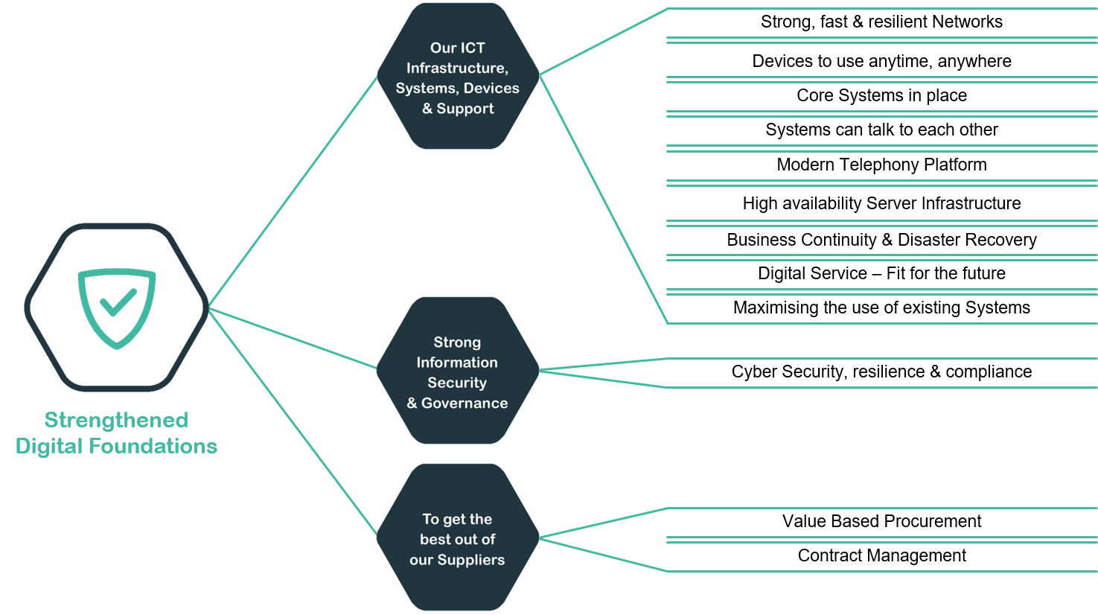

Our ICT Infrastructure, Systems, Devices & Support Provided Are Suitable For Today & The Future
Building Strong, Fast and Resilient Networks
We will develop networks that provide safe and high speed connectivity with fully resilient design to ensure continuity of service supporting the organisation in ensuring that all services continue to work uninterrupted.

We will continuously increase the bandwidth to Community Hospitals and Health Care Centres and develop additional Wi-Fi capacity across the Health Board for improved corporate and patient access.
Devices to Use Anytime, Anywhere
The continued roll out of a series of modern, secure and fit for purpose PC’s, Laptop, Tablets and Smartphones that meet the needs of services as their own demands change to meet patients requirements. Using software deployment methods to enable rapid roll out.

Finalising the migration of the PC and Laptop estate over to Windows 10.

Continued roll out of the O365 to support collaboration, improved communication and agile capacity as included in Ambition 2 – Connected Staff.

Core Systems Place
We will have the following systems in place, these are the systems that we need in place as our core systems:
- One Patient Administration System across the Health Board (WPAS)
- Welsh Clinical Portal (WCP)
- Welsh Laboratory Information Management System (WLIMS)
- Digital Health Record (DHR)
- Community Information Sharing System (Currently WCCIS)
- Welsh Emergency Department System (WEDS)
- Welsh Radiology Information System (WRIS)
- Welsh Immunisation System (WIS)
- Data Warehouse and National Data Resource (NDR)
Please note – these are our core systems and there are other critical clinical/departmental and corporate systems that will be needed to deliver this Strategy.

We have over 280 systems across the organisation that are managed in different ways. We want each of these systems to have Business Continuity Plans in place so if they fail, services can still be delivered.
Systems can Talk to Each Other
The safe portability of patient data using nationally agreed standards and Application Programming Interfaces (API’s), will support the our 'once for Wales' and indeed more broadly 'once for the patient' approach; i.e. of our patients that are transferred for speciality care, 96% receive this over our closest boarder into England and as a result we have to work closely on this with our partners and services within and beyond Wales.

Across our organisation we have lots of systems that need to talk to each other to realise the patient experience of providing their information once. When we put new systems in place we will fully assess if they can share information.
Some of our Primary Care and Secondary Care systems don’t talk to each other. Primary Care providers have two main systems. This is a big gap in sharing information and impacts the patient journey when they move between services we provide to patients. This is very challenging, but we want to see if it is possible, first on a small scale.

Modern Feature Rich Telephony Platform
We will finalise the IP Telephony to enable utilisation of wider functionality and the decommissioning of the legacy systems.

We will develop contact centre technology to deliver within the organisation including GP surgeries providing call menu options such as language choice, call queuing and the consolidation of patient contact into centres that can deal with multiple types of enquiries and bookings.

We will also further develop mobile application deployment and device management to support our mobile workforce
High Availability Server Infrastructure
We will become more demand responsive and we will be able to scale up and down instantly as to meet the needs and changing demands of our services, including our seasonal demands. Our private cloud will also integrate with other Public Cloud providers to develop a Hybrid Cloud Solution allowing us to increase our technology capacity and provide externally provided service seamlessly. This hybrid approach gives us the greatest benefit to where we are now this is our staged approach to being fully in the cloud.

Business Continuity and Disaster Recovery
We will continue to develop our disaster recovery plan and undertake regular exercises to provide the assurance that plans are in place and are ready to be invoked in the event of a critical incident.
A Digital Service that is Fit for the Future
Our ICT Support and Service will further develop customer engagement as to fully capture services requirements so we can meet our customers’ expectations, whilst also working towards achieving the Service Desk Institute (SDI) accreditation so we provide industry best practice.

Across Informatics, we will review our current service support model that we provide so that it can best meet the needs and demands of the services, we will also include how we can best use new communication technology.

We know from our response to Covid we need to have technology that is easily transferable or portable to be able to respond to business continuity incidents.
Maximising the use of Existing Systems
We have a number of systems that require upgrades and we include these in our business as usual but when we do upgrades we need to ensure we get maximum value out of the additionally that sometimes comes with upgrades.
We will also review the use of our key systems and provide staff with the support to use the systems better and ensure that all our systems have business continuity plans.

Our Diagnostic & Laboratory Systems provide a full digital system for test requesting, processing and reporting, this a national system near the end of its contract which requires a new agreement with upgraded functionality.

Strong Information Security & Governance
Cyber Security, Resilience and Compliance
We will have the right resources, technology, skills and staff awareness in place to prevent the increasing number of cyber-attacks and if we are attacked, we will minimise the damage and recovery required.

We will meet all our statutory requirements (Network & Information Systems Regulations Directive (NIS-D) and gain best practice certifications including Cyber Essentials (CE), IASME and ISO 27001 Certification.

Testing is important to see if what we have put in place works, so we will undertake external Penetration testing to provide assurance.

We will also ensure that there is a balance between Cyber Security and the needs of our organisation to carry out its business whilst meeting the Data Protection legislation

To Get The Best Out Of Our Suppliers
Value Based Procurement and Contract Management
We will continue to improve our procurement practices to ensure we gain the right systems/services to deliver what we need and that they are fit for purpose for the end user. This is important as it is directly related to our approach to Once for Wales. We also will work better with our suppliers to get more financial and social value from them through improved relationships and supplier management.
At a national level one of our key suppliers is Digital Health and Care Wales, they have to prioritise and meet the needs of all the Health Boards in Wales. As Health Boards are at different levels of digital maturity DHCW has to ensure they know what our priorities are to deliver this Strategy and work with us to develop our joint plans for delivery on an annual basis, before their plans are approved by the Welsh Government. We also need to monitor the implementation of our joint plan.

Delivery of Enabler 2 – Information For Improvement
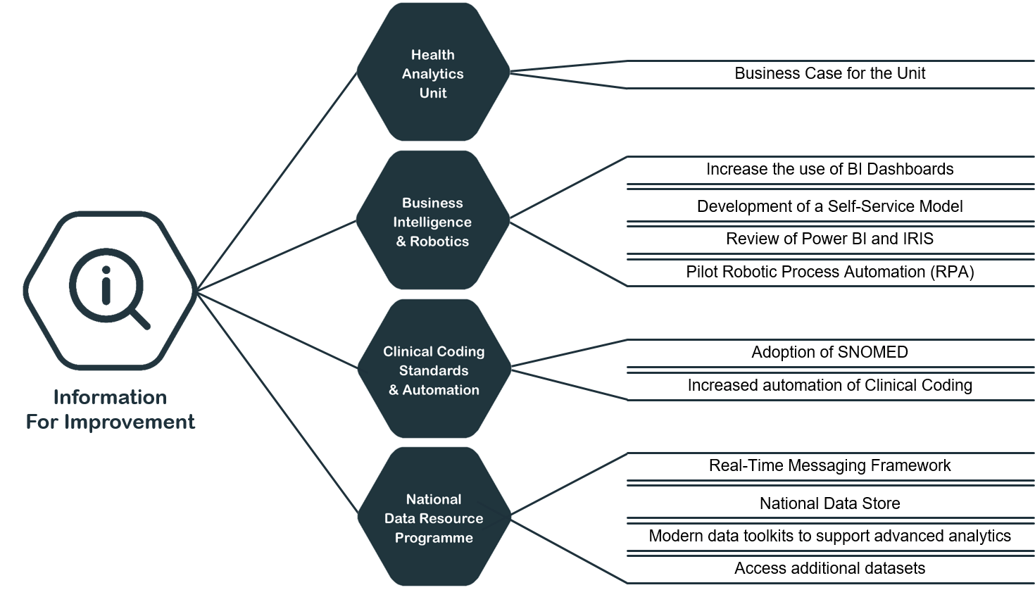

Health Analytics Unit
Develop a Business Case for the Health Analytics Unit
A Health Analytics Unit would enable us to create dedicated capacity and further develop skill within the team to undertake modelling and forecasting that proactively supports the organisation with longer term planning.
We will develop a Business Case to show the added value, costs and benefits that this Unit will bring.

Business Intelligence & Robotics
Increase the use of Business Intelligence (BI) Dashboards
Many of our services use business intelligence (BI) dashboards and more services can benefit from their use. We will do this by using and further developing our account management approach working with the services to ensure information gaps are addressed and that information is at the heart of service management and decision making.
Development of Self-Service Model
Working with the services to develop a Self-Service Model to meet basic information requirements. This will allow our team of analysts to spend time dealing with complex requests work closely with information customers and problem owners to interpret the vast amount of data available to us.
Review of Power BI and Iris
We will standardise our reporting templates and develop our brand to provide consistency and assurance to our information users.
Pilot Robotic Process Automation (RPA)
Identify and undertake a RPA Pilot to demonstrate the value it can bring to some repetitive key tasks.

Clinical Coding Standards & Automation
Adoption of SNOMED-CT (Systemized Nomenclature of Medicine Clinical Terms)
We will work nationally with DHCW to implement SNOMED-CT at BCU.
Increased Automation of Clinical Coding
Develop a project to increase the automation of clinical coding.

National Data Resource Programme (NDR)
We will continue our work with the NDR Team and we will:
- Establish a Real-Time Messaging Framework
- Establish National Data Store (Using Cloud & ‘Big Data’ Methodologies)
- Provide access to modern data toolkits to support advanced analytics
- Access additional datasets (i.e. WAST, 111,)

Delivery of Enabler 3 – Digital Organisation “Think Digital”

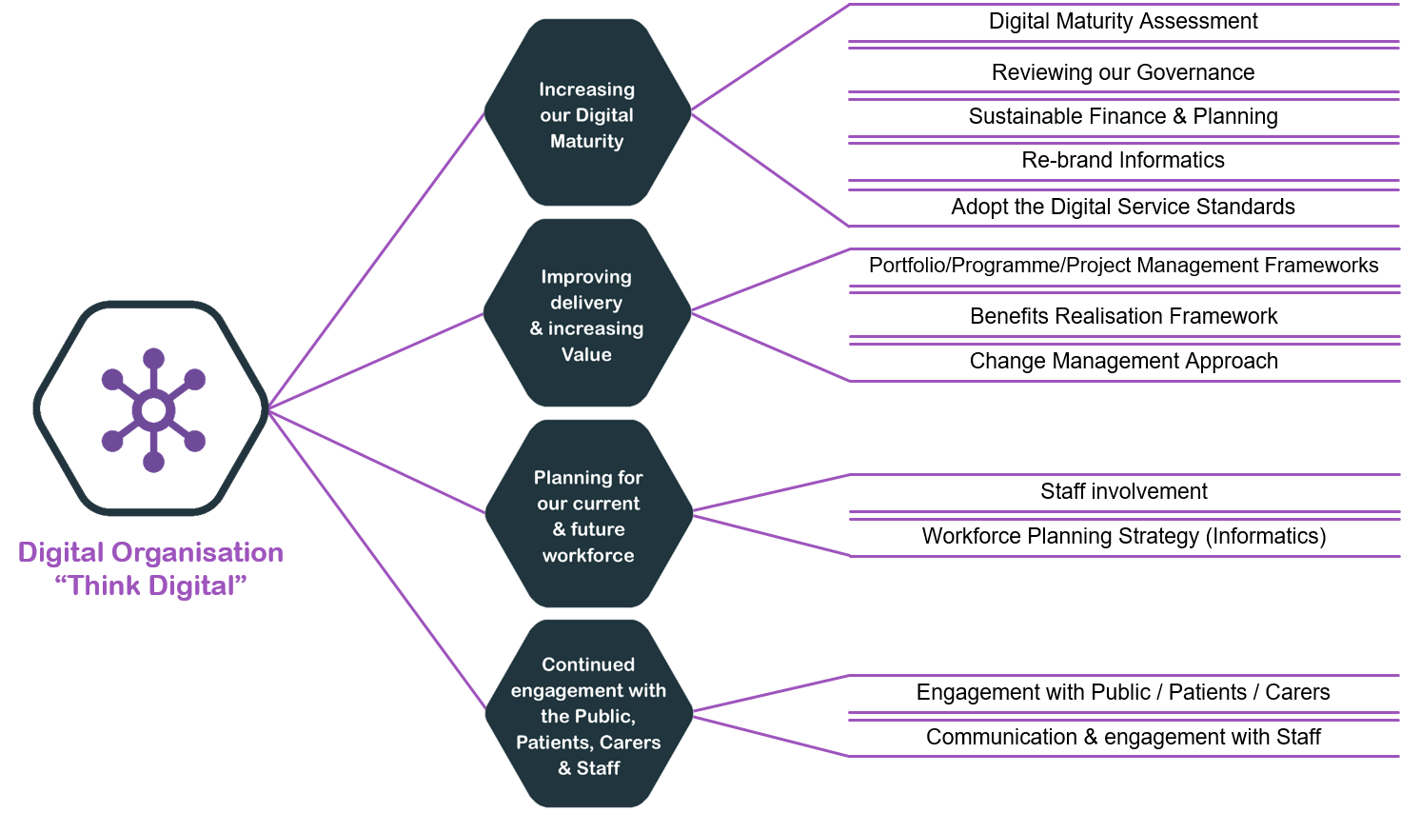

Increasing Our Digital Maturity
Digital Maturity Assessment
Our digital maturity will improve through knowing where we are now and where we want to get to with a clear plan in place. We will focus on our ability to plan and roll out digital services, increase the amount we use digital to deliver services and our infrastructure we have to support our digital service delivery.
Reviewing our Governance
Our systems and processes that we use to lead, control and direct our digital work (our governance) will need to be reviewed and strengthened. This includes our digital expertise and leadership making sure we have the right people with the right skills to contribute across our organisation. Our Governance will also include all the frameworks that we need to make change happen i.e. Change, Benefits etc.
Sustainable Finance and Planning
We have limited finances, this is one of the key areas identified by our staff which they felt could impact on the delivery of this strategy. Finance is our biggest risk in the delivery of this Strategy, but we have to ensure that we provide the best experiences and outcomes that matter to people, whilst looking after our limited resources and finances.
We will make best use of our existing budget and ensure we deliver value. We will introduce new ways of working such as Portfolio Management that will help us prioritise what we do, delivering what contributes to what we need to deliver our strategic priorities and we will align this new way of working with our existing governance structures.
Where there is short term funding available for digital transformation, we need to maximise the use of this resource but whilst also ensuring what we do will last longer than the length of the funding as short term solutions can have a negative impact on patient and staff experiences.
As our funding is limited and sometimes short term we will also look for additional sustainable funding opportunities, having this Strategy and knowing our priorities will make this easier for us to take these types of opportunities.
Our business cases need strengthening for projects across the organisation so that all digital costs are fully identified as well as taking into account the lifetime costs of the systems and equipment we put in place. Again, making the best use of our resources.
Digital planning for the future at a service level needs to improve as it allows us to plan our resources and funding better and for us to be able to deliver the right projects or work that deliver our strategic priorities, provides value and benefits.
Re-brand Informatics
To modernise our thinking, we will re-brand our Informatics Department so the service are not seen to be just about lap tops and phones, but about the wider digital agenda and support with transformational change.
Adopt the Digital Service Standards
Part of becoming a Digital Organisation is that we have to keep the people who use our services at the centre of what we do and we will do this by adopting the Digital Service Standards Wales as an organisation and integrate them into our digital projects, this also supports our approach to Digital Inclusion.

Improving Delivery & Increasing Value
Portfolio, Programme and Project Management Frameworks
To ensure that we are delivering the right programmes and projects and value we will implement a Portfolio Management Framework, this will help us prioritise what we need to do.
Delivering new systems and ways of working at a pace relies on us having the right amount of staff with the right skills but also implementing new ways of working, breaking down what we need to deliver into shorter tasks, assess more often with users and change our plans as required. We will implement a more agile approach to how we manage our projects and programmes where it is appropriate and will incorporate it into a review of our Project Management Framework and in the development of our Programme Management Framework
Benefits Realisation Framework
Having good plans in place won’t deliver the change, the work we do has to make a difference and provide value and we need to be able to show this. Benefits will be identified at the very beginning of what we do and we will monitor their delivery. Benefits have to be owned by the services and our Clinical leads will play an important role in embedding this way of working.

Our focus on benefits will be on the patient i.e. safety, outcomes and experience, our staff as well as financial, non-financial, social and environmental. We need to strengthen our knowledge and experience in relation to systems and the impact on these areas; particularly patient safety, this is a key area for research for us.
Change Management Approach
This Strategy will transform how we provide services, how we work day to day and will impact on our patients and carers. Embedding these changes to realise the benefits will be challenging so we will adopt/develop appropriate change management approaches.

Planning For Our Current & Future Workforce
Staff Involvement
Increasing our clinical and non-clinical staff involvement in leading and being involved with our digital projects is crucial as they know what they need from systems and any new ways of working, this is part of our End User Design approach.
Our current Digital Clinical Leadership Team needs to be strengthened to also include a Nursing Clinical Lead, to ensure that nursing profession is fully represented and shaping Our Digital Future.
All clinical staff who take on these lead roles will all have appropriate and ongoing support to continue to develop into their roles, this support will be clinically led by our Chief Clinical Information Officer. One of the key roles that has been identified through this strategy is to be the champions for clinical benefits realisation.
This strategy will impact on all of our staff, the wider staff involvement in this change is covered in the Staff Experiences section.
Workforce Planning Strategy for Informatics
To be able to deliver this strategy we need to have the right digital workforce now and a plan for what workforce we will need over the next 5+ years, including our leadership and management. We already know that we have an increasing need for staff with cybersecurity skills and we also expect this key area to become even more complex and expensive.
Training is a key part for planning for our future skill needs, we expect that in 5 years’ time our skills needs will be significantly different to today due to the pace of technological change.
Developing our Workforce Planning Strategy is a key area that we will need to work collaboratively on with our local Colleges, Universities and National Bodies such as Health Education Improvement Wales, Social Care Wales, Digital Health and Care Wales and the Centre for Digital Public Services.

Continued Engagement With The Public, Patients, Carers & Staff
Planned Engagement with the Public, Patients and Carers
The response to our Public/Patient Survey was great, and this strategy has been shaped based on the feedback and comments that we received.
Building on this engagement is important so see if this strategy is making a difference and we will work through our existing networks and also developing an informal Digital Patient Group who will be involved in testing digital solutions and providing views on approaches to digital solutions.

We will also need to continue to engage to assess if we have improved from the Public/Patient view as the engagement has provided us with a baseline to which we can assess our delivery of this Strategy.
Communication and Engagement with Staff
Continued Staff Engagement is also important, again so we can see if this strategy is making a difference.

All our Staff need to know about this strategy and their role to support its delivery, so we will develop a communication plan and continue to engage.

Delivery of Enabler 4 – Strong Partnerships

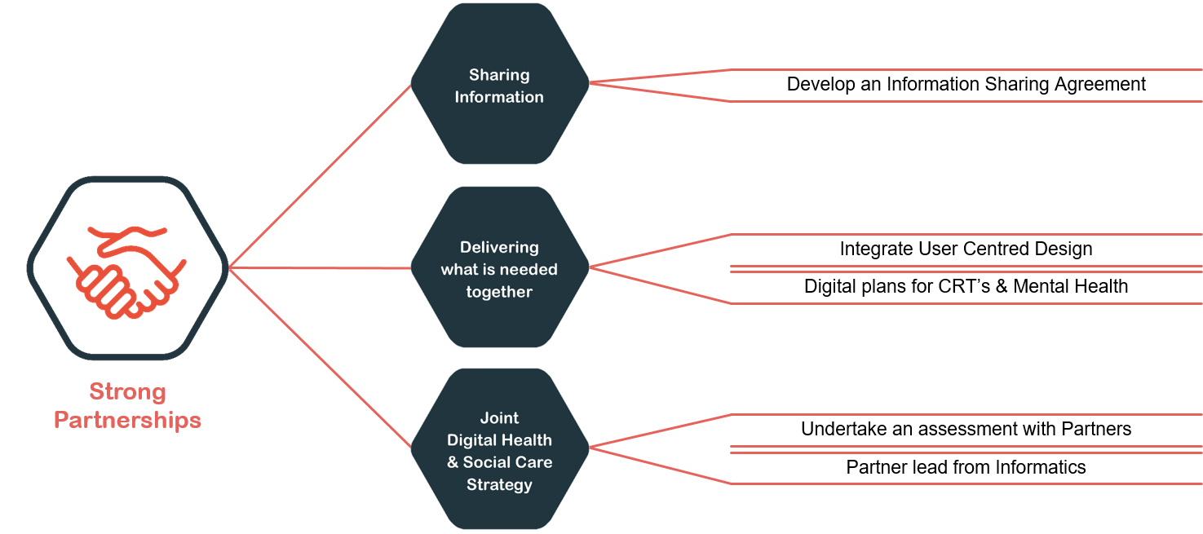

Sharing Information
We will work collaboratively with our Partners to develop an Information Sharing Agreement so that we keep information safe and we ensure that information is shared lawfully in line with Data Protection Legislation.

- Delivering what is needed together
We will train our digital staff to work more co-productively and to integrate User Centred Design into how we work.
We will work co-productively with our community resource and mental health team to develop service digital plans.
Our key internal partner is our Information Governance Team, who we will continue to work closely with to ensure we meet the Data Protection legislation and ensure privacy by design.

- Joint Digital Health and Social Care Strategy
We will work with our partners to assess if they would prioritise the development of a Joint Digital Health and Social Care Strategy.
We will provide a partner lead from the Informatics Service to continue to work with partners on digital opportunities that benefit our patients and staff.

Delivery of Enabler 5 – Digital Inclusion

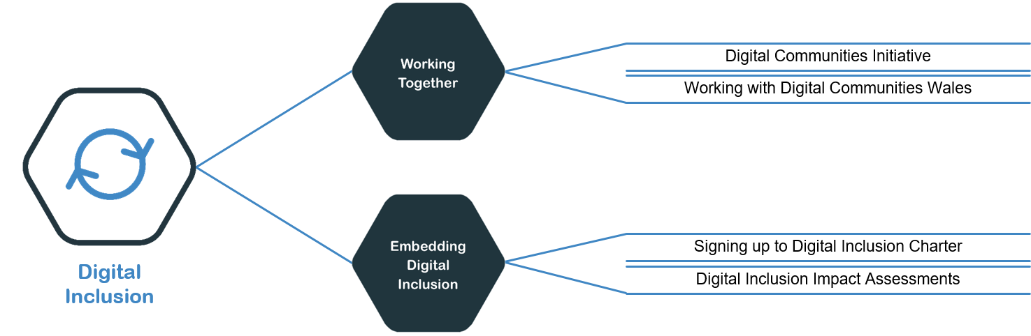

Working Together
Digital Communities Initiative
We are part of the Digital Communities Initiative and will continue to be a part of this group. We will focus on providing digital training to Health and Social Care Staff to support the most vulnerable to become digitally included; support citizens to engage with virtual consultations and support people with new or existing chronic conditions to use digital technology.*
As we have stated we want to assess if our Local Authority Partners want to have a Joint Digital Health and Social Care Strategy. Due to the significant impact of digital exclusion on people who use our services we want to progress our work with our partners to develop a digital strategy for personalised care and support, which will form part of an overall Joint Digital Strategy.
*Note: this may not be Health Board wide as Local Authorities have to opt in to be involved.
Working with Digital Communities Wales (and/or other Welsh Government Programmes which aim to reduce digital exclusion)
Digital Communities Wales: Digital Confidence, Health and Well-being is a three-year Welsh Government funded programme which aims to reduce digital exclusion and help improve basic digital skills levels across Wales
Digital Communities Wales is one of our key partners to improve digital inclusion of both our patients and our staff. We want to continue to work with them and engage with them early when we have patient facing or staff service changes. They are the experts in developing volunteers and digital champions and can advise us on best practice. They are also a key partner in relation to our plans to support our staff in developing their digital skills. (See Ambition2: Connected Staff).

Embedding Digital Inclusion
Signing up to the Digital Inclusion Charter
For our Strategy to be successful Digital Inclusion is crucial so we will sign up to the Digital Inclusion Charter and embed it into our ways of working.
Digital Inclusion Impact Assessments
The impact that we have on our users could be significant, we will fully assess the impact of the digital services that we implement and undertake a Digital Inclusion Assessment (DIIA) utilising the national digital inclusion checklist and incorporating our Socio-economic Duty.

Delivery of Enabler 6 – Embracing Innovation

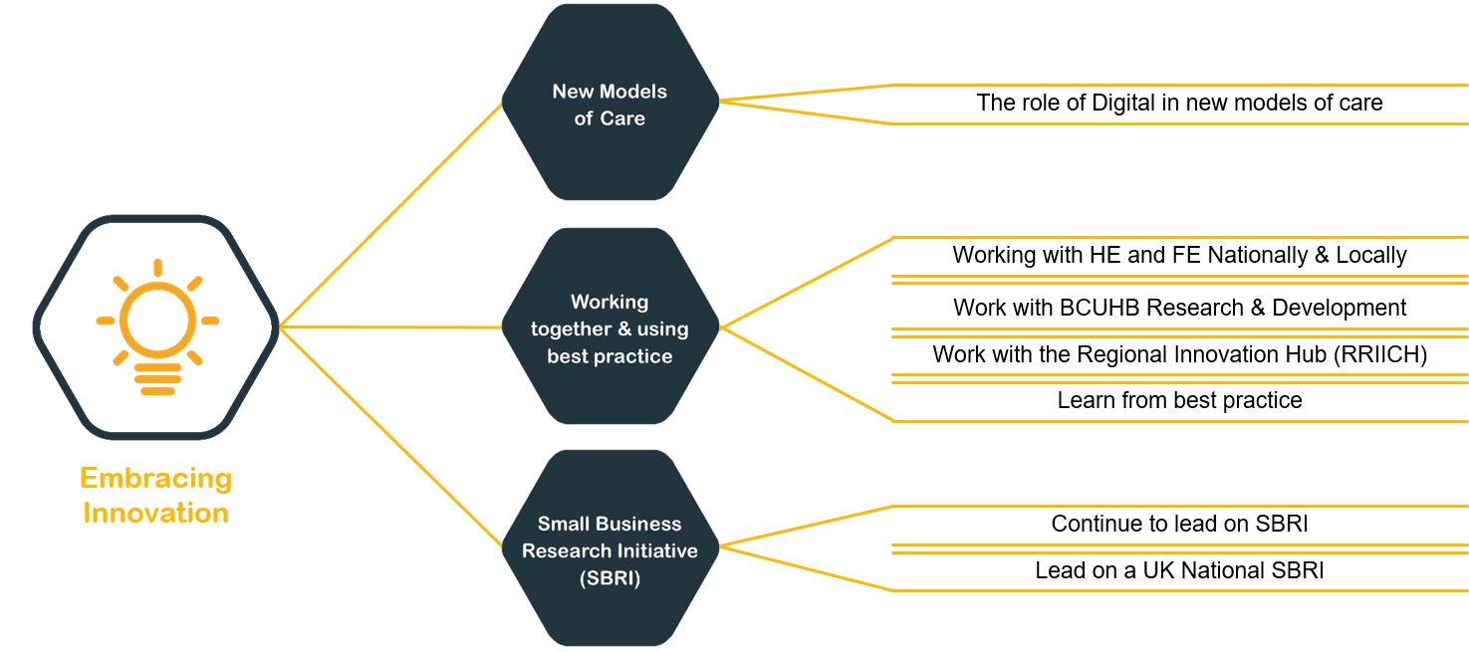

New Models Of Care

The Role of Digital in New Models of Care.
We need to research new models of care to see which ones will work for us, most of these new models of care will need to be digitally enabled, and these will be identified through our Clinical Strategy.
The future will be very different as the digital technology and we as an organisation advance in this area, this Strategy focuses on getting the basics right but we have to be one step ahead and look at our longer term vision which is more virtual, more automated with an increase in the use of robotics.
We have started real-time monitoring of patients using wearables during Covid. The Alaw Ward have been able to monitor some cancer patients who are on chemotherapy at home using a smart watch whose real-time data is being monitored by the clinicians who provide their care and who can pick up any early warning signs. We want to increase the use of this technology as it provides many opportunities to provide self-care and preventative care rather than re-active care.
Are virtual wards an option for us in the future? With the ability to remotely monitor it could support people who can and want to be at home.
Our GP Surgeries have adapted well to a more virtual approach through Covid, with some using e-Consult which has alleviated some access issues for some patients. Can our GP surgeries become more digital and work together in clusters so patients have access to a wider range of surgeries?

Working Together & Best Practice
Work with Higher Education (HE) and Further Education (FE) Nationally and Locally
Innovation in Digital is happening, cross all the HE and FE Institutes and providers across Wales. We want to build stronger relationships with Bangor University and Grwp Llandrillo Menai for both innovation and workforce planning. At a national level we want to learn from the Wales Institute of Digital Information (WIDI) and their approach to developing students to be the workforce for the future.
We will also look for opportunities to work at a national level and learn from best practice.
Work with BCU Research and Development
We have our own Research and Development Team who are leading the way in innovation and we want to bring Digital and Research closer together.
Work with the Regional Research, Innovation and Improvement Co-ordination Hub (RRIICH)
The aim of the hub is to coordinate research, innovation and improvement activity in North Wales about how health and social care services can work together better. It is really important for us to link in more with the work of the hub, existing research and information that has been developed at a regional level already. An example of this is that work has already been done on “Finding Quality Health Information Online” which is important to the delivery of this Strategy.
Learn from Best Practice
We have lots of good practice within BCU, from our Partners and other Health and non-health organisations.
Reviewing this will be part of our approach.
There are many examples of good practice; Our Audiology Department have been using a patient management system so have been using a paperless system for more than 20 years. A case study of this can be found in in Appendix 7.
Strong Partnerships are crucial for our future, our Cancer Services Team work with Macmillan and have just delivered the Transforming Cancer Services Together Programme, and patients have access to the Electronic Holistic Needs Assessment (EHNA) that supports person centred care. More details can be found in Appendix 8 – Macmillan Case Study.

Small Business Research Initiative (SBRI)
Continue to lead on the SBRI
The work that we have done leading the SBRI nationally is award winning and to further drive innovation we are keen to continue with this. This is funded through the Welsh Government currently on an annual basis, with a view to making permanent.
Lead on a UK National SBRI
There are so many opportunities for innovation and one of these is to work at a UK level with key partners to develop a national challenge and response

ROADMAP FOR DELIVERY & MEASURING SUCCESS
Please note The Projects that we have Funding Secured for are the delivery dates, not the start dates. For the Business Case Dependant Projects are the dates the Business Cases will be produced.
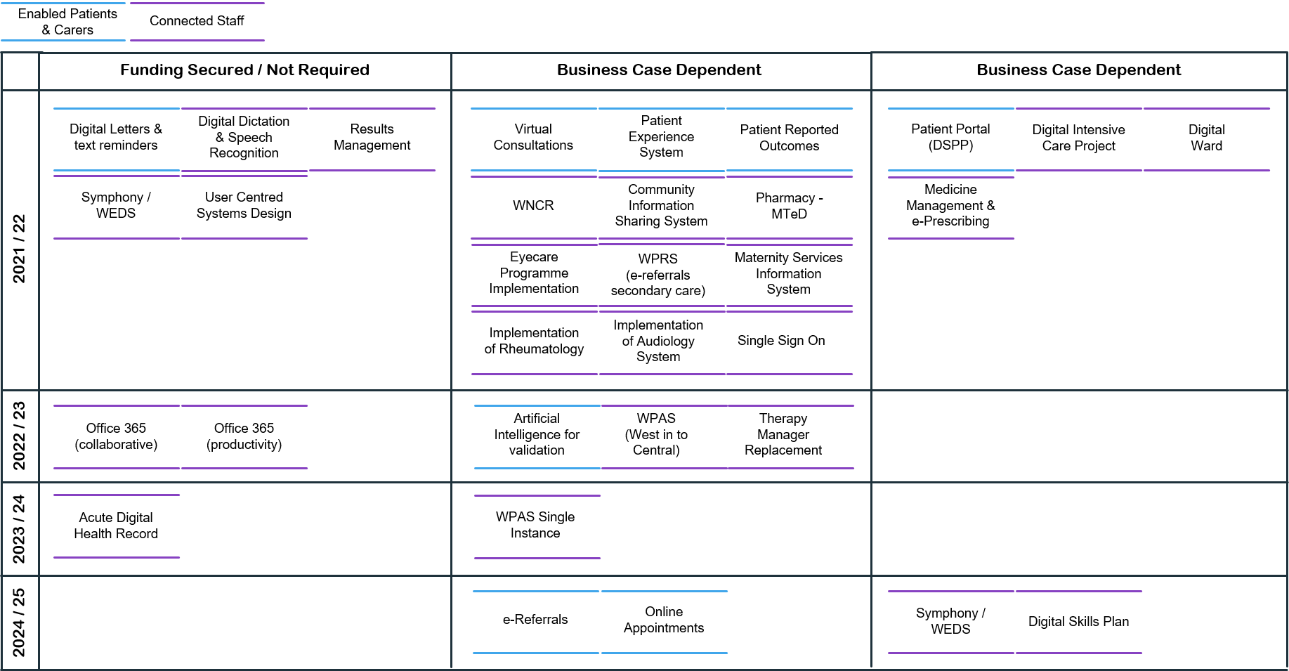

Measuring Success
The success of this Strategy will be measured in the following ways:
- Improved Experiences - patient, carer and staff experiences.
- Improved Benefits - The benefits that the strategy brings to the patients, carers, staff and the organisation, this will include financial and non-financial benefits and where appropriate the return on the digital investment.
- Increased Compliance with Legislation – Ensuring we meet the required legislation.
- Prioritised Investment - Prioritised sustainable investment in digital.
- Increased Digital Maturity – Meeting agreed maturity milestones.
- Right Workforce to Deliver - Having the right workforce with the right skills to deliver.
- Time to Delivery - Time from business case approval to implementation of the systems (Planned V Actual).

MONITORING & REVIEWING THIS STRATEGY
An annual update on progress of this strategy will be developed and will be monitored through the Digital Information Governance Committee (DIGC) and reported to the Health Board.

This is a 3 year strategy and will be reviewed in 3 years but due to the pace of change it will require an annual update.

APPENDICIES

APPENDIX | TITLE | DOCUMENT
Appendix 1 | Digital Strategy Engagement Summary  (link to full engagement report once published)
Appendix 2 | Delivery Plans
Appendix 3 | Full list of National Strategies, Plans and Programmes and other Key Links
Appendix 4 | Where are we now – Ambitions, Enablers and Current Systems
Appendix 5 | Overview of our IT Infrastructure
Appendix 6 | Our Response to Covid
Appendix 7 | Good Practice – Audiology
Appendix 8 | Good Practice – Macmillan
Appendix 9 | Glossary

