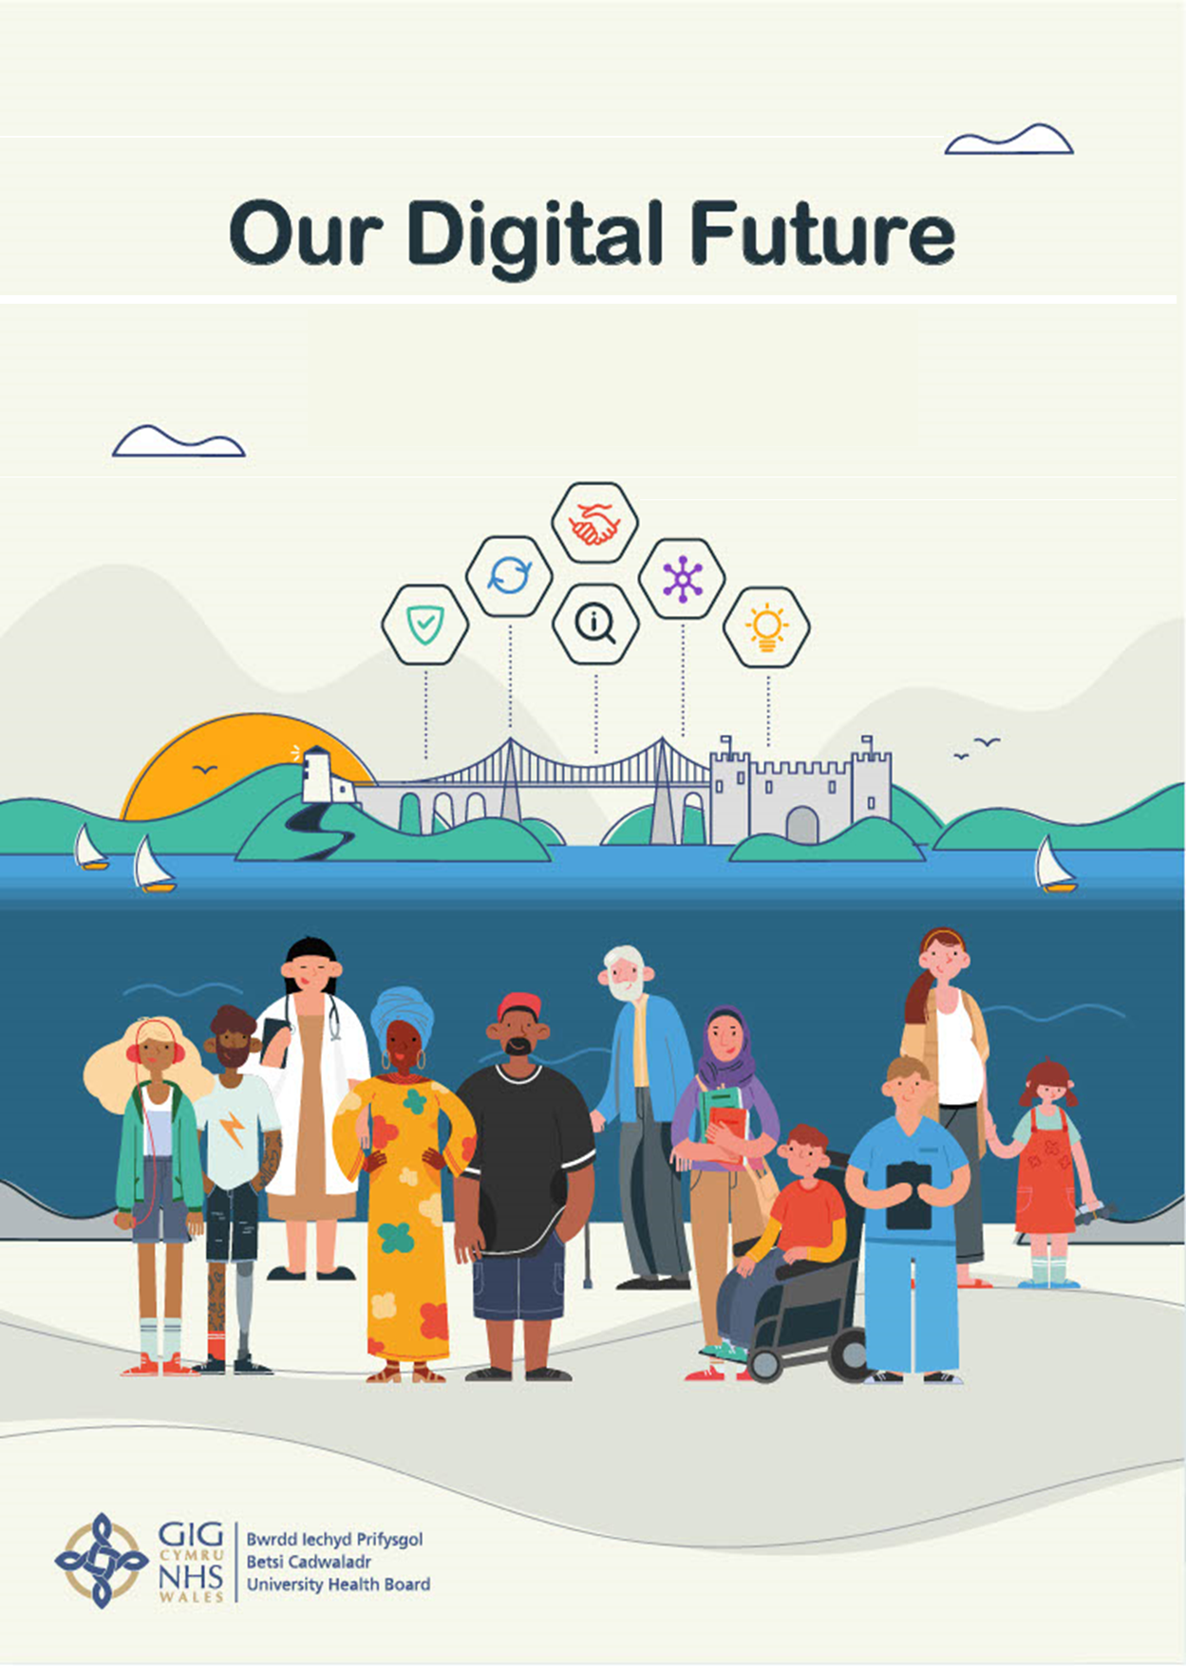

BCUHB Digital Strategy
Public/Patients Engagement Results

INTRODUCTION

In November and December 2020, Betsi Cadwaladr University Health Board asked various stakeholders to take part in our ‘Digital Strategy’ engagement, to inform the output of our new Digital Strategy for 2021-2024.
The purpose of engaging on the BCUHB Digital Strategy was to:



Understand patients and staff views on their current experiences of accessing and using digital within their care/work and what experiences they want in the future

Understand the barriers that are in place for both patients and staff in relation to digital services


Obtain stakeholders views on the draft vision, focus areas, experiences and principles of working and to identify ways of how we can work better together in the future.


To identify how digital planning is undertaken at a service level, discuss the legacy system arrangements, digital governance and to collate what digital projects and programmes are happening across the Health Board.

The Approach

The Health Board provided opportunities for stakeholders to engage to help develop the Digital strategy. The engagement aimed to capture stakeholder feedback on the contents of the draft Digital strategy as well as understanding stakeholder’s views and experiences in relation to digital.
The engagement was underpinned by a communications campaign containing key messages and specifically targeted our key stakeholders. The engagement also provided opportunities for stakeholders and the public to comment or feedback on what they feel the Digital strategy should focus on.
A two phased approach to engagement was undertaken:

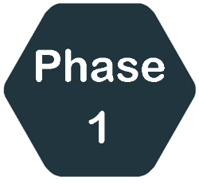
Engage with all stakeholders on the priorities within the draft strategy, including feedback on their current experiences in relation to digital and what the priorities are for each stakeholder group.
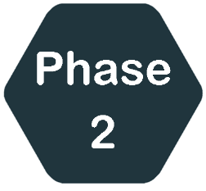
Once the draft Strategy had been amended to reflect the output of phase 1, further engagement on the final draft to ensure the views obtained from phase 1 are reflected within the final Strategy and it meets stakeholder needs.

We would like to thank all those people and groups who took part. A really important part of any engagement is feeding back to the participants about what has happened since they gave their opinions, and what effect their views have had.
This process of feedback is about being able to show where your views have impacted on the development of our strategy, and also explaining when there are times where we could not do everything suggested. So, we are now presenting this ‘You Said, We Did’ report.

THE STRATEGY

BCUHB would like to thank all respondents to the engagement exercise. The feedback received has allowed us to amend, shape and finalise a Strategy, which has now been agreed by BCUHB and published here. The strategy will be the Digital roadmap for health in North Wales until 2024.

SURVEY ANALYSIS
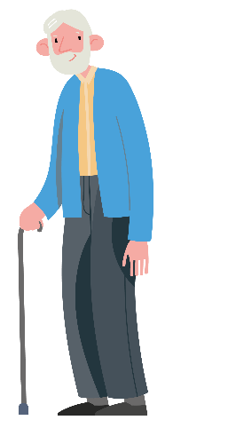
For those questions where respondents were asked to score responses from 1-10 (disagree – agree) rather than simply presenting the % of responses which agreed/disagreed with each proposal, each proposal has been given an ‘Average Score’. The higher the average score, the greater the level of agreement with the proposal. Viewing the responses in this way allows us to demonstrate more clearly the strength of opinion for each proposal, and therefore demonstrates the results more accurately.

PATIENTS / PUBLIC

There were a total of 321 responses from patients/general public

Your Experiences


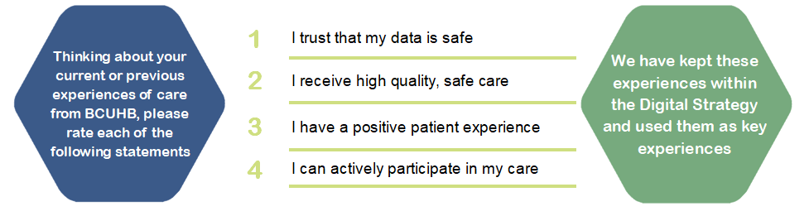

Active Patient / Carer

The following are what BCUHB want our patients and carers to experience

- I will receive safer care and better outcomes
- I will receive care closer to home
- When I am referred, I will get specialist care easier and quicker
- I will safely return home quicker
- I can be actively involved in the management of my care and I am supported to self-manage my care
- There is a single accurate source of information that held about me and that important information is available to all who treat me
- I will be able to access and update my own patient record in the future
- I can have a copy of my record when and in the way I ask for it
- I can access more timely appointments in a location better suited to my needs and be reminded of my appointments in the way that suits me
- I can receive correspondence electronically, and have access to them for future reference.
- I can access and contribute to my health information whenever I want and update it so the person who provides my care knows more about me.
- I can choose how I would like to communicate
- I don’t have to keep repeating my details unnecessarily
- It is easier for me to move between services
- I trust that my information is safe
- I won’t be disadvantaged if I cannot access digital services
- I can provide feedback easily
- I am listened to



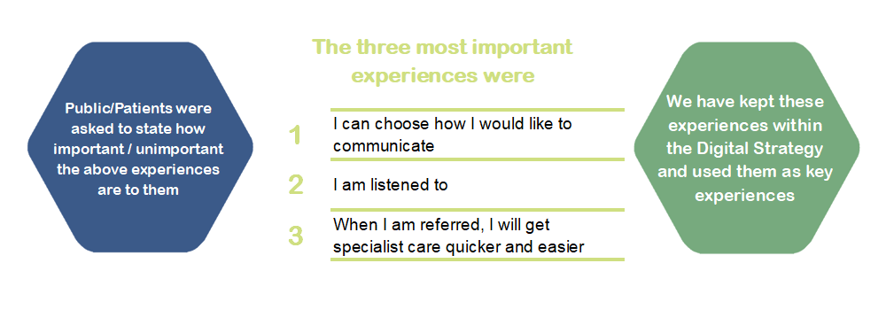

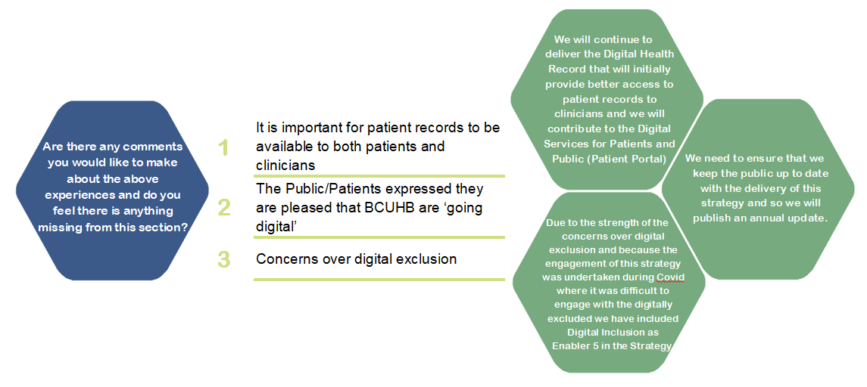

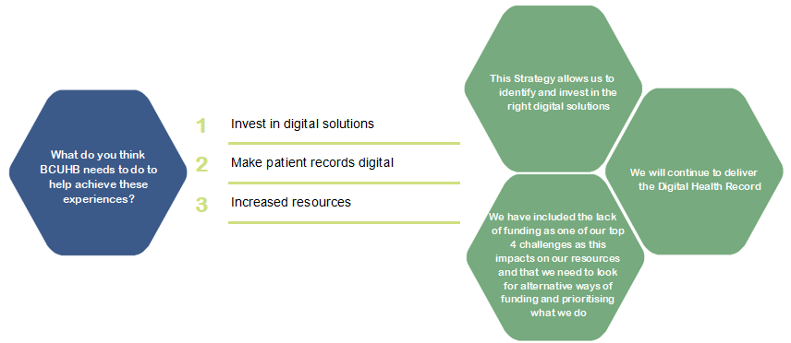

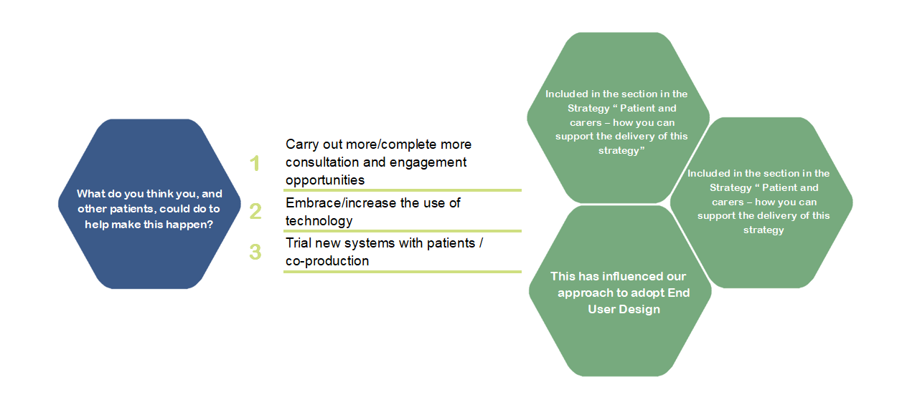
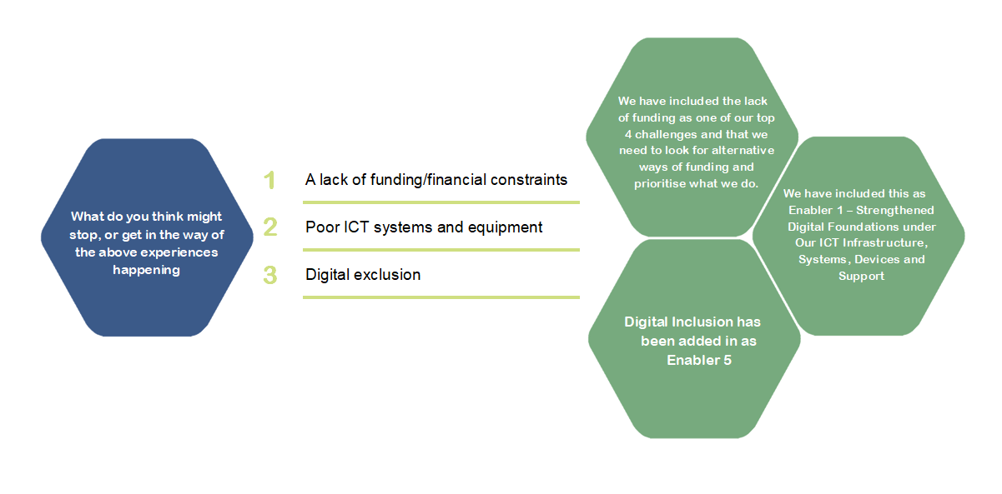

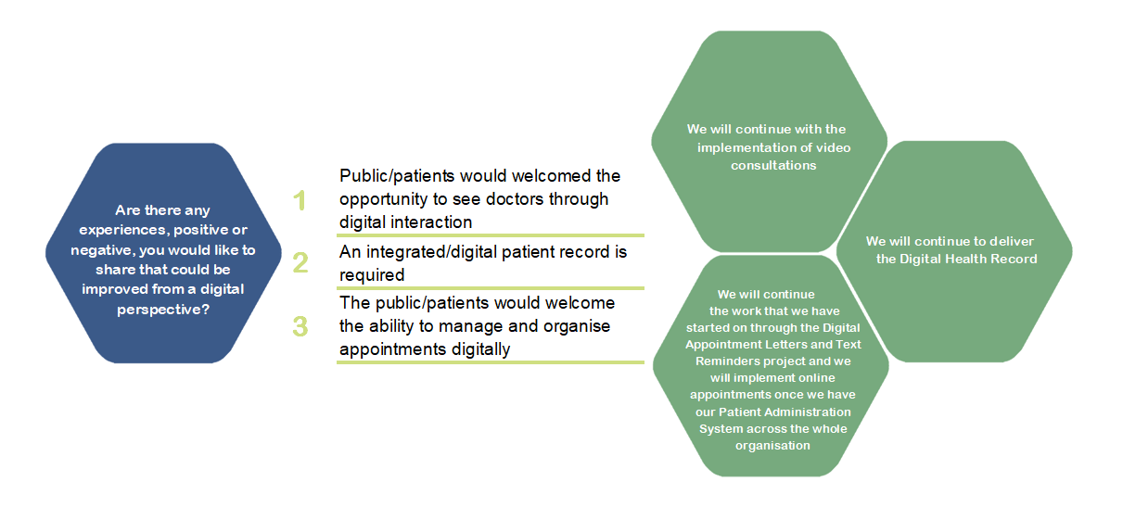
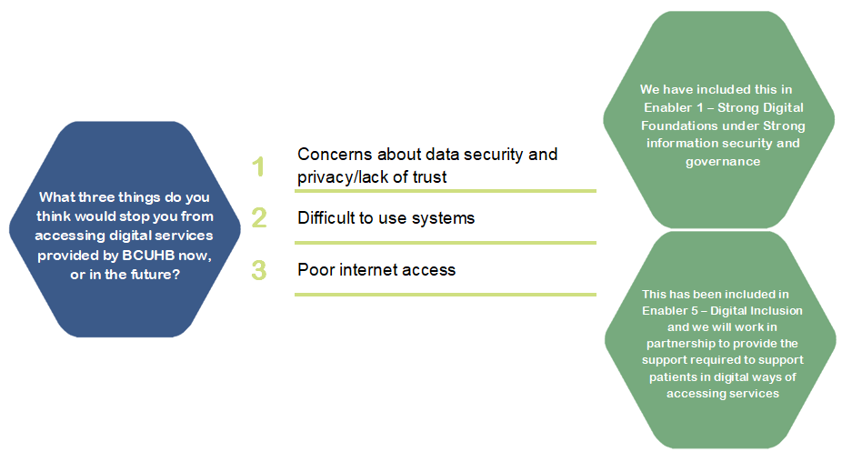

CONNECTED STAFF

The following are experiences that we think our staff want but we would also like to hear the views of our patients/general public.
- I can access patient information in a single place which supports me to make better decisions
- I have confidence in the systems that I need to do my work and that the information held within them is up to date
- I have easy access to relevant data and information to continually improve the services I deliver

- I have choice over how I communicate with my patients

- I can work effectively as part of a multi-disciplinary team
- I am actively involved in influencing any changes to the way I work
- I have the skills to work digitally and access to the training I need for the future
- I have the right equipment that enables me to do my job well
- I rely less on paper now
- I can log on once and be connected to everything that I need to do my job
- I can work from any location and meet my work colleagues virtually, spending less time having to travel to meetings


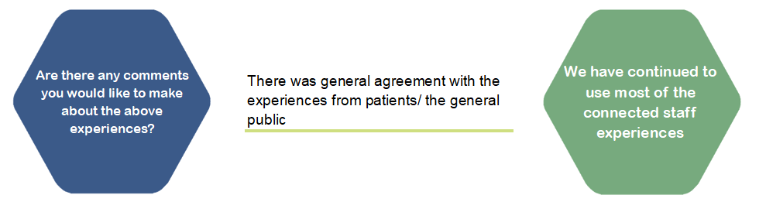

DIGITAL ORGANISATION

To deliver the experiences to patients and staff we need to be a more digital organisation, the following are what we think would make us more digital
- We will make use of our data to improve services, identify and respond to trends.
- We will make our digital readiness and maturity a priority
- We will match our investment to the digital needs in line with recommended standards
- We will include digital needs in all our services planning
- We will have an infrastructure that will be fit for now and the future
- We will focus our digital work on meeting our local and national strategic priorities.
- We will measure the benefits from the digital strategy (i.e social benefits, efficiencies, cost savings, environmental impact etc)
- We will keep data and information safe
- We will ensure that regulatory requirements are met
- We will invest in innovative research and development around digital
- We collaborate with partners and suppliers to deliver this strategy

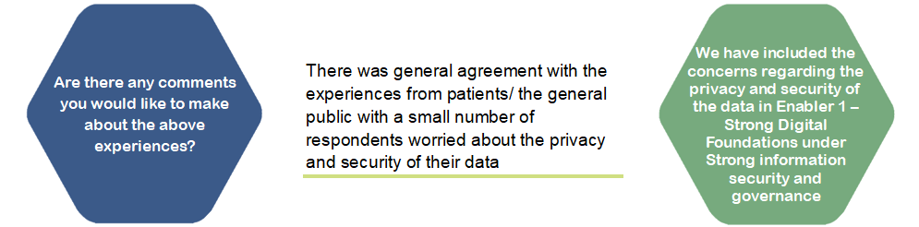

Our 6 principles of Digital Working

The following are our proposed Principles of Digital Working, these are the ways of working that we think we need in place so that we can deliver a Digital Strategy.
- Digital Leadership - Strong professional digital leadership by the Board, everyone can be a digital leader to improve our digital maturity
- Think Digital- Everyone needs to think digital in their planning while also improving services for the digitally excluded
- Once for the Patient - We will adopt standards and technologies that will ensure we provide safe care for every patient
- Co-production- Working as equal partners in developing new ways of working – Patients, Staff , Key Partners and Suppliers
- Evidence Driven- Understanding the need for digital health interventions and what challenges it will solve and what benefits they will bring
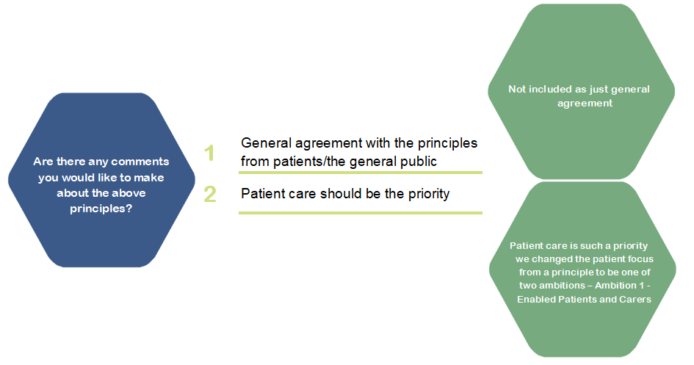
- Innovative- Focusing on new ideas and ways of working that are scalable as to be one step ahead

VISION

Our Digital Future – Improving care through digital ways of working
“Patients and their carers can actively participate in their care, with the confidence that their information is safe; Staff provide patient centred care by having access to the right information in the right place at the right time”

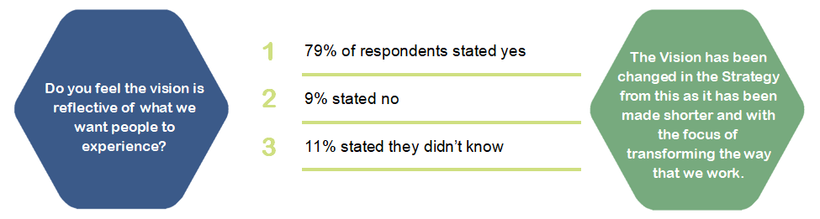
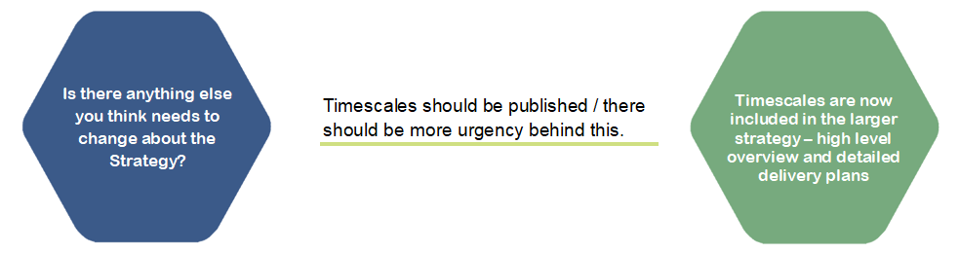
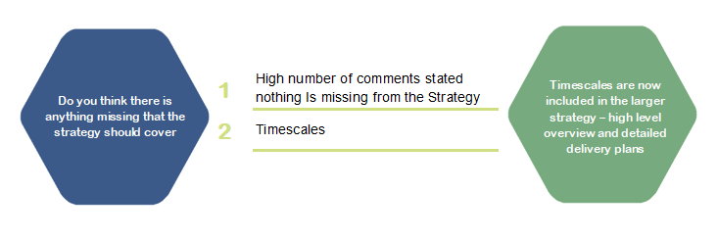

FOCUS GROUP RESULTS

A series of engagement ‘events’ were held to compliment the survey, to gather more in depth views on the strategy, as well as feedback from specific groups who were less likely to take part in an online survey. Due to social distancing requirements, the focus groups were held virtually, via video conferencing facilities such as Teams.

Staff
75 staff took part in focus groups via Mentimeter.
- When asked ‘how familiar are you with BCUHB’s current digital objectives’ the average score was 3.2 out of 10.
- 89% of respondents felt that the vision was reflective of what we wanted people to experience and what we need to deliver.

- Once for the patient, Think digital, and co-production were the 3 highest scoring principles when ranked against each other.

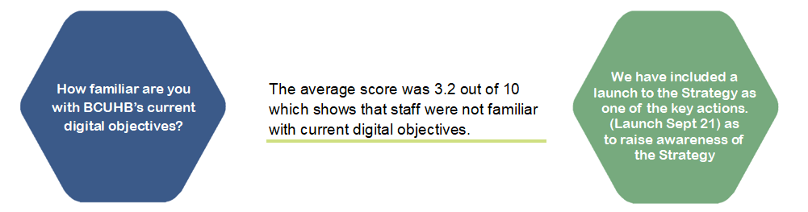
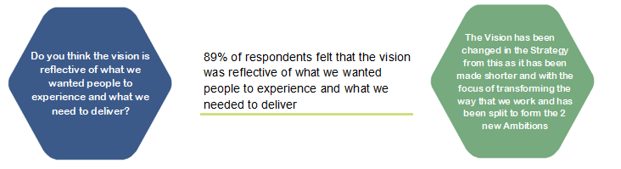

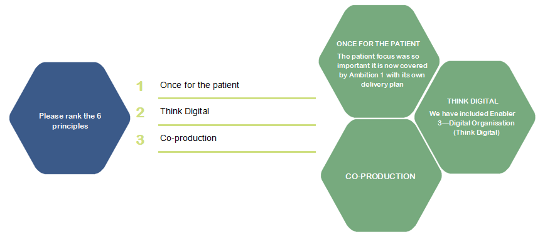

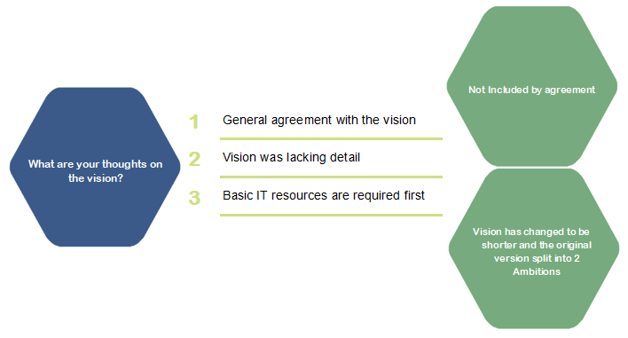

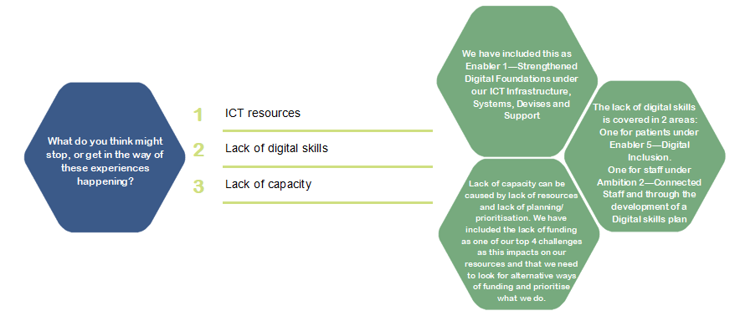

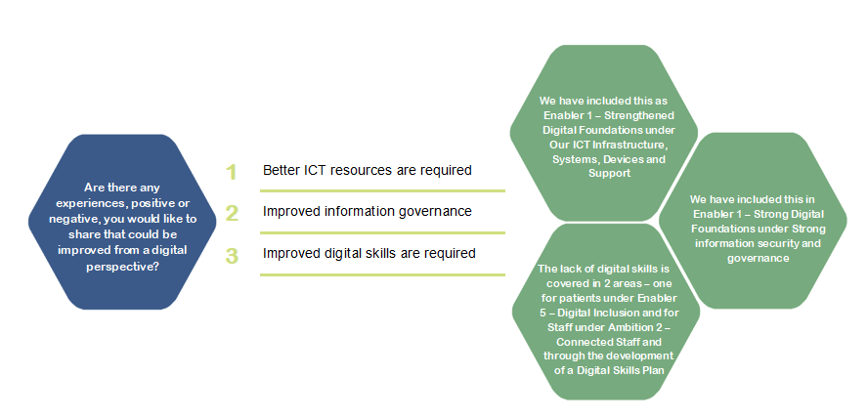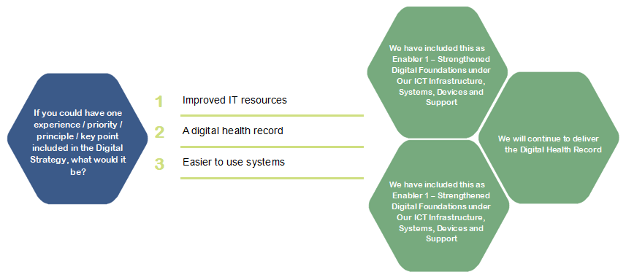

Public
