BCUHB Mortality Quarterly Report
Welsh Government
June 2025
Version 1.1

Contents | Page No.
Executive Summary and Title Page | 1-3
Crude Mortality Data | 4
Elective Post-Op Mortality Data | 5
Non-Elective Post-Op Mortality Data | 6
A&E % Admitted Mortality Data | 7
Condition Specific Mortality Rate Data | 8-10
Life Expectancy and Mortality Indicators | 11-17
Crude Mortality Trends for Inpatient and ED 01/01/2024 – 30/06/2025 | 18-20
Deaths by Location January 2023-June 2025 | 21

Executive Summary
Key Findings:
Data Quality and Availability
- BCUHB and RAMI data availability remains limited to March 2025 due to reduced clinical coding completion rates.
- Clinical coding completion target temporarily reduced to 75% (from 95%) with structured recovery plan in place.
- Critical benchmarking data (HSMR, SHMI, Dr Foster) remains unavailable, limiting comparative mortality analysis with other parts of the UK.

Mortality Performance
- Crude mortality rates demonstrate consistent trends with seasonal variation.
- All mortality data points within the latest 52 weeks fall within statistical control limits, indicating no significant cause for concern.
- Condition-specific mortality rates for heart attack, stroke, and hip fracture continue to be monitored against peer health boards.
- Post-operative mortality rates (both elective and non-elective) remain stable.
- We continue to review national registry and audit data incorporating specialty-based mortality metrics.

Operational Challenges
- Medical Examiner scrutiny continue to highlight system-wide pressures affecting:
  - Welsh Ambulance Service Trust (WAST)
  - Emergency Departments across BCUHB
  - General Medicine services.
- Concerns identified regarding End of Life (EOL) decision-making and advance care planning. Ongoing feedback shared with relevant stakeholders to inform ongoing quality improvement work.
- Percentage of deaths referred for internal review remains below national average.

Quality Improvement Initiatives
- Interface meeting with Medical Examiner Service (MES) facilitates dialogue around thematic learning/local trends.
- Ongoing improvements in MCCD processes to minimise delays in death certification process following statutory changes in September 2024.
- EOL decision-making training video developed for specialty Morbidity & Mortality meetings.
- Monthly Learning from Deaths Panel continue to drive organisational learning.
- Triangulation of Medical Examiner scrutiny findings with HM Coroner inquests inform quality improvement work streams within the Health Board. Learning and feedback also shared with relevant operational forums and stakeholders monitoring organisational performance and patient experience.

Strategic Priorities
- Data Quality Recovery: Restore clinical coding completion to 95% target within agreed timeframe.
- EOL Care Enhancement: Implement systematic approach to advance care planning and EOL decision-making.
- System Resilience: Address operational pressures across emergency and acute care pathways.

Conclusion:
While mortality indicators remain within expected parameters, the organisation faces significant data quality challenges that limit comprehensive performance assessment. The focus on End-of-Life care quality and system-wide operational pressures requires continued attention and targeted intervention to ensure optimal patient outcomes and family experience.

Reporting Author(s): Dr Ben Thomas, Mortality Associate Medical Director
Dr Gemma Lewis-Williams, Mortality Associate Medical Director
Julie Williams, Clinical Project Lead for Clinical Effectiveness
Rachel Jones, Mortality Facilitator

Contributor(s): Dr Robert Atenstaedt, Consultant in Public Health Medicine
Claire Jones, Public Health Intelligence Specialist
Alice Lanceley, Senior Information Analyst
Responsible Director: Dr James Risley, Deputy Executive Medical Director

In the mortality charts on pages 3-9 the Peer Group used throughout is ‘All Other Welsh Health Boards excluding Powys’
Crude Mortality Rate - BCUHB vs Peer
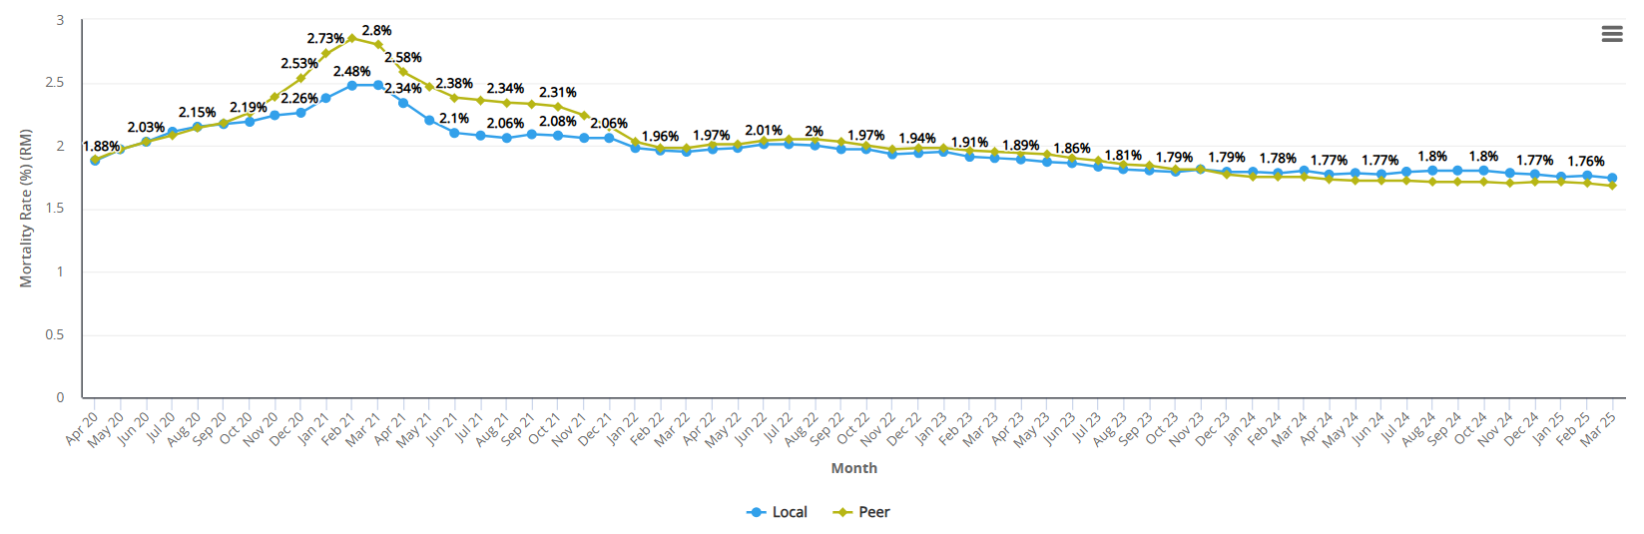

Indicator definition
Numerator = Spells where the patient died | Type = Percentage
Denominator = Total spells excluding well babies | Orientation = Lower is better
Exclusions = None

Elective Post-Op Mortality
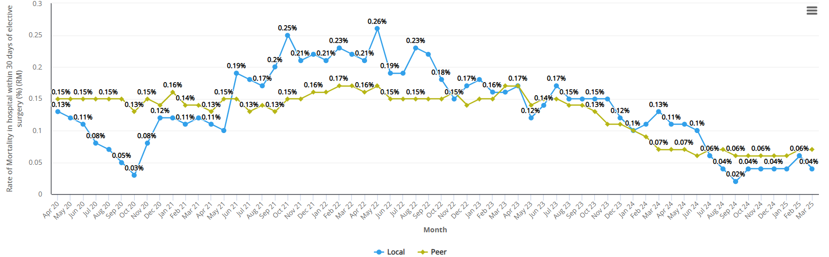

Non-Elective Post-Op Mortality
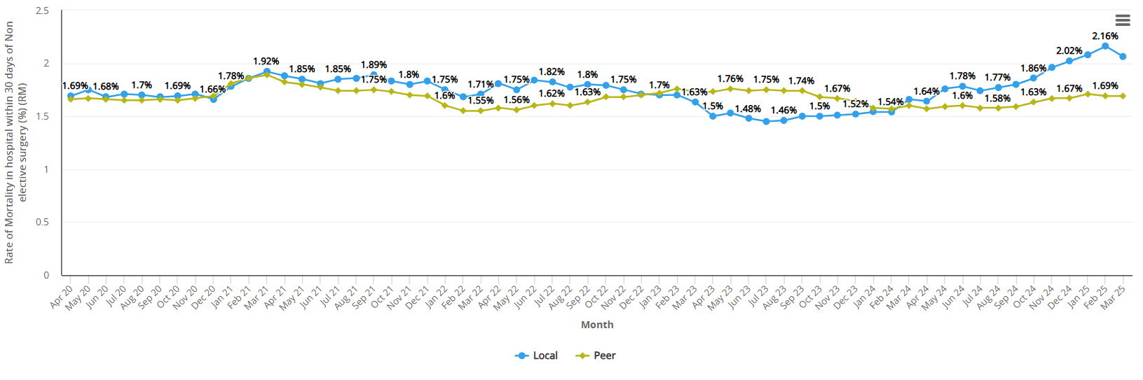

A&E % Admitted Mortality - BCUHB vs Peer

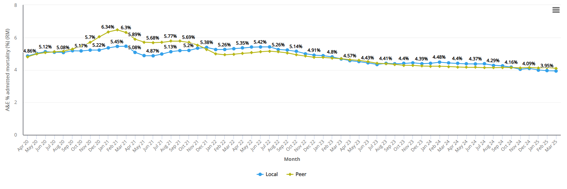

Condition Specific Mortality Rates

% Mortality in hospital within 30 days of emergency admission with a heart attack (MI) aged 35 to 74 - BCUHB vs Peer until March 2025
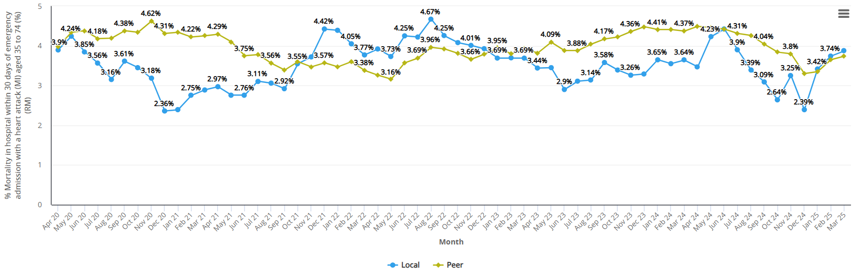

Indicator definition
Numerator = Emergency spells, where the patient died in hospital within 30 days of admission with a primary diagnosis of myocardial infarction AND age >34 and <75
Denominator = Emergency spells with a primary diagnosis of myocardial infarction AND age >34 and <75
Exclusions = None
Type = Percentage
Orientation = Lower is better

Rates of mortality in hospital within 30 days of emergency admission with a stroke - BCUHB vs Peer until March 2025
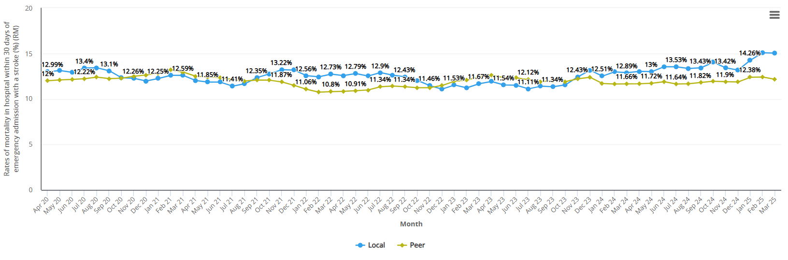

Indicator definition
Numerator = Emergency admission AND Primary Diagnosis of stroke OR Emergency admission AND Episode Length of stay of Finished Consultant Episode 1 in spell <2 AND Primary Diagnosis of stroke of Finished Consultant Episode 2 in spell AND Discharge Method = 4 AND Spell LOS <30
Denominator = Emergency admission AND Primary Diagnosis of stroke OR Emergency admission AND Episode Length of stay of Finished Consultant Episode 1 in spell <2 AND Primary Diagnosis of stroke of Finished Consultant Episode 2 in spell
Exclusions = None
Type = Percentage
Orientation = Lower is better

% Mortality in hospital within 30 days of emergency admission with a hip fracture (age 65 and over) - BCUHB vs Peer until March 2025
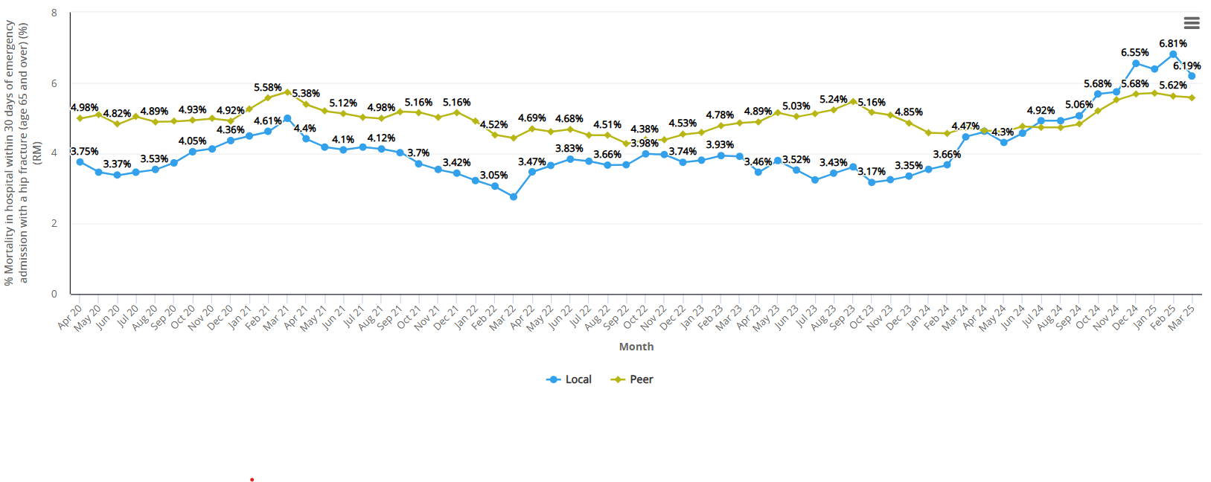

Life Expectancy and Mortality Indicators

Life expectancy at birth

Life expectancy is a measure of the average expected years of life for a new born based on recently observed mortality rates and is an estimate for the general population.
Overall life expectancy for males in Wales has remained fairly stable since 2011-13. In BCUHB in 2020-2022, life expectancy for males was 78.6 years. Male life expectancy is more than seven years lower in the most deprived areas compared to least deprived, with healthy life expectancy more than 12 years lower (2018-2020).
In Wales, females can expect to live around four years longer than males. Life expectancy for females in Wales has also remained stable since 2011-13; in BCUHB, life expectancy in 2020-2022 was 82.2 years. Female life expectancy is almost six years lower in the most deprived areas compared to least deprived during 2020-2022; healthy life expectancy is almost 11 years lower (2018-2020).
Source: Public Health Wales Observatory, PHOF Tool.

Age-standardised mortality rates (ASMRs) based on deaths registered in 2023
Age-standardisation allows for comparison of mortality rates across different populations while taking account of different age structures of those populations. Failure to take account of different age structures can be misleading when comparing rates in different populations. For example, in an area with a high proportion of older people, one would expect more people to die than in an area with a low proportion of older people. Without age standardisation, it would be difficult to compare the death rates in two such areas.
Across BCUHB, age-standardised mortality rates for males on the Isle of Anglesey are statistically significantly lower than Wales. The rate in Denbighshire UA, for all persons, is statistically significantly higher than Wales.

Age-standardised mortality rates (ASMRs) by sex and area of usual residence, deaths registered 2023

Source: Office for National Statistics, Age-standardised Mortality Rates

Avoidable mortality
The basic concept of avoidable mortality is that deaths caused by certain conditions, for which effective medical and public health interventions are available, should be rare and ideally should not occur. It is widely accepted that the contribution of healthcare to improvements in population health ought to be quantified. Avoidable deaths are all those defined as preventable, amenable (treatable) or both.
The all-persons avoidable mortality rate in BCUHB increased between 2018 and 2021 followed by a fall in 2022 and 2023, but it has remained below the Wales rate during this period.
In 2023, BCUHB had the fourth highest health board avoidable mortality rate in Wales (263.4 per 100,000) but was lower than the Wales average (277.3 per 100,000), although not statistically significantly lower.
Avoidable mortality rates are higher in males than females. In 2023, the rates were 323.2 per 100,000 males compared to 206.4 per 100,000 females. There were 1,870 avoidable deaths in BCUHB in 2022; 59% were in males.
Source: Office for National Statistics, Avoidable Mortality

Excess Winter Deaths
Excess Winter Deaths (EWD) are defined as the number of deaths in the winter period (December to March) which occur over and above the expected number for that period. The Excess Winter Mortality (EWM) Index is produced so that comparisons can be made between sexes, age groups and regions. It is calculated as the number of excess winter deaths divided by the average non-winter deaths, expressed as a percentage. For example, an EWM index of 20 shows that there were 20% more deaths in winter compared with the non-winter period.
Provisional data for Wales in 2021/22 show that there were 800 excess winter deaths including Covid-19 compared to 3,380 in 2020/21 (final data). There were 800 excess winter deaths excluding Covid-19 in 2021/22 (provisional data) and 150 in 2020/21.
In 2020/21, final data shows Wrexham UA had the highest EWM (excluding Covid-19) across BCUHB and was statistically significantly higher than Wales. For EWM (excluding Covid-19), the Isle of Anglesey and Denbighshire UAs were also statistically significantly higher than Wales. For EWM including Covid-19, Wrexham UA was also the highest across BCUHB and statistically significantly higher than Wales. EWM (including Covid) in Gwynedd, Conwy and Denbighshire UAs were statistically significantly lower than Wales.
Source: Office for National Statistics, Excess Winter Mortality

Excess Winter Mortality, Wales and North Wales unitary authorities, 2020/21 (final data)

Perinatal mortality, 2022
Perinatal deaths can be defined as stillbirths plus deaths in the first week of life (i.e. deaths under 7 days.) Perinatal mortality rates in Wales have remained largely unchanged since 2006.
In 2023 there were 167 perinatal deaths registered in Wales (180 in 2022). The perinatal mortality rate for Wales was 6.1 per 1,000 live and stillbirths in 2023 (6.2 in 2021). The rates for North Wales are based on small numbers and should therefore be treated with caution.
Number of perinatal deaths and perinatal mortality rate per 1,000 live births and still births, Wales and North Wales unitary authorities, 2023
Source: Office for National Statistics, Perinatal Deaths

Percentage of deaths in NHS hospitals by place of occurrence, 2023
In 2023, there were 35,054 deaths in Wales, of which 17,917 occurred in NHS hospitals (acute or community, not psychiatric), representing 49.7% of total deaths by place of occurrence in Wales.
Within BCUHB, there were 8,587 deaths in UHB residents, of which 4,260 (49.6%) deaths took place in NHS hospitals.
Source: Office for National Statistics, deaths registered in England and Wales

Deprivation: percentage of Lower-layer Super Output Areas (LSOAs) by deprivation fifths
The Welsh Index of Deprivation (WIMD) 2019 is the official measure of deprivation in small areas in Wales. It is a relative measure of concentrations of deprivation at small area level. WIMD is constructed from eight different types of deprivation. These are: income, housing, employment, access to services, education, health, community safety and the physical environment. The small area levels are known as Lower-layer Super Output Areas (LSOAs) and are based on defined geographical areas based on Census output areas with an average of 1,600 persons per LSOA. Based on Census 2011, there are 1,909 LSOAs in Wales. The number of LSOAs varies widely between health boards.
BCUHB has some of the most deprived areas in Wales, particularly along the North Wales coastline. Rhyl West 2 and Rhyl West 1 are the first and second most deprived LSOAs in Wales.
Denbighshire UA has the highest percentage of LSOAs in the most deprived 10% LSOAs in Wales.

Percentage of LSOAs by deprivation fifth, Betsi Cadwaladr UHB and unitary authorities, 2019
Source: Welsh Government, Welsh Index of Multiple Deprivation

Crude Mortality Trends for Inpatient & Emergency Department SPC Charts for Hospitals within BCU
until 30th June 2025

Inpatient & Emergency Department P Charts for Hospitals within BCU 01/01/2024 – 30/06/2025:
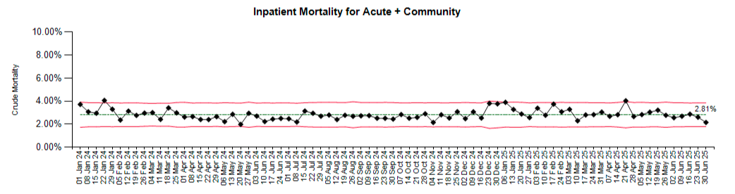
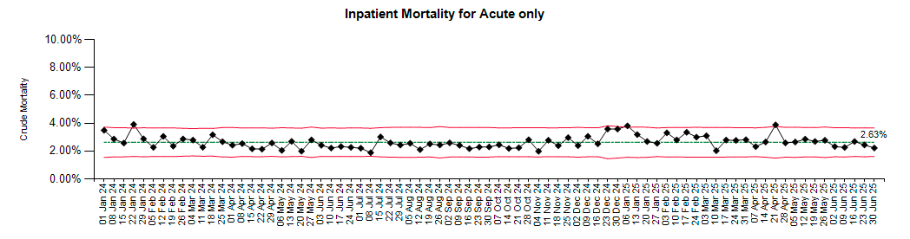
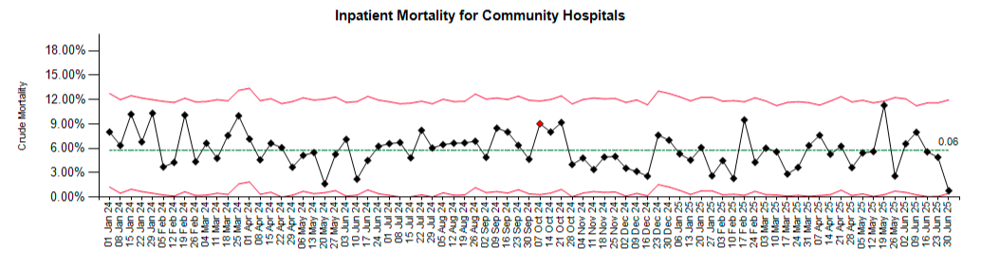
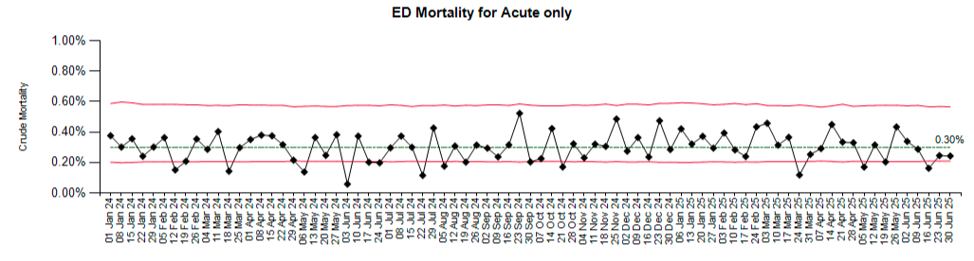

The crude mortality rate P charts demonstrate a relatively consistent trend in rate with some seasonal variation. All data points in the latest 52 weeks of data have been within the upper/lower control limits and therefore not statistically significant to warrant further investigation or particular concern.

BCUHB Deaths by Location January 2024-June* 2025
Hospital | 2024 | 2025* | Grand Total
Ablett Unit | 1 | 1 | 2
Bryn Beryl Hospital | 29 | 18 | 47
Bryn-Y-Neuadd Hospital | 3 | 1 | 4
Cefni Hospital | 4 | 1 | 5
Chirk Community Hospital | 41 | 11 | 52
Colwyn Bay Community Hospital | 28 | 21 | 49
Deeside Community Hospital | 16 | 9 | 25
Denbigh Community Hospital | 20 | 16 | 36
Dolgellau & Barmouth District Hospital | 14 | 15 | 29
Emi Unit (Bryn Hesketh) | 2 | 2 | 4
Eryri Hospital | 17 | 3 | 20
Holywell Community Hospital | 37 | 19 | 56
Llandudno General Hospital | 31 | 11 | 42
Mold Community Hospital | 42 | 15 | 57
North Wales Cancer Treatment Centre | 49 | 17 | 66
Penley Hospital | 3 |  | 3
Ruthin Community Hospital | 20 | 6 | 26
Wrexham Maelor Hospital | 898 | 442 | 1340
Ysbyty Alltwen | 14 | 11 | 25
Ysbyty Glan Clwyd | 1037 | 555 | 1592
Ysbyty Gwynedd | 885 | 484 | 1369
Ysbyty Penrhos Stanley | 19 | 15 | 34
Grand Total | 3210 | 1673 | 4883
*Until 30th June 2025.
Report Criteria: Pulled all patient discharges with the discharge method of: 4 - Patient died. Pivoted by hospital and year / month.

