BCUHB Mortality Quarterly Report
December 2023
Version 1.6

Contents | Page No.
Executive Summary and Title Page | 1
Contents | 2
Crude Mortality Data | 3
Elective Post-Op Mortality Data | 4
Non-Elective Post-Op Mortality Data | 4
A&E % Admitted Mortality Data | 4
Condition Specific Mortality Rate Data | 4
Life Expectancy and Mortality Indicators | 4
Crude Mortality Trends for Inpatient and ED until 31st December 2023 | 5-6
Deaths by Location January 2022-December 2023 | 7
Medical Examiner Mortality Summary | 8

Executive Summary
- BCUHB data for all causes of mortality continues to be consistent when compared to Welsh peers. RAMI data has also been consistent, which continues to be encouraging.

- Ongoing receipt of Medical Examiner scrutiny letters, Inquest outcomes and Regulation 28’s highlight that all services, particularly WAST, Emergency Departments and General Medicine across BCUHB remain under considerable pressure.

- The Medical Examiner Service (MES) continues to provide evidence of where BCUHB can learn from mortality, identifying themes and potential improvements that could reduce mortality.

- There has been a gradual increase in MES reports coming back to the Health Board, which is likely due to the fact that community services and Primary Care are now also participating in the service. There is an expectation that these figures will continue to rise until the process has been fully implemented, with the largest rise expected after April when new legislation comes into force. An overview of the death certification reform for England and Wales can be found on the link below:
An overview of the death certification reforms - GOV.UK (www.gov.uk)

- The Integrated Health Care (IHC) organisations continue to embed mortality processes within both acute and primary care settings.

- A reduced rate of Clinical Coding Completion may have an impact on Condition Specific Mortality Rate data within this report. Data from prior to August 2023 reaches the required 95% completion confidence threshold data following this period may effected by coding completeness. Work is underway at the Health Board to reduce the backlog of coding to improve the confidence levels in the report.

Reporting Author(s): Dr James Risley, Deputy Executive Medical Director
Julie Williams, Clinical Project Lead for Clinical Effectiveness
Rachel Jones, Mortality Facilitator

Contributor(s): Dr Robert Atenstaedt, Consultant in Public Health Medicine
Alice Lanceley, Senior Information Analyst

Responsible Director: Dr Nick Lyons, Executive Medical Director

Crude Mortality Rate - BCUHB vs Peer
Peer Group used throughout is ‘All Other Welsh Health Boards excluding Powys’

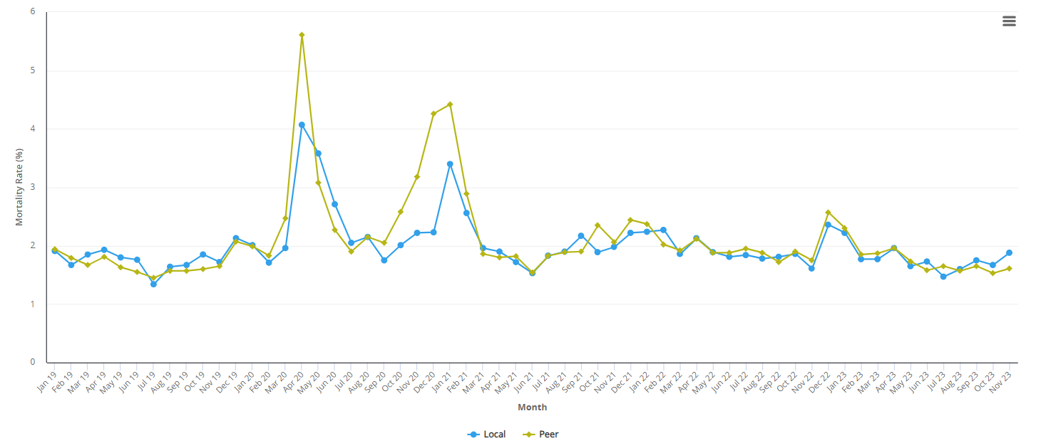

Indicator definition
Numerator = Spells where the patient died | Type = Percentage
Denominator = Total spells excluding well babies | Orientation = Lower is better
Exclusions = None

Elective Post-Op Mortality
See September 2023 report for latest data. Updated data not available due to staffing challenges within the Clinical Coding department. Clinical coding is currently reporting for measures requiring coded data up to July 2023, which was the data included in the previous report, this has been registered as a risk at the Planned Care – Data, Planning & Performance Work Stream.

Non-Elective Post-Op Mortality
See September 2023 report for latest data. Update data not available due to staffing challenges within the Clinical Coding department. Clinical coding is currently
Reporting for measures requiring coded data up to July 2023, which was the data included in the previous report, this has been registered as a risk at the
Planned Care – Data, Planning & Performance Work Stream.
A&E % Admitted Mortality - BCUHB vs Peer
See September 2023 report for latest data. Updated data not available due to staffing challenges within the Clinical Coding department. Clinical coding is currently reporting for measures requiring coded data up to July 2023, which was the data included in the previous report, this has been registered as a risk at the
Planned Care – Data, Planning & Performance Work Stream.

Condition Specific Mortality Rates
See September 2023 report for latest data. Updated data not available due to staffing challenges within the Clinical Coding department. Clinical coding is currently reporting for measures requiring coded data up to July 2023, which was the data included in the previous report, this has been registered as a risk at the Planned Care – Data, Planning & Performance Work Stream.

Life Expectancy and Mortality Indicators
No further update since previous report due to staffing challenges within the Clinical Coding department. Clinical coding is currently reporting for measures requiring coded data up to July 2023, which was the data included in the previous report, this has been registered as a risk at the Planned Care – Data, Planning & Performance Work Stream.

Crude Mortality Trends for Inpatient & Emergency Department SPC Charts for Hospitals within BCU until 31st December 2023
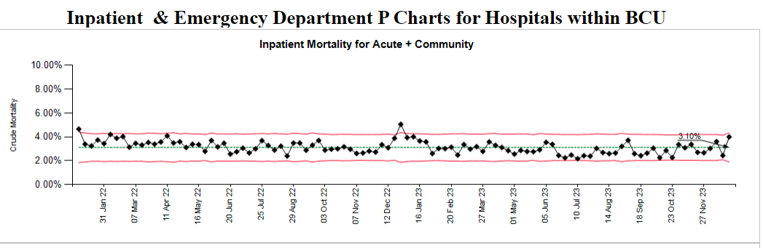
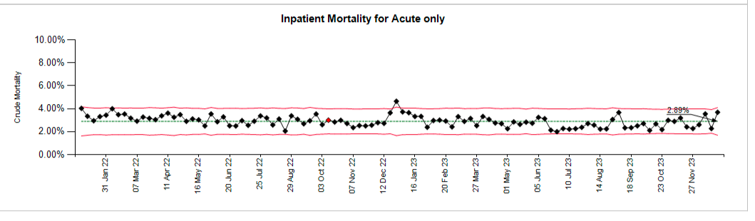
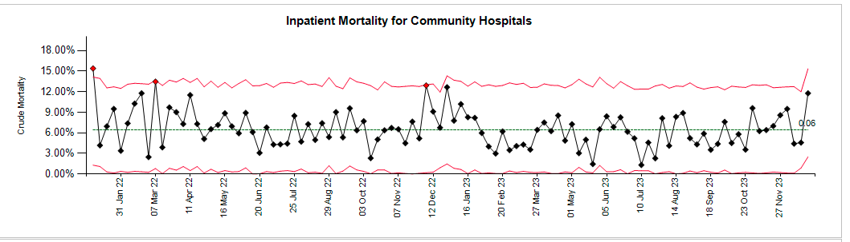
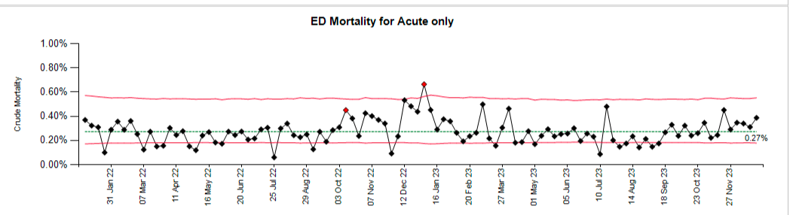
The crude mortality rate P charts demonstrate a relatively consistent trend in rate with some seasonal variation. All data points in the latest 52 weeks of data have been within the upper/lower control limits and therefore not statistically significant to warrant further investigation or particular concern. There is a previous peak in crude rate in December 2022 that was above the upper control limit however this could be seasonal impact with a similar point outside of control limits in December 2021, this trend however has not been reflected over the most recent winter period.
BCUHB Deaths by Location January 2022-December 2023
Where an anomaly is identified within these statistics, triangulation between all processes is undertaken to note if there have been any changes within a specific area which may account for the anomaly. Additional reassurance can be drawn that all deaths within the Health Board are reviewed by the Medical Examiner and will be flagged to the Health Board if the MES pick up a signal of concern based upon location.
Comparing 2022-2023 number of hospital deaths, we have noted a rise in deaths within Bryn Beryl Hospital, Denbigh Community Hospital and Mold Community Hospital.
As an example of triangulation, Mold Hospital Matron commented on the increase: “Over the last 12 months we have seen an increase in the number of patients who are coming to Mold for end-of-life care. These patients are not only coming from acute hospital sites but also directly from the community following requests by GPs and District Nursing teams.
The acuity of the patients being transferred from acute sites has also increased and the patients we are now caring for have complex medical comorbidities along with increased frailty and longevity in their years.
During the later months of 2023 I can recall a number of patients who were transferred specifically for end-of-life care with the expectation that they would pass away whilst in our care.”

I cannot recall any patients where their passing has not been excepted or any medical emergency which has resulted in a patient’s death.

Please let me know if you need any additional information

Hospital | 2022 | 2023 | Grand Total
Ablett Unit | 1 |  | 1
Bryn Beryl Hospital | 29 | 35 | 64
Cefni Hospital | 1 | 3 | 4
Chirk Community Hospital | 32 | 25 | 57
Colwyn Bay Community Hospital | 28 | 29 | 57
Deeside Community Hospital | 26 | 22 | 48
Denbigh Community Hospital | 15 | 22 | 37
Dolgellau & Barmouth District Hospital Site | 18 | 19 | 37
Emi Unit (Bryn Hesketh) | 3 |  | 3
Eryri Hospital | 16 | 17 | 33
Holywell Community Hospital | 47 | 36 | 83
Llandudno General Hospital Site | 54 | 54 | 108
Mold Community Hospital | 27 | 41 | 68
North Wales Cancer Treatment Centre | 64 | 35 | 99
Penley Hospital | 9 | 1 | 10
Ruthin Community Hospital | 18 | 20 | 38
Tywyn & District War Memorial Hospital Site | 8 | 3 | 11
Wrexham Maelor Hospital | 1061 | 949 | 2010
Ysbyty Alltwen | 22 | 18 | 40
Ysbyty Glan Clwyd | 1058 | 1048 | 2106
Ysbyty Gwynedd | 956 | 931 | 1887
Ysbyty Penrhos Stanley | 28 | 18 | 46
Grand Total | 3521 | 3326 | 6847

Report Criteria: Pulled all discharges from BCU with a discharge method of: 4 - Patient Died. Pivoted by site and calendar year.

Medical Examiner Mortality Summary
From 1st October to 31st December 2023, 389 ME Scrutiny Letters were received from the Medical Examiner Service and input into BCUHB’s Mortality Datix system for consideration of review.

