

Therapi Galwedigaethol Plant
Canolfan Iechyd Plant Wrecsam
Ffordd Croesnewydd, Wrecsam LL13 7TD

Children’s Occupational Therapy
Wrexham Child Health Centre,
Croesnewydd Road, Wrexham LL13 7TD
Fine Motor Skills 1

Play dough

Squeeze it

Pinch it

To make your own playdough, you will need:
- 8 tbsp plain flour
- 2 tbsp table salt
- 60ml warm water
- food colouring
- 1 tbsp vegetable oil
Method
1. Mix the flour and salt in a large bowl. In a separate bowl mix together the water, a few drops of food colouring and the oil.
2. Pour the coloured water into the flour mix and mix together with a spoon.
3. Dust a work surface with a little flour and turn out the dough. Knead together for a few minutes to form a smooth, pliable dough. If you want a more intense colour you can work in a few extra drops of food colouring.
4. Store in a plastic sandwich bag (squeeze out the air) in the fridge to keep it fresh.

Arts and Crafts
- Finger painting
- Gluing and sticking – tear up tissue paper, roll into balls and stick on paper, rip up wrapping paper into small pieces and stick.
- Peel and stick stickers onto paper
- Stamps and ink pads
- Colouring and drawing
- Using stencils
- Make necklaces - Paint penne pasta and thread onto string

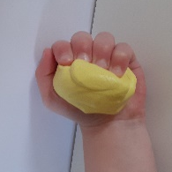

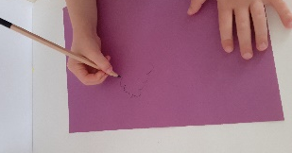
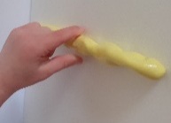

Pin

Toys and games
- Threading beads
- Windup toys
- Blow bubbles – pop using index finger
- Marbles
- Tiddlywinks
- Spinning tops
- Pick up sticks
- Jenga
- Kerplunk
- Finger puppets
- Lego

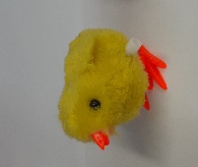

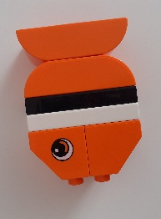

Household objects
- Threading – Thread pasta or cereal onto string
- Clothes pegs – attach onto card or other
objects, help to hang up the washing, create a
washing line and encourage them to hang up any artwork they create using pegs.
- Coins – Spin coins, how many can you spin at once, put coins into piggy bank, how many can you get in in a minute?
- Chopstick/tweezers- Use chopsticks to pick up different objects around the house
- Bubble wrap – practice popping the bubble wrap.
- Spaghetti – Use pieces of dried spaghetti and marshmallows to create structures.

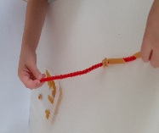

Twinkle, Twinkle Little Star
Twinkle, twinkle little star,
How I wonder what you are,
Up above the clouds to high
Like a diamond in the sky
Twinkle, twinkle little star
How I wonder what you are.

Action songs
Tommy Thumb, Tommy Thumb,
Where are you?
Here I am, here I am,
How do you do?

Peter Pointer, Peter Pointer,
Where are you?
Here I am, here I am,
How do you do?

Toby Tall, Toby Tall,
Where are you?
Here I am, here I am,
How do you do?

Ruby Ring, Ruby Ring,
Where are you?
Here I am, here I am,
How do you do?

Baby Small, Baby Small,
Where are you?
Here I am, here I am,
How do you do?

Fingers all, Fingers all,
Where are you?
Here we are, here we are,
How do you do?
Here we are, here we are,
How do you do?

Twinkle, Twinkle
Twinkle, twinkle little star,
How I wonder what you are,
Up above the world so high,
Like a diamond in the sky,
Twinkle, twinkle little star,
How I wonder what you are


Incy Wincy
Incy Wincy spider climbed up the water spout,
Down came the rain and washed the spider out,
Out came the sunshine and dried up all the rain,
So Incy Wincy spider climbed up the spout again.

