
Postural Stability 2

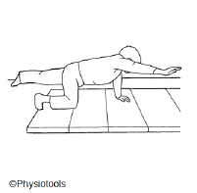 | Balancing  Start on hands and knees, weight evenly distributed.  Hands should be flat on the floor and head in the midline.  Raise an arm to the same height as your shoulder.  Raise the opposite leg to hip level.  Aim to hold this for a count of 10 seconds. Relax for 5 seconds.  Repeat to the other side.
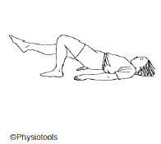 | Lying on back with knees bent up and feet flat on floor.  Lift bottom from floor to make a bridge.  Straighten one leg keeping your hips up and level. Bend knee and return foot to floor. Lower bottom to floor.
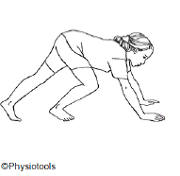 | Sprinter.  Take a sprinters starting position.  Keeping arms still, alternate leg positions.  Do this fast....... or slowly with control.
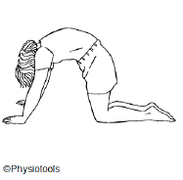 | Start on your hands and knees.  Round your back up like a cat.  Return so your back is flat (not arched)..

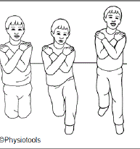 | High Kneeling to Standing  Start in a high kneeling position. Slowly bring one leg forward to half kneeling. Slowly rise to standing then move back to half kneeling.  Alternate the leading leg.  Progress to crossing your arms over your chest then placing your hands on your head.  Repeat all of the above with your eyes closed.
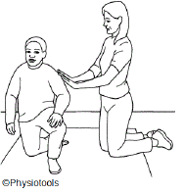 | Statue  In a half kneeling position, with one leg forward and your hips level. Pretend  to be a statue, stiffening your body, while someone pushes you gently from different directions. Try not to fall over.  Repeat to the other side.
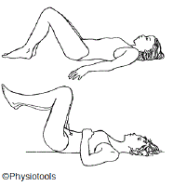 | Lying on your back with your knees bent up and feet on floor.  Tighten your tummy and lift your legs so your hips and knee are bent to 90  degrees as shown. Keep your back flat on the floor at all times.  Return to starting position by placing one leg down onto the floor at a time.
Wheelbarrows.

Make sure person supporting keeps back straight.
The "barrow" should :
Not over arch the back
Not lock the elbows
Keep thumbs pointing forwards with the hands at 2 o'clock.

