
Postural Stability 1

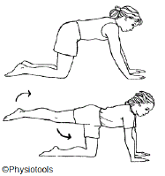 | Start on hands and knees.  Stretch one leg behind you. Hold your straight leg so your foot is the same height as your bottom. Hold this position for 5 secs. Return your  knee slowly to floor.  Then try to see if you can lift one arm straight out in front of you, keeping your hand the same level as your shoulder. Hold this position for 5 secs and return slowly to the floor.
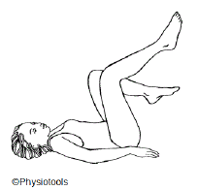 | Upside down cycles.  Caution: This should be done with legs high in the air as shown, NOT with the feet a few inches from the floor.
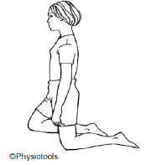 | Kneeling.  Knee walking.  You can knee walk sideways, forwards and backwards.
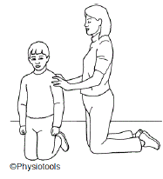 | Statue  In a high kneeling position with your hips level.  Pretend to be a statue, stiffening the body, while someone pushes you  gently from different directions.  Try not to fall over.

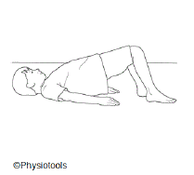 | Lie on your back with knees bent.  Tighten your pelvic floor muscles. Keep the contraction and slightly pull your lower stomach in. Lift your hips and then roll down your back to the starting position. Relax the pelvic floor muscles.  Can you hold this position for 10 seconds?
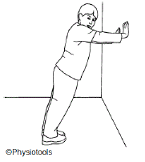 | Push Ups  Place your body at a 45-degree angle to the wall.  The palms of your hands should be flat on the wall with your wrists bent back. Your elbows should be straight and in line with your shoulders. Make sure your body is in a straight line with your head up.  Slowly bend your elbows and push back up. Pause for 2 seconds and then repeat.

