Advice and Guidance on Posture and Seating

This document is available upon request in various languages and format’s . Date of publication 27/07/2022 Date for review: 27/07/2025

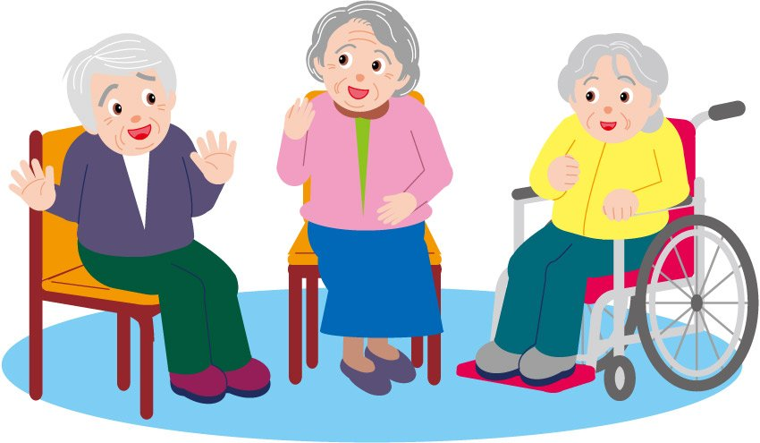

Who Needs Postural Care?

- Those who do not have the physical ability to change position

- Those who do not have the cognitive awareness to know that they need to change position

- Those who do not have the communication skills to convey that they need to change position

Irreversible body positioning for example foetal positioning in bed, can occur over time. It is vital to intervene as early as possible to prevent irreversible positioning, reduce incidence of pressure sores and encourage health and wellbeing for the individual.

Importance of Good Posture Management

Posture management is an essential part of care and should be a 24 hour approach, involving the management of all positions that an individual uses throughout the day, i.e. lying in bed, sitting and standing.

Availability of correct seating is as important as the availability of the correct bed.

It is important to manage posture to:

- Improve and optimise the possibility of taking part in daily life - physically, mentally and socially

- Minimise the chances of injury e.g. Development of pressure sores or contractures

- Communicate, breathe easier and be able to eat drink and sleep well

- Stop the situation from getting worse, and losing skills

- Improve quality of life

- Manage pain and discomfort

- Move as freely as possible, with as much independent mobility as can be achieved, thereby facilitating independent function

Posture and Pressure

Incorrect posture can increase the risk of shearing, friction and pressure, which in turn can cause damage to the skin. The most important of all the reasons for supporting a good position of the individual is to reduce pressure on the various body parts and to prevent the formation of pressure areas.

The longer the individual is in the same position the more pressure from the supporting surface is on the skin, blood vessels and underlying tissues. The end result, if the pressure continues, is pressure sores.

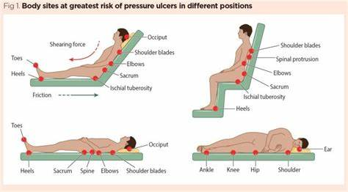

Knight. J et al (2019) Effects of bedrest 6:bones, skin, self-concept and self esteem. Nursing Times (on-line);115:5,58-61. Accessed 17/08/2022

Body posture and positioning have a direct influence on the pressure going through specific body sites (Sprigle & Sonenblum 2011). The body can only withstand high interface pressures for a very short period of time, and when the pressure is not regularly relieved pressure injuries can develop (Waterlow 2007).

The area’s of skin most commonly affected is that which is located over bony areas or in moist crevices, such as contractures. Although we can see the effect of pressure on the skin, other organs of the body can also be affected by the force of pressure, for example, the lungs are extremely susceptible to pressure (especially when lying on the side). As the individual’s body remains in one position, the weight of the upper lung presses down on the lung beneath making it harder to breath.

“Everyone is potentially at risk of developing a pressure injury” (NICE 2014)...

- The skin and underlying tissues are compressed for a period of time
- Blood cannot circulate causing lack of oxygen and nutrients
- The lymphatic system cannot drain waste products
- Cells die and the area of resulting dead tissue is called pressure injury

National Institute for Health and Care Excellence (NICE) (2014) [CG179] Pressure ulcers: prevention and management Available from: www.nice.org.uk/guidance/cg179. Accessed 17/08/2022.

Sprigle S, Sonenblum S (2011) Assessing evidence supporting redistribution of pressure for pressure ulcer prevention: A review Journal of Rehabilitation Research and Development 48(3):203-14. Accessed 17/08/2022

Waterlow (2007) Pressure Ulcers Available from: http://www.judy-waterlow.co.uk. Accessed 17/08/2022

Sitting Posture

Things to check for when looking at an individual sitting in their chair:

- Their knees should be at a 90° angle and slightly separated to provide relaxation and promote alignment

- Their sacrum is positioned at the back of the chair facilitating a hip angle of 90° with hips in a midline position to promote pelvic stability

- Their back is supported in the chair with any changes of the spine being accommodated

- Their elbows are flexed and supported by the arms on the chair with shoulders remaining in a neutral position, without them needing to support themselves using their arms

- Their head is positioned in midline of the body and is supported by the back of the chair, whilst still allowing free and independent head movement if able

- While sitting, the best posture to use is ‘feet flat and a 90º/90º/90º position

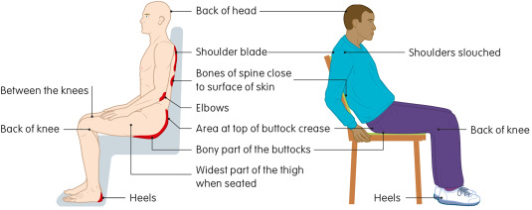

Picture above shows areas at risk of pressure ulcer damage when seated and areas at risk of pressure ulcer damage when seated slouched in the chair.

A range of seating should be available as standard, including adjustable height and reclining chairs and those suitable for smaller or heavier individuals. If the needs are specialised, e.g. specific postural support, the care home/health setting should request an assessment of the individual’s seating needs to enable a suitable chair to be provided or appropriate advice given.

Understanding the association between pressure ulcers and sitting in adults what does it mean for me and my carers? Seating guidelines for people, carers and health & social care professionals Journal of Tissue Viability Volume 27, February 2018, pages 59-73

Specialist equipment is defined as a piece of equipment issued specifically for one resident to meet their needs. Any piece of equipment that can be used by more than one resident is not specialist e.g. basic tilt in space chair. (RCOT 2019).

Care Homes and Equipment Guiding principles for assessment 2019 Care Homes & Equipment Guide - Assessment & Provision - RCOT

Sitting Posture
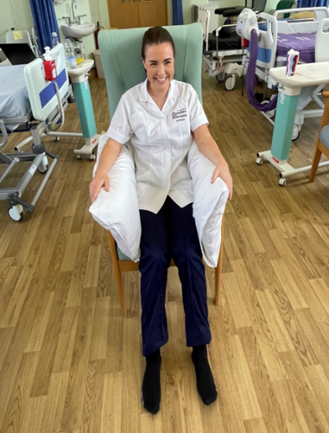
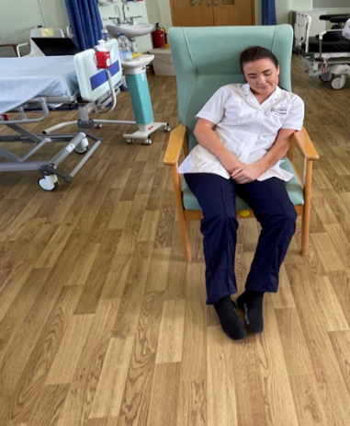

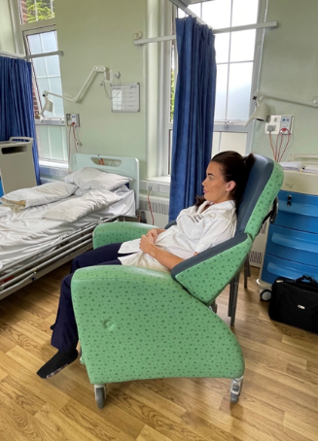
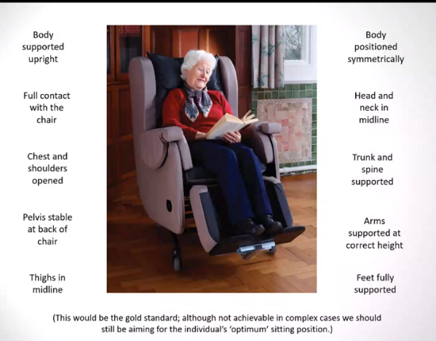

Careflex—24 Hour Postural Management and Specialist Seating. Rebecca Dunstall Clinical Specialist. rebecca.dunstall@careflex.co.uk. Accessed 17/08/2022.
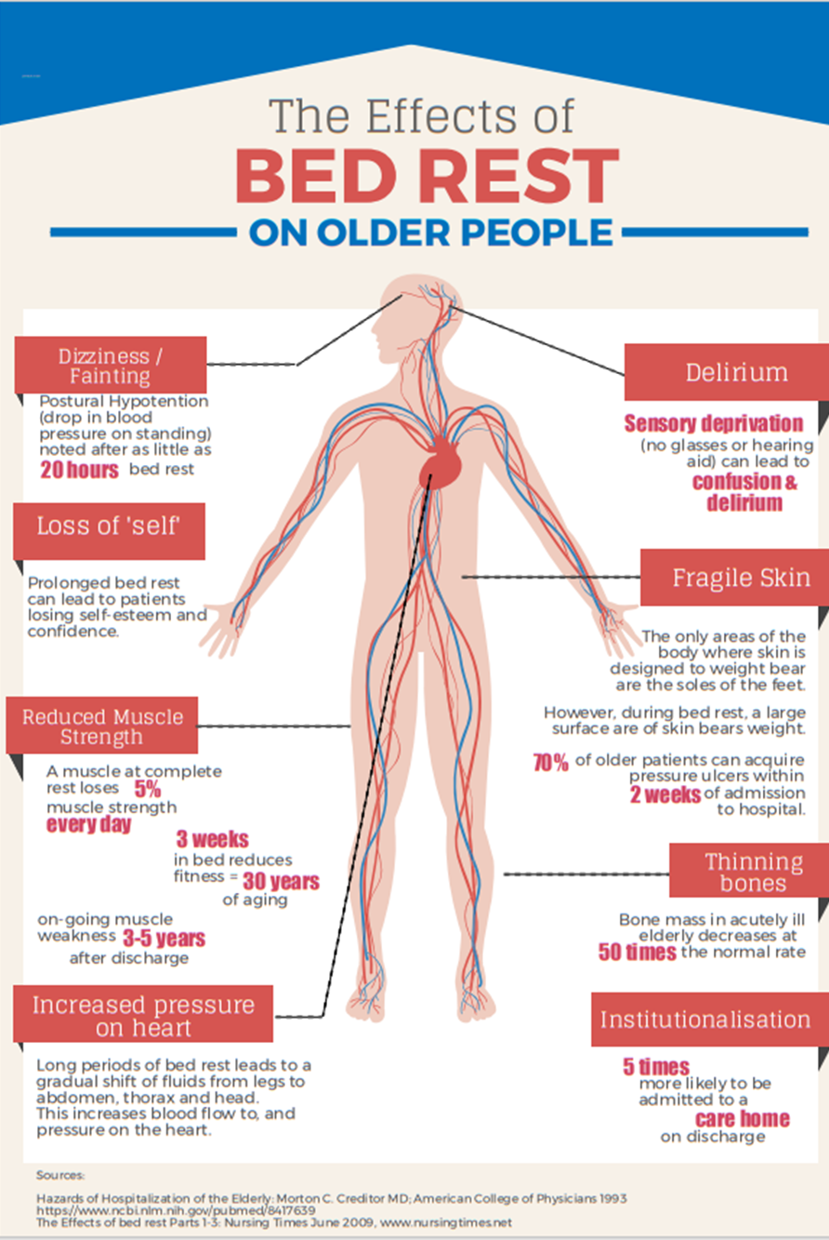

Positioning

The goal of good body alignment is to position the individual in such a way that there is no undue stress placed on the muscles or skeleton. Good body alignment should be maintained from side to side (laterally) as well as front to back (anterior-posterior). It is not enough to just position the individual on a turning schedule and expect that the individual will stay in that position for the duration of the time. In between times, the individual should be checked to ensure proper alignment has been maintained.
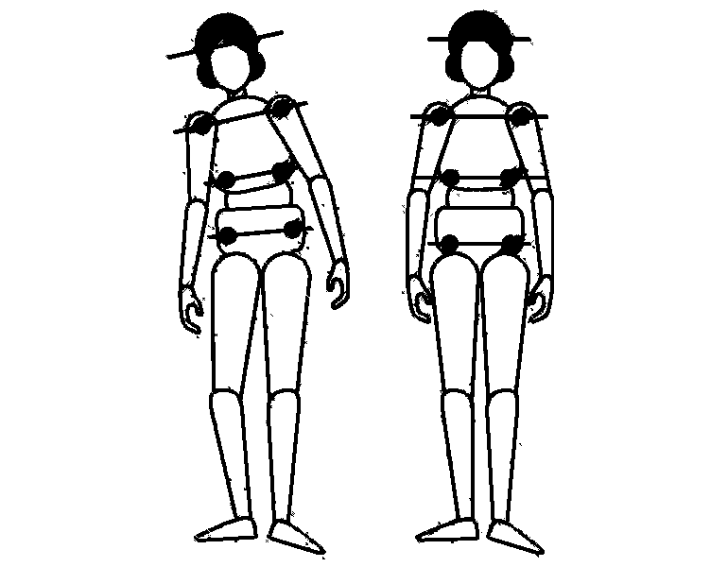

http//:accora.care.com. Accessed 17/08/2022

Individuals with dementia have limited awareness of the position of their body within the surrounding environment (proprioception) and this can lead to them creating a foetal position to provide themselves with some sensory feedback. We can encourage a more relaxed, open posture by providing full body support within their bed/chair, meaning that they do not have to fight against gravity to maintain that position.

Repositioning

Due to this lack of proprioception, being moved/repositioned frequently can create an increase in muscle tone thereby increasing contracture risk. These individuals will respond better to all intervention being completed slowly and with slower speech. It is also important to reduce the amount of passive mobilisation as much as possible so when completing activities such as personal care, complete one roll for washing/dressing/fitting sling – the turn only once principle.

Repositioning is important to maintain body alignment and reduce pressure risk. The recommended frequency of repositioning is at least every 6 hours for adults at risk and every 4 hours for adults at high risk (National Institute for Health and Care Excellence 2014). Repositioning an individual more frequently than this, when not required, will potentially increase their risk of developing contractures due to reduced proprioceptive and sensory feedback.

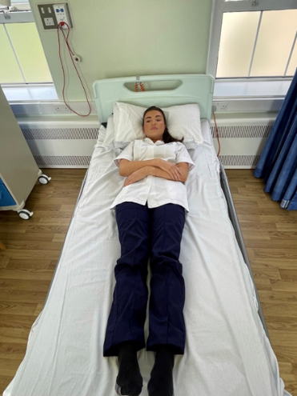
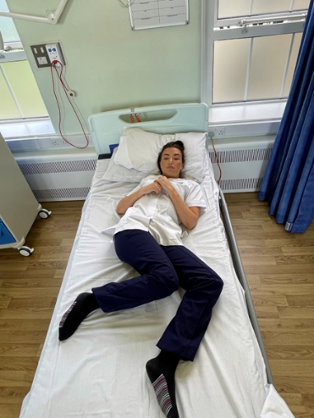

National Institute for Health and Care Excellence (NICE) (2014) [CG179] Pressure ulcers: prevention and management Available from: www.nice.org.uk/guidance/cg179. Accessed 17/08/2022.

Bed Positioning Examples

Resting on Back

- Use only one pillow under the head

- Place a pillow under each arm as shown in photograph

- Place pillows at bottom of the bed to keep feet upright and provide sensory feedback

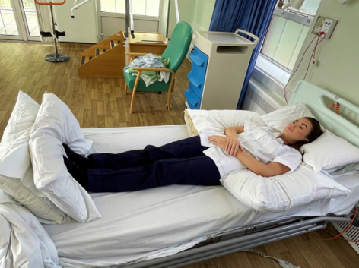

Resting on the Side

- Support the head with a pillow

- Place 1-2 pillows behind back for support, folding them for firmness if needed

- Place pillow lengthwise between legs

Place another pillow under bottom leg so that the foot is unsupported

- Use pillow to support top arm, hold the shoulder blade of the bottom arm slide it forward and out from underneath the person

- NEVER pull or jerk the arm

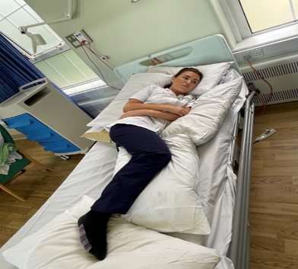

These examples are just for guidance, it is important to remember that the amount of support required for positioning depends on the individual. When creating a care plan and positioning schedule for an individual, the nurse/senior carer must look at the individual needs of that person. It should also be noted when positioning, the individual may have different needs or conditions, such as osteoarthritis, swallowing difficulties, hearing, vision, respiratory problems, contractures etc. All must be considered when creating a care plan for the individual.

Contractures

As well as pressure sores, contractures are another common consequence of poor positioning. If a movement (e.g. straightening a knee) is not carried out regularly, it may become stiff, and over a long period of disuse it will adapt by tendons and ligaments permanently shortening resulting in a permanent contracture.
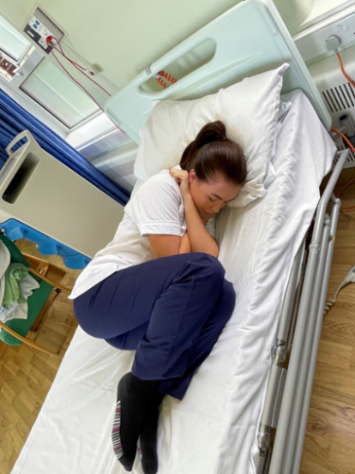

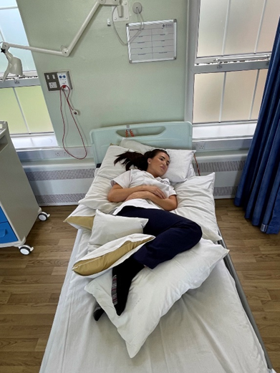

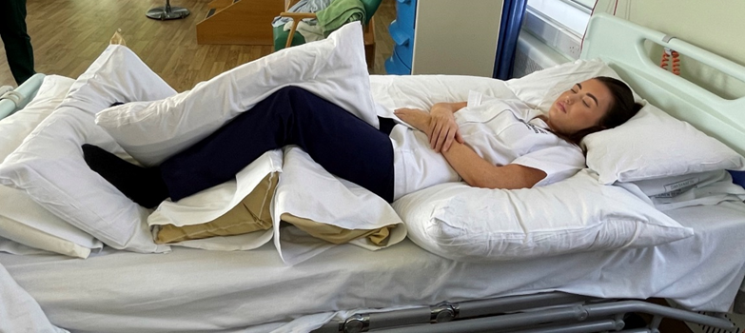

The presence of contractures will affect the ability to position the individual effectively and comfortably, and could create further tissue viability problems. Above shows a couple of examples of how to use pillows to support an individual in bed with contractures. It is essential to use the guidance in this leaflet to think about positioning the individual to reduce the risk of and manage contractures.

Hand hygiene can also become difficult due to contractures if it is difficult to open the hand or it causes pain refer to the orthotics service.

If you are worried a contracture is worsening or if you feel you are unable to manage the positioning with pillow’s please request an assessment from Occupational Therapy/Physiotherapy.
Things to Look Out For

- Prolonged periods in bed with inability to move themselves

- Sliding forward in seat

- Leaning to the side

- Complaints of discomfort and pain

- New/worsening hand contractures

- Issues with pressure areas caused by positioning

- Recurrent falls from a chair

- Increased difficulty completing personal care due to the presence of contractures

If you identify any of the above and are unable to manage the issues with the guidance in this document, please refer to community therapy team via Single Point of Access for your area. Your referral should detail the issues experienced and the interventions you have already tried.

Flintshire SPOA is 03000 858858 ssduty@flintshire.gov.uk
Wrexham 01978 298222 adultsspoa@wrexham.gov.uk
Denbighshire: 03004561000 BCU.SPoAAdultDenbighshire@wales.nhs.uk
Conwy: 0300456111 Wellbeing@Conwy.gov.uk
Caernarfon 01286 679099 OedolionCaernarfon@gwynedd.llyw.cymru
Bangor/Bethesda 01248 363240 OedolionBangor@gwynedd.llyw.cymru
Llyn 01758 704099 OedolionLlyn@gwynedd.llyw.cymru
North Meirionydd 01766 510300 OdolionEifionydd@gwynedd.llyw.cymru
South Meirionydd 01341424499 OedolionDeMeirionnydd@gwynedd.llyw.cymru
Anglesey: 01248 752752 asduty@ynysmon.gov.uk

The following companies will provide free assessments and training here are some links to access their resources:
Careflex
info@careflex.co.uk
Accora
Info@accora.care.com
Health Care Matters
info@healthcare-matters.com
Byw Bywyd
post@byw-bywyd.co,uk
Direct Health Group
info@directhealthcaregroup.com
Smirthwaite -smirthwaite.co.uk
Simple stuff works simplestuffworks.com

This list is for information only, other companies are available to offer quotes. Betsi Cadwaladr does not endorse any individual company.

Leaflet created by:
Kerry-Ann Roberts CHC Occupational Therapist Central Area
Kerry-ann.roberts@wales.nhs.uk
Ceri Razavi CHC Occupational Therapist East Area
CERI.RAZAVI@wales.nhs.uk
Jessica Roberts CHC Occupational Therapist West Area
Jessica.M.Roberts@wales.nhs.uk
Nicola Bone Community Physiotherapist Central Area
Nicola.Bone@wales.nhs.uk
Betsi Cadwaladr University Health Board

