NHS WALES POLICY MAKING DECISIONS ON INDIVIDUAL PATIENT FUNDING REQUESTS (IPFR)

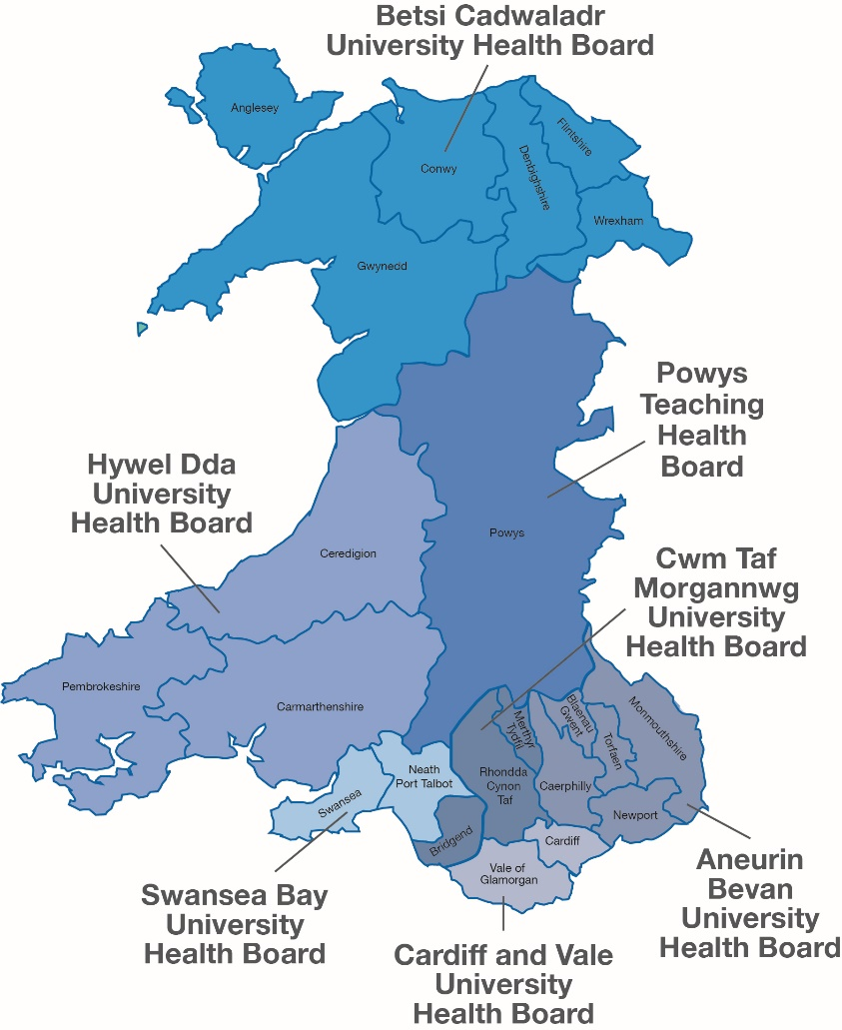

APPLICATION FORM

COMPLETING THIS FORM:

Before submitting an IPFR, please check you are using the correct process and that this should not be considered via another route such as a referral management system, compassionate drug use etc, that your Health Board may have in place. IPFRs can be submitted by an NHS consultant or GP where he/she will be responsible for delivering/administering the treatment. The requesting clinician is responsible for providing all supporting information and evidence.

If you would like help to complete this form, please don’t hesitate to contact the appropriate IPFR team.

- Application Form: Please complete the form electronically, expanding the boxes as required (Incomplete and unsigned forms will be returned). Handwritten forms will not be accepted
  - A password protected word version to be emailed as long as signatures are present. Password to be emailed separately or telephoned through. (Password protection only required for emails received outside Wales).
  - Applications for Specialised Services should be completed by the patient’s secondary care clinician.
  - Applications for tertiary referrals should be completed by patient’s secondary care clinician unless extenuating circumstances dictate otherwise.
  - Not every question need be answered for every case; but please signify ‘not applicable’ rather than leaving a blank.

- Supporting Evidence: Please also enclose the latest clinic letter(s), relevant evidence and any supporting clinical information you feel is appropriate. Please note however that all pertinent information should be included within the form.

- Where to Submit the Form and Supporting Information:
Aneurin Bevan University Health Board | IPFR Co-ordinator, Aneurin Bevan University Health Board, Llanfrechfa Grange, Room 43, Llanfrechfa Grange House, Cwmbran, NP44 8YN | ABB.IPFR@wales.nhs.uk  Fax: 01633 623817  Tel: 01633 623449
Betsi Cadwaladr University Health Board | IPFR Team, Betsi Cadwaladr University Health Board, Block 22, Glan Clwyd Hospital, Sarn Lane, Bodelwyddan, LL18 5UJ | BCU.IPFR@wales.nhs.uk  Tel: 01745 448788 ext 7930  Fax: 01745 448 211
Cardiff & Vale University Health Board | Cardiff and Vale IPFR Commissioning Team, 1st floor, Global Link, Dunleavy Drive, Cardiff, CF11 0SN | CAV.Irt@wales.nhs.uk  Fax: 02921 832117  Tel: 02921 832101
Cwm Taf Morgannwg University Health Board | IPFR Co-ordinator, Cwm Taf Morgannwg University Health Board, Ynysmeurig House, Navigation Park, Abercynon, CF45 4SN | Cwmtaf.IPFR@wales.nhs.uk  Fax: 01443 744889  Tel: 01443 744821
Hywel Dda University Health Board | IPFR /RMC Manager, Springfield Building  Withybush General Hospital, Fishguard Road  Haverfordwest, Pembrokeshire, SA61 2PZ | hdd.ipfr@wales.nhs.uk  Fax: 01437 772402  Tel: 01437 834486
Powys Teaching Local Health Board | IPFR Co-ordinator, Commissioning Team, Powys Teaching Health Board, Bronllys Hospital, Bronllys, Brecon, Powys, LD3 0LU | monitoring.powyslhb@nhs.net  Fax: 01874 712685  Tel: 01874 712690
Swansea Bay University Health Board | Individual Patient Care Services Manager, Swansea Bay University Health Board, 1 Talbot Gateway, Baglan Energy Park, Port Talbot, SA12 7BR | planning.office@wales.nhs.uk  Fax: 01639 687675  Tel: 01639 683615
Welsh Health Specialised Services Committee (WHSSC) | IPFR Team, Welsh Health Specialised Services Committee (WHSSC), Unit G1, The Willowford, Treforest Industrial Estate, Pontypridd, CF37 5YL | whssc.ipc@wales.nhs.uk whssc.ipc@nhs.net  Fax: 02920 869534  Tel: 01443 443 443 ext 78123

PART 1: DETAILS OF CLINICIAN SUBMITTING REQUEST

Details of Clinician making request (must be a GP/ Consultant who is currently providing care for the patient)
Name: Mr/Mrs/Ms/Dr
Job Title:
NHS Health Board, Trust or GP Practice:
Correspondence address:
Tel:
Email:
Secretary’s Name: |  | Tel:
Secretary’s Email:

PART 2: DETAILS OF PATIENT

Details of Patient
Forename: |  | Surname:
Address:  (including postcode) |  | Postcode:
NHS Number:
Date of Birth: (dd/mm/yy) |  | M or F:
Registered GP or GDP Name and Practice:

PART 3: URGENCY

How urgent is the request and why?  (tick as applicable) |  | Urgent:  24 – 48 hours | Soon:  within 3 wks | Non-urgent:  4 – 6 wks
If the request is urgent or soon clinical reasons must be provided. Administrative reasons will not be considered.
Please provide dates or timescales for any scheduled appointments, where known
Points to Consider | - Applies to working days only (not weekends or bank holidays).  - If application is ‘urgent’ contact department before submitting application to notify them that an application will be sent in.
The information included in parts 4 to 9 will be copied and seen by IPFR panel members, therefore do not include/refer to any patient’s identifiable information such as name, age, gender etc within these parts.

PART 4: DIAGNOSIS AND PATIENT’S CURRENT CONDITION RELATED TO REQUEST

Diagnosis:
Has this been discussed by the MDT? |  | Yes |  | No |  |  |  |  |  |  | If Yes, please provide a copy of the minutes to support the discussion
Relevant Medical History:
 | Current status of the patient (complete A or B):
- Intervention for cancer: |  | What is disease status? (e.g. at presentation 1st, 2nd or 3rd relapse)
 |  | What is the WHO performance status?
 |  | How advanced is the cancer? (stage)
 |  | Describe any metastases:
- Intervention for non-cancer: |  | What is the patient’s clinical severity? (where possible use standard scoring systems e.g. WHO, PASI, DAS scores, walk test etc)
Please summarise the current status of the patient in terms of quality of life, symptoms etc:
Summary of previous interventions for this condition:  Reasons for stopping may include:  - Course completed  - No or poor response  - Disease progression  - Adverse effects/poorly tolerated |  | Date of Intervention |  |  | Nature of Intervention |  |  |  |  | Duration of intervention |  |  | Reason for stopping/  response achieved | Location that Intervention was carried out

PART 5: DETAILS OF INTERVENTION RELATED TO REQUEST

Clinical indication for intervention:
Provider and location of the intervention:
Details of clinician who will undertake the intervention: | Name:
 | Job Title:

PART 5A: DRUG INTERVENTIONS

Full name of drug and manufacturer:
Planned dose and frequency:
Patient weight or BSA:
(include if dose based on weight/BSA)
Line of treatment:
Planned duration of intervention:
Optimal start date:
If the intervention forms part of a regimen, please document in full:
(e.g. drug X as part of regimen Y (consisting of drug V, drug W, drug X and drug Z)
Drug licensed for requested indication in the UK? | Yes No Don’t know
 | If No, is it licensed within the:- | EU USA

PART 5B: NON DRUG INTERVENTIONS (Surgical procedures, Therapies)

Nature of the intervention:  (If combination, tick all that apply) | Medical device  Second opinion  Surgical procedure  Therapy  Other
If medical device is required for intervention has it received a CE marking for use within the EU? | Yes No  If No, please give details and provide documented support of the reasons
What specific intervention is being requested:
Add any additional information here relevant to the intervention and treatment plan as it applies to this patient.
Why it is necessary for the patient to be specifically treated at the proposed provider?

PART 5C: TREATMENT OPTIONS

Has the patient been through all NICE/AWMSG approved regimes?
What is the usual treatment pathway and why is the patient not following the usual treatment pathway?
What is the alternative treatment intervention?
What are the reasons for not using an alternative intervention strategy?

PART 6: ANTICIPATED OUTCOMES

Please outline any anticipated or likely adverse effects of the requested intervention, including the toxicity of any drug?
How will you monitor the effectiveness of the requested intervention? What specific outcomes (markers/tests etc) will you use to assess response to treatment?
What are the criteria for stopping the treatment?
What is the minimum timeframe/course of treatment after which a clinical response can be assessed?

PART 7: EVIDENCE OF CLINICAL EFFECTIVENESS

Give details of key studies supporting the use of the requested intervention for this condition:

Please provide references or attach articles
The intervention has been considered for this indication by: | AWMSG NICE Not considered  Other (e.g. SMC, Royal College, Locally Agreed Clinical Pathway)
Please reference technology appraisal number and specify outcome/status
Points to Consider | - Are there peer reviewed clinical journal publications available?  - Is there evidence from clinical practice or local clinical consensus?  - Has the rarity of the disease been considered in terms of the ability for there to be a comprehensive evidence base available?  - Service and Policy Implications  - Does the decision indicate a need to consider policy or service change? If so, refer to service change processes.

PART 8: ECONOMIC ASSESSMENT

What is the cost of the intervention? (inc VAT)

Where appropriate, include here the total cost of the treatment, taking into consideration the patients weight or BMI, any loading dose required and the number of cycles applied for.

Please provide a breakdown of the cost per cycle/month and annually.

If this treatment is part of a regimen / pathway, what is the total cost of the rest of the regimen /pathway to deliver the treatment?

This should include cost for any additional follow up/outpatient appointments.
What is the cost of the alternative interventions or formulary alternative?
Are there any offset costs? | Yes No
If Yes, please describe
What is the potential net cost to the health board division, if any?
Points to Consider | Treatment costs may vary significantly based on a patient’s weight/BMI.  Costs included must reflect true costs to the Health Board as the amount of funding agreed will be based on the economic assessment provided within this request. If true costs are higher they will not be funded.

PART 9: STATEMENT IN SUPPORT OF APPLICATION

Please describe as clearly as possible the clinical case for this patient, complete either part A or B depending upon whether there are guidelines indicating not to use this intervention (Part A) or no guidelines are available (Part B).

Part A
If guidelines (e.g. from NICE or AWMSG) recommend not to use the intervention, explain:

Why the patient’s clinical circumstances are significantly different to the general population of patients AND why the patient is likely to gain significantly more clinical benefit from the intervention than would normally be expected from patients for whom the recommendation is not to use the intervention.

Include here any additional information you may have about why the value for money of the intervention for that particular patient is likely to be reasonable.

Part B
If the intervention has not been appraised (e.g. in the case of medicines, by NICE or AWMSG) explain:

Why the patient is likely to gain significant clinical benefit when compared to patients with the same condition and at the same stage in the progression of that condition.

Include here any additional information you may have about why the value for money of the intervention for that particular patient is likely to be reasonable.
Point to Consider | - If guidelines do not exist or do not provide clear rationale for a negative recommendation then use part B.  - Refer also to guidance notes.

PART 10: CONFIRMATION STATEMENT BY CLINICAN

I confirm that as the patients Consultant/GP I have fully completed and discussed this IPFR Application and its process with my patient (and / or their representatives) and I believe that:

- they have understood what is proposed in this application
- they are aware that the IPFR Administration Team will retain this application as part of the administration process for IPFR application
- they understand that the IPFR decision panel will not receive identifiable information and will not be able to identify them from this application

I have explained the process around IPFR and that this case may or may not be approved.

I have discussed what the treatment is likely to involve, the likely benefits and risks of this treatment and any available alternative treatments (including no treatment) and the particular concerns of this patient which I am able to address with my knowledge.

I understand that consent of the patient for the treatment/procedure will be required after full discussion with the healthcare professional responsible for prescribing or providing the treatment. This form should not be regarded as informed consent for the proposed treatment/procedure.

To the best of my knowledge the information I have provided within this document is a true and accurate reflection of the current clinical circumstances of the patient at the time of completion of the form.

I will make myself available, where possible, to provide any clinical advice required on or before the day of the panel to clarify any clinical issues to avoid unnecessary delays to the panel in reaching a decision.

I agree to provide outcome data within a timely manner to the IPFR team on the progress of the patient regardless of the IPFR decision.

I will discuss the decision of the IPFR panel with the patient and explain the rationale provided by the panel.

This IPFR application has been authorised to proceed through the IPFR process by the MDT, Medical Director or appropriate Clinical lead.

The IPFR Administration Team retains a record of the IPFR application and subsequent decision and any outcome data that is provided by the clinician. Data will be retained to help inform future planning requirements by identifying patient cohorts both at a local and national level. Data will also be used for the production of an annual report on IPFR’s every year as required by the Welsh Government. This will not include any identifiable data and will use aggregated data.

Clinician’s Name(Print):
Clinician’s Signature:
Designation / Job title:
Date:

