Special Measures Improvement Framework
May 2018-September 2018 - Overview Report

1. | Purpose of the Report

This report sets out an overview of the progress made against the May 2018 – September 2018 expectations set out in the second Special Measures Improvement Framework issued by Welsh Government in May 2018. It draws upon the recommendations of the Wales Audit Office (WAO) Structured Assessment 2017 and the recommendations of the Deloitte Financial Governance Review 2017.
It is influenced by the findings and actions emanating from the independent investigation and governance review relating to Tawel Fan. It also reflects the third joint governance review undertaken by Healthcare Inspectorate Wales (HIW) and the WAO in June 2017. A mapping exercise has been undertaken to ensure that progress monitoring of special measures expectations, and the other actions referred to above are aligned.

2. | Introduction/Context

2.1 Following the Health Board being placed in special measures in June 2015, a continuous organisation-wide programme of work to strengthen governance arrangements has been in place. This remains a dynamic process, as the organisation works not only to address the specific expectations set out in the Special Measures Improvement Frameworks (SMIFs), but also to respond to the emerging challenges. For example, the deterioration in the financial and performance position during summer 2017 led to these areas initially being escalated into ‘targeted intervention’ status then subsequently placed under the ‘special measures’ arrangements.

2.2 This report is the fourth of a suite of reports setting out the progress made against the expectations in the SMIFs. It specifically covers the period which ran from May to September 2018 and builds upon the significant number of actions previously taken. These were reported in the End of Phase 1 report published in May 2016 and available via the following link:
http://www.wales.nhs.uk/sitesplus/documents/861/16_91%20Special%20Measures%20Improvement%20Framework%20End%20Phase%201%20Report%20v1.0.pdf
also the End of Phase 2 Report, published in November 2016 and available via
http://www.wales.nhs.uk/sitesplus/documents/861/Agenda_bundle%20Health%20Board%2017.11.16%20v2.0%20REVISED%20reduced%20file%20size.pdf
and finally the End of Phase 3 Report published in January 2018:
http://www.wales.nhs.uk/sitesplus/documents/861/Agenda%20bundle%20Board%2011.1.18%20Public%20V2.0%20pdf.pdf

2.3 On 1.2.18 the Cabinet Secretary for Health & Social Services provided an update on an escalation status review of health organisations under the escalation and intervention arrangements. The statement outlined additional support for Betsi Cadwaladr University Health Board. The Cabinet Secretary noted the Health Board had made some progress against the expectations set out in the SMIF, in particular in the areas of leadership and governance, with a full Executive Team in place, established Board committee structure and development programme, and improvement in clinical oversight and management of concerns. Key milestones had also been achieved in respect of mental health strategy development, public engagement, staff survey feedback and innovative primary care delivery. Significant improvement had taken place in maternity services, to the extent that this area was de-escalated from special measures.

2.4 Despite the successes in some important areas, the Cabinet Secretary also noted that the Health Board continued to face significant challenges, particularly in finance and performance as referred to earlier in this report, and also in relation to mental health services quality improvement and leadership (following a loss of momentum resulting from the sickness absence of key senior managers). A set of intervention actions and additional support was therefore announced, with improvement criteria to be progressed by April 2018. The Board published a report on these actions in June 2018:
http://www.wales.nhs.uk/sitesplus/documents/861/Agenda%20bundle%20Health%20Board%207.6.18%20Public%20V1.0.pdf

2.5 The SMIF for the period May 2018 – September 2019 was issued by Welsh Government in May 2018. It comprised the four themes of leadership & governance, strategic & service planning, mental health and primary care including out of hours services, with expectations spread across three time periods. It was made clear by the Cabinet Secretary that future progress assessments would need to demonstrate that sustainable solutions were in place to maintain improvement.

3. | Progress

3.1 With the requirement to deliver transformational sustainable solutions in mind, the Special Measures Improvement Framework Task & Finish (SMIF T&F) Group established by the Health Board at the outset of special measures and which continues to meet regularly to track progress, decided to re-focus its approach to progress monitoring. The Group (chaired by the Board Chairman with effect from September 2018), with a membership of both Independent Members and Executives / Directors and advisory input from David Jenkins (appointed as additional support by Welsh Government), agreed a refreshed scrutiny approach for its progress monitoring log. The purpose of this was to clearly articulate the reasons for taking specific actions and the intended measurable beneficial outcomes. Ultimately, the aim is to achieve the SMIF expectations which, taken together with key elements such as waiting time reduction plans and the financial turnaround plan, will impact positively on the Health Board’s key performance areas of finance, mental health, delayed transfers of care, unscheduled care and referral to treatment time (RTT) targets. The SMIF T&F Group has continued to fulfil its purpose in advising and assuring the Board on the effectiveness of the arrangements in place to respond to the SMIF. An example of assurance reports submitted to the Board by the Group can be found here:
http://www.wales.nhs.uk/sitesplus/861/page/94107

3.2 In reviewing progress made during May – September 2018, the Task & Finish Group believes that some important progress has been made, though it is clear that significant challenges still remain. Key achievements to highlight across the themes are as follows:

- building improved Board capability and stability
- developing a comprehensive response to HASCAS and Ockenden recommendations, including embedding them in the Mental Health Quality Improvement and Governance Plan
- improved staff engagement and perceptions
- a staff survey response rate above the all Wales average, with improved scores in some key areas
- clinical involvement in service change proposals
- rollout of patient safety huddles
- partnership working during the rollout of the Together for Mental Health Strategy
- achieving a culture of not placing mental health patients out of area.
Further information on these highlights and measures of success are included later in this report.

4. Special Measures Improvement Framework Themes:

This section of the report outlines the progress made in meeting the expectations set out under the four themes:

4.1 Leadership and Governance

4.1.1 Expectation: Sufficient steps will have been taken in building a capable and competent board of executives and non-executives with the skills to deliver the strategic priorities of the health board; Recruitment of new Chair, Vice-chair and 5 independent members completed and appropriate induction delivered; Team based development programme continuing to be implemented for the Executive Team

During May to September 2018, all Board vacancies were addressed. Following successful Public Appointments processes, a new Chairman was appointed and commenced in post in September 2018, a new Vice-Chair and 5 Independent Members (IMs) were appointed (3 new members – 1 in post since March 2018 - and 2 re-appointments). A new Associate Board Member (Director of Social Services) has also been appointed to the Board following the end of the previous Director’s tenure. To meet the expectations set out under special measures on the need for the Board to ensure appropriate focus on primary care, a realignment of the 9 Executive portfolios took place. The role of Chief Operating Officer was removed, and its responsibilities re-allocated. The post of Executive Director of Primary & Community Care has been created (this responsibility was previously incorporated into the Chief Operating Officer role) and appointed to with effect from October 2018 and an Executive Director of Planning and Performance has been appointed with effect from November 2018. Local induction was provided for new joiners and Independent Members of the Board will participate in the national induction programme from October 2018.

4.1.2 In July 2018 Board members received financial training delivered by the Healthcare Financial Management Association (HFMA). In September 2018 the Health Board received an award from HFMA Wales and the Association of Chartered Certified Accountants (ACCA) at their annual conference, in recognition of the financial training and development delivered to a range of staff across the organisation. Further financial training is under consideration for Independent Members.

To underpin Board Member development, the new Chairman has introduced a new appraisal system with more frequent (quarterly) appraisals for IMs and the Chief Executive. Committee Chairs are also now required to submit Assurance Reports to the Board that have been strengthened to include mitigating actions for concerns and risks identified.

A new schedule of Board member walkarounds is due to commence in November 2018. In addition, some Board members have also attended Board meetings at other organisations deemed to be high-performing, for good governance benchmarking purposes. The Health Board’s own schedule of Board meetings, mainstreaming of special measures expectations into committee business, and committee membership have been revised and agreed at the Board meeting in September 2018, in order to support good governance.

4.1.3 To further support Board development, it was decided to commission an externally facilitated comprehensive programme. The tender specification was widened to incorporate three specific elements – namely whole Board development, IM development and Executive Team development. Bidders were required to factor in opportunities for coaching, mentoring and support for individual Board members on a one to one basis. The original plan was to make the contract award at the end of October 2018, with the contract commencing in early November 2018. However, the tendering process did not yield an adequate calibre of applicants. Therefore, over the next 6 months, a revised programme has been developed, which will include in-house Board sessions on a monthly basis, in the form of workshops focusing on key priorities and risks, alongside input from external experts on key topics including finance and risk management.

4.1.4 Expectation: Work progressed to meet the recommendations set out in the Deloitte Review as set out in the agreed action plan

An action plan was approved by the Board in February 2018 and progress is being tracked as part of special measures monitoring. For example, in relation to Deloitte comments regarding organisational structure, the Board has given careful consideration to the appropriateness of the current arrangements that were implemented over 3 years ago. Following this consideration, it was concluded that the current structure, which is well received by key partners such as Local Authorities, was conducive to delivering integrated care. However, it will be kept under review. Furthermore, it was acknowledged that organisational effectiveness within the existing structure required improvement, much of which would result from implementation of recommendations from the Deloitte Review. In respect of accountability arrangements, the Health Board recognises that more needs to be done; revisions were made in May 2018, which resulted in some initial improvement. However there is now a need for further review following Executive portfolio changes and to this end principles for a refreshed Performance & Accountability Framework have now been agreed (at the October 2018 Board workshop). Work is in train to finalise the Framework.

In addition, as previously stated, following the departure of the Chief Operating Officer, opportunities arose to re-align Executive portfolios – a process that has promoted integration and cohesion at Executive level and across the wider organisation. Furthermore adjustment is required now and the portfolios will be finalised at the Remuneration & Terms of Service Committee in November.

By the end of September 2018, the Health Board’s Deloitte action plan showed that, of the 14 recommendations in total, 9 were deemed partially/almost complete (‘amber’ rating) and 5 were deemed fully addressed (‘green’ rating). Recommendations covered by the amber rating were R1, 3, 4, 8, 9, 10, 12, 13 and 14, covering the subjects of Board team development, Independent Board Member skills sets, benchmarking against other Boards, financial re-basing, IMTP approach, Programme Management Office plans, accountability arrangements, organisational structure and workforce strategy development. These are all being progressed with vigour. Completed recommendations covered R2, 5, 6, 7, and 11, on the subject of the Chief Operating Office role, Board seminars, Finance & Performance Committee terms of reference, Finance Recovery Group role and Finance Department senior leadership. Progress against the Deloitte recommendations is robustly scrutinised at the monthly special measures meetings with Welsh Government officials.

4.1.5 Expectation: Finance plan at end of the first six months delivered as outlined to achieve the agreed finance control total; A Turnaround team in place to support the Turnaround Director deliver and is demonstrating increased pace on actions against the agreed plan and methodology

The Health Board remains in a very serious financial situation. The Health Board has acknowledged an interim deficit budget of no greater than £35m for 2018/19 which is predicated on delivering a £45m savings target. The savings will be achieved via a mixture of cash releasing savings and cost containment focused on improving operational efficiency. The Board has approved a targeted deficit reduction programme to address the £49m underlying deficit from a service and cost driver perspective. A Turnaround Director was appointed in May 2018 to realise rapid improvements in the delivery of the savings and the deficit reduction programme. At Month 6 the Health Board was £200k off plan with a deficit of £20.3m and savings were £0.5m ahead of plan. The work of the Turnaround Director has been supported by the external appointment of a senior finance individual to provide value and efficiency expertise. Additional resources made available by Welsh Government have allowed immediate strengthening of the turnaround function through the recruitment of a Head of Programme Management Office, Programme Manager and Project Manager. Recruitment of a multi-disciplinary clinical team will commence in October 2018 as will formal consultation on the substantive structure, appointment to which will follow the national organisational change policy. Further interim appointments to support short term delivery will be secured in November 2018. The elements of the turnaround activity for delivery in year are being developed in accordance with the approach previously set out. The Board recognises the need to shift from turnaround to transformation, and the required approach will be developed to underpin the IMTP which will be considered by the Board in January 2019 and also in conjunction with partners through the Regional Partnership Board.

4.1.6 Expectation: Evidence of improved integrated clinical, service, workforce and financial planning to deliver turnaround and transformational change

The financial savings identified for 2018/19 are reflected in the organisation’s annual plan. Improvement areas such as theatres, length of stay and outpatients are supporting operational delivery and performance requirements as well as improved efficiency. As the IMTP is developed the Transformation Programme for 2019-22 will be embedded within and alongside it to ensure that financial and service planning and outcomes are aligned. Development of the IMTP and transformational change programmes will be underpinned by key enablers including digital, workforce and estates strategies.

4.1.7 Expectation: Visible Board leadership and commitment to the effective process, preparation and response to the HASCAS investigation and Ockenden review recommendations demonstrating pace, candour and effective communication with families, staff, partners, the wider public and the media that ensures the wider issues identified are addressed

There has been visible Board leadership and commitment in responding to the Health & Social Care Advisory Service (HASCAS) investigation and Ockenden Review recommendations. This will continue. In recognition of the fact that the recommendations do not apply solely to Mental Health, the Executive Director of Nursing & Midwifery has assumed the lead role for this work. The HASCAS report was published in May 2018 and the Ockenden report was presented in public at the Board’s July meeting. The publication of these reports required a complex and comprehensive communications and engagement exercise encompassing Tawel Fan families, staff, partners, public and the media. In total,14 broadcast interviews were undertaken and over 50 news pieces were generated across print and online media. An Improvement Group has been established to oversee the implementation of recommendations; the Group held its inaugural meeting in August 2018. Operational leads have been assigned to each recommendation arising from both reports. The Stakeholder Sub-Group will hold its first meeting in October 2018. Invitations have been sent and representatives confirmed in respect of Tawel Fan families, the Health Board, Community Health Council, Bangor University, St Kentigern Hospice, North Wales Police, Local Authorities, Community Voluntary Councils, the North Wales Adult Safeguarding Board and Care Forum Wales.

4.1.8 Expectation: Local Well-being Plans agreed for the four Public Services Boards and Health Board actively involved in delivering on the joint priorities

Local Well-being Plans have been agreed for all four Public Services Boards (PSBs). These were approved by the Health Board in May 2018 and are published on the Local Authority and Health Board websites: http://www.wales.nhs.uk/sitesplus/documents/861/Agenda%20bundle%20Public%20Health%20Board%202.5.18%20V1.0%20pdf.pdf.
The Board is actively involved in delivering on the joint priorities, which include health, social care, mental health (linking to Local Implementation Teams) and the prevention agenda. The Board is also an active participant on the North Wales Regional Partnership Board (NWRPB), whose guiding principles direct the transformational change required to realise the aspirations of ‘A Healthier Wales: Our Plan for Health and Social Care’. The Chairman and Chief Executive have emphasised the importance of PSBs and the NWRPB as key partnerships, and as such have increased Health Board representation. The Board is also maintaining a keen interest in progress across this landscape and has been instrumental in the development of bids to the national Transformation Fund. The Board is looking forward to taking up the role of chair of the RPB in March and to supporting the partnership in other respects.

4.1.9 Expectation: A workforce and OD strategy developed and agreed by the Board with leadership developments as a key priority

A 3 year Workforce & Organisational Development strategy is being developed, and there is clarity on its four high-impact improvement objectives and associated timelines (improvements to be delivered by 31.3.19), as listed in the Annual Plan under the capacity, competence, culture and strategy and infrastructure themes. These themes encompass commitments to better utilise the workforce, deploy multi-professional workforce models in critical areas, reduce premium rate agency spend, improve personal accountability and enable staff to understand the impact of their role on service users. Leadership development is a key priority, as exemplified by the ‘Proud to Lead’ framework which has been embedded within the performance appraisal and development review (PADR) process, the ‘Step into Management’ programme and the establishment of senior management masterclasses which have been up and running since May 2018.

4.1.10 Expectation: Evidence of continued improved staff engagement demonstrated from surveys and feedback from Trade Unions

Efforts to further improve staff engagement continue across the organisation, in recognition of the fact that there exists a clear correlation between staff engagement and positive impacts on staff morale, improved organisational performance and patient outcomes. The NHS Staff Survey 2018, open between June and August 2018, provides evidence of continued improved staff engagement. The response rate for BCUHB was 31% - higher than the national average of 29% and the best response rate of all of the large health boards - which suggests that ongoing work to involve staff is having a positive impact on their willingness to engage on a shared strategic narrative for the organisation. The results show a number of positive improvements since the 2013 and 2016 surveys and whilst the Health Board is behind the overall NHS Wales scores on some questions, significant improvements can be seen in other areas, most notably in staff engagement. The engagement index scores have continuously increased since 2013. It is also important to note that the Health Board’s rate of improvement is slightly above the all Wales average rate. The all Wales overall improvement rate is 0.39 whilst Betsi’s is 0.41.

This is indicative of stability in some key areas which support trust and confidence of staff in the organisation. It also reflects the achievements and progress made against the Staff Engagement Strategy, approved in August 2016. Several successful initiatives have been implemented as part of the strategy, such as the monthly Seren Betsi Award for outstanding staff which is presented by the Chief Executive; an internal model (3D – Discover/Debate/Deliver) to involve and listen to staff, thus supporting service improvement, improved experiences at work, and development of better teams. Staff Engagement Ambassadors and Listening Leads have been appointed and ‘Proud of’ groups have been established within hospitals and departments as part of the development of a Proud to Lead Behavioural Framework for all managers and leaders.

Other key areas where the Staff Survey results show improvement on previous years are under the themes of values, teamwork, line managers, communications, resources, change in the organisation and learning and development. The trajectory of improvement clearly demonstrates an improved culture of staff engagement as the areas highlighted have a direct correlation to positive behaviours. The graph below illustrates the steady progress made on the values theme:

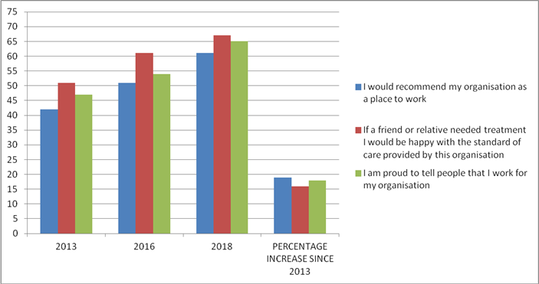

Building on conversations to date, relationships are developing positively with and between trade union representatives, for example, Unison have now returned to the table and are providing valuable feedback on staff engagement issues – a senior trade union partner reports ‘things continue to improve albeit slowly…pride of being a BCU employee is coming back along with evidence of staff awards…clearly showcasing us in a more positive way…staff engagement is better…there appears to be a better vibe with the Exec team and things are getting done swifter and in a more friendly way for staff…the way (Tawel Fan) was handled at the end with the meetings and moving on is to be commended as it was done with great empathy and sensitivity for all parties affected’. Another senior trade union leader commented that there were ‘a lot of examples of good practice in this area including the 3D events and lots more engagement using social media; there have been positive comments regarding the current leadership masterclasses… engagement with trade unions is generally good’.

4.1.11 Expectation: Demonstration of improved public engagement and perception demonstrated in feedback from surveys and partners including the Community Health Council

During the reporting period, the Board established a programme of public engagement activity including developing the approach to engaging with seldom heard groups, maintaining the contribution to stakeholder networks and other strategic partnerships and ensuring representation at high profile public events such as the National Armed Forces Day hosted in Llandudno in June 2018. Measures to evaluate the effectiveness of engagement with the public and stakeholders continue to be developed. Stakeholders have been asked about their perceptions of the Board and a second public perception survey which yielded over 1,100 responses is due to report in December 2018. Since June 2018, the Board has been measuring the sentiment of press coverage as a potential indicator of engagement success. At the time of writing, the split between positive and negative media coverage was marginally more positive, with 141 positive, 137 negative and 41 balanced pieces of coverage. The Board continues to take every opportunity to receive input and feedback from its Community Health Council (CHC) partners. The CHC is involved with a multitude of Board groups and initiatives including service reviews, transformation programmes, joint Board to Board meetings, the Annual Achievement Awards, the HASCAS/Ockenden response, the Equality & Human Rights Stakeholder Forum, and the recent open day in Llandudno Hospital. The purpose of the open day was to share with the CHC the approach being taken to improving dementia services. Positive feedback was received from the CHC on behalf of patients and the public as a result of this initiative. The Board and CHC continue to work in partnership during regular Service Planning Committee meetings.

4.2 Strategic and Service Planning

4.2.1 Expectation: Further development of a Board endorsed long-term integrated clinical services strategy

‘Living Healthier, Staying Well’ is the long term strategy for north Wales. It provides direction and focus for the years ahead, to ensure future health provision meets the needs of the population and is sustainable.
A significant programme within this is the overarching acute hospital strategy accepted by the Board in March 2018. This sets out the common provisions at each of the district general hospitals together with the broad vision for future service configuration. This strategy was communicated to the public, local politicians, clinicians and Welsh Government, and was well received. A series of individual speciality strategies have now been developed, with constructive clinical engagement. The plans are at various stages on the continuum from development to implementation. For example, the Sub-Regional Neonatal Intensive Care Centre (SuRNICC) and primary percutaneous coronary intervention (PPCI) plans have been implemented. Implementation of the vascular surgery plan is underway and some early successes have been seen. For example, the vascular network has now successfully undertaken an elective Endovascular Aneurysm Repair (EVAR) procedure in the new interventional radiology suite at Ysbyty Glan Clwyd Hospital. The network has also been successful in attracting and appointing consultant vascular surgeons despite a national shortage of trained and experienced surgeons. The ophthalmology and orthopaedics plans have local actions in implementation pending resolution of some investment decisions, and further demand and capacity work in respect of orthopaedics. The urology and stroke plans have been widely engaged upon and broad consensus is emerging, however further work is required on detailed costings and consequential investment decisions. It is acknowledged that the requirement for a detailed, fully endorsed long-term integrated clinical services strategy cannot be fully realised until the Integrated Medium Term Plan (IMTP) is in place, and it also needs to be described more clearly.

4.2.2 Expectation: An operational plan for 2018/19 will have been agreed by the Board and Welsh Government and delivery against the first six months is on schedule. This to include improvements in areas of quality, unscheduled care and planned care, noting that final targets for year are currently subject of continuing discussion
- Improvement in the numbers of patients waiting over 36 weeks;
- Improvements in the % of patients to receive ambulance handover in less than an hour, patients spending less than 4 hours in all major and minor emergency units, and a reduction in the number of patients spending more than 12 hours;
- Demonstration of timely and organisation-wide learning from the concerns, complaints
- incident and claims processes to further improve and meet quality standards and full engagement in the all-Wales arrangements in place to enable and ensure consistent shared/system learning

A draft annual operational plan was developed and endorsed by the Board in July 2018, setting out key actions for 2018/19. The plan has not been fully agreed by Welsh Government, due to the requirement for more work on ensuring sustainable planned and unscheduled care plans. During the reporting period, the Board has been supported by the Delivery Unit (DU) to review the modelling work on capacity, demand and proposals to close the gap on RTT, including the need to move towards a sustainable position with demand and capacity in recurrent balance. This will require detailed plans to be implemented through the IMTP process.

Support was commissioned from Price Waterhouse Cooper (PWC) to develop the short term actions and the longer term model for unscheduled care. Following initial diagnostic work, the focus was on improving 4 Hour Emergency Department (ED) performance in Ysbyty Glan Clwyd by enhancing ED, processes for managing flow, by improvements in the discharge process and through the use of the SAFER patient flow bundle methodology. The work then shifted to focus on re-design of the model for unscheduled care in North Wales. PWC has reported back on its findings and it is recognised that sustaining any of the short-term improvements such as shorter mean time in ED and reduced site risk scores on an ongoing basis will be the challenge ahead (4 hour waits did not improve to the extent anticipated as a result of PWC work). The established work streams are continuing to address performance issues, however dialogue is underway with Welsh Government with regards to securing additional support to conclude the work started with PWC and thereby realise the anticipated benefits.

In August 2018 a workshop was held, including partners and clinical staff, to develop a 90-day improvement plan for unscheduled care. A ‘confirm and challenge’ launch event of the plan was held in October and weekly oversight and scrutiny meetings are now in place to drive improvement.

4.2.2.1 The Board’s overall performance remains in a very serious position, with September data showing RTT failing to meet the 95% national target (84.46%). As at September 2018, 6291 patients were waiting beyond 36 weeks, however the graphs below illustrate the improvement in numbers waiting when compared to last year:

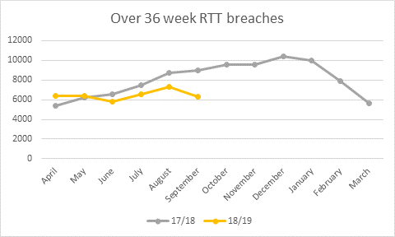

RTT over 36 weeks | 17/18 | 18/19
April | 5371 | 6348
May | 6233 | 6381
June | 6570 | 5767
July | 7461 | 6579
August | 8703 | 7291
September | 8982 | 6291
October | 9608
November | 9543
December | 10365
January | 9976
February | 7933
March | 5663

4.2.2.2 This improvement in part represents the Health Board’s decision to continue to invest non-recurrently in additional off job plan activity, and to contract additional external capacity to enable patients to be treated in the first 6 months of this year. These initiatives remain in place at present, pending agreement with Welsh Government on target trajectory and funding.

In terms of orthopaedic pathways the lifestyle programme has been expanded to accept referrals for all musculoskeletal conditions, enabling it to meet the level of service capacity it was set up to achieve (1000 capacity with 1138 referrals received in 2017-18, significantly up on the previous year). The musculoskeletal service has continued to be effective in both expanding the range of conditions it can manage and in triaging to other services. This means that approximately 40% of patients referred proceed into secondary care orthopaedics, enabling the average waiting time for a first outpatient appointment to improve, although this also means that patients seen in outpatients are more likely to require surgical intervention and so the pressure at stage 4 remains high. A sustainable orthopaedic service plan will be submitted to Welsh Government shortly; this is viewed as key to securing significant further improvement.

Examples of the extended range of services now offered by the Clinical Musculoskeletal Assessment & Treatment Service (CMATS) include the back pain pathway, joint injections, ultrasound and extracorporeal shockwave (ECSW) therapy (some of these services are in early stage of implementation and effectiveness is being evaluated prior to full roll out).

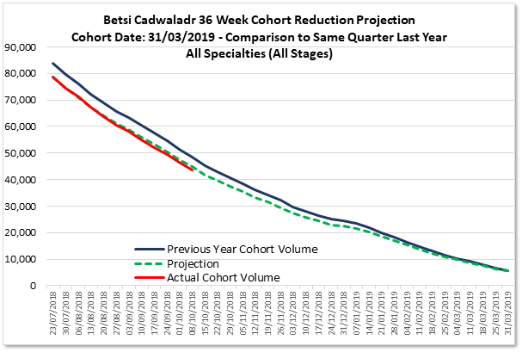

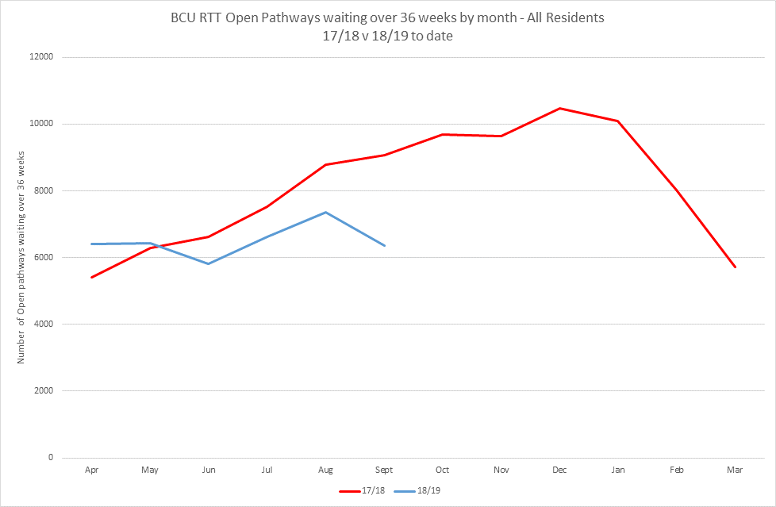

4.2.2.3 There has been a reduction in the percentage of patients receiving ambulance handover in less than 1 hour, a deterioration in the 4 hour ED wait performance from 74.5% to 71.3%, and a deterioration in the 12 hour target (400 more waited over 12 hours in July 2018). The Board recognises that current performance is far from acceptable and is working with partners to turn around the position and achieve steady, sustainable improvement. Action is underway, with support from Welsh Government, to reverse the deterioration in performance, as set out in the regular Integrated Quality & Performance Report (IQPR). The action taken includes the development of the 90 day unscheduled care improvement plan focusing on demand management, flow management and discharge management. Additional staffing has been put in place at times of peak demand. Initial actions are intended to ensure that patients attending minor injury units (MIUs), and paediatric patients, are all seen, treated, referred on or discharged within 4 hours.

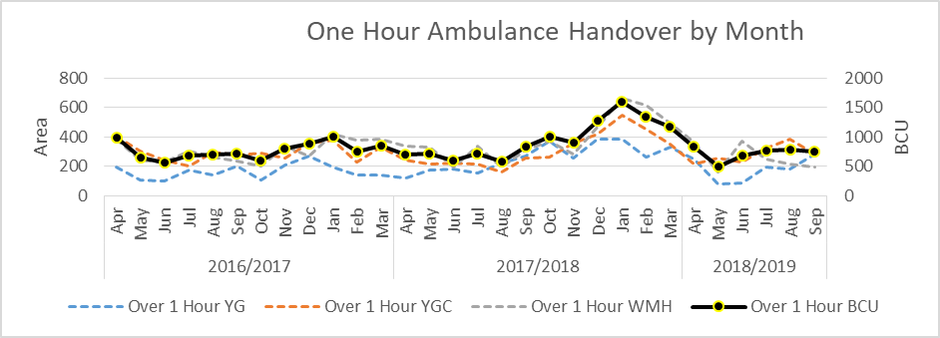

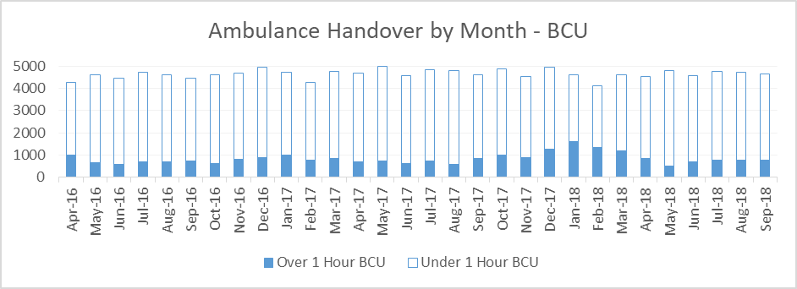

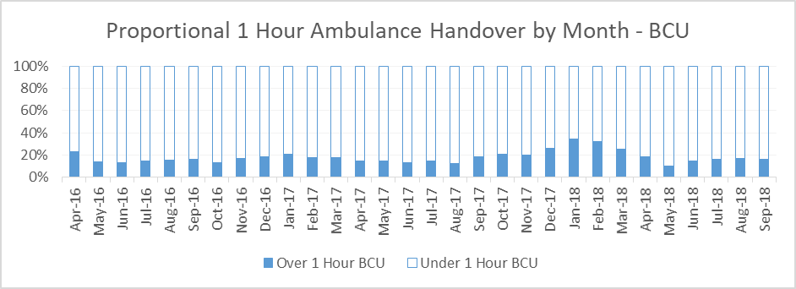

4.2.2.4 An increase in the volume of patients classed as major cases has impacted on Emergency Department capacity. A comparison of September 2017 performance data with September 2018 data shows that the proportion of Emergency Department attendees classed as major cases rose by 5.7%, with a corresponding reduction in minor cases. The increase in major cases over the summer of 2018 contributed to the deterioration in performance; similar deterioration was experienced over that time period across most Health Boards in Wales.

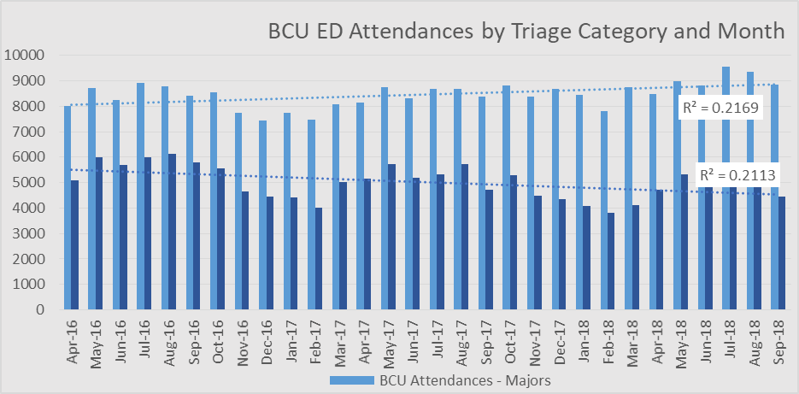

4.2.2.5 In respect of performance on organisation-wide learning from concerns, complaints, incidents and claims, a weekly incident review meeting has been established to review all serious incidents in the previous week and monitor progress in terms of incident management across the organisation. The Board is a key participant in a national project to identify and share learning from claims earlier in the process and staff will be chairing an all Wales panel on behalf of the Welsh Risk Pool to identify and share learning, themes and trends from claims. Internally there is a monthly shared learning meeting, with clinical executives sighted on the issues earlier in the process. The reporting arrangements between the divisions and the Quality & Safety Group have been strengthened with all divisions providing a monthly report on quality and safety.

4.2.2.6 A comprehensive programme of work has commenced across the organisation to focus on some of the most commonly reported incidents, including infections, pressure ulcers, falls and medication safety issues. These harms are reported into the Health Board’s incident management system and then re-profiled into the Harms Dashboard, which give a visual overview of the numbers of incidents and the areas in which they have occurred. An associated work programme is focusing on reducing avoidable harm and seeking to deliver the improvements outlined in the Quality Improvement Strategy. The work includes a ward accreditation process, medication, pressure ulcer and falls collaboratives and also the Safe Clean Care initiative, which has contributed to a reduction in infections as illustrated in the chart below:

Organism | Trajectory status | Performance against previous year
C.difficile | Above | 29% improvement
E.coli | Above | Performance similar to previous year
Klebsiella | Above | 22% improvement
Pseudomonas | Above | 29% improvement
S.Aureus | Above | 16% improvement
MRSA | Below | 63% improvement
MSSA | Above | Performance similar to previous year

4.2.3 Expectation: Patient safety huddles consistently implemented across the Health Board with clear executive support; Progress on delivery of the principles of the SAFER patient flow bundle to reduce delayed transfers of care

Patient safety continues to be an absolute priority throughout special measures. Patient safety huddles are now in place and the focus is now on achieving consistency and, with executive support, on disseminating this good practice. The huddles work has been evaluated by the DU. The DU’s final report showed that an overwhelming majority of staff involved in the huddles found them to be beneficial from a patient perspective. Each acute site has developed improvement plans, embedded within the unscheduled care improvement plan, which include system rollout of key elements of the SAFER bundle which is having an impact on flow, patient safety and experience. SAFER has been included in the ward accreditation programme, so that all wards will be assessed against the relevant standards.

4.2.4 Expectation: Progress on developing the integrated clinical hub with WAST to support the development of alternative pathways that help to reduce conveyance of patients by emergency ambulance to Emergency Departments

Work is well underway to establish a pan Health Board Unscheduled Care Coordination Hub (this also forms part of the wider Unscheduled Care Plan developed with PWC, and incorporates the work on a future model for GP out of hours, and implementation of the 111 service.) A Clinical Director with significant experience of setting up Urgent Care 24/7 has been recruited to drive delivery. In addition operational improvement capacity has been secured, and the recruitment of senior nursing support to deliver a triumvirate implementation approach is in hand. Pathways for ambulance conveyance are in place.

4.2.5 Expectation: Leadership and additional capacity and capability in place within the planning team to lead and develop strategic plans in partnership

In terms of leadership and additional capacity and capability within the planning team, an appointment has been made to the post of Executive Director of Planning and Performance (the appointee will commence in November 2018). A review of the capacity and skills within strategic and operational planning is underway to strengthen these and to underpin the revised Executive Team portfolios. As previously described, additional capacity was commissioned from PWC and this strengthened local programme management, accountability, reporting and escalation arrangements.

4.2.6 Expectation: Development of a winter resilience plan aligned to the Welsh Government guidance and developed in partnership with Local Authorities and clinical leaders across the unscheduled care pathway that includes measurable / quantifiable action

A winter plan self-assessment checklist was submitted to Welsh Government in September following review and approval by the North Wales Regional Partnership Board.

As detailed above, the Health Board has developed a 90 day unscheduled care improvement plan, structured under the 3 main headings of demand management, flow management and discharge management. This plan was presented at an unscheduled care event which was attended by 180 people including front line clinicians as well as representatives from WAST, local authorities, care homes, housing and the third sector, including the British Red Cross. This event followed on from a previous workshop which was attended by a range of staff and stakeholders and which helped shape the early drafts of the 90 day plans. The 90 day plans are supported by key quality measures designed to demonstrate the effectiveness of each task in improving operational performance and overall patient safety and experience. Monitoring and governance is via the Health Board’s Unscheduled Care Programme Board. Primary care clusters are closely involved with this work and work with non-emergency patient transport (NEPTS) has matured to a point where a winter plan aligned to the Health Board priorities has been drafted. This provides enhanced discharge capacity and capability for weekends and holiday periods. PWC provided support on winter resilience planning. In future, seasonal resilience planning will be integrated with service improvement.

4.2.7 Expectation: Development of a three-year integrated medium-term plan (to be submitted in January 2019) will be on schedule against the agreed time

The Health Board is clear as to its strategic goals and the route to the longer-term outcomes that it seeks to achieve. A strategy and planning map has been devised, setting out the enabling strategies and underpinning service delivery plans and transformation programmes that will feed into the IMTP. The planning timetable and review/tracking arrangements for developing the IMTP were agreed by the Board at its meeting in September 2018, with the key milestones being: engagement workshops on 4.10.18, 8.11.18 and 13.12.18, draft Plan to be reviewed by the Strategy, Planning & Population Health Committee on 4.12.18, followed by Board review in December and on 10.1.19 prior to submission to Welsh Government. This work has commenced in line with the agreed timeline, working with the leadership of all divisions. The regional plans being developed with the Regional Partnership Board (RPB) will be a significant element of the IMTP. Regular reporting on delivery has been incorporated into the Strategy, Planning and Population Health Committee and Board governance processes.

4.2.8 Expectation: Evidence of increasing consistency in clinical practice and that clinicians are engaged and working alongside planning and professional directors on clinical services proposals

As regards consistency of practice in clinical leadership and clinicians working alongside planning and corporate directors on clinical services proposals, clinical lead appointments have been made across a range of speciality areas which will support closer collaboration between clinicians and planning and professional directors. These new leaders have key roles in progressing the clinical strategy and this can be seen through the community resource teams in the clusters, in secondary care, in the work carried out on the mental health strategy and through the acute hospital stream. There are many good examples of extensive clinical involvement, such as during the development of vascular, urology, ophthalmology, orthopaedics and stroke plans. In respect of the latter, stroke services clinicians (medical, nursing, therapies and other) have been involved in the stakeholder group leading and shaping the stroke services review work from the outset. A series of workshops were held with strong clinical leadership. The clinical leads have reached a consensus on proposals for improvement to the whole stroke pathway and have presented these to the Healthcare Professionals Forum (HPF). The HPF welcomed the clinical leadership displayed and confirmed in their minutes (May 2018) that ‘members support and share the vision of the North Wales Stroke Services and ask the Health Board to also support this fundamental work’. ‘Promoting clinical engagement –an unscheduled care workshop’ took place on 10.10.18, and involved a large number of clinicians.
4.2.9 Expectation: Progress on developing sustainable orthopaedic services demonstrated, including completion of an option appraisal that has been tested and discussed with Welsh Government;

In terms of progress on developing sustainable orthopaedic services, a detailed plan has been developed to support the transformation required at the three acute hospital sites. The Board recognises that there is more to do to ensure that the orthopaedics plan is costed and is affordable, and will finalise and submit the business case by the end of November 2018. Section 4.2.2.2 of his report outlines how initiatives underway in relation to the orthopaedics pathways are helping to reduce waiting times.

4.2.10 Expectation: North Wales ophthalmology plan approved by the Board and an implementation plan developed and agreed with Welsh Government

The ophthalmology plan was approved by the Board in April 2018 and the governance structure for implementation has been developed. This work is being taken forward under the direction of the Area Director (West), supported by the eye care lead clinician. Strengthened governance arrangements have been put in place through the Eye Care Collaborative. Four new pathways have been implemented, namely the post cataract pathway, visual fielding in the community, eyelash removal and glaucoma support in patients’ own homes. Work to address inefficiencies within the system is ongoing. As with the orthopaedics plan, there is more to do to ensure that the ophthalmology plan is costed and affordable, and this is being progressed.

4.3. Mental Health

4.3.1 Expectation: Continued improvements in compliance with relevant targets including those set out under the Mental Health Act and Mental Health (Wales) Measure, for example, assessment within 28 days

The Board recognises the scale of the challenge in improving mental health services across North Wales on a sustainable basis. The improvement actions initiated during the three phases of the first SMIF have been built upon, to ensure a fully operational management structure, the implementation of the ‘Together for Mental Health’ Strategy, compliance with targets, quality improvement, appropriate responses to Health & Social Care Advisory Service (HASCAS)/Ockenden recommendations and the elimination of service user out of area placements.

4.3.2 In respect of achieving continued improvements in compliance with relevant targets including those set out under the Mental Health Act and Mental Health (Wales) Measure, the following actions have been taken:
- The Delivery Unit (DU) commenced during August 2018 a supportive intervention with the mental health senior management team and operational service managers. The intervention focuses on developing the skills and processes required to understand service demand and service capacity and improving the management of pathways and flow into and from the service. This intervention seeks to improve patient safety and quality through a review of the four key areas of demand, referral, activity and backlog. Work to develop capacity and demand capability alongside pathways will support improvement and development of current services and act as a platform for more transformational change, as implementation of the mental health strategy progresses. The work will also provide clarity on the workforce requirements to sustain compliance with the Mental Health Measure (MHM).
- The ongoing prioritisation of crisis response and alternatives to admission by the local implementation teams (LITs) and the implementation of the strategy in relation to alternative community support will impact on referrals into MHM part 1.
- The review of Psychological Therapies will include review and requirements at all tiers including tier zero.
- Whilst the Mental Health & Learning Disability Division’s percentage compliance rates for part 1a have been broadly maintained since May 2018, reported at 71% in August 2018, the service has seen a steady increase in referral activity under part 1 since 2015. Referrals in the first 6 months of 2015 numbered 4047 compared to the 6280 referrals during the first 6 months of 2018. To offset this increase a pilot has been undertaken in Wrexham utilising a consultant psychiatrist to review patients and work more closely with GPs. Early successes are improved patient experience and a 20% reduction in patients moving into secondary care. The pilot is to be replicated in Conwy, a county that has also seen increases in referrals. A consultant psychiatrist specifically for primary care has also been successfully recruited.
- In respect of MHM part 1b, the Division has reviewed its skill mix and has recruited Support Time and Recovery (STaR) workers across north Wales. The aim of this is to contribute to improving and sustaining MHM compliance by providing more group focused interventions, thereby improving outcomes for patients. In addition joint working is taking place with Powys colleagues to introduce an electronic cognitive behavioural therapy (e-CBT) package. Whilst Part 1b compliance figures have seen a deterioration from 83% in May 2018, to 66% in August 2018, it is intended that the above developments and weekly scrutiny will address the performance issues across the Division.

4.3.2.1 Addressing a deterioration in compliance figures and perceived silo working in Child & Adolescent Mental Health Services (CAMHS) has also been a priority. This issue is being addressed by bringing CAMHS under the auspices of the Mental Health & Learning Disabilities Directorate by December 2018.

4.3.3 Expectation: A Thematic Quality Improvement and Governance Plan (TQ &G Plan) for mental health services and process to be in place to monitor delivery and impact, which is line with the overall corporate quality improvement and governance requirements and sets out a clear response to recommendations from reports including HASCAS and Ockenden

A Quality Improvement and Governance Plan for mental health services was approved by the Board in August 2018. The document is aligned to the overall corporate Quality Improvement Strategy and governance requirements and sets out a clear response to recommendations from the HASCAS and Ockenden reports. A procurement exercise was undertaken to commission training for the ‘Today I Can’ methodology and the first 90 day change agent initiative took place in early October 2018. The Mental Health Division has also progressed recruitment for Service Improvement Leads. These posts will support the Area Teams to develop and embed their plans, and will ensure that the change programme is sustained across north Wales.

4.3.4 Expectation: Implementation of strategy progressing including Local Partnership Board actions plans agreed and being delivered by the local implementation teams with full engagement of service users and partners

Responsibility for implementing the Together for Mental Health strategy has been delegated by the Together for Mental Health Partnership Board to three Local Implementation Teams (LITs) and Quality & Workforce Groups (Q&WF) covering Anglesey & Gwynedd, Conwy & Denbighshire, Wrexham and Flintshire. Their membership comprises representation from the Health Board staff, patients, carers, the third sector and partner organisations including Ambulance, Police, Local Authorities, benefits agencies and the Community Health Council. Work undertaken by the LITs has informed a bid submitted to the transformation fund that came into being following the Parliamentary Review. If successful, this bid will provide the necessary pump-priming needed to support the Mental Health Strategy’s pathway development. LITs are also working to identify solutions to other local problems identified by service users, healthcare professionals and partner organisations. For example, the Anglesey & Gwynedd LIT is taking action to ensure that there is appropriate support in place for people whose mental health may be affected by the imminent rollout of Universal Credit. As the groups continue their work throughout 18/19 they will develop detailed 90 day local plans that will be monitored via an overarching Delivery Group. This Group will oversee the implementation of strategy from a system-wide perspective.

4.3.5 Expectation: Continued sustainable reduction in patient out of area placements, including CAMHS

Another important element of the mental health strategy is the eradication of inappropriate out of area placements, for the benefit of service users and their families, and also to reduce costs. The negative impact on families and carers and the risk of patients being admitted out of area during an acute phase of their condition is fully recognised by the Mental Health and Learning Disability Division and admission out of area is always a last resort. Importantly, the Division has successfully repatriated all patients who were clinically inappropriately placed from out of area settings and there is now a consistent pattern of patients not being sent out of area. In line with other health boards, on occasions when demand outweighs bed capacity, an out of area placement may be sourced, but repatriation will be in a timely manner. For adult Mental Health out of area bed day use has seen a steady decrease from 1643 in 16/17, 886 in 17/18 to just 91 in 18/19, and during this year the use of out of area beds has coincided with temporary bed closures in relation to environmental works being completed.

To support the continued reduction in out of area beds the Division is progressing the development of a strategic outline business case for the Ablett Unit, which will include capacity and demand modelling across all in-patient estates which will ensure adequate capacity to meet the needs of the people of north Wales. This work represents one of the key priorities of the Together for Mental Health Partnership Board and its partners. In addition the DU has agreed bespoke risk based escalation training across all mental health sites, which will have a positive impact on patient flow. The training will be in place in October 2018.

During the current year, CAMHS out of area placements have continued to reduce compared to the previous year. However, towards the end of the reporting period there was an increase in the number of patients requiring psychiatric intensive care (which is not provided in Wales) due to the acuity of their illness, and as at the end of September 2018 this had resulted in 2 out of area placements.

4.3.6 Expectation: New management structure fully operational

The Division’s new management structure is almost complete. Tiers 1, 2, 3 and 4 have been operational since April 2018. The progression of tiers 3 and 4 saw the significant investment in on-site triumvirates in response to a number of previous external reviews and realised the ambition of clinically led and managerially supported services. Over the past 6 months the new triumvirates have been familiarising themselves with local teams and services. Their impact has been acknowledged by external reviews in terms of improved leadership, accountability and positive impacts on staff morale. The Division will now embark upon formal consultation on the remaining tiers (matrons and service managers) during November 2018, and substantive appointments will be made immediately thereafter.

4.4 Primary Care

4.4.1 Expectation: Director of Primary Care and Community Care reporting to the Chief Executive and Board working effectively with clusters and partners to develop a future plan
- to establish approaches to ensure resilience in primary care services is in place, making best use of available resources
- with specific actions, timelines and outcomes, to adopt and adapt the transformational model for local health services, which has emerged from the national pacesetter programme
- setting specific actions on how cluster level working will develop, underpinned by the recurrent cluster level funding

The new Executive Director of Primary & Community Care has been appointed (commenced with effect from 1.10.18). Working towards full achievement of all primary care special measures expectations will be a key proprity for the post-holder. The Director has already commenced discussions with cluster leads to emphasise the ambition for step change in moving clusters forward and the need to embrace a broader vision reflecting partnership and other primary and community care synergies. Primary care monies will support the transformational model to be adopted. Service level agreements are being reached in many clusters to improve the longevity of new positions which support the transformation model. Advanced paramedics, other allied health professionals, nurse consultants, additional support for clinical training in primary care as well as a recruitment drive for GPs are all being supported across the three areas. The Director is due to report progress and his vision for the future to a Board Workshop in November.

4.4.2 Expectation: Review the purpose and membership of the Primary Care Transformation Group so that it provides advice and challenge to the health board on its plan and delivery

The purpose of the previous Primary Care Transformation Group was reviewed and the group was then superceded by a refreshed Care Closer to Home (CCtH) Delivery Group, which met for the first time in October 2018. At this first meeting, the group’s terms of reference were agreed, together with a commitment to commence reporting to the Regional Partnership Board alongside the Health Board. The newly appointed Executive Director of Primary & Community Care emphasised the need to set robust blueprints for work streams, with a shared vision and commitment to true partnership. Four core work streams with leads and champions, supported by several smaller enabling streams, were agreed. The work streams cover cluster maturity, the new model for primary care, community resource teams within clusters, and health & wellbeing centres incorporating community hospitals.

4.4.2 Expectation: Continued improvements in out-of-hours services including better shift coverage and access that is based on an agreed strategic plan; Evidence that the health board has implemented and continues to make progress in meeting the revised national out of hours standards

Work continues to improve GP out of hours services and to meet the revised national standards. In terms of the urgent 20 minute standard, the Health Board performance is mid-range when compared against the rest of Wales. In terms of the 60 minute standard, the Health Board performs at the lower end of the range when compared to the other organisations, though is not the worst performer. Performace data incorporating comparisons over time and with the rest of Wales is as follows:

% 20 minutes:
 | Jan-18 | Feb-18 | Mar-18 | Apr-18 | May-18 | Jun-18 | Jul-18
ABM | 79.90% | 77.50% | 78.50% | 83.10% | 85% | 85% | 85.10%
AB | 82.20% | 76.70% | 85.90% | 86.50% | 86.20% | 86.20% | 82.60%
BCU | 62.50% | 62.80% | 60.80% | 68.90% | 74.80% | 74.80% | 73.70%
C&V | 72.90% | 67.60% | 70.60% | 75.10% | 76.20% | 76.20% | 84%
CT | 59.40% | 53.70% | 63.40% | 65.80% | 66.70% | 66.70% | 62.90%
HD | 62.80% | 56.80% | 58.50% | 65.80% | 61.50% | 61.50% | 65.20%
Powys | 81.10% | 82.50% | 100% | 87.80% | 84.80% | 84.80% | 89.50%

% 60 minutes:
 | Jan-18 | Feb-18 | Mar-18 | Apr-18 | May-18 | Jun-18 | Jul-18
ABM | 83.30% | 25% | 66.70% | 50% | 60% | 60% | 33.30%
AB | 62.70% | 72.20% | 60% | 73.70% | 78.40% | 78.40% | 63.90%
BCU | 55.60% | 50% | 40% | 100% | 42.90% | 42.90% | 50%
C&V | 56.50% | 84.60% | 61.30% | 90.90% | 73.10% | 73.10% | 84%
CT | 79.20% | 64.60% | 75.80% | 76.70% | 82.60% | 82.60% | 59%
HD | 100% | 66.70% | 80% | 100% | 100% | 100% | 66.70%
Powys | 95.20% | 92.30% | 76.70% | 85.70% | 85.30% | 85.30% | 80%

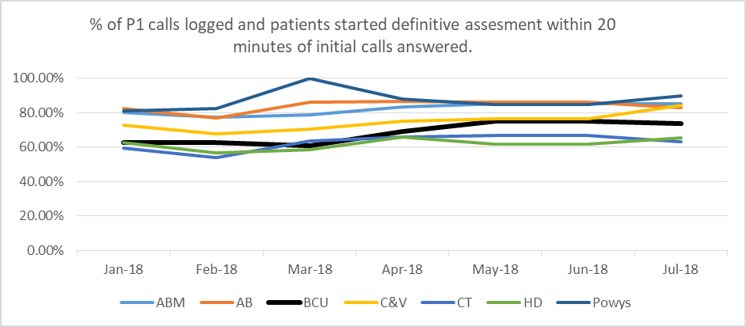

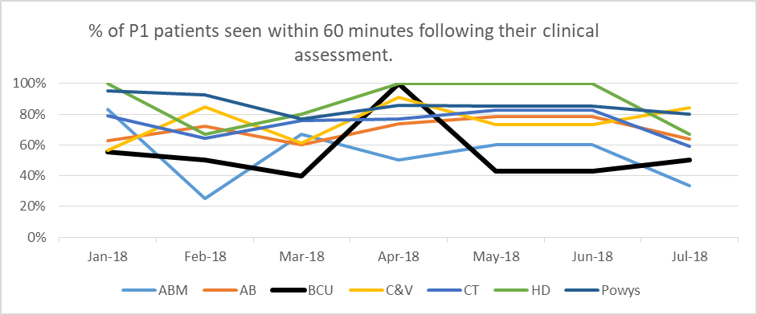

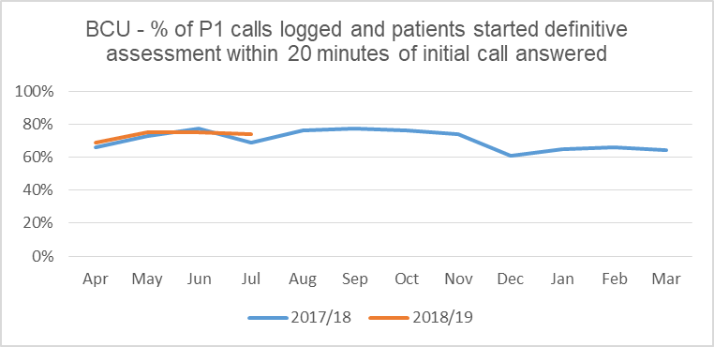

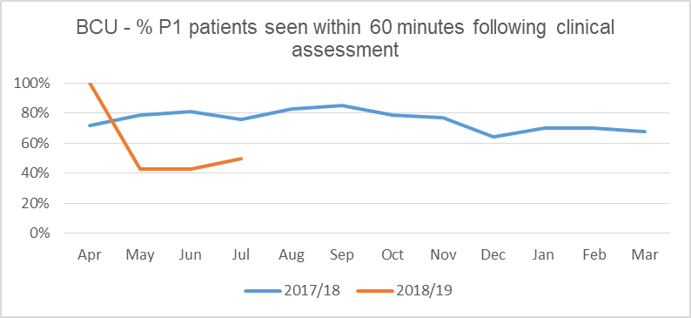
Work continues to improve GP out of hours services and to meet the revised national standards. In May 2018, 87% rota fill was achieved across the Health Board and by Division the compliance was 97% in the East, 87% in Central and 79% in the West. September 2018 saw a drop to 85% across the Health Board, and by Division the compliance was 87% in East, 94% in Central and 79% in West. In spite of this in month reduction in compliance, the overall compliance for July to September 2018 remains at 86% (as per April to June 2018). In terms of patient feedback, the three Divisions carried out patient surveys in July/August 2018 and the majority of respondents described the service as “excellent” (80%) or “good” (13%). The most recent published data (August 2018) showed that telephone triage performance was in line with All Wales performance (74% compliance for urgent cases, against 74% nationally (BCU was in 4th place) and 83% compliance for non-urgents against 84% nationally (5th place). Face to face consultations were 67% compliant for very urgent cases within 60 minutes against 76% nationally (equal 5th place), 79% urgent cases within 120 minutes against 82% nationally (5th place), and 98% for less urgent cases within 360 minutes against 97% (2nd place) nationally. Indicators from a recent Wales Audit Office report http://www.audit.wales/publication/primary-care-outofhours-services showed that out of hours services remain fragile across the whole of Wales. The ambition is to transform the service model so that it becomes fit for purpose and sustainable. Steps are being taken to align the 111 service and out of hours into the into the integrated coordination hub.

5. | Equality Impact Assessment

As this is a retrospective report concerning progress on implementation of the Improvement Framework, an equality impact assessment is not considered necessary.

6. | Conclusions/Next Steps

As described in this report, the Health Board has made progress against the May-September 2018 expectations of the second Special Measures Improvement Framework. However, it is recognised that significant challenges remain in some areas as outlined in this report, and there is considerable further work to be done, particularly in respect of unscheduled care, RTT and finance. The Board has a clear understanding of those areas requiring additional focus and the improvements required. Work is ongoing and some areas are on an improvement trajectory. The additional special measures funding of £6.8m provided by Welsh Government will be used to move forward on key priorities. Progress made during each of the special measures phases will continue to be monitored to ensure that improvement is achieved and sustained.

The Board approved this report for submission to Welsh Government at its meeting held on 1.11.18.

