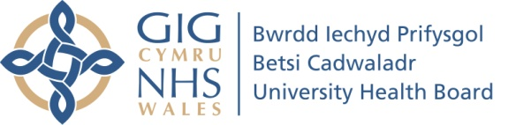

Cyfarfod a dyddiad:  Meeting and date: |  | Health Board  23rd January 2020
Cyhoeddus neu Breifat:  Public or Private: |  | Public
Teitl yr Adroddiad  Report Title: |  | Special Measures Improvement Framework (SMIF)  December 2019 – Self-Review Overview Report
Cyfarwyddwr Cyfrifol:  Responsible Director: |  | Gill Harris, Deputy Chief Executive and Executive Director of Nursing & Midwifery
Awdur yr Adroddiad  Report Author: |  | Gill Harris, Deputy Chief Executive and Executive Director of Nursing & Midwifery
Craffu blaenorol:  Prior Scrutiny: |  | Executive Team and The SMIF Task & Finish Group (Health Board Chair, Executives, Independent Members)
Atodiadau  Appendices: |  | Appendix 1 – self review report
Argymhelliad / Recommendation:
The Board is asked to note the report for information.
Please tick one as appropriate (note the Chair of the meeting will review and may determine the document should be viewed under a different category)
Ar gyfer  penderfyniad /cymeradwyaeth  For Decision/  Approval |  |  | Ar gyfer Trafodaeth  For Discussion |  | Ar gyfer sicrwydd  For Assurance |  | Er gwybodaeth  For Information | x
Sefyllfa / Situation:
The Health Board is required periodically to submit reports on special measures progress to Welsh Government.
Cefndir / Background:
The purpose of this, the sixth of a suite of reports submitted to Welsh Government since the Health Board was placed under special measures in June 2015, is to present the findings of a self-review carried out by the Health Board. The findings provide a position statement as at December 2019, including an overview of the progress made by the Health Board since its previous report of May 2019. The report has been received by Board members and was submitted to Welsh Government by the 13.12.19 deadline set.

Asesiad / Assessment & Analysis:
Set out within Appendix 1

Appendix 1
1. | Purpose of the Report

1.1 The purpose of this, the sixth of a suite of reports submitted to Welsh Government since the Health Board was placed under special measures in June 2015, is to present the findings of a self-review carried out by the Health Board. The findings provide a position statement as at December 2019, including an overview of the progress made by the Health Board since its previous report of May 2019.
1.2 The Board acknowledges that the challenges set out within the document require changes in how it encourages people at all levels of the organisation to deliver continuous improvement in local health and care systems and to gain pride and joy from their work. It further recognises that work currently being undertaken to review both the clinical risk management approach and governance processes will play a key role in achieving the organisation’s ambitions as outlined within the special measures improvement framework.
1.3 The methodology adopted for the self-review involved the identification of Executive Leads for each area of the framework, nominated by the Chief Executive. It was acknowledged that the whole Executive Team had a shared responsibility to contribute to and own the exercise. Each lead gathered the necessary evidence to produce a narrative. This was then considered at a ‘confirm and challenge’ session in which all Executives participated. The process was based on evidencing a key lines of enquiry (KLOE) approach and allowed an analysis of strengths, weaknesses, opportunities and threats (SWOT) relating to the assessed position.
1.4 Following the Executive challenge, the report was presented to the Independent Members at a Task & Finish Group meeting, for further in-depth scrutiny and to make a judgement on any areas requiring further improvement in order for the Health Board to be considered for de-escalation. This further challenged the evidence and content of the document and resulted in a revised version of the report.
1.5 It has been emphasised that the evidence needs to be current, relevant and easily accessible should it be requested, and drawn from internal and external sources. Deep dives to assess this will be built into future meetings. This report represents the first response to the new framework and the methodology described will need to mature as the process moves forward.

2. | Introduction/Context

2.1 As previously reported, since June 2015 a continuous organisation-wide programme of work to strengthen governance arrangements and make improvements to services has been in place, with a focus on quality throughout. This remains an ongoing process as the organisation works not only to address the specific expectations set out in the SMIF, but also to respond to emerging challenges. This report builds upon the significant number of actions previously taken. These were reported in the first report published in May 2016, the second report published in November 2016, the third report published in January 2018, the fourth report published in November 2018 and the fifth report published in May 2019.
2.2 The Special Measures Improvement Framework Task & Finish (T&F) Group, established by the Health Board at the outset of special measures, continues to meet to oversee progress. Its membership comprises both Independent Members and Executives / Directors, and the group is personally chaired by the Health Board Chair. The special measures clinical leadership and quality focus has been given a renewed impetus following the commencement of the Deputy Chief Executive / Executive Director of Nursing & Midwifery as the T&F Group’s Lead Executive in July 2019. The Group has continued to fulfil its purpose in advising and assuring the Board on the effectiveness of the arrangements in place to address to the SMIF. An example of an assurance report submitted to the Board by the T&F Group’s Chair can be found here.
2.3 In June 2019, the Minister for Health & Social Services made a statement updating on the Health Board’s progress, noting particular improvement, corroborated by Independent Advisers, in governance and quality processes, board leadership, mental health services, engagement, partnership and general practice. Alongside this, the Minister also highlighted the requirement for further work on the Health Board’s challenging financial position, planning and waiting time performance. He supported the commissioning of PricewaterhouseCooper (PwC) to work with the Health Board on planning and sustainable improvement, as well as the need to bring in high calibre turnaround expertise to reinforce recovery.
2.4 The Minister made a further statement and published a revised SMIF in November 2019. He reiterated that the Health Board had already proven it could deliver on a number of expectations, with some notable successes in achieving the removal from special measures of maternity services and GP out of hours. He emphasised the immediate priorities of planning, unscheduled and planned care performance, and financial management.
2.5 The revised SMIF comprises Part A: expectations to be met as a minimum in order to be de-escalated from special measures, and Part B: characteristics the Health Board will need to demonstrate it is sustaining and building upon in order to step down to routine arrangements status. Both parts include expectations set out under the four key areas of
- Leadership and improvement capability
- Strategic vision and change
- Operational performance
- Finance and use of resources.
The following section describes progress made against Part A expectations, as at December 2019.
3. | Progress

3.1 Area 1: Leadership and Improvement Capability - Leaders understand the challenges and ensure relevant expertise and capability across the system are addressing barriers, making tangible impact and delivering improved outcomes.
3.1.1 The Board has seen significant change over the last 4 years, with new Independent Members and Executive Directors appointed. The Board is clear on the challenges faced by the organisation and the Executive Team has a significant level of experience in moving organisations forward in a systematic and sustainable way. The opportunities associated with bringing a fresh view are being optimised. The development programme being supported by the King’s Fund is focused on recognising the strengths of individuals and, importantly, how bringing these together within a strong team will benefit the organisation. The senior leadership team is cognisant of the need for role modelling behaviours to support improvement, and is committed to these.
3.1.3 The Health Board can evidence a number of key areas where it has invested resources (including time and extra funding) in additional capability and expertise, to drive continuous development and improvement. These have included:
- The appointment of an interim Recovery Director
- The development of a Programme Management Office (PMO)
- The BCU Quality Improvement (BCUQI) Hub
- A range of leadership development interventions including the Institute of Learning Management (ILM) and the Ward Manager Development programme
- Creating additional leadership capacity and capability on the three acute sites
- Investing in the development programme for Board members, led by King’s Fund experts
- Investing in senior leadership support for the Executive Director of Primary Care
3.1.4 In order to support a better understanding of the challenges faced by the Health Board, improvement skills (including analysis of data/intelligence) have been integrated into all leadership and management training programmes from introduction/supervisory management through to the Leading for Transformation Programme for senior leaders. A Leadership Network has been established, designed to increase the understanding of challenges at a macro as well as micro level, and to facilitate collaborative solution-building and deployment.
3.1.5 In addition, there has been an increased use of integrated ‘dashboards’ for clinical, performance, financial and workforce intelligence provision, together with a greater focus on development of improvement trajectories to meet target key performance indicators (KPIs).
3.1.6 In respect of supporting the achievement of tangible impacts and delivering improved outcomes, the Health Board has sought to become a learning organisation with an emphasis on quality initiatives, as evidenced by:
- The Ward Accreditation Programme requires all wards to undertake Quality Improvement (QI) Projects driven by incidents, concerns and patient feedback. Since the introduction of ward accreditation in October 2018, 68% of all acute, mental health / learning disabilities, community, women’s and paediatric wards have been accredited, with a further five to be completed in December 2019. The programme reviews evidence to allocate gold, silver or bronze awards, with those not meeting minimum standards (white) supported with an improvement package and heightened monitoring.
- Staff are encouraged to report incidents to support learning. The implementation of the Quality Dashboard and the Ward Accreditation Programme has supported transparency with quality data published. An upgraded Harms Dashboard (launched in December 2019) will provide users with real time access to data on harms, incidents, concerns and Welsh Government reportables as part of the Phase 1 launch. Weekly incident meetings support organisation-wide learning.
- In October 2019 the Corporate Nursing Quality Improvement Team held ‘Going for Gold’ roadshows across the organisation, to encourage staff, patient and public engagement with ward accreditation and quality improvement. These roadshows facilitated engagement with over 200 members of staff on a one to one basis, and the roadshows were held in public spaces to enable patient and visitor engagement.
- The Health Board introduced a programme of focused improvement work, including, Safe Clean Care, the Ward Accreditation Programme, followed by the Hospital Acquired Pressure Ulcer Collaborative (HAPU) in November 2018 and then the Inpatient Falls Collaborative in June 2019 to support areas with higher levels of associated harm. Early data analysis indicates a reduction in falls for falls cohort collaborative wards, however it is too soon to identify a data trend and sustainability of interventions.
- Presentations explaining the Ward Accreditation Programme and its methodology have been well received by the Community Health Council (CHC). The Corporate Nursing Quality Improvement Team has worked in partnership with the CHC to map the CHC audit questions to the Healthcare Standards used for their visits e.g. Care Watch and Bug Watch. A process and template are in place for reporting up to the Board. All CHC data is reviewed as part of the ward accreditation process. In addition to this, all Healthcare Inspectorate Wales (HIW) inspection reports (where available) are reviewed and discussed as part of the visit.
- All key programmes of focused improvements provide an opportunity for the Health Board to learn and embed the principles of a common quality improvement language and methodology, embracing the use of data as well as embedding a set of standards to frame our quality, safety and patient care and Quality Improvement Strategy agenda.
- A quarterly progress paper is submitted to the Quality & Safety Group (QSG) and in turn the Quality, Safety & Experience (QSE) Committee, to provide assurance to the Board. Common themes identified during ward accreditation visits are presented as part of this paper and also mirrored / noted on the Health Board’s ward accreditation intranet page.
- The new Patient & Service User Experience Improvement Strategy 2019-2020 has been approved by the Health Board and is now in place with progress monitoring through quarterly reporting. It is a core element of the ward accreditation visits.
- The new Patient Advice and Liaison Service has been launched across the Health Board with hubs in all the main hospital site entrances, and ‘Care to Share’ clinics are undertaken across the Health Board to disseminate learning from patient feedback.
- Customer care training and recording of patient stories is being delivered across the Health Board. Quality & Safety meetings have introduced patient stories as an opening agenda item to address key learning from patient’s individual experiences. The ambition is to develop a patient story library with associated learning on the Health Board website.
- The Health Board takes an active leadership role in areas relating to quality improvement at a national level. Representatives are involved in the various all-Wales patient safety and experience networks, including chairing the Redress Peer Review Panel and the Datix IQ Cloud Content Governance Group.
- Positive impacts ensue as a result of the intense focus on quality and safety as described above. One positive outcome of note for patients is the fact that MRSA bloodstream infection rates have continued to decrease within the Health Board with only 6 MRSA infections reported to date for 2019/20, 33% less than the same period for 2018/19.
- MRSA screening, decolonisation and device management continue to be key elements of focus in 2019.
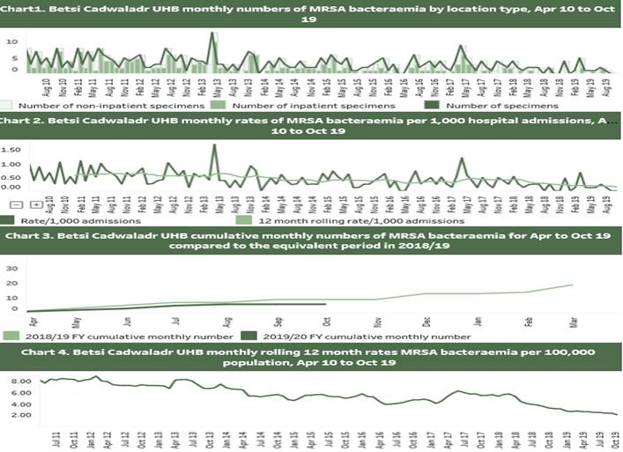

3.1.7 The positive impacts of leadership and improvement capability can be seen in the numerous examples of national awards and recognition for the Health Board’s work. The organisation had a double success at the Society of Radiographers Awards 2019, with an award for Radiographer of the Year Wales (for service improvements at HMP Berwyn) and Team of the Year for the post operative head and neck radiotherapy pathway team (for reducing waiting times for patients needing radiotherapy). At the Advancing Healthcare Awards Wales 2019, Health Board staff were shortlisted for improving public health outcomes, for joint working with social care colleagues, for leadership and change management, and for Pharmacist of the Year. A member of staff was a finalist for nurse leadership (improving patient safety) at the NHS Wales Awards 2019, two members of staff were recognised for their improving health and nurse education work at the RCN Wales Nurse of the Year Awards, and the Health Board won the Nursing Times Team of the Year 2019.
3.1.8 Recognising all of this, the Board is clear that there remains more to be done in terms of both Board/Executive leadership and leadership across the organisation.
The change in the Executive team, whilst positive, has resulted in a level of instability and ‘forming’. This, set against a context of significant improvement activity at pace, has had an impact on the organisation and there is a need for a ‘reset’ as part of the planning for 2020/21 and beyond. This is being supported by the development programmes outlined above e.g. the King’s Fund Board Development and Leading for Transformation as well as developing a clear direction of travel with senior leaders across the organisation.
3.1.9 The Health Board needs a clear, sustainable improvement system to support delivery of its longer term plan and future Clinical Services Strategy. In developing this system, it also recognises the need for decisions to be taken regarding the make-up and focus of a central support infrastructure, and then to implement this at pace. Not only will this signal to the organisation that the Health Board is committed to improvement and transformation, but it will also promote the development of broader capacity and capability across the organisation. This will embed improvement as a way of working rather than a centrally driven ‘initiative’

3.2 Area 2: Strategic Vision and Change – It can evidence it is working with staff and partners to develop a clear and comprehensive picture of how services will look in the future and a realistic credible three year plan has been considered by the Board by April 2020.
3.2.1 In respect of long term strategic direction, Living Healthier, Staying Well (LHSW) is the Health Board’s long-term strategy that describes how health, well-being and healthcare in North Wales will look in ten years’ time. The Health Board approved LHSW in March 2018. The Annual Plan clarified the Board’s commitment to producing a clinical services strategy by 31st December 2019, following a period of ‘discovery’ and a review of current service strategies: maternity, primary care, out of hours, care closer to home, population health, and some acute specialties.
3.2.2 In respect of the Health Board’s proposed digitally enabled clinical services strategy, the first phase of review and debate was completed at the end of September 2019 and covered:-
- Alignment of service specific strategies
- Interdependencies
- Fit with ‘A Healthier Wales’
3.2.3 Clinical engagement, leading to local ownership by staff of the strategy and commitment to its implementation, is essential. Further work is underway to ensure that this is developing as part of the work on the strategy.
3.2.4 Following review of the existing strategies and through further discussion with the Strategy, Partnerships, and Public Health (SPPH) Committee and Board members, the need to modify the emphasis to ensure development of a digitally enabled health and social care strategy was identified. This is the essential base upon which to build clinical and social care services in future.
3.2.5 The Health Board will adopt a ‘digital first’ approach, ensuring that all existing service plans are revisited to incorporate digital processes, to improve outcomes. This ensures healthcare data underpins transformation. Digitalisation offers a new opportunity to engage with partners and stakeholders, and to involve citizens in the co-production of the future strategy. Following a presentation at the Board workshop in October 2019, the agreed timeline is as follows:
- November 2019 – an initial outline of the digitally enabled clinical strategy was presented to the Digital and Information Governance Committee on 21 November 2019.
- December 2019 – the next version will be presented to the SPPH Committee and Health Board in December 2019.
- January to March 2020 - Stakeholder meetings will be held to engage further and design implementation of the strategy.
- March 2020 – the final version of the digitally enabled clinical strategy will be completed with a 3 year implementation plan.
- 2020/21 - clinical summits will be held to develop and test future pathways, supported by networks and digital healthcare technology, to help a patient with a specific condition or set of symptoms move towards positive outcomes and promoting prudent (value based) healthcare.
3.2.6 Working with partners will be an integral part of all work undertaken. There has been a focus on the key priorities of the North Wales Regional Partnership Board, with joined up action plans developed to deliver improvements in care and support. There is good evidence of strategic alignment with partners, as demonstrated in the following quote from the survey commissioned by the Health Board’s Engagement Team (taken from a repeat survey undertaken as part of the work on continual engagement): “almost all of the stakeholders are aware of BCUHB’s “Living Healthier, Staying Well” strategy with several stating that they are already integrating it with or basing their own strategies upon it. The publication of the strategy has enabled partners to evaluate how their organisations could assist the delivery of it. Partners value the emphasis on prevention within the strategy and are now more able to see clearly the fit between their own organisations and the Health Board… a considerable step forward, and an area that BCUHB could cultivate with its stakeholders to really strengthen the relationships further and develop the level of partnership working that is clearly sought.’
3.2.7 In respect of the development of the Health Board’s Integrated Medium Term Plan (IMTP), work is currently underway to refresh the 3 Year Outlook for 2020/23 and to develop a more robust Annual Plan for 2020/21. This will build upon the existing 2019/20 work programme and the outputs of the digitally enabled clinical services strategy. The Health Board remains fully committed to the production of a three-year IMTP for 2021/24. There is no agreed IMTP in place for the current year, however the intention is to produce an approvable plan for 20/21, working alongside the financial planning process. Ongoing work will build upon sound progress made in 2019/20 with an emphasis on:
- Leadership
- Good governance
- A clear sense of direction
- Digitally enabled clinical strategy
- Finance
- Performance
- Partnerships

3.2.8 The approach to planning has been strengthened through the formation of health economy planning. The health economies will produce plans that respond to key deliverables identified for 2020/23 and incorporate plans developed at a cluster level, including priority areas of integrated working with partners. The move to health economy planning is closely linked to the Health Board’s strengthened accountability arrangements, which include the development of activity plans and performance profiles at a health economy level in response to key NHS Wales planning framework priorities and related targets. Internal processes have been reviewed and enhanced to ensure that a more robust business case process is in place, with a focus upon having clear and measurable benefits/ outcomes. Work is underway to build upon the pipeline savings programme developed in 2019/20. Supported by the range of Improvement Groups that have been established, workshops have been arranged to ensure a focus on financial sustainability alongside addressing areas of challenge in relation to unscheduled care and referral to treatment time targets (RTT).
3.2.9 Positive progress has been made in terms of cluster planning. Key priorities from this are being incorporated into the health economy plans that will respond to both local and specific national priorities and requirements such as the critical care delivery plan. The Improvement Groups have reviewed health economy plans, ensuring an emphasis on sustainability, with clear deliverables and impacts across key programmes of work. These include improving health and reducing health inequalities, care closer to home, planned care and unscheduled care programmes.

3.2.10 The timeline for plan development milestones is as follows:

- November 2019 - health economy plans drafted.
- December 2019 - draft refreshed 3 year outlook to be considered by the SPPH Committee.
- January 2020 - plan to be submitted to the Board.
- 31st January 2020 - plan to be submitted to Welsh Government together with underpinning health economy plans.

3.3 Operational Performance:
- Demonstrate progress being made in planned and unscheduled care performance underpinned by an understanding of demand and capacity;
3.3.1 The operational plan includes actions with milestones and measures for delivery which have been mapped to the indicators in the Annual Delivery Framework. The progress of actions within the operational plan are red, amber, green, purple (RAGP) rated and peer reviewed by the Executive Team each month. The outcome of this review is reported to the Board and its committees via the annual plan monitoring report.
3.3.2 The Health Board’s reporting mechanisms and processes support better understanding of demand and capacity. The integrated quality and performance report (IQPR) has been mapped to the actions and measures within the operational plan. Planned and unscheduled care performance is RAG rated against these measures and scrutinised by the Board and its committees. The operational plan annex C indicators are being developed for 2020/21, with each health economy developing profiles based on the actions they have prioritised to deliver improvement towards meeting national standards within available resources. Health economies have been provided with forecast of future performance based on previous performance trends to consider impact of actions proposed on delivery. The All Wales Performance Managers meetings are used in part to consistency check processes for reporting of performance of key performance indicators (KPIs) across Wales and to apply learning towards meeting national standards.
3.3.3 Furthermore, effective processes are in place to understand risks and issues in delivering planned and unscheduled care performance targets. The corporate risk register is regularly reviewed and updated to ensure the register reflects the risks relating to delivery of the targets. The imminent replacement of the Datix risk management system and the work being undertaken to build the hierarchy will further assist with analysis of the risks to delivery. Clinical risks are managed via the Quality and Safety Group, which provides executive leadership to operational delivery of safe and effective care, and reports to the Quality, Safety and Experience Committee
3.3.4 The new Accountability Framework agreed in January 2019 introduced health economy reviews as a mechanism for holding to account for operational delivery and to support whole system working. The reviews provide an opportunity to better understand demand, capacity and performance. Learning from these reviews and the revised framework will be aligned to the development of the 2020-2023 planning cycle.
3.3.5 Improvement Groups have been established for planned and unscheduled care. The Groups are focused on ensuring that the risks identified in the delivery of key performance indicators are mitigated. There is engagement in national initiatives such as the Planned Care Programme. A risk stratified approach will be taken to the delivery of evidence-based transformation in planned and unscheduled care.
3.3.6 A regular review cycle is in place based on the key performance indicators. Daily real-time data is now available in key areas for use by operational teams, to inform immediate actions in relation to unscheduled and planned care. Internal governance processes have been strengthened to provide site level support with examples including gold command arrangements in Wrexham, and deployment of site based planned care improvement leads. Weekly patient tracking list (PTL) reviews for planned care are held on each site, with pan-organisation access meetings re-instated to provide a performance management function reporting to the Planned Care Improvement Group. Unscheduled care (USC) improvement projects are reported to the USC improvement group. Both Improvement Groups have Executive leadership and provide challenge to performance. The national performance measures and operational plan progress are scrutinised by the Quality, Safety and Experience and the Finance and Performance Committees. Exception reports focused on action, impact and timescale to delivery are provided to these committees for areas where performance falls short of trajectory.
3.3.7 Further action is required to finalise the balance of the additional non-recurring work between insourcing, outsourcing and internal waiting list initiatives. The RTT position has been re-forecast and this is informing discussion through the accountability reviews as to further actions to improve year end delivery. The present spend on additional RTT at month 7 is £7.741m. The waiting list initiative approval group is meeting weekly to scrutinise all requests for additional internal activity to ensure it meets with RTT requirements and that activity to be delivered is quantified and costed. The outsourcing of orthopaedics to the Countess of Chester and Robert Jones & Agnes Hunt hospitals has progressed well with the majority of the transfers now completed and treatments commencing. The priority for further outsourcing and insourcing is proposed to include ophthalmology and maxillo-facial procedures.
Unscheduled Care
3.3.8 In respect of demonstrating improved performance in unscheduled care, overall, performance against the 4 hour target in Emergency Departments (EDs) and MIUs started to improve in the first six months of 2019/20 compared to the same period in 2018/19. However, in EDs, despite improvement in the rate of patients experiencing 4 hour delays, performance against the 12 hour target was worse for the first six months in 2019/20 compared to the same period in 2018/19. For most of the first six months of 2019/20, the number of ambulance handover delays was lower than for the same period in 2018/19. However, significant improvements have been seen at Wrexham Maelor Hospital, where between April and August 2019 the average number of delays was 39 per month. This has led to continued reduction in lost ambulance hours on hospital forecourts. There has also been continuing good performance on the Category A, 8 minute target, as well as the impact on conveyance through the use of SiCAT.
3.3.9 There has been an increased demand across EDs of 8% against a forecast of 2%. In addition, the triage category of patients presenting to EDs continues to rise, with a higher proportion of patients being classified as majors. This higher acuity of patients presenting to EDs is impacting on the ability to achieve the 4 hour performance target. It is positive to note that whilst improvements have been below trajectory and less than planned, partly due to the increased demand in the system, BCUHB has been able to make improvements on the 4 hour performance.
3.3.10 The improvements in performance for patients over 12 hours in ED continues to be below the trajectory due to a slower pace of improvement from embedding the ‘SAFER’ patient flow bundle, which has been demonstrated to improve early discharge. Performance against the 12 hour standard improved slightly in October with 1,802 patients waiting in an ED for more than 12 hours, which equates to a daily average of 58. This is a decrease in the number for September which was 1,977.
3.3.11 The Health Board’s current improvement plan focuses on a zero tolerance for patients waiting in ED for longer than 24 hours. After a deterioration in the position during September, all three sites improved in October, although this is still below trajectory.
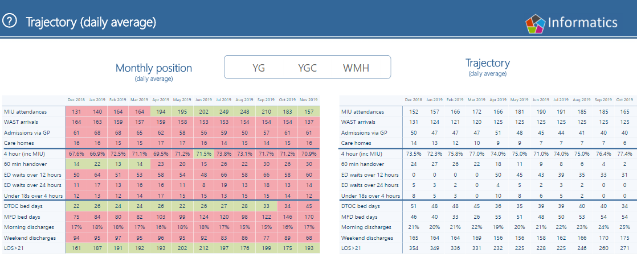
3.3.12 The Health Board continues to work towards having no over-60 minute handovers, and performance on this continues to improve across the organisation. Wrexham Maelor Hospital has made the biggest improvement and is currently reporting as having the best performance in Wales. This has been enabled by a continued, increased focus and strengthened robust processes for ambulance handover, improving flows and where necessary application of corridor nursing. Learning from the improvements at Wrexham has been shared with the other sites. Welsh Ambulance Service NHS Trust (WAST) have agreed an improvement programme of work with Ysbyty Glan Clwyd, acknowledging the consistently high number of ambulances received at the site and the increased level of patient acuity.
3.3.13 The management of long lengths of stay for patients (super stranded over 21 days) began at the end of July 2019. As reflected in the emergency care intensive support team (ECIST) best practice work, the sites are beginning to see the impact after 3 months predominantly in the reduction of bed days lost due to long length of stay patients.
3.3.14 Demand on ED minor injury units (MIUs) continues to increase, both in volume of attendees and severity of presenting conditions. During the summer months of 2019, the MIUs experienced unprecedented demand, attributable to seasonal variation. Whilst demand has subsequently decreased slightly, higher than predicted MIU attendances continue to be seen.
3.3.15 Within the East Area, the location of its only MIU in Mold, which is some distance from the main population of the region, means that it has limited impact on reducing ED demand. Actions have been identified to support additional ED attendances, including enhancing the skills of Advanced Nurse Practitioner (ANP) and Emergency Nurse Practitioner (ENP) nurses within ED to support minor injuries and minor illness. GP services were introduced in the ED in November 2019, with GP or ANP cover providing treatment for minor illness.
3.3.16 Further challenges have been experienced as a result of staffing shortages at Mold MIU. In response to this issue, and to ensure consistency in opening hours, winter funding is providing support from St John’s Ambulance for minor illnesses and ailments at Wrexham Maelor Hospital every weekend, 10am-6pm. This will be in place from December 2019 until March 2020. This short-term urgent treatment centre at the front door of ED will provide an additional streaming option away from ED.
3.3.17 Ongoing reviews of the scope of MIU services across North Wales is underway to better determine how to reduce demand on ED.

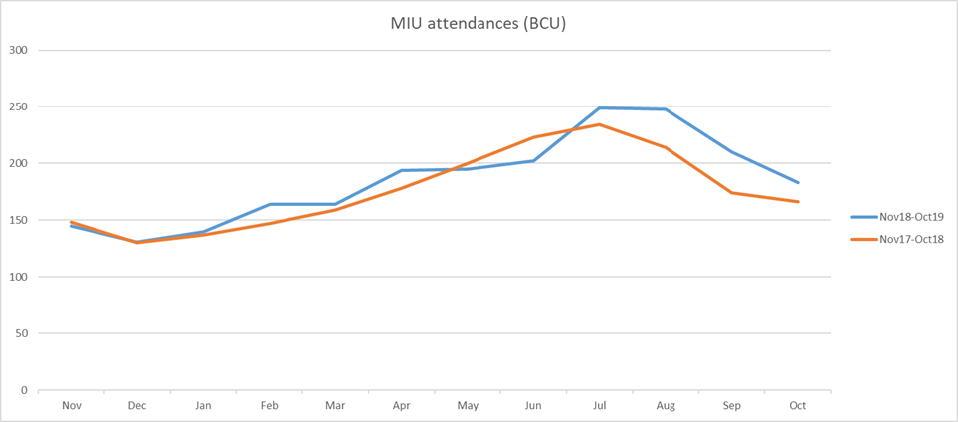
3.3.18 The Single Integrated Clinical Assessment and Triage (SiCAT) model is demonstrating a significant contribution to signposting patients to alternative pathways including early supporting care, avoiding conveyance to ED and enabling management of care in the community. As at the end of October 2019, since its inception in November 2018, SiCAT had taken 4,834 calls, avoided 3,889 ambulance conveyances and saved 3,127 ED attendances.
3.3.19 In recognition of differing levels of performance between the main hospital sites, the level of support provided on-site has been enhanced through the use of a Gold level command and control team. This provides focus on challenge and support against key operational processes. Due to continuing under-performance at the Wrexham Maelor site, this was the first site of focus for Gold Command. This commenced in October 2019 and saw the following improvements during the 6 weeks of this increased support:
- 9% improvement in 4 hour performance
- Reduction in the number of 12 hour breaches (average of 15 per day) and 24 hour breaches (average of 1 per day)
- Continuing Wrexham’s improvement work on ambulance handovers that has seen 10 over-60 minute ambulance handovers in November
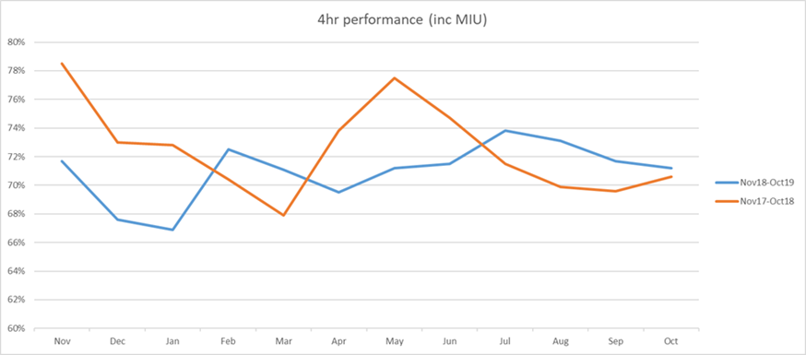

3.3.20 Roll out of the Gold command and control commenced at both the Ysbyty Glan Clwyd and Ysbyty Gwynedd sites in November 2019 with the aim of delivering improvements on 4 hour, 12 hour and 24 hour breaches.
3.3.21 Furthermore, reconfiguration of beds and processes on the Wrexham site has also been implemented to create ambulatory and short stay medical capacity located close to the ED, with a view to supporting flow away from ED for suitable patients. This enables more rapid assessment, diagnosis, treatment and discharge for these patients and so minimises the need for admission, releasing bed capacity to those patients who require in-patient hospital treatment. This reconfiguration also segments medical from surgical patient flows, increasing capacity for medical patients and reducing the need for medical patients to occupy surgical beds. This aims to ensure that medical teams can be placed directly within the medical area and elective capacity for surgical patients can be better protected, early indications are that this is being effective.
3.3.22 Similarly work is underway to progress ward reconfiguration plans at Ysbyty Gwynedd. The new ED which opened in September 2019, provides additional minors space to support improvements in patient flow. The increased presence of a senior clinician in ED out of hours is helping to improve non-admitted performance and reduce ED doctor waits. Further reconfiguration in line with plans is underway to enhance patient flow and experience. At Ysbyty Glan Clwyd an acute physician commenced during November 2019. This post will support the Same Day Emergency Care service (SDEC), Ambulatory Emergency Care Unit and Acute Medical Unit (AMU). The focus will be on improving ambulatory pathways to support earlier discharge and improving the effectiveness of AMU in order to reduce length of stay.
3.3.23 In addition to the continued increased focus on performance as set out above, winter plan initiatives are being progressed to ensure delivery of safe, effective services, and to respond to increased demand on services over the winter months. The initiatives include schemes that focus on increased multidisciplinary team (MDT) capacity to turn patients around at the ED front door, as well as support patient recovery in their own homes. Implementation of four Discharge to Recover / Assess (D2RA) pathways will ensure that patients remain in hospital when this is the only environment that can meet their clinical needs, and where appropriate that recovery and assessment needs are delivered within the home environment. This will be supported by improved access to responsive community services including Community Resource Teams, Acute Response Teams and re-ablement focused domiciliary care. This will augment the Home First model that promotes early supported discharge.
Planned Care
3.3.24 In respect of planned care, the Health Board recognises that this is a significant challenge which will need to reflect improved use of data and information, as well as significant cultural and practice changes. As such it receives significant scrutiny by the Finance & Performance Committee and is included on the Corporate Risk Register (CRR). It is acknowledged that recent close working with Welsh Government provides an opportunity to ensure that there is a shared understanding of the size of the challenge and areas for improvement. This enhanced understanding will represent a major milestone in building confidence in the Health Board’s revised systems and processes.
3.3.25 The systems and processes that have been in place to support demand and capacity planning, reporting and monitoring of RTT have been robustly challenged, reviewed and are being strengthened. Welsh Government have worked alongside the Health Board over the last two months, to enable a better understanding of appropriate methodology.
3.3.26 The Health Board recognises that in order to achieve its ambitions within planned care, there is a need to shift the focus way from operational staff managing waiting lists, to instead focus on engaging with clinicians – thus enabling them to own their activity and adapt their practice to support patient pathways. However, it will take time to embed and sustain these improvements and thus, drawing upon learning from the approach taken to infection control and unscheduled care, the Health Board has developed a rolling 90 day plan to improve and sustain RTT. The significant amount of ongoing improvement work - such as that to validate over 32-week waits, theatre booking and treat-in-turn - is carried out within the context of the following first iteration of the corporate 90 day plan. This will be underpinned by the production of local delivery plans:
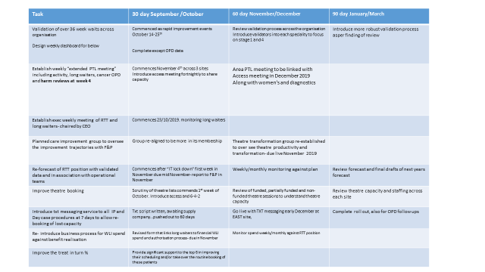

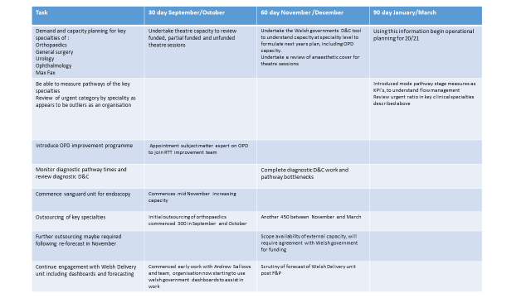
3.3.27 The Health Board’s main areas of challenge are RTT, follow up and diagnostic (mainly endoscopy) access times. A slight improvement in stage 4 RTT has been noted, but the overall position has not improved. The recruitment process for the appointment of 6 additional orthopaedic consultants was successful, which will ultimately improve capacity.
3.3.28 The past year saw increased pressure on specialties such as dermatology and gastroenterology. In gastroenterology, increased waits in endoscopy together with workforce challenges have resulted in longer waiting times. While slightly improved recently, the volume of patients overdue their follow up appointment in Outpatients represents an urgent priority for the Health Board. The reduction in follow-up waiting times is part of the organisation’s long term strategy, to mitigate patient harm. However, given the number of patients involved, it is acknowledged that there is a requirement for a supplementary process. This has been considered by the Health Board’s quality forums.
3.3.29 Despite the slight recent improvement in RTT and follow ups, both remain considerably worse than the original planned position. The over 36 week waiting list volume requiring treatment in 2019 has been significantly higher than at the same time last year (5,686 higher at the time of writing):
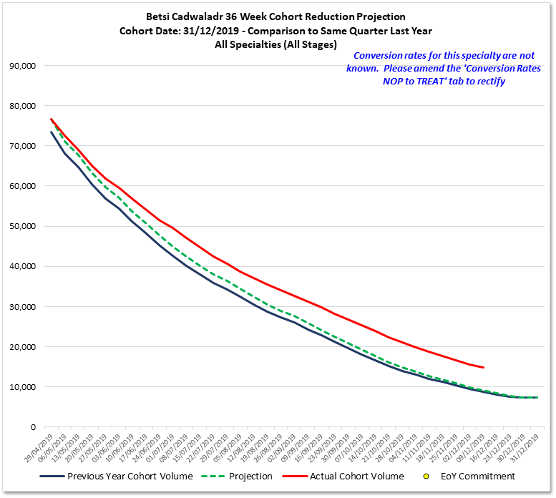
3.3.19 Based on November data, the actual number of RTT over 36 week waits was 11,525. The number of overdue follow-ups stood at 89,235. Addressing this will clearly require a significant amount of further activity and improvement.
3.3.20 The table below illustrates the summary position for planned care:

3.4 Area 3: Operational Performance:
- Sustained progress in the delivery of quality sustainable mental health services and development of new models of care
3.4.1 The Mental Health & Learning Disabilities (MHLD) Division has strengthened its leadership and governance structures over the last 2 years, resulting in significant improvements in the delivery of quality sustainable mental health. The Division can evidence a number of key areas where it has invested resources in additional capacity and expertise, to drive continuous development and improvement:
- The appointment of the Director of Mental Health and Learning Disabilities with a seat on the Board has created improved visibility for mental health and learning disabilities at Board level. The establishment of the team of directors supporting the relevant portfolios has created further strength and depth to leadership across the Division.
- The appointment of local triumvirates across East, West and Centre and regional specialist services has further strengthened leadership through devolved responsibility and accountability.
- Following a formal organisational change process during 2019, the Division’s structure at tiers 5 and 6 was implemented in Quarter 2. This completes the full management structure for the Division at band 8a and above.
3.4.2 In addition, there has been a significant improvement in the governance structure across the Division, with an enhanced approach to the use of intelligence to scrutinise clinical, financial and workforce elements, together with the development of improvement trajectories to meet key performance indicators.
3.4.3 The Division’s risk management process has been reviewed by Internal Audit and demonstrates the strengthened grip and control developed over recent years. The Division’s Putting Things Right (PTR) process is reviewing concerns within the time-frame set with far greater scrutiny of incidents, learning and improvement.
3.4.4 The Division’s ability to respond to “On the Spot” (OTS) concerns remains consistent over the last reporting quarter, with the vast majority being successfully resolved. Whilst the number of OTS concerns has increased significantly (50%) during October 2019, the response and closure date remains within timescales.
3.4.5 Themes and trends from the Datix system are reported through agreed governance structures via the Divisional Quality Safety Experience Effectiveness Leadership (QSEEL) Group. A regional learning event took place during November 2019, with lessons shared across the Division, the wider organisation and with partners.
3.4.6 The Division has embraced a culture of learning with an emphasis on quality initiatives, as evidenced by:
- Co-production embedded across the Division
- Value-based interviewing undertaken with people with lived experience on all senior appointments
- The TODAY initiative that has been rolled out across the Division, leading to a “can do” culture and local ownership of change
- Weekly incident meetings supporting Divisional-wide learning
- The innovative work of the Positive Intervention Clinical Services has led to assaults on staff reduced by almost 50% in the last five years
- A successful initiative that has resulted in a reduction in the use of restraint
- Regular reporting to the QSE Committee, to provide assurance to Board.
- Rollout of QI methodology across the Division at all levels.
- Evidence from HIW visits to Cemlyn Ward at Cefni Hospital, Ty Derbyn Community Mental Health Team, the Hergest Unit and the Nant-y-Glyn Community Mental Health Team have provided independent assurance on service improvements
- Work with Macmillan Specialist Palliative Care Services in conjunction with the Tawel Fan families stakeholder group to improve the environment for people in last hours and days of life
- A pilot of the ICAN programme in partnership with Bangor University, CAIS (personal support services charity) and the Rhyl City Strategy (RCS) group
- The Division has received national recognition for its work via the Nursing Times Team of the Year Award 2019 and the Royal College of Psychiatrists Memory Services National Accreditation Certificate

3.4.7 The Division has delivered significant improvement in its financial performance over the same period relative to the overall change in the financial position of the Health Board, with movement from a £9.6m overspend in 2017/18, £4.6m in 2018/19, to a forecast deficit of £1.5m in 2019/20. Increased accountability and financial governance has had a particular impact in relation to out of area placements and continuing healthcare / packages of care.
3.4.8 Following the implementation of a recruitment and retention strategy, more than 20 doctors have been employed substantively in North Wales. This has produced a saving in excess of £1m in the last financial year against the cost of agency locums. Retention has been successful, with few individuals leaving to take up alternative roles.
3.4.9 In terms of areas for further development, the implementation of the strategy is now underway and this is beginning to identify areas within the structure that would benefit from further review. There are also opportunities to strengthen the partnership approach within our structures. Although there have been improvements in the recruitment of doctors across the Division, there remains a significant challenge in filling all the posts. The Division is working to develop innovative approaches to the workforce model in order to meet the deficit. However this is not a short-term fix and will take time to yield results.
3.4.10 In respect of strategic vision and change, the Division successfully led the development of an all age integrated mental health strategy that clearly sets out the long-term strategic direction for north Wales. The division has made positive progress in the implementation of the Together for Mental Health (T4MH) strategy as shown by the delivery plan. The delivery plan sets out how the mental health strategy will be implemented across north Wales for 2019-2024.
3.4.11 The regional governance structure established to support the implementation of the strategy is functioning well through the relevant groups, which include the Together for Mental Health Partnership Board, with members from all 6 Local Authorities, other statutory partners, stakeholders and people with lived experience.
3.4.12 Through clinical leadership, the clinical service model has been agreed, as have the pathways both in and out of statutory services.
3.4.13 The Division has adopted a rigorous approach to reviewing the services it provides against the strategy, using a mixture of external independent review and peer review. Most recently, an external review of psychological therapies was undertaken, that will shape the future development of the service.
3.4.14 The Division has been successful in bidding for additional funding to support the implementation of the strategy, including £2.3 million from the Healthier Wales Transformation fund to support the development of the ICAN pathway. The success of developing the ICAN brand and pathway is seeing impacts through:
- I CAN Mental Health Awareness Training - with 1500 people signed up to receive the training
- I CAN Mental Health Urgent Care Centres to support people in crisis who do not require medical treatment or admission – since January 2019, the service has supported over 1700 people
- I CAN in primary care settings established and due to commence in the coming weeks

3.4.15 The implementation of the strategy is evolving with incremental change. It is acknowledged that the Health Board has been successful in securing investment but less successful as regards implementation. There has not been sufficient focus on programme management support to facilitate the establishment of the relevant programmes of work to underpin implementation. However this is now being addressed through the development of the Service Improvement Team. It is also taking time for the culture of the Division to evolve, and although a significant amount of work has been undertaken, this is will take time to embed.
3.4.16 The Division has a number of strengths in relation to operational performance:
- Accountability: The Division has matured in the level of accountability at the operational level and this is seen in the control over key performance indicators, with examples relating to Datix reporting, concerns investigation and investigation of Welsh Government reportable incidents. There is an expectation of a shift towards further devolved accountability at the local operational level, with clear lines of reporting through to Divisional Directors and the Board.
- Out of Area: It has been possible to demonstrate sustained controls over people who require out of area placement compared to previous years, given some of the issues with available beds. This is through sustained local management and working together across the Division.
- Workforce: The Division has sustained its registered nursing and health care support worker (HCSW) numbers and there is a sustainable pipeline of graduates planned for the years ahead. NHS Benchmarking shows a relatively higher skill mix for inpatient registered nurses and this contributes to the quality of care. The workforce is being diversified with nurse consultants and advanced practice nurses in training. There is now greater control over employee relations issues and better scrutiny via personal appraisal and development reviews (PADRs) - reported at 80.3%, and mandatory training - reported at 84% as at the end of November 2019.
Part 1 A Mental Health Measure
3.4.17 During a recent 90 day review with the Welsh Government Delivery Unit, it was highlighted that whilst the Health Board’s achievement of the Part 1 target remains a challenge, the organisation assesses a much higher number of referrals than other Health Boards in Wales. For most of 2019, 80% of all referrals were assessed whilst for most other Health Boards across Wales the norm stood at 55%. The reason for this is the offer of several assessment appointments for ‘did not attend’ and could not attend’ patients. Whilst this improves the patient experience, it creates additional activity that the Delivery Unit considers, for this level of patient referral and risk, may be an over-offer.
3.4.18 The workforce position for the Division is 1.3 whole time equivalents (WTE) per 20,000 registered population for part 1 of the measure, set against the All Wales position which is closer to 2-2.5 WTE per 20,000 registered. The additional Welsh Government investment in relation to the MHM part 1 will address the workforce WTE to support target achievement.
3.4.19 Review of Part 1 activity across the Health Board demonstrates that many referrals assessed do not require a part 1 therapeutic intervention and therefore the further development of the ICAN pathway and strategic direction will address this issue moving forward.
3.4.20 For Part 2, the continued attention, hard work and mitigating actions taken by the operational teams means that the Division is still performing across a number of Local Authority areas. The Division expects to remain consistently compliant by out turn March 2020 across all Local Authority boundary areas. Progress against Part 3 of the Measure has been sustained.
UK Benchmarking
3.4.21 Data has been compiled from providers from across the UK to conduct the largest ever mental health benchmarking study in terms of contributor numbers and population coverage. The report includes detailed commentary on the shape of NHS mental health services in 2019 and looks closely at variation in mental health services across the UK.
3.4.22 This year’s submission from the Health Board was more robust than previous years, with more data being available. Utilising ward stay data has enabled more meaningful analysis of inpatient activity. The following points were made in the Mental Health NHS Benchmarking Network final report published in October 2019.
- The Health Board sits within the interquartile range of bed provision for both adult and older people’s mental health (OPMH) beds.
- The length of stay in adult mental health (AMH) beds in the lower quartile of the range of AMH length of stay and OPMH is within the interquartile range of OPMH length of stay.
- Shorter lengths of stay in AMH and OPMH beds result in high admission rates and occupancy levels.
- The readmission rate in AMH beds is in line with the UK median, OPMH is in the upper quartile which is indicative of the specialist nursing home.
- The Health Board has a much lower level of restraint than other organisations across the UK, with OPMH restraints at 31 per 10,000 occupied bed days compared to a UK median of 65 OPMH restraints per 10,000 occupied bed days. In AMH the restraints are 48 per 10,000 occupied bed days compared to a UK median of 98 restraints per 10,000 occupied bed days. Within the psychiatric intensive care unit environment, restraints are 184 per 10,000 occupied bed days against a UK median of 426 restraints per 10,000 occupied bed days.
- Admissions under the Mental Health Act (MHA) are low for all but one of the Welsh Health Boards. The majority of the rest of the UK has a rate of MHA admissions above 40% whilst 4 of the Welsh Health Boards have a rate below 20%.
- The Health Board is the 6th lowest of all organisations for admission under the MHA. Low levels of admissions across the Welsh Health Boards under the act may indicate that admission is facilitated prior to significant deterioration or there may be other factors influencing this metric.
- The Health Board has the 2nd highest number of registered nurses per 10 beds in Wales on OPMH and adult wards, and the highest number of OPMH psychiatrists per 10 beds

3.5. Area 4: Finance and Use of Resources:
Improvements demonstrated in financial planning and in the financial position including delivery on savings / efficiency opportunities

3.5.1 The Health Board continues to strive to improve its financial planning and reporting, and to underpin effective decision-making.
3.5.2 Progress is being closely monitored against the Three Year Outlook and the 2019/20 Annual Plan. The Plan focuses on the key priorities of addressing health improvement and health inequalities, care closer to home, planned care, unscheduled care, workforce, digital and estates. Progress against actions in each of these key priority areas is reported regularly to the Board through the Finance & Performance (F&P) Committee, alongside regular finance reports.
3.5.3 The Health Board has initiated a significant programme of schemes to optimise its workforce:
- Additional controls have been established for the rapid resolution of workforce optimisation initiatives.
- A control process has been implemented to challenge all changes to the establishment.
- Appropriate vacancies are being swept and held/challenged and unfunded posts reviewed.
- A number of areas of non-conformance have been identified and are being addressed.
3.5.4 In respect of reporting of savings, the original savings target for 19/20 was set at £34.5m - comprising £25m of cash releasing savings and £9.5m of cost avoidance. The original savings target has been revised to incorporate an additional stretch of £10m cash releasing savings to support delivery of the £25m deficit control total. This gives a total savings requirement of £44.5m which was reflected in the revised financial plan submitted to Welsh Government in July 2019.
3.5.5 The establishment of the Health Board’s financial recovery programme and the appointment of the Recovery Director have generated a significant increase in savings plans since July, in both the quantum of total opportunities identified (£14.8m) and the value of savings within the deliverable categories of amber (£4.1m) and green (£8.7m).

3.5.6 Movement in the savings programme since the submission of the revised financial plan is shown in the table below:
3.5.7 Total savings of £15.9m have been generated up to month 7 against a profile of £15.5m for those schemes which are delivering, as shown as follows:

Forecast out-turn:

Note – the variance compares forecast cash releasing savings to the cash releasing savings budget of £35m.
3.5.8 The Health Board needs to build on the progress made in developing its approach to savings this year. The process of opportunity identification and conversion will need to be more timely in any given year, so as to avoid undue pressure for delivery in the later months. The process will also need to be continuous so as to inform subsequent years’ planning on an ongoing basis.
3.5.9 In order to achieve the £35m cash releasing target for the year, savings of £17.1m were required at month 7. Actual achievement was £11.3m leaving a shortfall of £5.8m. Forecast out-turn savings for 2019/20 stand at £32.5m. Cash releasing savings are forecast at £21.1m leaving a deficit against the required £35m cash releasing savings value of £13.9m. At Month 7 the original planned deficit is achievable if the Health Board can convert and deliver around 50% of the remaining red rated schemes, continue to deliver green and amber schemes, and contain or offset emerging cost pressures. It is recognised that this presents a significant challenge for the final quarter
3.5.10 The Health Board has now begun to plan on a more integrated basis, and to identify improvement and savings opportunities on a pan-Health Board and cross-divisional basis. This will need further development, including building the capacity and capability of the Health Board’s Improvement Groups and improving information and communication flow around the organisation.
3.5.11 The development of the clinical strategy offers the greatest opportunity for the Health Board to review clinical pathways, and to optimise digital solutions to support the re-design of services. This re-design will incorporate inbuilt efficiencies and consistencies, thus maximising opportunities for prudent and value-based health care.
3.5.12 Accelerating the identification and conversion of savings brings the opportunity to improve the level of surety around forecasting the Health Board’s position, and to reduce the risks needing mitigation. In-year the forecast out-turn has been subject to volatility and revision as the savings programme has been developed, with the increased delivery risks being managed through the Board’s recovery programme.
3.5.13 Improvements to financial governance and control processes are underway. These improvements are expected yield significant benefits in culture and in financial management for the future. Improvements include:
- Processes are being streamlined to increase integration and standardisation, and to improve budget management, reporting and accountability.
- Communications have been shared with all Executives, divisional senior management and budget-holders reminding them of their financial obligations under the Health Board’s financial governance framework.
- All divisions and their respective senior managers and budget-holders are being challenged to identify and deliver on actions that will ensure financial recovery through fortnightly recovery meetings. Progress of the financial recovery programme is reported through to the Financial Recovery Group and Finance and Performance Committee.
- Improvement Groups are being challenged to find savings and improvement opportunities in thematic areas that will support the Health Board’s recovery.
- A new business case process was agreed with Executives with all pipeline projects being subject to the requirements of the new process.
- PMO and specific programme management functions have been transitioned from PwC to a new interim team.
- The Better Care Spending Well initiative has been launched to involve staff in recovery; a schedule of ‘roadshow’ type events is in place, to which all staff are invited to tell the Executive Team about their views and ideas.
3.5.14 The Health Board has developed the Financial Recovery Action Plan (FRAP). The FRAP incorporates the recommendations PwC’s financial grip and control review of the Health Board, the recommendations from the Wales Audit Office Structured Assessment 2017, and a comprehensive framework of NHS good practice financial management. The FRAP monitors over 300 potential measures the Health Board is taking to improve financial grip and control, which have been assigned to relevant leads across a wide range of the Health Board’s business areas including Finance, Workforce, Planning and Procurement.
3.5.15 Progress addressing recommendations within the FRAP is monitored by the Financial Recovery Group. The overall status of recommendations, based on November data, is illustrated on the chart below:
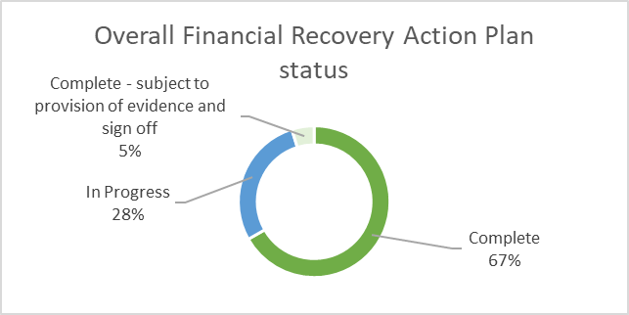

3.5.16 In respect of non-pay controls, the Health Board has initiated a significant programme of schemes designed to identify and convert savings and improvement opportunities in procurement:
- A control process has been set up to challenge all discretionary requisitions through a weekly review panel.
- Staff are being reminded through communications and other means of the Health Board’s policies in relation to P2P/ Procurement.
- Expense levels are being monitored. This includes the evaluation of positive impacts of recent policy changes e.g. transport/ vehicle policies on expense levels and related environmental impacts.
3.5.17 The re-alignment of the permanent Finance Team currently underway is expected to deliver closer and more standardised working practices across the finance function and devolved budget-holders, and to support improved working across health communities.
3.5.18 Budget holders will be reminded of their responsibilities in agreeing their 2020/21 budgets and appropriate training will be offered to the budget holders. Budget holders are accountable for their budgetary performance throughout the year, including the identification and delivery of savings and need to ensure they have local strategies to manage cost pressures that inevitably arise from time to time through the year. The increased accountability that has started in 2019/20 through the Recovery meetings will continue in some form in the new financial year to support any directorate / division which is moving away from the plan.

4. | Conclusions/Next Steps

As described in this report, the Health Board has made some progress against the expectations of the revised Special Measures Improvement Framework. However, a number of milestones in the key areas of finance, planning and performance have not been fully achieved. The Health Board’s position is not currently where it wishes to be, and it is recognised that significant challenges remain and there is considerable further work to be done. It remains fully committed and determined to achieve the required improvement. The Health Board is grateful for the additional support provided by Welsh Government, and will continue to work together with the Government on the joint ambition to secure de-escalation from special measures.

V2.0

