Out and about with your new baby
Helpful tips for feeding your baby in public places

The thought of feeding your baby whilst out and about might feel a little daunting at first but a little planning and preparation can make you feel more confident and remember most people never even realise a mum is breastfeeding!

- Layering your clothing will be helpful, 2 light, loose tops with trousers or skirt is easier for feeding than a one piece top
- Loose fitting tops you can lift up are better than a
- front opening top. You can pop your baby under a loose fitting top without exposing yourself too much
- Many mums find wearing a front opening top/cardigan or jacket over their top helps avoid exposing the side of their tummy and midriff
- Carry a cotton or silk scarf in your bag so that if you feel a little unsure of yourself when feeding the scarf can be draped over your shoulder and across the baby. This will look more like “normal” clothing than using a muslin cloth or a baby blanket that can make baby uncomfortably warm
- The “cradle hold” can be more discreet for feeding in public – if you are not sure ask your midwife or health visitor to show you how to feed like this
- Many mums say they feel better feeding in a corner for example in a café, where they can have a wall at their back or to their side. Having a supportive friend or relative with you will help in the early days
- It may help to practice feeding in front of a large mirror at home; you will then see what you look like to other people. Most people do not usually notice that a mum is breastfeeding!
- If you have a car some mums find it handy to feed baby in the car when they reach their destination, so that baby has had a good feed before they go shopping

Most places would rather have a happy, quiet baby feeding than a crying hungry one! Above all look confident and be proud that you are giving your baby the best start in life!
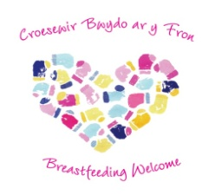
Look out for this sign! |  | Welsh Government Breastfeeding Welcome scheme

Remember - The law protects a new mum’s right to breastfeed her baby in public places

