So You’re going to be a Grand-parent
Congratulations!
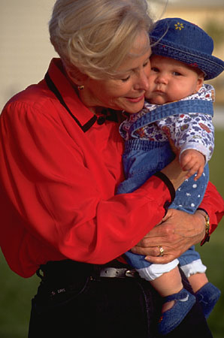
Naturally, you want the very best for your new grandchild.
You probably want to pass on advice and the benefit of your experience to the new mum too.
Many new mums these days decide to breastfeed, maybe you don’t know an awful lot about it as you may have only seen babies being bottle-fed
This leaflet will give you the latest information on breastfeeding. Then you will feel more confident in supporting mum in her decision to breastfeed.

How does breastfeeding “work”?
A normal mum is perfectly able to make more than enough milk for her baby. Baby does not normally need “top ups” of formula or water
Baby needs to be in a good position on the breast in order to get a good feed this in turn ensures mum makes plenty of milk
During a feed, mum’s milk changes: with a lot of lower fat milk in the beginning to smaller amounts of creamy high fat milk towards the end.
Baby should have a good feed and finish the 1st breast to get both low and high fat milk before being offered the 2nd breast
A normal baby needs to feed about 8-12 times in 24 hours. It is normal for feeds to not be regularly spaced - don’t expect “4 hourly feeds”
If baby is attached properly to the breast mum should not become sore. If mum is not comfortable then ask the midwife or health visitor to help her to improve the technique.

Lots of babies are bottle-fed and turn out ok, so what is so good about breastfeeding?
A lot of research over the past few decades has shown us that breastfeeding is very important for the health of babies and children. Mum’s milk passes on important immunity and protection to her baby
Babies fed formula milk are at greater risk of infections such as gastroenteritis, chest infections, ear infections and urine infections
Babies fed on their mum’s milk are protected against eczema, asthma and are less likely to develop obesity and diabetes in childhood
For mum: Breastfeeding reduces a mum's risk of breast cancer and ovarian cancer and can also help mum bond with the baby.

How can I help if mum is breastfeeding? New mums need lots of support and encouragement!
Grandparents have a very important part to play in helping with the new baby: changing baby’s nappy, bathing baby, winding & settling baby after feeds

You can help the new mum by doing practical things like cleaning, cooking, washing, shopping, just making a cup of tea or holding baby while she has a bath. Looking after any older children is often helpful too. Encourage mum to ask for help if things don’t seem to be right rather than suggesting she gives baby a bottle Be positive about the breastfeeding: tell her she is doing a good job and that you are proud of her!

Encourage her to keep going – it will soon get so much easier.
Your help & support can make a big difference to your grandchild’s health

