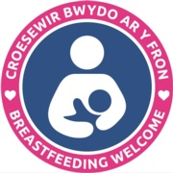
Amlwch Pre-school Playgroup

Blueberries

Bradleys Coffee Shop (Bradleys of Anglesey)

Breeze Hill Hotel

Bull Inn, Pentraeth

Castle Court Hotel

Catch 22 Brasserie

Chaplin’s Ice Cream

Cylch Meithrin Stryd-y-Bont

Harbour Hotel

Jessie Hughes Community Centre

Jollys Coffee House & Patisserie

Kinmel Arms

Rowlands Pharmacy

Meithrinfa Siwgr Plwm

Menai Bridge Library

Mon CF

Pili Palas Nature World

Rhosneiger Pharmacy

Rowlands Pharmacy

RSPB

Sandy's Bar & Bistro

Stesion y Llan

Strings Holland Arms

Tesco, Holyhead

The Bay Café

The Benllech

The Panton Arms

The Tavern 1924
Ty Dderw Country Inn

Waitrose, Menai Bridge

Worburn Hill Hotel

Ysgol Gymuned Llanfechell

Ysgol Llanfawr

Ysgol Parc Y Bont

