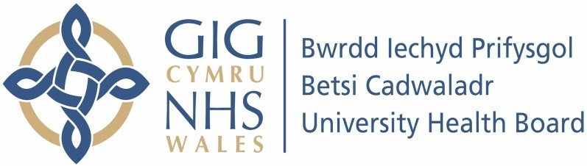

Our ref: 2459073
26 June 2024

Freedom of Information Act 2000

This request is being handled under the Freedom of Information Act 2000.

I am writing to advise you that, following a search of our paper and electronic records, I have established that the information you requested is not held by Betsi Cadwaladr University Health Board.

Your request:

The Chair had a Team's (sic) meeting with a Consultant Vascular Surgeon who is also the Network Lead on Vascular within the NHS Executive, along with the Chief Executive of BCUHB on the afternoon of 16 January 2024.

Please supply me with the minutes and any other record of this meeting.

Our response:

The minutes of this meeting are held by Welsh Government. Under our duty to advise and assist, we have included their website link below.

Requesting information from the Welsh Government (FOI requests) | GOV.WALES

