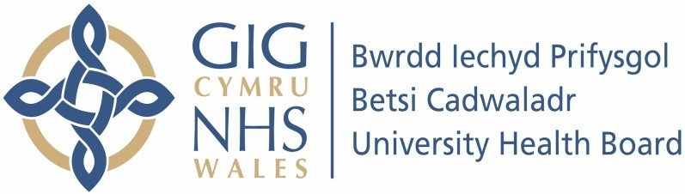

Our ref: 2361689
2 July 2024

Freedom of Information Act 2000

I can confirm that the information requested is held by Betsi Cadwaladr University Health Board (BCUHB). I have detailed below the information that is being released to you.

Your request and our response:

- Please confirm your overall spend on interpreting, translation and transcription services for the following financial years:

2021-22 - £415,635
2022-23 - £502,401

- Who is your incumbent supplier(s) for language services? If you have more than one supplier, which services does each one provide to you?

BCUHB contract is with Cardiff Council, Wales Interpretation and Translation Services (WITS) and they use Big Word and Language Line Services.

- If you have a separate British Sign Language/non-spoken supplier, who is this?

Not applicable.

- If you have a separate transcription supplier, who is this?

Not applicable.

- Do you have any in-house interpreters/translators?

No.

- When is your current language services contract(s) due to expire, a) without extensions and b) with all possible extensions?

Contract due to expire June 2025.

- Please provide the name, phone number and email address of the contract manager responsible for language services.

We do not have permission to release this information.

- Could you please provide the name, phone number and email address of the person responsible for your language services budget?

We do not have permission to release this information.

- Could you please provide the following data for 2023:
Total number of face-to-face interpreting assignments (spoken language) and hours completed
Total number of face-to-face interpreting assignments (non-spoken language) and hours completed
Total number of telephone interpreting calls and minutes completed Total number of video interpreting calls (spoken language) and minutes completed
Total number of video interpreting calls (non-spoken language) and minutes completed
Total number of document translations and words translated
Total number of audio transcriptions and total audio duration
- What were your top 20 highest-volume languages for interpreting/translation requests in 2023?
- Can you please provide the fill rate % you received for the following services in 2023:
Face-to-face interpreting
Telephone interpreting
Video interpreting
Document translation
Audio transcription

This information is held by Cardiff Council direct. Under our duty to advise and assist, we have included their website link below.

Freedom of Information (cardiff.gov.uk)

- What languages has your provider been unable to source in the last 12 months?

This information is not recorded.

- Have service credits been applied to your language services contract in the last 12 months? If so, what performance failure was this linked to?

No.

- What social value has been delivered as part of this contract in the last 12 months?

Free staff training.

- If your contract was awarded through a tender process, can you please provide a copy of the winning bidder's tender?

Not applicable.

- What are your contracted rates for each of the following services?
Spoken face-to-face interpreting: hourly rate
Non-spoken face-to-face interpreting: hourly rate
Telephone interpreting: per minute rate Spoken video interpreting: per minute rate Non-spoken video interpreting:
Document translation: per word rate
Audio transcription: per audio minute rate

Please see response to questions 9-11 above.

- Has your provider of language services increased their charge rate to you in the last 12 months?

Yes.

- What is the Health Board typical route to market?

This contract is commissioned on an All-Wales Health Board level through Cardiff Council.

- Does the Health Board currently have any interpreter on wheel devices as part of their current contract? If yes, please advise how many and if these are provided free of charge or paid for by the Authority.

BCUHB has 9 interpreter on wheels – no charge for them.

- Could you please provide the name, phone number and email address of the person in charge of procurement for the Health Board?

This information is held by North Wales Shared Services Partnership (NWSSP). Under our duty to advise and assist, we have included their website link below.

Making a Freedom of Information Request - NHS Wales Shared Services Partnership

