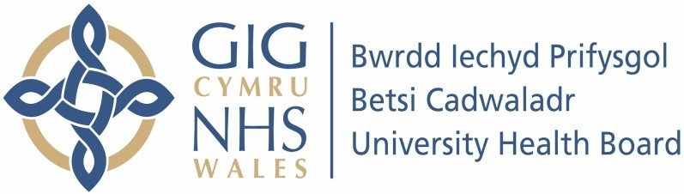

Our ref: 2326626
25 June 2024

Freedom of Information Act 2000

I can confirm that the information requested is held by Betsi Cadwaladr University Health Board. I have detailed below the information that is being released to you.

Your request and our response:

- How many members of staff do you have in Hwb Eifionydd (Criccieth and Porthmadog), what are their job roles? (i.e. the number of administrative staff, number of nurses, number of AMP's, number of doctors and so on)

There are 31 staff members employed in Hwb Eifionydd. The jobs roles include GP (General Practitioner), nurse, healthcare assistant, administrator including receptionist, manager and cleaner.

- How many staff work full time and how many staff work part time? What job roles are full time/part time?

10 staff are employed full-time in job roles as GP, nurse, administration, management.

21 staff are employed part-time in job roles as GP, nurse, healthcare assistant, administration, management and cleaner.

- What are the agreed weekly working hours for all the staff?

Clinical staff work between 8:30am to 6pm, Monday to Friday depending on the number of hours and patterns of working within their individual contract.
Non-clinical staff work between 8am to 6:30pm; Monday to Friday dependent upon the number of hours and patterns of working within their individual contract.

- How much clinical hours does the medical staff undertake each week? If possible, please note this per person?

CLINICIAN | CLINICAL HOURS
GP1 | 12.5
GP2 | 27
GP3 | 17
GP4 | 14
GP5 | 24
GP6 | 20
GP7 | 27
Locum GP | 16

GPs are the medical staff directly employed, providing 157.5 hours per week (including 16 locum GP hours). The breakdown for the GPs clinical hours each week is 12.5, 27, 17, 14, 24, 20, 27 and 16.

- How much administrative hours does the medical staff undertake each week?

62.5

- How many appointments are available with all the staff each week?

947

- How many of the above are face to face appointments?

685

- How many of the above are telephone appointments?

62

- How many of the above are home visits?

83
*Home and Residential Home visits may take up multiple appointment slots due to travel

- On average, how many appointments are missed each week?

38 ‘Did Not Attend’s’ (DNAs) on average per week.

- How many phone calls have been received over the last three months?

MARCH -MAY
14004

- How many phone calls were answered over the last three months?

MARCH – MAY
10648

- How many phone calls were missed over the last three months?

MARCH – MAY
OVERFLOWED OFF (lines busy) 30
ABANDONED BY PATIENT 3326

- On average, how many emails are received in the enquiry box per week?

273

- On average, how many emails about prescriptions are received per week?

145

- How many patients does Hwb Eifionydd have?

7509

