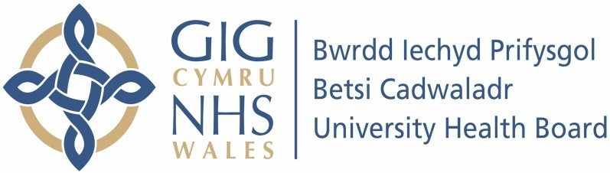

Our ref: 2299899
27 June 2024

Freedom of Information Act 2000

I am pleased to provide some of the information you have requested. I have enclosed copies of the information.

Your request:

Please provide all communications, including emails, letters, meeting minutes, and any other correspondence, that reference the "All Nations Centre" (also known as "All Nations Conference Centre" or any similar variations) in conjunction with either of the following phrases: "Conversion Therapy" or "LGBTQ" (or any variation of this acronym), within the last twelve months.

Our response:

We have undertaken a search based on the criteria provided above and the attached document is what has been located. Please note that any information that is personal has been redacted under Section 40 – Personal Information of the Freedom of Information Act and any information that is not in relation to the search.

The information is exempt from disclosure under Section 40(2) of the Freedom of
Information Act (FoIA). The information is personal data as defined by the Data Protection Act 2018 (DPA). As it is information about someone else I’m unable to give this to you; release of this information would constitute a breach of Principle 1 of the DPA. Principle 1 states that personal data shall be processed (used) fairly and lawfully and, in particular, shall not be used unless at least one of the conditions in Schedule 2 of the DPA is met; in this case none of those conditions have been met. This response therefore acts as a refusal notice under section 17 of the FoIA.

