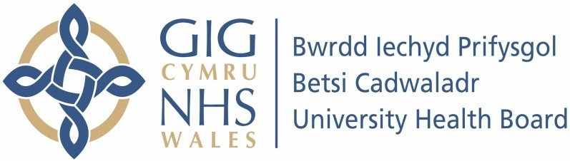

Our ref: 2286465
8 July 2024

Freedom of Information Act 2000

I can confirm that the information requested is held by Betsi Cadwaladr University Health Board (BCUHB). I have detailed below the information that is being released to you.

Your request and our response:

- Does your integrated care board (ICB) commission Tier 3 weight management service?

BCUHB does not commission an external Level 3 weight management service. However, there is an internal BCUHB Level 3 adult weight management service and a Level 3 weight management service for Children and Young People
- If answer to question 1 was yes:
  - In 2023/24 how much did your ICB spend on Tier 3 weight management services?

Not Applicable

  - Who is commissioned to provide the Tier 3 services?

Please see question 1.

  - What are the start and end dates on these contracts?

Not applicable.

  - How many patients are your Tier 3 services commissioned to provide care for?

The BCUHB Level 3 weight management service for adults has the
capacity to care for 150 patients per annum. The BCUHB level 3 service for Children and Young people has the capacity to care for 136 Children and Young people per annum.

  - Do the Tier 3 services you commission include pharmacotherapy?

The BCUHB Level 3 weight management service for adults includes pharmacotherapy for a limited number of patients.

  - Are your Tier 3 services face-to-face only, or do you commission a digital-only weight management service?

BCUHB does not commission a digital only Level 3 weight management service.

- If answer to question 1 was no, do you have any plans to commission Tier 3 services in 2024/25?

No.

- Were patients prescribed Wegovy (semaglutide) in your ICB area in 2023/24?

No.

- If answer to question 4 was yes:
  - How many patients were prescribed Wegovy in 2023/24?
  - Clinicians from which organisations prescribed Wegovy in 2023/24?

Not applicable.

- Are there any plans to review your Tier 2 and Tier 3 weight management services in 2024/25?

Services adopt a continuous improvement approach.

- Who in your organisation would be responsible for the commissioning of weight management services and/or diabetes? Please provide name, position and contact details where possible.

Heads of Service for Dietetics in West, East and Central Integrated Health Communities, Betsi Cadwaladr University Health Board.

