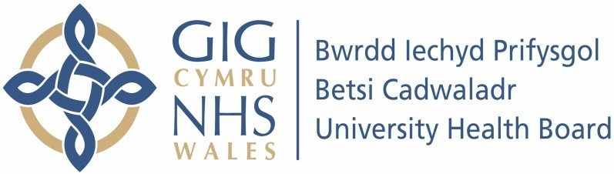

Our ref: 2262869
27 June 2024

Freedom of Information Act 2000

I can confirm that the information requested is held by Betsi Cadwaladr University Health Board. I have detailed below the information that is being released to you.

Your request:

The number of pest control call outs at hospitals in your area in 2021, 2022 and 2023 and 2024 to date.

Please break this information down by hospital, including details of the date of the call out, the reason for the call out, the location within the hospital, the outcome and the cost of the callout.

Our response:

Please see document attached with this response. Due to the way this information is recorded, we are only able to provide the number of call outs to sites per yead and a list of the most common reasons on each site. We are unable to provide the breakdown as requested above.

In accordance with the Freedom of Information Act 2000, this letter acts as a Refusal Notice under section 17 of the Act.
This is not information that the Health Board routinely compiles for all areas under the remit of Betsi Cadwaladr University Health Board (BCUHB). Therefore, we would have to carry out a specific exercise to determine the specific details of each call out. From our preliminary assessment, we estimate that to comply with your particular request would exceed the appropriate cost limit under section 12 of the Freedom of Information Act 2000. This is currently £450. In reaching this decision we estimate that it would take staff in excess of 40 hours to review each call out request. This figure is based on a timescale of 5 minutes per request, there currently being 484 request to review for
2021 alone. Therefore, to obtain the data would work out at approximately 40 hours @ £25.00 per hour (cost permitted under the Act) = £1,000.

Section 12 is not an exemption which requires us to consider the application of the public interest test.

