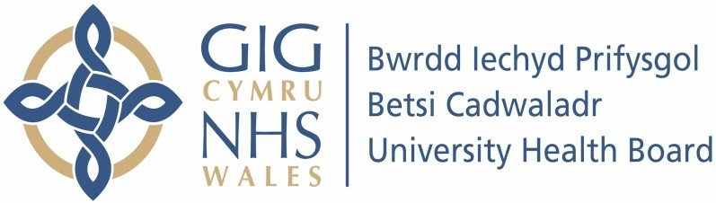

Our ref: 2624817
28 June 2024

Freedom of Information Act 2000

This request is being handled under the Freedom of Information Act 2000.

I am writing to advise you that, following a search of our records for covid Cases within your postcode and within Conwy town we have found no cases of a positive covid-19 case before the date specified. You may wish to contact Public Health Wales who hold further records regarding Covid than ourselves.

Freedom of information - Public Health Wales (nhs.wales)

