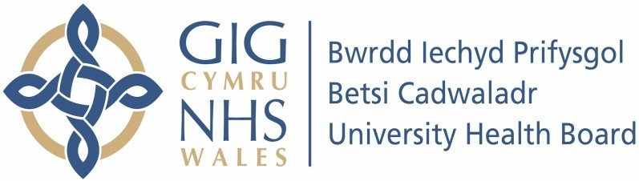

Our ref: 2595553
2 July 2024

Freedom of Information Act 2000

I can confirm that the information requested is held by Betsi Cadwaladr University Health Board. I have detailed below the information that is being released to you.

Your request and our response:

- I would like to know if Semaglutide tablets have had any adverse effects recorded for patients since January 2024.

This information is not recorded. Information regarding side effects can be found on the Medicine and Healthcare products Regulatory Agency (MHRA) website. under our obligation to advise and assist we have provided the link below.

MHRA Products | Home

- I would like to know if they were not fully approved in Britain in January 2024.

Oral semaglutide was licensed in the UK in January 2024.

