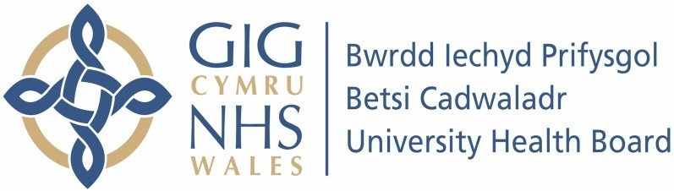

Our ref: 2510205
8 July 2024

Freedom of Information Act 2000

I can confirm that the information requested is held by Betsi Cadwaladr University Health Board (BCUHB). I have detailed below the information that is being released to you.

Your request:

Please supply me with date on the number of deaths recorded by BCUHB whether these occurred in your hospitals or elsewhere in which only Covid is cited as the cause of death on the death certificate.

I require the figures from 2019 until now, broken down both monthly and yearly.

Our response:

 | Jan | Feb | Mar | Apr | May | Jun | Jul | Aug | Sep | Oct | Nov | Dec | Total
2019 |  |  |  |  |  | None |  |  |  |  |  |  | 0
2020 | 0 | 0 | 0 | ≤5 | ≤5 | ≤5 | ≤5 | 0 | 0 | ≤5 | ≤5 | ≤5 | 17
2021 | 8 | ≤5 | ≤5 | 0 | 0 | 0 | ≤5 | ≤5 | ≤5 | ≤5 | ≤5 | 0 | 23
2022 | 0 | 0 | 0 | 0 | ≤5 | 0 | 0 | 0 | ≤5 | 0 | 0 | 0 | ≤5
2023 | 0 | 0 | 0 | 0 | 0 | 0 | 0 | 0 | ≤5 | 0 | 0 | 0 | ≤5
2024 |  |  |  |  |  | None |  |  |  |  |  |  | 0

We have provided the data using ‘equal or less than 5’ due to the low numbers involved. If we were to release the exact figures for the criteria specified, they could be linked with other information available in the public domain, thus potentially risking identification of individuals.

