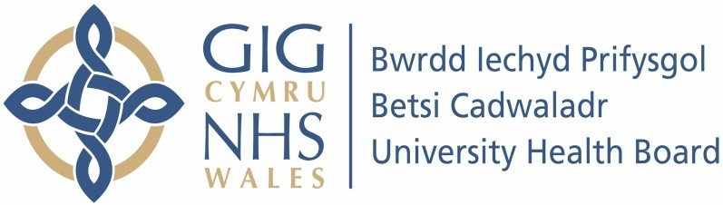

Our ref: 2490869
8 July 2024

Freedom of Information Act 2000

I can confirm that the information requested is held by Betsi Cadwaladr University Health Board (BCUHB). I have detailed below the information that is being released to you.

Your request:

Please can I have a copy of policy/ procedures that rheumatology department follow for rheumatoid arthritis patients?

Please can I also ask if the rheumatology department follow National Institute for Health and Care Excellence (NICE) guidelines?

Our response:

For Rheumatoid Arthritis from diagnosis (through Early Arthritis Clinic Service) to management (including procedures), it is policy to follow NICE Guidance. Please see link below.

Overview | Rheumatoid arthritis in adults: management | Guidance | NICE

For further escalation of treatment there is also a BCUHB pathway that we follow. Please see document attached to this response.

