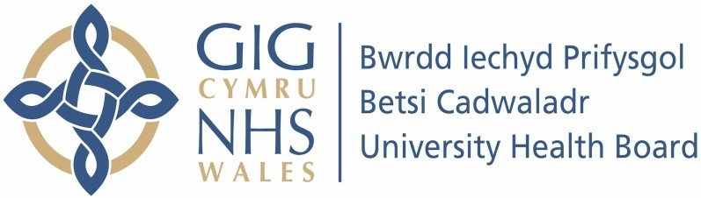

Our ref: 2488384
8 July 2024

Freedom of Information Act 2000

I can confirm that the information requested is held by Betsi Cadwaladr University Health Board. I have detailed below the information that is being released to you.

Your request and our response:

I am researching the usage of high-cost drugs in ophthalmology. Your answers to the following questions will be highly appreciated.

- For the 4 months from January to April 2024, how many patients received the following intra-vitreal treatments for any eye condition:

Treatment | No. Of Patients
Aflibercept | 931
Bevacizumab | 5
Brolucizumab | 0
Dexamethasone | 7
Faricimab | 138
Ranibizumab - Lucentis | 2
Ranibizumab - Ongavia | 333

- For the patients above, how many were new to intra-vitreal treatment? Please provide the patient numbers by the treatments listed below, excluding patients who previously had received any of these treatments.

Treatment | No. Of Patients
Aflibercept | 12
Bevacizumab | 5
Brolucizumab | 0
Dexamethasone | 1

Faricimab | 0
Ranibizumab - Lucentis | 0
Ranibizumab - Ongavia | 21

