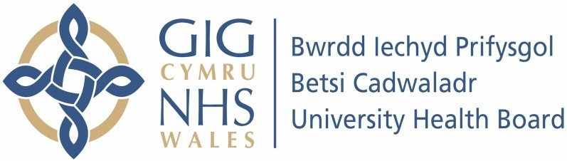

Our ref: 2487678
12 July 2024

Freedom of Information Act 2000

I can confirm that the information requested is held by Betsi Cadwaladr University Health Board (BCUHB). I have detailed below the information that is being released to you.

Your request and our response:

- How many patients have been treated in the past 3 months with the following agents for renal cell carcinoma (any stage) :

Treatment | No. of Patients
Avelumab + Axitinib | 7
Axinitib | 0
Cabozantinib | 0
Everolimus | 0
Lenvatinib + Everolimus | 0
Lenvatinib + Pembrolizumab | 11
Nivolumab monotherapy | 5
Nivolumab + Cabozantinib | 0
Nivolumab + Ipilimumab | 1
Pazopanib | 9
Pembrolizumab monotherapy | 9
Pembrolizumab + Axitinib | 0
Radiotherapy only | Unknown
Sunitinib | 1
Temsirolimus | 0
Tivozanib | 10
Other active systemic anti-cancer therapy | 0
Palliative care only | Unknown

- In the last 3 months, how many patients have undergone full or partial nephrectomy (any of the following OPCS codes M02.1, M02.2, M02.3,M02.4, M02.5, M03.1, M03.9, M04.2, M10.1 or M10.4)?

Please note, we are only able to provide this information for the latest 3 coded months as below.

 |  | 2023
Aug | Sep | Oct | Grand Total
2 | 2 | 2 | 6

- In the last 3 months, how many patients have been initiated* on the following agents for treatment for Renal Cell Carcinoma?

Treatment | No. of Patients
Nivolumab (monotherapy) 5 | 5
Nivolumab + Ipilimumab less than five (1) | 1
Nivolumab + Cabozantinib 0 | 0
Lenvatinib + Pembrolizumab 11 | 11
Avelumab + Axitinib 7 | 7

*Patients are considered initiated if they have not been treated in the previous 6 months with any of the drugs that are part of the named regimen.

Q4. Does your Health Board participate in any clinical trials for the treatment of renal cell carcinoma? If so, please provide the name of each trial and number of patients that are taking part?

BCUHB does not currently participate in any clinical trials for the treatment of renal cell carcinoma.

