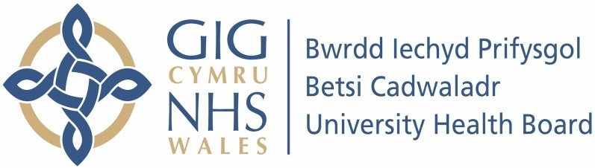

Our ref: 2475837
5 July 2024

Freedom of Information Act 2000

As this information is routinely published it is therefore exempt from disclosure under Section 21 – Information accessible by other means. As this is an absolute exemption under the Freedom of Information Act 2000, there is no requirement for the Health Board to consider the public interest test.

The information requested is available on the Health Board’s internet site and is therefore exempt from disclosure under Section 21 – Information accessible by other means.

https://bcuhb.nhs.wales/about-us/information-request1/disclosure-logs/foidisclosure-log-202425/foi-disclosure-log-april-2024/redacted-1910485-finalresponse-doc/

https://bcuhb.nhs.wales/about-us/information-request1/disclosure-logs/foidisclosure-log-202425/foi-disclosure-log-april-2024/redacted-1910485-finalresponse-attachment-docx/

