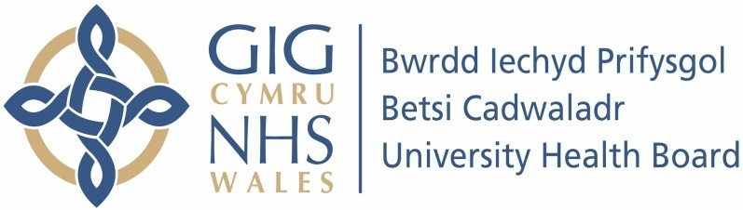

Our ref: 2473937
11 July 2024

Freedom of Information Act 2000

I can confirm that the information requested is held by Betsi Cadwaladr University Health Board (BCUHB). I have detailed below the information that is being released to you.

Your request:

please can you confirm how many pharmacies have closed and notified you for the last three years, and how many fines you have imposed?

Our response:

Please note, we are only able to provide closures from July 2021, when records started until 31st May 2024. BCUHB does not impose fines on pharmacies for closure. We withhold remuneration for the affected period.

Period | Number of Pharmacy closures | Number where  Remuneration withheld
July 2021 - 31 March 2022 | 431 | 17
1 April 2022 - 31 March 2023 | 430 | 10
1 April 2023 - 31 March 2024 | 309 | 0
Total | 1170 | 27

