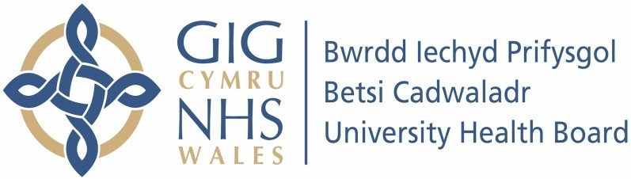

Our ref: 2473206
5 July 2024

Freedom of Information Act 2000

I can confirm that the information requested is held by Betsi Cadwaladr University Health Board. I have detailed below the information that is being released to you.

Your request and our response:

1) In the past 6 months, what was the number of patients treated with a combination of Dabrafenib + Trametinib for the following conditions:

- Metastatic Melanoma

6

- Adjuvant Melanoma

0

- BRAF mutated Lung Cancer

2

2) In the past 6 months, what was the number of patients treated with a combination of Encorafenib (Braftovi) + Binimetnib (Mektovi) for the following conditions:

- Metastatic Melanoma

2

- Colorectal Cancer

0

