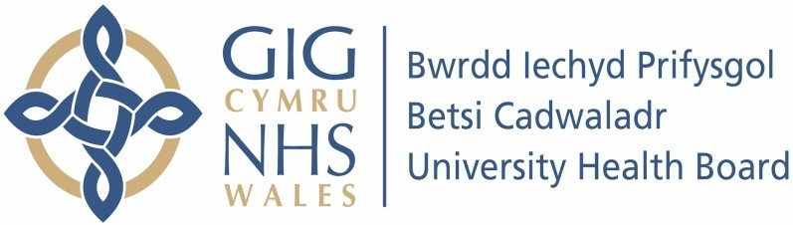

Our ref: 2469805
02 July 2024

Freedom of Information Act 2000

I can confirm that the information requested is held by Betsi Cadwaladr University Health Board. I have detailed below the information that is being released to you.

Your request:

Please could you kindly complete the spreadsheet attached to provide information on the diagnostic tests carried out within the Health Board for both point of care testing and laboratory over the last calendar year (January 2023 - December 2023).

Our request:

Please see document attached with this response.

