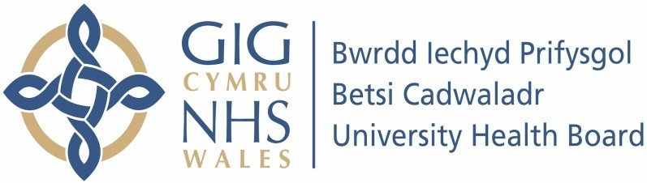

Our ref: 2453482

Freedom of Information Act 2000

I can confirm that the information requested is held by Betsi Cadwaladr University Health Board. I have detailed below the information that is being released to you.

Your request and our response:

1. How many non-small cell lung cancer (NSCLC) patients were treated in the past 3 months with:

Treatment | No. Of Patients
ALK Inhibitors (Alectinib, Brigatinib, Ceritinib, Crizotinib, Lorlatinib) | 9
Amivantamab | 0
Atezolizumab Monotherapy | 8
Atezolizumab + Bevacizumab + Carboplatin + Paclitaxel | 8
Dabrafenib + Trametinib | 2
Docetaxel monotherapy or in combination with  Carboplatin/Cisplatin | 2
Durvalumab | 3
Gemcitabine | 9
Nitedanib + Docetaxel | 3
Nivolumab | 3
Osimertinib | 20
Other EGFR Inhibitors (Afatinib, Erlotinib, Gefitinib, Dacomitinib,  Mobocertinib) | 3
Paclitaxel | 12
Pembrolizumab Monotherapy | 32
Pembrolizumab + Paclitaxel + Platinum (Carboplatin/Cisplatin) | 7
Pembrolizumab + Pemetrexed + Platinum (Carboplatin/Cisplatin) | 9
Pemetrexed + Platinum (Carboplatin/Cisplatin) | 11
RET Inhibitors (Pralsetinib, Selpercatinib) | 0

Sotorasib | 6
Tepotinib | 2
Vinorelbine monotherapy or in combination with  Carboplatin/Cisplatin | 4
Other active systemic anti-cancer therapy | 11
Palliative care only | Unknown

