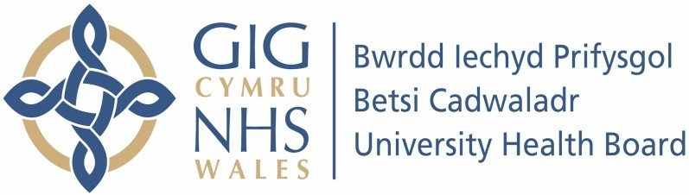

Our ref: 2409981
4th July 2024

Freedom of Information Act 2000

I can confirm that the information requested is held by Betsi Cadwaladr University Health Board. Please accept our sincere apologies for the delay.

Your request:

Please provide information about the antenatal and postnatal courses available for women and birth partners through Betsi Cadwaladr University Health Board (BCUHB), including the Welsh language courses available.

I have had a look on your website and can see that there is some information on there but no details about courses that women and birth partners can complete within the district.

Our response:

Face-to-face antenatal education sessions delivered by BCUHB Maternity Services are available across North Wales. These sessions are designed to support parental preparation for labour, birth and the postnatal period. The midwifery team in Caernarfon delivers these sessions bilingually.

In addition, Maternity Services provide women and birth partners with patient information leaflets during pregnancy, the majority of which are bilingual, (if internal they are bilingual as per conforming with Welsh Language Standards, but other leaflets such as external ones can be arranged for translation should the patients require). They also have access to the BCUHB Best Start Hub/Hwb Dechrau Gorau, which is a fully bilingual online information resource, (which can be also be translated into numerous other languages via the internet page) There is also a section on the website promoting the value of bilingualism for children, under 'You and your baby / You and your child' ) 'Children's service'. Midwives continue to also signpost women and birth partners to the Solihull Approach Online Parenting Courses, developed by NHS England which contain a postnatal element and are available in 108 languages, including Welsh.

BCUHB Maternity Services recognise that further improvements can be made to the antenatal education offer and improvement work is currently taking place to review the content, quality, standardisation and inclusivity of the sessions, which will include consideration of Welsh to ensure full compliance with the Welsh Language Standards. Consideration will also be given to other language needs

