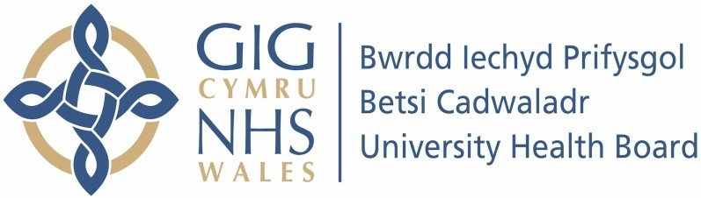

Our ref: 2403853
5 July 2024

Freedom of Information Act 2000

I can confirm that the information requested is held by Betsi Cadwaladr University Health Board.

Your request and our response:

- How many patients were treated in the last 3 months by the Gastroenterology department (for any medical condition) with the following biologic drugs:

Provided in the table below are the number of patients treated by the
Gastroenterology department (for any condition) with each of the medications listed from 1st March to 31st May 2024.

Treatment | Number of Patients
Adalimumab - Humira | 6
Adalimumab Biosimilar | 222
Etrasimod | 0
Filgotinib | 2
Golimumab | 0
Infliximab – Remicade | 0
Infliximab Biosimilar | 234
Mirikizumab | 0
Ozanimod | 0
Risankizumab | 1
Tofacitinib | 0
Upadacitinib | 6
Ustekinumab | 38
Vedolizumab | 126

- Could you please provide the numbers of patients treated for Crohn's Disease in the last 3 months with the following biologic drugs:
Provided in the table below are the number of patients treated for Crohn’s Disease with each of the medications listed from 1st March to 31st May 2024.
* Please note that diagnosis is not recorded on one of the three acute sites.
Treatment | Number of Patients
Adalimumab - Humira | 6
Adalimumab Biosimilars | 152
Golimumab | 0
Infliximab – Remicade | 0
Infliximab Biosimilars | *105
Risankizumab | 1
Upadacitinib | 5
Ustekinumab | 35
Vedolizumab | * 44

