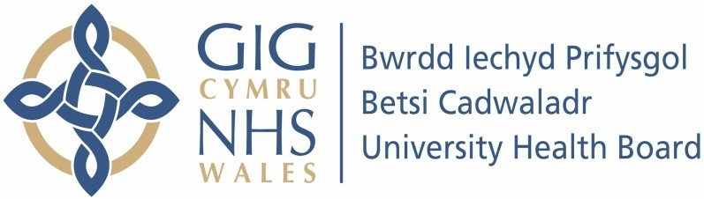

Our ref: 2399249
04 July 2024

Freedom of Information Act 2000

I can confirm that the information requested is held by Betsi Cadwaladr University Health Board (BCUHB). I have enclosed copies of the information that is being released to you.

Your request and our response:

- Please provide a breakdown of how many patients were transferred from BCUHB to hospitals in England to receive extracorporeal membrane oxygenation (ECMO) care in 2022 and 2023.

Please refer to the table below.

Please note, we have provided the data using ‘less than or equal to 5’ due to the low numbers involved. If we were to release the exact figures for the criteria specified, they could be linked with other information available in the public domain, thus potentially risking identification of individuals.

Hospital | 2022 | 2023
Ysbyty Glan Clwyd | ≤5 | 0
Ysbyty Gwynedd | 0 | 0
Ysbyty Wrexham Maelor | 0 | 0

- Please also provide the number of referrals from BCUHB that were refused by English hospital due to insufficient room for patients in the ECMO facilities.

BCUHB does not collect data regarding declined ECMO referrals.

