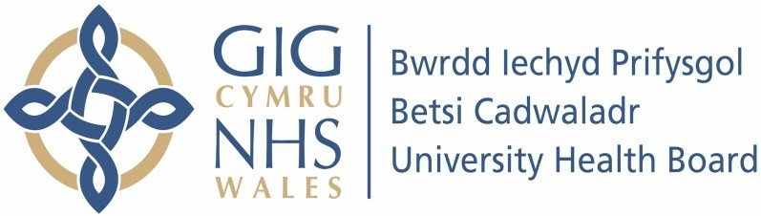

Our ref: 2387317
01 July 2024

Freedom of Information Act 2000

I can confirm that the information requested is held by Betsi Cadwaladr University Health Board. Please find our response below.

Your request:

I am seeking information pertaining to the acute NHS hospitals within BCUHB, excluding hospitals specialising in mental health or psychiatric care.

- Please provide copies of all policies related to violence by patients and/or their visitors against staff. Please include all policies related to the following:

- Any physical, verbal, or sexual aggression, assault, or stalking.
- Violence both experienced and witnessed by staff.
- Any separate policies for different types of violence, different staff groups, or different phases of violence, e.g. during and following the event.

- Please provide copies of all policies/procedures related to the following post-violence measures, if not included within the above (1):

· Immediate sanctions for aggressor(s) (e.g. discharge)
· Processes for incident reporting
· Processes for debrief with staff member(s) and/or aggressor(s)

· Follow-up with aggressor(s) (e.g. accountability letter, behaviour contract)
· Counselling or similar longer-term psychological support for staff member(s)
· Incident investigation (e.g. root cause analysis) and feedback to relevant parties
· Longer-term sanctions for aggressor(s) (e.g. card system)
· Examples of processes for tailored management plans for patients with a known history of aggressive behaviour (including use of a flag/alert system)
· Staff sickness absence and/or returning to work following work-related injury.

Our response:

All BCUHB staff are supported to access psychological / emotional wellbeing support through Occupational Health and Wellbeing counselling service and our Staff Wellbeing Support services. The programme is managed by the Occupational Health and Wellbeing team in collaboration with the Staff Wellbeing Support service (psychology services) to ensure that staff have access to support both within the Health Board programme, and via external services where staff are signposted to access more appropriate emotional wellbeing interventions.
We have a crisis referral pathway in place which supports timely and effective referrals into specialist services for those staff assessed as high risk / extremely vulnerable and is monitored by our programme leads for safety and accuracy. The wellbeing programme supports all staff across the Health Board by providing self-referral mechanisms and escalated procedures into support services with links to out of hours programmes for 24-7 support, advice and information (i.e. NHS 111 press 2 services).
All information, advice and support is promoted and highlighted on our Betsinet pages for staff health and wellbeing.

Please refer to the attached documentation for further information:

- HS02 – Protecting Employees from Violence & Aggression – V2. Please note, this document is currently under review.
- Datix Cymru User Guide Incidents v3b
- Handout – Incident Training

Please note, BCUHB does not have an alert system in place. Tailored plans would be agreed in a professional risk meeting. Examples cannot be provided due to data protection issues as they often form care plans for individuals.

