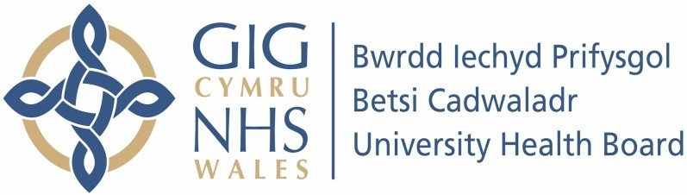

Our ref: 2379181
9th July 2024

Freedom of Information Act 2000

This request is being handled under the Freedom of Information Act 2000. Please accept our sincere apologies.

Your request:

Please provide the following information in relation to Betsi Cadwaladr University Health Board (BCUHB):

1. How many people are on a waiting list for a first appointment with the following specialties, as of 1st June 2024 and what is the estimated number of weeks a new patient joining that list will have to wait. Could the response be supplied in the exact number of weeks people can expect to wait and the exact number of people who are waiting.

Gynaecology
Clinical oncology
Clinical radiology
Ophthalmology
Dermatology
Clinical immunology and allergy
Trauma and orthopaedics
General surgery
Oral surgery
Paediatric surgery
Ear, nose and throat
Neurology
Rheumatology
Urology
Gastroenterology
Endocrinology
Audiological medicine
Dental medicine
Anaesthetics

2. How many people are on a waiting list for the following procedures, from the point of confirmation the procedure is needed, as of 1st June 2024 and what is the estimated number of weeks for a patient joining that list before surgery?

Knee replacement
Hip replacement
Gynaecological laparoscopy
Colonoscopy
Bariatric surgery
Mastectomy
Breast reconstruction surgery
Colostomy and ileostomy
Hernia repair
A transurethral resection of the prostate
Heart surgery (not including transplant)
Arthroscopy

Our response:

Under section 21 of the Freedom of Information Act (FoIA), we are not required to provide information in response to a request if it is already reasonably accessible to you. This response therefore acts as a refusal notice under section 17 of the FoIA.

The information you requested is available from NHS 111 Wales using the following link https://111.wales.nhs.uk/PlannedCare/Default.aspx

If you do not have access to the internet at home, you may be able to use facilities at your local library.

