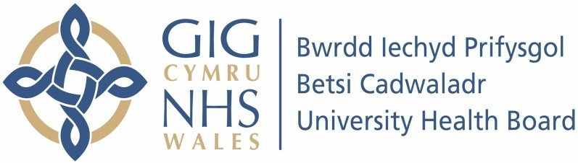

Our ref: 2323465
25 June 2024

Freedom of Information Act 2000

I can confirm that the information requested is held by Betsi Cadwaladr University Health Board.

Your request:

Please see Freedom of Information request kindly be responded to in excel format.

Our response:

Please refer to the attached spreadsheet for our responses in relation to the information requested.

Some of this information is exempt from disclosure under Section 31(1a) of the Freedom of Information Act 2000 (FoIA). We consider that if the data you have requested were to be combined with other information which may be available in the public domain, there would likely to be an increased risk of a cyber-security attack upon the Trust. As part of the Critical National Infrastructure for the NHS, the Trust/Health Board has a duty to protect the integrity of our systems. The disclosure of the information requested could expose weaknesses in our systems and lead to breaches, making the UK or its citizens, in this case our patients, more vulnerable to security threat.

Public Interest Test
To use this exemption, we are required to undertake a public interest test. The matters which were considered in applying the public interest test are as follows:

Factors in favour of disclosure:
- Disclosure of the data supports the general public interest in the transparency, accountability and general understanding of the delivery of public services.

Factors in favour of withholding:
- Breaches in Health Board security and is therefore a reasonable threat to the confidential patient data held on our systems.
- Temporary or long term lack of availability of IT systems
- Corruption/loss of patient data which would prevent or interrupt provision of patient care.

There is a strong public interest in protecting the confidentiality of patient data and of ensuring that healthcare services can be provided to the public without increasing the possibility of attack by hackers or malware, or of putting personal or other information held on these systems at risk of corruption or subject to illegal access. For these reasons, the Health Board has decided that it is in the public interest to withhold this information at this time.

This response therefore acts as a refusal notice under section 17 of the FOIA.

