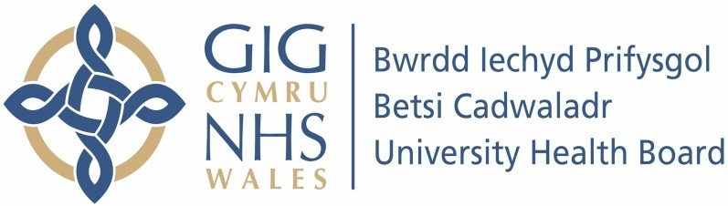

Our ref: 562614
08th December 2023

Freedom of Information Act 2000

I can confirm that the information requested is held by Betsi Cadwaladr University Health Board. I have attached the information that is being released to you.

Your request:

I should like to make a Freedom of information request to the Betsi Cadwaladr Health Board on the therapy treatment provided in the Health Board area to children living with Cerebral Palsy.

1. How many children are living with Cerebral Palsy in the Betsi Cadwaladr LHB area?

- 0-3 year olds?

- 4-19 year olds?
Our Response:

Therapy Services are unable to provide information on the number of children living with Cerebral Palsy within the Health Boards geographical area of responsibility. The number of children with Cerebral Palsy who are open to Paediatric Physiotherapy services in the Health Board is 240, however there may be other children living with Cerebral Palsy residing within our HB area but are not under care of our Services.

2. How are you providing Therapy treatment to children with Cerebral Palsy and in 2022/23 for how many children? as follows:-

(a) 0-3 years

- How many by your LHB Community therapists?

- How many by other Welsh LHB therapists?

- How many by external therapists from the rest of UK?

- How many by external therapists in Wales?

(b) 4 - 19 year

- How many by your LHB Community therapists?

- How many by other Welsh LHB therapists?

- How many by external therapists from the rest of UK?

- How many by external therapists in Wales?

Our response:

The service is unable to provide the data split by age. Occupational Therapy Paediatric services provide care according to functional need therefore the number of patients by condition is not recorded. Therapy Services are therefore unable to answer the remaining questions.

