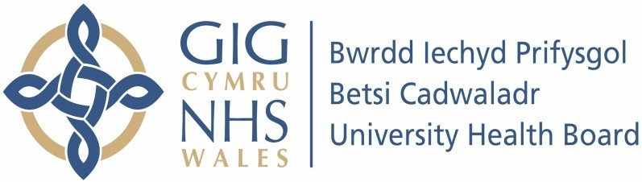

Our ref: 559198
21 November 2023

Freedom of Information Act 2000

I can confirm that the information requested is held by Betsi Cadwaladr University Health Board. I have detailed below the information that is being released to you.

Your request and our response:

Under the Freedom of Information (Scotland) Act please could you provide the following data for your Board, broken down by each year for the previous five years:- 2018, 2019, 2020, 2021,2022.

Total live births

 | Year |  |  | Total Live Births
 | 2018 |  |  |  | 5972
 | 2019 |  |  |  | 5753
 | 2020 |  |  |  | 5613
 | 2021 |  |  |  | 5596
 | 2022 |  |  |  | 5435

Total stillbirths

 | Year |  |  | Total Stillbirths
 | 2018 |  |  |  | 24
 | 2019 |  |  |  | 26
 | 2020 |  |  |  | 21
 | 2021 |  |  |  | 13
 | 2022 |  |  |  | 15

Term stillbirths (from 37 weeks or more)

In accordance with the Freedom of Information Act 2000, this letter acts as a Refusal Notice under section 17 of the Act.
This is not information that the Health Board routinely compiles. Therefore, we would have to carry out a specific exercise to determine the number of term stillbirths. From our preliminary assessment, we estimate that to comply with your particular request would exceed the appropriate cost limit under section 12 of the Freedom of Information Act 2000. This is currently £450. In reaching this decision we estimate that it would take staff in excess of 24 hours to retrieve and review each patient record. This figure is based on a timescale of 15 minutes per patient record, there currently being 99 records to review. Therefore, to obtain the data would work out at approximately 24 hours @ £25.00 per hour (cost permitted under the Act) = £600
Section 12 is not an exemption which requires us to consider the application of the public interest test.

Total neonatal deaths

 | Year |  |  | Total Neonatal Deaths
 | 2018 |  | 7
 | 2019 |  | 6
 | 2020 |  | 2
 | 2021 |  | 1
 | 2022 |  | 3

The number of midwifery staffing red flags
This information is not routinely compiled and would therefore require a specific exercise to determine the number of incidents that would be categorised as a ‘red flag’ event. The cost limit for this request has been exceeded, please refer to response to question 3.

