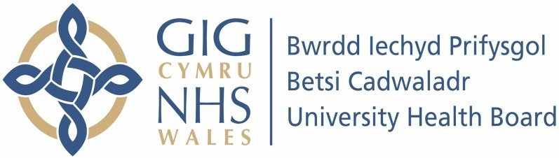

Our ref: 447979
6 November 2023

Freedom of Information Act 2000

1. How many Consultants/ Doctors in your NHS hospitals currently carry out private work using NHS staff and Resources? A) By Hospital.
- By Department.
- By speciality.

Please see the attached table for the details of the consultants by hospital and speciality.

Hospital | Speciality
Ysbyty Glan Clwyd | Respiratory
Ysbyty Glan Clwyd | Gynaecology
Ysbyty Glan Clwyd | Cardiology
Ysbyty Glan Clwyd | Cardiology
Ysbyty Glan Clwyd | Cancer
Ysbyty Glan Clwyd | Urology
Ysbyty Glan Clwyd | Imaging
Ysbyty Glan Clwyd | Imaging
Ysbyty Glan Clwyd | Imaging
Ysbyty Glan Clwyd | Imaging
Ysbyty Glan Clwyd | Imaging
Ysbyty Glan Clwyd | Imaging
Ysbyty Glan Clwyd | Imaging
Llandudno | ENT
Wrexham Maelor | Imaging
Wrexham Maelor | Imaging
Wrexham Maelor | Cancer
Wrexham Maelor | Cancer
Wrexham Maelor | Imaging
Wrexham Maelor | Cancer
Wrexham Maelor | Cancer
Wrexham Maelor | Imaging
Wrexham Maelor | Imaging
Wrexham Maelor | Urology
Wrexham Maelor | Ophthalmology
Wrexham Maelor | Imaging
Ysbyty Gwynedd | Ophthalmology
Ysbyty Gwynedd | Imaging
Ysbyty Gwynedd | Gynae
Ysbyty Gwynedd | Imaging
Ysbyty Gwynedd | Respiratory
Ysbyty Gwynedd | Gastro
Ysbyty Gwynedd | Imaging
Ysbyty Gwynedd | ENT
Ysbyty Gwynedd | ENT
Ysbyty Gwynedd | Neurophysiology
Ysbyty Gwynedd | Ophthalmology
Ysbyty Gwynedd | ENT

Staff must have written permission of the Hospital Medical Director before undertaking any private practice on Health Board premises

2. How are the Consultants billed for the use of NHS staff and resources?

Consultants are not billed for the use of NHS staff and resources. Invoices are charged either directly to the patient or to their insurance provider if applicable for any NHS charges.

- Who collates the bill?

The Health Board’s finance team collate the invoice based on information supplied to it.
- Can you provide a blank copy of the bill/invoice format?

Invoices are not raised to consultants and unable to supply a blank bill/invoice due to electronic billing and concerns / security of issuing a blank template.

3. How are the NHS staff and NHS resources identified for billing?

Employees practicing privately within Health Board facilities must comply with the Health Board’s policies and procedures. This includes a personal obligation by any employee responsible for admitting a private patient to the Health Board’s facilities to ensure, in accordance with local procedures, that they identify that patient as private and that the responsible manager is aware of that patient’s status. The Health Board ensure there are agreed systems (including within patient administration systems) for identifying patient as having private status to help employees comply with the requirement to identify such patients. This includes the recording of time input to the treatment of private patients.

- How is NHS staff time worked out?

Time is recorded as part of the Health Board’s price list; Staff are required to record time spent on private patient activity.

- Are NHS resources billed at NHS cost rates or Private Cost rates?

NHS resources are billed at the Health Boards published private practice tariffs.

4. Are NHS staff made aware they are working with private patients and are they paid at private care rates that will be billed to these private patients?

Employees practicing privately within Health Board facilities must comply with the Health Board’s policies and procedures. This includes a personal obligation by any employee responsible for admitting a private patient to the Health Board’s facilities to ensure, in accordance with local procedures, that they identify that patient as private and that the responsible manager is aware of that patient’s status. The Health Board ensure there are agreed systems (including within patient administration systems) for identifying patient as having private status to help employees comply with the requirement to identify such patients.

NHS staff employed by the Health Board that includes any treatment of private patients during scheduled NHS time are paid at the usual NHS rates as per the terms and conditions of their NHS employment.

- Can NHS staff refuse to work on Private patients?

If the activity is within contracted core hours of the staff (clinical and non-clinical), and the health board is being paid for the activity. Staff would be expected to work with the patient irrespective of private status. If it was additional work to contracted activity, then staff can opt out.

- Does the NHS make a profit from Consultants Private patients being seen using NHS facilities?

The Health Board has a duty to recover the costs incurred through the treatment of private patient by its staff within its facilities and its charges are set in order to ensure that occurs.

