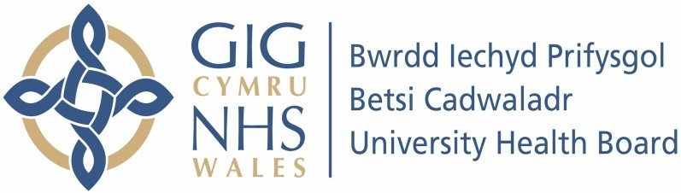

Our ref: 602733
27th of November 2023

Freedom of Information Act 2000

I can confirm that the information requested is held by Betsi Cadwaladr University Health Board. I have detailed below the information that is being released to you.

Your Request and our Response:

How many people have been fined for smoking on Hospital premises in Wales since 2007?

Betsi Cadwaladr University Health Board (BCUHB) are currently taking forward a programme of work to encourage smoke- free sites across the Health Board. Part of this work involves linking with Local Authorities to look at potential enforcement activity for people who are caught smoking on hospital grounds. The enforcement of smokefree legislation on hospital grounds in BCUHB and the issuing of fines comes under the remit of local authorities in North Wales. To date no fines have been issued to people smoking on hospital grounds in North Wales.

