

Our ref: 597733
27th of November 2023

Freedom of Information Act 2000

I can confirm that the information requested is held by Betsi Cadwaladr University Health Board. I have detailed below the information that is being released to you.

Your request and our response:

In the past 3 months (latest 3 months available) how many patients have received the following treatments (for any disease):

Treatment | Number of patients
Berinert (Human C1-esterase inhibitor) | ≤5
(Human | 0
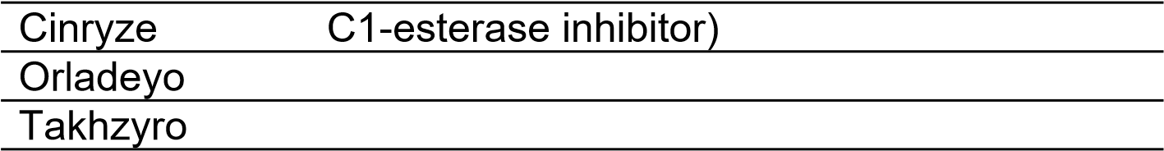(berotralstat) | 0
(Lanadelumab) | 0
Ruconest (Recombinant human C1-  esterase inhibitor) - | 0
Firazyr (Icatibant injection) | 0
Generic Icatibant Injection - any brand except Firazyr | 0

We have provided the data using ‘less than or equal to 5’ due to the low numbers involved. If we were to release the exact figures for the criteria specified, they could be linked with other information available in the public domain, thus potentially risking identification of individuals.

