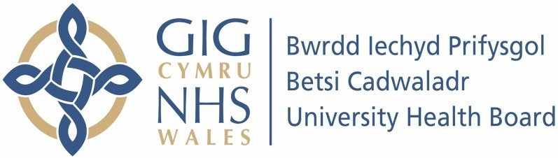

Our ref: 568371
November 2023

Freedom of Information Act 2000

This request is being handled under the Freedom of Information Act 2000. We previously issued you with a fees notice and I understand that issues concerning the costs associated with the request have been satisfactorily concluded.

I can confirm that the information requested is held by Betsi Cadwaladr University Health Board. Please find our response below.

Your request and our response:

I am writing to request the following information under the Freedom of Information Act (2000).

For the years 2018, 2019, 2020, 2021 and 2022 please provide the following broken down by calendar year.

Please further segregate the data by children and young people (CYP) and Adults.

If it is not possible to provide the information requested due to the information exceeding the time or cost limits identified in Section 12, please provide the information in part and chronologically with a priority placed upon 2022 data.

1. Number of people who sought / were referred for an ADHD diagnosis.

Children:

Betsi Cadwaladr University Health Board’s (BCUHB) Children’s Neurodevelopment service has one waiting list for all assessments (Autism Spectrum Disorder (ASD), Attention Deficit Hyperactivity Disorder (ADHD) and dual assessments). We are unable to split this down to accurately provide data. However, we can provide the total number of referrals in to the service for ADHD, ASD and dual assessments by year, which is shown in the table below.

Year | 17/18 | 18/19 | 19/20 | 20/21 | 21/22 | 22/23
Total  Referrals within a  12-month position | 1971 | 2205 | 2441 | 1842 | 2848 | 4047

Adults:

BCUHB’s central service have started to capture patients who were referred for ADHD assessment this year. However, BCUHB do not use clinical coding for cases other than inpatients. The requirement for an ADHD diagnosis may be recorded in the detail of the SPOAA (single point of access) referral, but will be recorded as text and therefore cannot be extracted electronically.

2. Number of individuals who were then referred for assessment.

Children:

BCUHB’s Children’s Neurodevelopment service has one waiting list for all assessments (ASD, ADHD and dual assessments). We are unable to split this down to accurately provide data. However, we can provide the accepted number of referrals in to the service for ADHD, ASD and dual assessments by year, which is shown in the table below.

Year | 17/18 | 18/19 | 19/20 | 20/21 |  | 21/22 | 22/23
Total of accepted referrals within a  12-month position | 1304 | 1423 | 1570 | 944 |  | 1566 | 2178

Adults:

The number of individuals who were then referred for assessment is recorded as text and therefore cannot be extracted electronically. Within BCUHB’s central service, there are almost 50,000 files to manually trawl through to identify ADHD assessments for the period required. Therefore, we will not be able to provide this information at present as we do not hold this information electronically

3. Number of those assessed who were given an official diagnosis.

Children:

At present we do not consistently record the diagnosis on the Welsh Patient
Administration System (WPAS), therefore we are unable to provide this information.
Adults:

The number of those assessed who were given an official diagnosis would only be available in the notes. Therefore, it is not possible to provide the information requested due to the information exceeding the cost limit identified in Section 12 as laid out below.

Refusal notice under Section 12 of the Freedom of Information Act 2000.

Patients with ADHD are referred, assessed, and diagnosed across the 3 acute hospital sites. Our systems do not enable us to split data accurately and electronically extract what you have requested. In order to provide you with the level of detail you have requested, we would have to do a manual trawl of patient notes held across all hospital sites to determine whether patients have been referred, assessed or diagnosed with ADHD. From our preliminary assessment, we estimate that to comply with your particular request would exceed the appropriate costs limit under section 12 of the Freedom of Information Act 2000. This is currently £450. In reaching this decision we estimate that it would take staff in excess of 12,500 hours to locate and review the patient notes. This figure is based on a timescale of 15 minutes per patient record, there being over 50,000 patient records to review for the time period specified. Therefore, to obtain the data would work out at approximately 12,000 hours @ £25.00 per hour (cost permitted under the Act) = £312,500.

