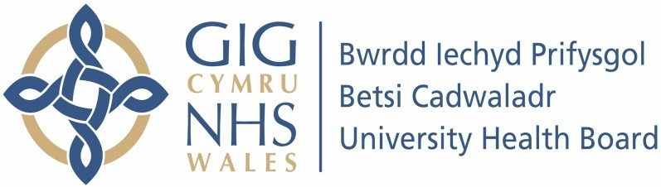

Our ref: 558963
15th November 2023

Freedom of Information Act 2000

I can confirm that the information requested is held by Betsi Cadwaladr University Health Board. I have enclosed the information that is being released to you.

Your request:

We are trying to establish the amount of money spent on medical equipment across Wales over a number of years and how much of this related to replacing existing equipment v's expanding or adding capacity.

It would be helpful to analyse spend against the categories below but if this is not possible, please provide total information against a single line.

An excel file can be provided attached to provide the information.

- Please provide information on Capital spend in the following format for all years

Request 1 - Total Spend on Medical Equipment per year

Capital Spend Categories 2022/23
Actual 2023/24 Budget
2023/24 Forecast
2024/25 Budget

  - Equipment - Clinical theatres and critical care

  - Equipment - Clinical diagnostics

  - Equipment - Clinical other

  - Total Spend on Medical Equipment

Our response:

 | 2022 / 2023 Actual | 2023 / 2024 Budget | 2024 / 2025 Budget
All Wales – Major equipment | £4.61M | Not confirmed | Not known
Discretionary | £1.52M | £2.33M | Not known
Donated | £0.19M | £0.28M | Not known
TOTAL | £6.31M

- Please provide a best estimate of the total % spent replacing existing equipment as opposed to investing in additional capacity.

Our response:

In general we estimate that around 90% of capital spend is on replacing existing equipment, in some cases replacing the existing equipment with a faster system effectively increases capacity.

