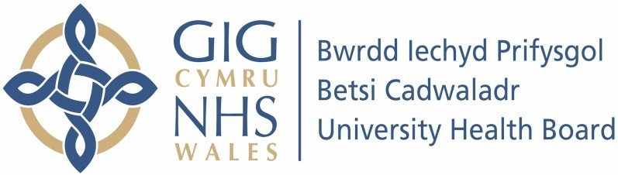

Our ref: 558957
28th of November 2023

Freedom of Information Act 2000

I can confirm that the information requested is held by Betsi Cadwaladr University Health Board. I have detailed below the information that is being released to you.

Your request and our response:

I should appreciate answers to the following questions about the Vascular Service in Ysbyty Gwynedd:

- Is there, and has there been continuously since the beginning of September 2023 [I.e. since Mr Tariq Barakat left], an appropriately qualified vascular consultant based at Ysbyty Gwynedd?

Yes, we have two Consultant Vascular Surgeons in Ysbyty Gwynedd, and an additional Consultant Vascular Surgeon who joined the team, replacing Mr Barakat, on the 6th of September 2023.

- If not, why not?

N/A – Please see above.

- How many vascular outpatient appointments have been cancelled by the hospital/consultant during the period 1st September to 31st October 2023?

80.

- How many vascular patients have had a second or subsequent outpatient appointment cancelled by the hospital/consultant during the same period?

5.

- Ignoring cancellations by patients, how many outpatient appointments have been kept by the hospital/consultant during the same period?

247.

- How many outpatient clinics have been cancelled during the same period?

15 (2 x annual leave, 5 x surgeons of the day (SOD), 5 x Vascular Consultants of the Week (VCOW), 3 x Clinical Governance).

- How many outpatient clinics have taken place during the same period?

25.

- How many outpatient appointments originally scheduled for November 2023 have already been cancelled by the hospital/consultant?

39.

- How many outpatient appointments scheduled for November 2023 are currently expected to go ahead?

166.

- How many elective vascular operations on Ysbyty Gwynedd patients were scheduled for the period 1st September to 31st October 2023, whether at Ysbyty Gwynedd or elsewhere?

Ysbyty Glan Clwyd – 11
Ysbyty Gwynedd - 15

Ysbyty Wrexham Maelor had not undertaken any patient procedures on behalf of Ysbyty Gwynedd during this time.

- How many of these elective vascular operations have been carried out?

Ysbyty Glan Clwyd – 11
Ysbyty Gwynedd - 10

- Why does BCUHB, unlike many [most?] other hospital boards, not publish details of consultants on its website, and also indicate vacancies?

As part of our content plan, we do not advise creating a meet the team section on service websites as these can be time consuming to manage and update for all services, as a small digital team. Using images of staff on pages also affects the accessibility of the website when viewed on smartphones or tablets. As an alternative we recommend that services describe relevant roles in general e.g., Advanced Nurse Practitioners, Health Visitors, and use general contact information.

