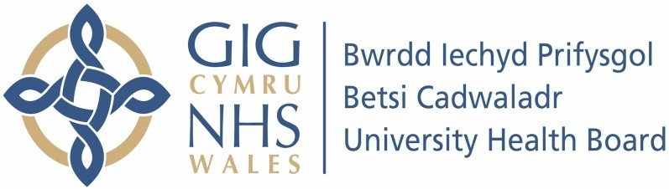

Our ref: 1196480
29 February 2024

Freedom of Information Act 2000

I can confirm that the information requested is held by Betsi Cadwaladr University Health Board. I have detailed below the information that is being released to you.

- Do you have local provisions for all to receive NHS ADHD services? If no, and if relevant, under the NICE guidelines please detail on alternate services which the NHS will fund

Yes, we have Neurodevelopment Teams within our three IHCs in the Health Board. Each team has a combined waiting list which consists of C&YP waiting for an ADHD assessment, ASD assessment or combined assessments

- Current waiting time for NHS child ADHD assessment & diagnosis

The service does not have a separate waiting list for children with ADHD, all children waiting for a neurodevelopment assessment (Autism/ADHD/Combined) are on the same waiting list. The waiting time for an ND Assessment is in excess of WG guidance of 26 weeks. Currently waiting times are standing at around 48 months and growing following a significant increase in referrals post Covid-19. BCUHB are not an outlier in this position. We are commencing a programme of work to support our service which is aligned to the Welsh Government Neurodivergent Improvement Programme.

- Number of children on waiting list for ADHD assessment & diagnosis

The total number of children on our Neurodevelopmental waiting lists, waiting for an assessment as at end December 2023 was:

4955 children/YP on the ND waiting list; 3838 waiting over 26 weeks.

(We cannot split out average wait for each assessment)

- Based on the individual who is currently on the waiting list, what is the longest so far a patient has been waiting for an assessment & diagnosis.

Our longest waiter as at end December 2023 was waiting 254 weeks.

- How are the waiting list ordered? (i.e. first come first served? or are patients added based on urgency of how symptoms affect them, once on waiting list is it position fixed or can they be bumped down or up?)

Date of referral into the service, there is currently no criteria to move patients up/down the waiting list.

- If someone moves out of the region are they removed from the waiting list?

Yes, when we are notified, then the patients are removed from the waiting list (we would if requested forward on any documentation related to the referral).

- If someone moves into the region do they have to begin at the bottom of the waiting list all over again?

We would review the referral and see what information has been shared by referring Healthboard/Trust to determine where a patient is placed on the waiting list.

- Budget value in GBP and percentage allocated to ADHD services

We were unable to provide the data. We do not hold details down to this level within Childrens Services for ADHD.

- Do you operate under 'Right to Choose' (i.e. patients can choose where to get ADHD diagnosis funded by NHS, and can be referred to certain private providers with NHS contracts for diagnoses if NHS waiting list are long)

No

- If relevant, cost to the NHS of using private practices for diagnosis

N/A

- Do you accept private diagnoses and shared care? (i.e. patient seeks private diagnosis due to long NHS waiting lists, will GP then accept this diagnosis and allow patient to receive NHS prescription rather than private?)

We accept a private diagnosis if the assessment report meets specific criteria (e.g. meets NICE guidance, has a clear diagnosis etc). Reports are reviewed by clinicians to see if they can be accepted or not. If accepted they are placed on our medication pathway and will wait their turn to be seen in the ADHD clinic. We do not accept private shared care agreements. Our ADHD doctor/clinics will initiate their own shared care agreement when they deem it appropriate to do so once the YP is stable on medication

- How many staff are trained to diagnose and treat ADHD within BCUHB.

Assessment for ADHD only contributes to part of our clinical staffs job role:

East - Those trained in all elements of assessment through and can diagnose are qualified staff: 10 staff members but they are not all full time and have different roles within the service. 3 staff trained to treat.

West – 4 staff trained to diagnose and x 2 staff trained to treat.

Centre – 7.7 wte qualified staff to assess and 4 trained to treat.

- Are you making any improvements to these services/do you have any plans to improve these services.

We are commencing a programme of work to support our service which is aligned to the Welsh Government Neurodivergent Improvement Programme. We have locally agreed improvement plans and recruitment is currently underway to support this work.

-Does BCUHB have targets relating to ADHD care and the aforementioned points? If so what are these? Are they being met?

The WG target for Neurodiverse Assessments is 80% of CYP waiting under 26 weeks for assessment. This is not being met. As stated above WG note that this is a National
issue and we are working with them to help them deliver their Neurodivergent
Improvement Programme

