
Version: 1

Reference Number: 0.1

Cerebral Palsy in Children and Young People 0-19 years
Evaluation, Diagnosis and Overview of Management for health professionals working in secondary care and community Paediatricians in Primary care

Author & Title | - Dr Rose Bandla, ST8 Paediatric Trainee, East Betsi Cadwaladr University Health Board (BCUHB)  - Dr Brahan Sathyamoorthy, Community Paediatric Consultant East BCUHB  - Dr Sakeer Kunnath, community paediatrics consultant East BCUHB  - Dr Shona Parry, Community paediatric Consultant, West BCUHB  - Angela wing, Physiotherapist, Clinical Lead Operations Physiotherapy, BCUHB
Responsible Dept / Director: | - Childrens and Young People Division, BCUHB
Type of Document | Guideline
Approved by: | BCUHB Policies and Procedures (MPPP)
Date approved: | BCUHB MPPP: CAG approval: 2021
Date activated (live):
Documents to be read alongside this document: | - MM01 BCUHB Medicines Policy  - MM12 Procedure for the Management of Medication Administration Incidents and Near Misses including Management of Nursing / Midwifery Staff, or other Registered Healthcare Professionals  - MM73 Bone health management for children  - BCU pathway for hypersalivation in paediatrics  - BNF for Children 2021-2022. London: BMJ Publishing Group Ltd and RPS Publishing. www.bnfc.nice.org.uk
Date of next review: | September 2024
Date EqIA completed / reviewed: | 10/02/2020
First operational: | New guideline
Previously reviewed: | NO
Changes made yes/no: | YES  This will be the first time this document has been used in BCUHB.  The purpose of the guideline is to set out a framework, which promotes the safe and effective clinical management of children who are at risk or has signs and symptoms of cerebral palsy. This document has been written by the multi-disciplinary team and is to be used in conjunction with BCUHB pathway for hyper-salivation and bone health guidance MM73  This document has undergone an extensive consultation process throughout BCUHB including both Secondary care and specialist Community Practitioners.
Details of changes since last review

N.B. Staff should be discouraged from printing this document. This is to avoid the risk of out of date printed versions of the document. The Intranet should be referred to for the current version of the document

Table of Contents
Page
- Introduction and purpose of guidelines………………………………….3
- Pathway of Care…………………………………………………………...4
- Definitions…………………………………………………………………..6
- Diagnosis of Cerebral Palsy
  - Risk factors and causes……………………………………………….6
  - Signs of cerebral palsy…………………………………………………7
  - Diagnosis………………………………………………………………..7
  - Types of cerebral palsy……………………………………………….7-8
  - Red flags for other neurological disorders…………………………..9
  - Investigation……………………………………………………………10
- Management……………………………………………………………….10
  - Multidisciplinary management………………………………………..11
  - Medical management………………………………………………….13
    - Spasticity management………………………………………………..13
    - Saliva control……………………………………………………………14
    - Bone health……………………………………………………………..14
    - Pain, sleep and mental health………………………………………...15
    - Orthopaedic Management……………………………………………..15
    - Management of comorbidities…………………………………………15
- Transition of care to adult services……………………………………….15
- Additional resources for CYP and their families……………………….15-16
- References…………………………………………………………………16-17
- Appendices…………………………………………………………………18-21

- Introduction

Cerebral palsy (CP) is described as group of disorders of the development of movement and posture, causing activity limitation, that are attributed to non-progressive disturbances that occurred in the developing fetal or infant brain. The motor disorders of cerebral palsy are often accompanied by disturbances of sensation, cognition, communication, perception, and/or by a seizure disorder.¹
There is an estimated 2.4-3.2 per 1000 children in Wales affected by CP. A total of 7,113 and 5,218 Children and Young People (CYP) with CP were identified in the English and Welsh datasets respectively. CP affects people from all social backgrounds and ethnic groups¹⁰. With an estimated population of CYP aged 0-19 years of 153, 064 in BCUHB¹³, about 360-490 children are affected by CP.
Cerebral palsy is the most common cause of physical disability in children and young people in high-income countries. The physical manifestation of disability varies depending on the location and extent of underlying brain damage and may change over time. Management focuses on optimising functional ability, decreasing secondary musculoskeletal deformity and managing comorbidities¹¹.
The purpose of this document is to provide a standardised guide within BCUHB that reflects the current evidence-base and the relevant national guidance to support a patient and family-centred approach in the diagnosis and management of CP in (CYP) age 0 to 19 years of age.
The guide aims to:
- Support the identification of independent risk factors and abnormal signs suggestive of cerebral palsy.
- Aid decision making when considering referral for developmental follow-up and and/or multidisciplinary assessment.
- Clarify regional pathways and improve access to tertiary services.

All clinicians involved in caring for CYP with CP have responsibility for supporting the patient through the diagnosis, assessment, and management process. The BCUHB pathway to support this process is pictured in Fig.1. By following a standardised pathway, we can achieve the best possible outcomes for these vulnerable children.

- Cerebral Palsy Pathway of Care
Signs of
CP
Primary care
referral
High risk population needing surveillance

Referral to community paediatrics and physiotherapy

Further investigation or neurology referral
Red flags for other neurological conditions
Consider risk
factors, causes and signs of CP

Investigations including MRI

Diagnosis of CP
Information regarding management and prognosis

Associated health issues
MDT Assessment and Management

Medication and other specialist treatment

Fig 1. Cerebral Palsy Pathway of Care

- Definitions

3.1 The Gross Motor Function Classification System (GMFCS)
A widely used five level clinical standardised system to classify the gross motor function of children with (CP), with emphasis on function in sitting and walking.
See appendix 1.

3.2 Cerebral Palsy Integrated Pathway (CPIP): UK pathway for hip surveillance to prevent hip dislocation. The Pathway consists of regular, standardised physical and radiological assessments which allows the early identification of hip displacement and facilitates timely intervention. This is led by the physiotherapist within BCUHB.

3.3 National Institute for Health and Care Excellence (NICE): National health body that oversees up to date guidance, policies, procedures, and publications on all health-related topics

3.4 Surveillance of Cerebral Palsy in Europe (SCPE): European association to develop best practice in monitoring trends in cerebral palsy, to disseminate knowledge to health professionals, policy makers, patients and families, to provide information for resource planning and to raise standards of care for patients with cerebral palsy.

- Diagnosis of Cerebral Palsy
  - Risk factors and Causes:

Antenatal Factors | Perinatal Factors | Postnatal Factors
- Preterm birth  - Chorioamnionitis  - Maternal respiratory tract infection or  - genito-urinary infection treated in hospital | - Low birth weight (at increased risk if birth weight <1.5kg)  - Chorioamnionitis  - Neonatal encephalopathy (as a result of, eg, sepsis, hypoxic-ischaemic injury)  - Neonatal sepsis  - Maternal respiratory tract infection or genito-urinary infection treated in hospital | - Meningitis or other infections  - Head injury

Risk factors may have a cumulative adverse impact on the developing brain.

4.2 Signs of cerebral palsy

Early motor features
- Abnormalities of movement (eg, unusual fidgety movements, asymmetry, or paucity of movement)
- Abnormalities of tone (eg, hypotonia, spasticity or dystonia)
- Abnormal development of motor skills
- Persistent of primitive reflexes
- Feeding problems

Delayed/abnormal motor milestones
- Unable to sit by 8 months corrected gestational age (Corrected Gestational Age (CGA))
- Unable to walk by 18 months CGA
- Persistent toe-walking
- Hand preference before 1-year CGA

4.3 Diagnosis
Cerebral palsy is a clinical diagnosis¹² made by an awareness of risk factors, regular developmental screening of all high-risk babies and neurological examination. A systematic approach focusing on maternal, obstetric, and perinatal histories, review of developmental milestones, and a thorough neurological examination and observation of the child in various positions such as supine, prone, sitting, standing, walking and running is mandatory. The patterns of various forms of CP emerge gradually with the earliest clues being a delay in developmental milestones and abnormal muscle tone.
4.4 Types of Cerebral palsy based on Tone^{14, 15}
Spastic CP is characterized by increased muscle tone.
Non-spastic CP will exhibit decreased or fluctuating muscle tone.
When referring to location of the brain injury, spastic and non-spastic CP is referred as pyramidal and extrapyramidal CP.
-Spastic CP (70-80% of cases): The injury to the brain occurs in the pyramidal tract and is referred to as upper motor neuron damage. Depending on which limbs are affected, it can be described as spastic diplegia, spastic hemiparesis, and spastic quadriplegia.
-Non-spastic CP (20% of cases): In this type, decreased and/or fluctuating muscle tone is noted and predominantly associated with involuntary movements. Movement can be slow or fast, often repetitive, and sometimes rhythmic.
It is divided into two groups:
Dyskinetic (15% of cases): separated further into two different groups; athetoid and dystonic.
Athetoid CP includes cases with involuntary movement, especially in the arms, legs, and hands.
Dystonia/Dystonic CP encompasses cases that affect the trunk muscles more than the limbs and results in fixed, twisted posture.
Based on specific movement dysfunction, it can be athetosis, chorea, choreoathetoid or distonic types.
Ataxic (5% of cases): This type affects coordinated movements. Balance and posture are involved. Walking gait is often very wide and sometimes irregular. Control of eye movements and depth perception can be impaired. Often, fine motor skills requiring coordination of the eyes and hands, such as writing, are difficult. Does not produce involuntary movements, but instead indicates impaired balance and coordination
Mixed: A child’s impairments can fall into both categories, spastic and non-spastic, referred to as mixed Cerebral Palsy. The most common form of mixed Cerebral Palsy involves some limbs affected by spasticity and others by athetosis.
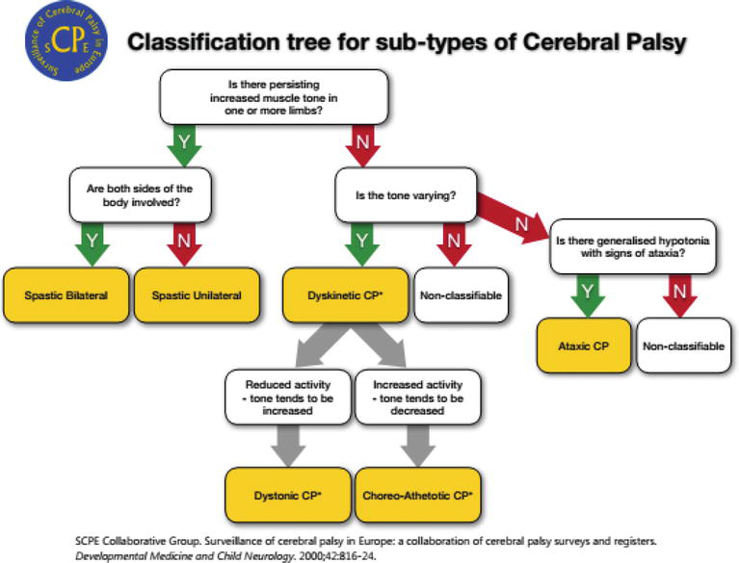
4.5 Red flag signs for other neurological disorders:
Recognise the following as red flags for neurological disorders other than CP which require further investigation and urgent specialist review.
- absence of known risk factors
- family history of a progressive neurological disorder
- loss of already attained cognitive or developmental abilities
- development of unexpected focal neurological signs
- MRI findings suggestive of a progressive neurological disorder
- MRI findings not in keeping with clinical signs of cerebral palsy.

4.6 Investigations
When deciding the best age to perform a Magnetic Resonance Imaging (MRI) scan for a child with CP, consider the following:
- Subtle neuro-anatomical changes that could explain the aetiology of CP may not be apparent until 2 years of age. Some children with CP will have a normal MRI scan.
- MRI can support discussion with the families regarding prognosis.
- That general anaesthesia or sedation is usually needed for young children having MRI.
- The views of the child or young person and their parents or carers.

- Management
CYP with CP and their parents or carers have a central role in decision-making and all clinicians should support person-centred planning.
Clinicians should ensure that the CYP with CP has access to a local integrated core multidisciplinary team with access as required to an expanded network of care and support as shown in Fig.2.

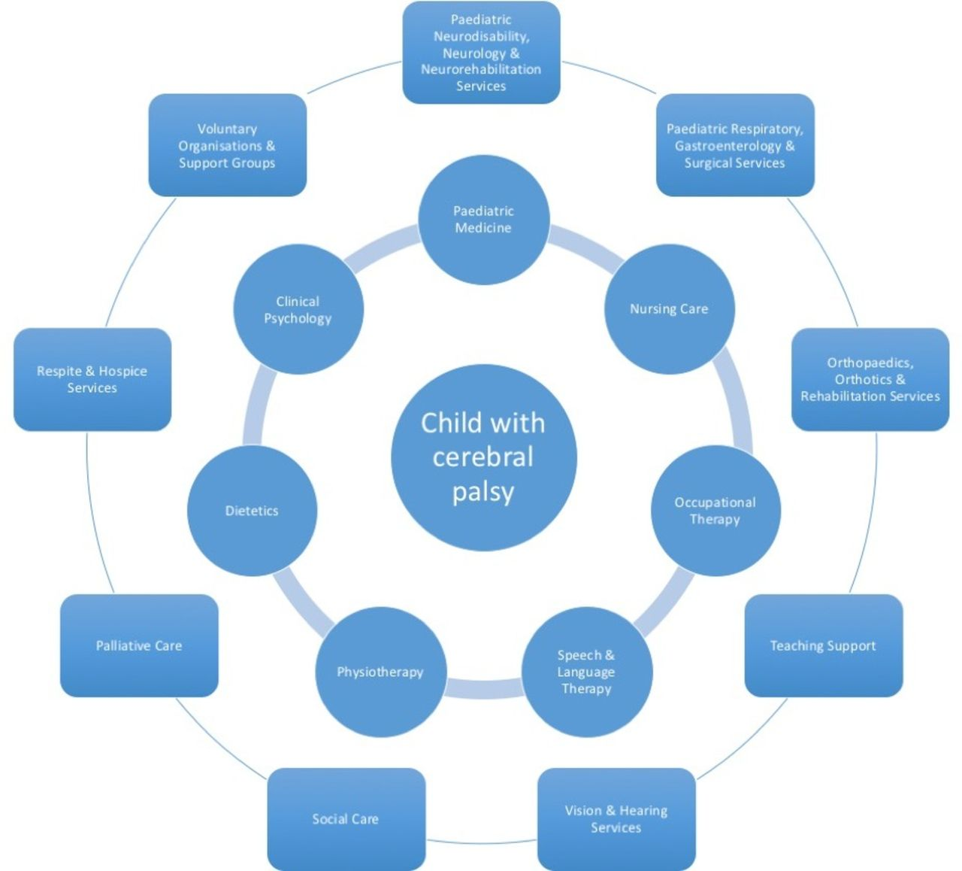
Fig.2 Core and Expanded network of care around the CYP with CP¹¹
5.1 Multi-disciplinary management

Physiotherapists

Physiotherapists play a key role in supporting children with CP. Physiotherapists usually become involved in the early stages of diagnosis. Their main aim will be to help CYP develop and to be as mobile and independent as possible.
Physiotherapists will provide intervention, equipment, training and support to CYP with CP and their parents or carers.
Physiotherapists lead in hip surveillance in CYP with CP (CPIP).(please see appendix)
All children with CP should be referred for physiotherapy assessment.
It is important to signpost to physiotherapists if there is gross motor delay who will refer to Orthopaedics as necessary unless they are already known to Orthopaedics.

Speech and Language Therapists (SLT)

Speech and Language therapists play a key role in supporting CYP with CP. SLT’s may become involved early on during the pre-school years and this may continue throughout their school life dependent on the child’s needs. CYP with CP may have difficulties with speech, language and communication skills as well as difficulties with feeding and swallowing.
CYP with CP should be referred to the Speech and Language Therapy Team for assessment if:
- There are concerns with overall communication skills
- There are concerns that the child’s understanding or use of language is delayed for their age
- There are concerns that the child’s speech is delayed or they are difficult to understand
- There are concerns about feeding and / or swallowing such as:
  - Coughing, choking, gagging, altered breathing pattern or change in colour when eating and drinking
  - Recurrent chest infections
  - Prolonged meal times
  - Mealtimes are stressful for the child, carer/parent.

The SLT will liaise with the child’s paediatrician regarding the need for further investigations of the child’s swallowing difficulties such as videofluoroscopy.

Dieticians

Many CYP with CP have feeding and nutritional problems linked to their muscle tone, level of disability, immobility and any associated feeding or swallowing difficulties.
All CYP with CP should have their weight and length (under 2 years for all and for those CYP who are not weight bearing at any age) or height measured regularly and plotted on an age appropriate growth chart.

The following CYP with CP should be referred to a Paediatric Dietitian:
- More than 2 centile line or spaces difference between weight and length/height (over or underweight)
- No weight gain for 3 consecutive weights at age appropriate intervals or weight loss on 2 occasions with no explanation i.e. infection, feeding position and no improvement with first line advice
- Children with organic feeding difficulties - should be referred to joint Speech and Language Therapy (SLT) and Dietetic feeding clinic via SLT (referral should state this on it) to avoid duplicate appointments for parents.
- Behavioural feeding difficulties – refer for joint Dietetic and Psychology appointment.
- Tube feeding - if being considered, should be discussed with dietitian before referral for tube and decision confirmed to parents. Ideally this should be discussed with parents in a joint appointment between the Consultant and Dietitian. Any child with a feeding tube (eg arriving from out of area, Alder Hey Children’s Hospital etc) should be referred to the Dietitian.

Occupational Therapists
Occupational Therapists play a key role in supporting CYP with CP by assessing their level of independence in everyday activities and implementing strategies that will allow further engagement or participation in daily life by:
- The use of postural and positioning equipment both at home and school
- Assessment and treatment of hand function development
- Prevention of hand deformities through hand splinting
- Assessment of sensory issues that may interfere with development
- Training of parents and other professional groups
- Supporting the access to education, communication, environment and functioning using technology and electronic assistive devices.

Orthotists

Provide orthotic appliances to maintain muscle length, improve posture and increase function e.g. ankle foot orthoses, specialist footwear and contracture correction devices

Posture and Mobility Service
Provide equipment such as specialist buggy or wheelchair to support mobility around the child or young person’s environment. Liaise with the CYP physiotherapist or occupational therapist to arrange referral to this service.

5.2 Medical management
5.2.1 Spasticity Management
As a result of spasticity, the child could experience pain, decreased function and movement, deterioration of posture or a complication affecting the structure of the musculoskeletal system eg. joint contracture or abnormal bony torsion.
Optimal Spasticity Management can help to:
- Reduce spasticity related pain
- Improve sleep
- Aid posture management
- Assist cares or educe carer requirement
- Improve age dependent changes eg contractures and joint deformities
- Improve function eg fatigue, dressing, walking distance
Medications
Consider oral Diazepam or Baclofen if spasticity is contributing to discomfort or pain, muscle spasms or functional disability.
If oral diazepam is initially used because of its rapid onset of action, consider changing to oral baclofen if long-term treatment is indicated. Baclofen is particularly useful if a sustained long-term effect is desired. Start oral baclofen treatment with a low dose and increase the dose stepwise over about 4 weeks to achieve the optimum therapeutic effect.
If dystonia is considered to contribute significantly to problems with posture, function, and pain, consider a trial of trihexyphenidyl, levodopa or baclofen.
Surgical management

Refer CYP with CP who may need further assessment to manage their spasticity to specialist clinic in Alder hey for Intra Thecal Baclofen pump, selective dorsal rhizotomy.

5.2.2 Managing saliva control
Drooling, swallowing, and feeding problems are quite common in CYP with CP. Consequently, they experience increased risks of malnutrition and dehydration, aspiration pneumonia, and poor quality of life
Assess factors that may affect drooling in CYP with CP, such as positioning, medication history, reflux and dental issues, before starting drug therapy.
To reduce the severity and frequency of drooling in CYP with CP, consider the use of anticholinergic medication:
- transdermal hyoscine hydrobromide or
- glycopyrronium bromide (oral or by enteral tube) or
- Atrovent inhalers or
- trihexyphenidyl hydrochloride for children with dyskinetic CP, but only with input from specialist services.

Regularly review the effectiveness, tolerability and side effects of all drug treatments used for saliva control.
Refer the CYP to a specialist ENT service at a tertiary centre if the anticholinergic drug treatments are contraindicated, not tolerated or not effective, to consider other treatments for saliva control. Specialist administration of botulinum toxin A and a surgical opinion may subsequently be required if medications prove unsuccessful or intolerable.

The BCUHB pathway for hyper-salivation in paediatrics here:
http://howis.wales.nhs.uk/sites3/docmetadata.cfm?orgid=475&id=492041

5.2.3 Bone health problems
Children with cerebral palsy are prone to have low bone mineral density and are at risk of non-traumatic fractures. This is discussed in a comprehensive manner in the BCUHB Bone Health Guidance.
Refer Bone health guidance.
MM73 - Bone Health Management for Children at Risk of Fractures for Health Professionals working in Secondary Care - V1.pdf

5.2.4 Pain, sleep and mental health
- Ask about signs of pain or discomfort and sleep disturbance and explore any emotional difficulties during consultations. Assessing such symptoms can be challenging in those with communication or learning difficulties.
- Manage pain, discomfort or distress
- Identify treatable causes of sleep disturbance, such as obstructive sleep apnoea, seizures, pain, poor sleep hygiene, night-time interventions, need for repositioning and medication side effects. Consider a trial of melatonin in the absence of a treatable cause. Refer to specialist sleep services if disturbances are ongoing.
- Use validated tools to assess mental health problems and refer for specialist psychology assessment if there are concerns. Address possible contributing factors, such as communication difficulties, medication side effects and polypharmacy, comorbidities or social care needs.
    - Orthopaedic Management
CYP with CP can experience secondary orthopaedic complications due to muscle weakness, altered muscle tone and asymmetrical posture eg. Hip migration/dislocation, muscle shortening, bony deformities and scoliosis. Consider referral to specialist orthopaedic clinic.If children are already known to Orthopaedicians,if there is a clinical concern,we can refer to them directly.Migration percentage are usually reported by orthopaedic surgeons.
Discussions will be ongoing with Radiologists to report Migration percentage.

5.2.6 Other comorbidities
- Management of visual impairment, hearing impairment, learning disability, communication difficulties and behavioural difficulties should also be assessed as appropriate
- Referral to audiology/orthoptist/OT as appropriate
- Management of other comorbidities such as vomiting, regurgitation, reflux, constipation and epilepsy as per NICE guidelines^{16,17,18,19}.
- Some quadriplegics may require palliative care.
6. Transition of care to adult services
- Consider transition for paediatric to adult services when developmentally appropriate for the young person
- Ensure a patient and family centred approach to transition, considering the young person or families needs at all times.
- Ensure all members of the MDT supporting the family are involved in their transition of care
- Recognise that this is a difficult and challenging time for young people and their families and ensure they are fully supported throughout the transition period.

For further information see NICE guideline²⁰

7. Additional resources for CYP and their families

Association of Chartered Paediatric Physiotherapist
https://apcp.csp.org.uk/parent-leaflets
Children in Wales

https://www.childreninwales.org.uk/
SCOPE
https://www.scope.org.uk/
HemiHelp
https://www.contact.org.uk/hemihelp
Contact a Family
https://contact.org.uk/
CPIP Wales:
www.cpipuk.org

- References
1) Bax, M., Goldstein, M., Rosenbaum, P., Leviton, A., Paneth, N., Dan, B., Damiano, D. (2005). Proposed definition and classification of cerebral palsy, April 2005. Developmental Medicine and Child Neurology, 47(8), 571-576
2) National Institute for Health and Care Excellence, Jan 2017, Cerebral Palsy in under 25s: assessment and management
3) National Institute for Health and Care Excellence, Aug 2017, Developmental follow up of children and young people born preterm
4) Ganesan et al, RCPCH Stroke in Children: Clinical Guidelines in Diagnosis, Management and rehabilitation, 2017
5) Cerebral Palsy Integrated Pathway UK https://apcp.csp.org.uk/content/cpip-uknational-network
6) Gross Motor Functional Classification Scales, Cerebral Palsy Integrated Pathway Scotland: Origins and development, core dataset, clinical assessment manual 2017 https://apcp.csp.org.uk/content/cpip-uk-training-manual-assessment-forms
7) National Institute for Health and Care Excellence, July 2012, Spasticity in under 19s: management [CG145]
8) National Institute for Health and Care Excellence, Feb 2006, Nutrition support for adults: oral nutrition support, enteral tube feeding and parenteral nutrition [CG32]
9) National Institute for Health and Care Excellence, Feb 2017, Severe sialorrhoea (drooling) in children and young people with chronic neurological disorders: oral glycopyrronium bromide [ES5]
10) Carter B, Verity Bennett C, Bethel J, Jones HM, Wang T, Kemp A. Identifying cerebral palsy from routinely collected data in England and Wales. Clin Epidemiol. 2019; 11:457‐468. Published 2019 Jun 5. doi:10.2147/CLEP.S200748
11) Shaunak M, Kelly VB
Cerebral palsy in under 25 s: assessment and management (NICE Guideline NG62)
Archives of Disease in Childhood - Education and Practice 2018;103:189-193.

12) Sankar, C., Mundkur, N.
Cerebral palsy-definition, classification, etiology and early diagnosis.
Indian J Pediatrics 72, 865–868 (2005).

13) Welsh Government statistics and research (https://gov.wales/statistics-and-research)
14) Cerebral palsy.org

15) Surveillance of Cerebral Palsy in Europe
16) National Institute for Health and Care Excellence, Diarrhoea and vomiting caused by gastroenteritis in under 5s: Clinical guideline [CG84] 22 April 2009
17) National Institute for Health and Care Excellence, Constipation in children and young people (CG99) July 2017
18) National Institute for Health and Care Excellence, Gastro-oesophageal reflux disease in children and young people (NG1) October 2019
19) National Institute for Health and Care Excellence, Epilepsy in children and young people (QS27) February 2013
20) National Institute for Health and Care Excellence, Transition from children’s to adult’s services for young people using health or social care services (NG43) February 2016
21) All wales Cerebral Palsy Register

10. Appendix 1

Gross Motor Function Classification System (GMFCS) and Revised (GMFCS E&R)

The descriptors and Illustrations for the GMFCS E&R are only available for age 6-18 years. Age 2-6 are currently from the GMFCS.
The full details of the GMFCS E &R can be found at:
https://www.canchild.ca/system/tenon/assets/attachments/000/000/058/original/GMFCS-ER_English.pdf
GMFCS Between 2nd and 6th birthday: Descriptors and Illustrations
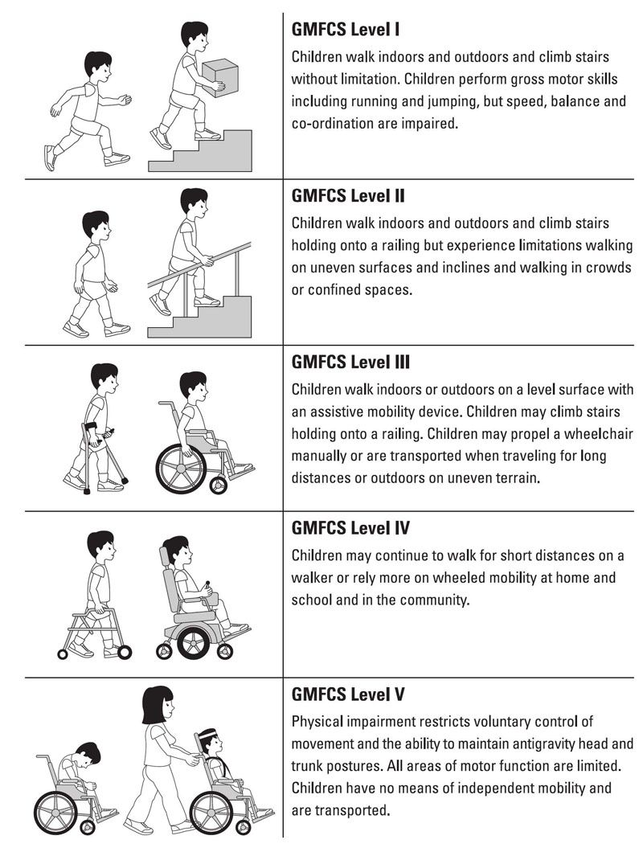

GMFCS E&R Between 6th and 12th birthday: Descriptors and Illustrations
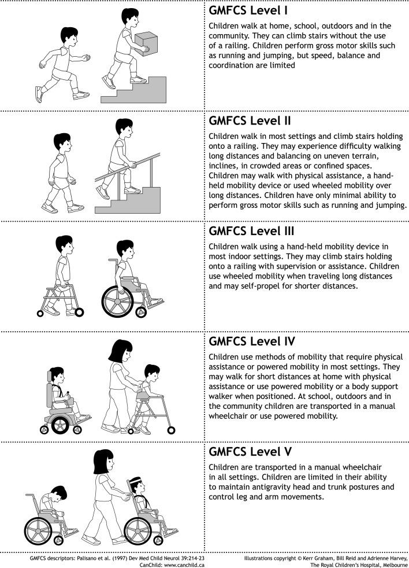
GMFCS E&R Between 12th and 18th birthday: Descriptors and Illustrations 