
All-Wales Induction Programme for Health and Care Workers supporting Nursing and Allied Health Professionals

Name: ....................................................................................................
Department: ...........................................................................................
Induction Start Date: ……………….............................................................
Date workbook to be completed by: ……………….....................................
Named Assessor: ....................................................................................
Do not use any printed copy unless obtained from the Education/Learning & Development Department.
Contents continually updated.
Version 6.1
Contents
Contact Details 4
Learner Agreement Form/ Certificate of Authenticity 6
Summary of achievement record 7
1. Understand the role of a Health and Care worker 8
2. Understand person-centred practice 10
3. Understand the importance of effective communication in health and care 10
4. Demonstrate effective communication 12
5. Understand the principles of infection prevention and control 13
Hand Hygiene technique assessment 14
6. Know how to support an individual who has fallen and how further falls can be prevented 15
7. Understand pressure injury 16
8. Know the importance of diet, nutrition and hydration 19
Completing a Fluid Balance Chart (ACc 8.3, ACn 8.3) 20
Complete the Fluid Balance Chart below: (Clinical setting) 21
Complete the Fluid Balance Chart: (Care setting) Error! Bookmark not defined.
Completing an All-Wales Food Record Chart (ACc 8.3, ACn 8.3) 23
9. Know how to support individuals to maintain continence while preserving their dignity 25
10. Understand how to support the wellbeing of individuals in a health and care setting 26
11. Know how to support oral care 26
12. Know how to support foot care 27
13. Understand the needs of individuals who have a cognitive impairment 27
14. Understand the needs of individuals who have a learning disability 28
15. Understand the needs of individuals with a mental health condition 29
16. Know how to support individuals with sensory loss 29
17. Understand the signs of a deteriorating patient 30
18. Know the factors that may affect physiological measurements 31
19. Be able to take physiological measurements - Learner Assessment Record Sheet 32
20. Understand how to support the hygiene needs of individuals 39
21. Know about death and dying 39
22. Know how clinical specimens are taken 40
23. Be able to use reflection in a health and care setting 41
Learning from practice – Template 1 41
Learning from Practice – Template 2 41
Curriculum Details 43

AN IMPORTANT NOTE FOR BOTH STUDENT AND ASSESSORS

- As this document requires digital signatures, it is best viewed via Acrobat Reader. If you do not have it downloaded, click here.

Click here for a visual online guidance to completing a digital signature.

- Click on the subject fields and fill in the relevant details. The text will shrink to fit the boxes.

- If you click on a box that requires a digital signature, you will be asked to enter your Digital ID. If you do not already have one, you can set one up. Click “Configure New Digital ID”.

- Click on “Create a new Digital ID”. Click on “Save to file”. Fill in all relevant details. For the field “Use Digital ID for”, leave it at “Digital Signatures”. Click “Continue”.

- Set up a password for your signature. Your signature is now ready to use on this document and any others you open on your computer. Click “Continue”.

- To complete your signing of the document, you must enter your password on the bottom left of the window. Click “Sign”. The document now has your digital signature embedded in it. Save the document to your computer.

- If needs be, attach the document to an email to send to the next person that needs to sign it.

Contact Details

Health and Care Learner
Name:
Full address and postcode:
Date of Birth:
Job Title:
Place of work:
(Please include department and hospital base)
Contact number:
Email address:

Course Tutor
Name:
Job Title:
Place of work:
(Please include department and hospital base)
Contact number:
Email address:

Assessor
Name:
Job Title:
Place of work:
(Please include department and hospital base)
Contact number:
Email address:

Assessors/Mentors who have observed and assessed you for the observations in your workbook:
Name:
Job Title:
Band and/or Qualification:
Place of work:
(Please include department and hospital base)
Activity assessed:
Signature:

Name:
Job Title:
Band and/or Qualification:
Place of work:
(Please include department and hospital base)
Activity assessed:
Signature:

Name:
Job Title:
Band and/or Qualification:
Place of work:
(Please include department and hospital base)
Activity assessed:
Signature:

Name:
Job Title:
Band and/or Qualification:
Place of work:
(Please include department and hospital base)
Activity assessed:
Signature:

Learner Agreement Form/ Certificate of Authenticity

PLEASE READ CAREFULLY AND MAKE SURE YOU ARE HAPPY WITH THE COMMITMENT YOU ARE AGREEING TO UNDERTAKE BEFORE YOU SIGN.
The learner agrees to:
- Attend study days when required
- Engage in learning activities and take responsibility for their own learning and development
- Submit summative assignments as required (i.e. workbooks and competencies)
- Contact Education Team/manager if you are experiencing any difficulty/ falling behind with your work/discuss any mitigating circumstances
- Notify the Education Team of any change of circumstance at work – such as new base, change of manager or personal circumstance which may affect your progress through the Induction workbook
- Participate in the evaluation of the course
- Confirm that all work submitted in fulfilment of the Induction workbook is their own work
- Confirm/Agree that any unfair practice that is undertaken will result in the appropriate action being taken in line with organisational policy
- Gives permission for all of this work to be shared with the awarding body
- Confirm that the following have been received, read and understood:

  - Induction workbook
  - Course resources/handbook

Learner signature: .............................................................................
Date: ...............................................................................................

Summary of achievement record
Please date and sign when all activities/reflections etc for each subject have been completed.
Week 1/ Week 2/Week 3
Subject | Date | Subject | Date
Role of the  Health and Care worker |  | Foot Care
Person-centred Practice |  | Cognitive impairment
Communication Skills |  | Learning Disabilities Awareness
Principles of Record Keeping and Reporting |  | Mental Health Awareness
Infection Prevention and Control |  | Sensory Loss
Prevention of Falls |  | Understand and take physiological measurements (Nursing Unit only)
Care of Pressure Areas |  | Deteriorating patient (Nursing Unit only)
Nutrition and Hydration |  | Hygiene needs  (Nursing Unit only)
Maintenance of Continence |  | Care of the Dying (Nursing Unit only)
Support the Wellbeing of Individuals |  | Specimens Collection (Nursing Unit only)
Oral care |  | Reflection
Assessor Comments:

Student signature: |  | Assessor Signature:
Date Credits Achieved |  | Date of Assessment
Internal Quality Assurer Signature:

Understand the role of a Health and Care worker
Describe your role, including limitations in relation to the following:
Scope of Practice (ACc 1.1a, ACn 1.1a):

The Code of Conduct (for Healthcare Support Workers in Wales) (ACc 1.1b, ACn 1.1b):

Obtaining consent (ACc 1.1e, ACn 1.1e):

The role and responsibility of a chaperone (ACc 1.1i, ACn 1.1i):

Duty of care (ACc 1.1h, ACn 1.1h):

Mandatory and statutory training in your own work setting (ACc 1.1j, ACn 1.1j):

Explain what accountability and delegation mean to you within your role (ACc 1.1c, ACn 1.1c):

Describe how to maintain confidentiality within your role as a Health and Care worker. Ensure you include specific reference to issues with social media (ACc 1.1f, ACn 1.1f):

Explain the key points of local policies and procedures for: (ACc 1.1d, 1.1k, ACn 1.1d, 1.1k):
- Record keeping

- Reporting concerns in line with organisational policies and procedures

List ways to support environmental sustainability in your work area i.e using more sustainable products/materials (ACc 1.1, ACn 1.1):
1. ___________________________________________________________________________
2. ___________________________________________________________________________
3. ___________________________________________________________________________
4. ___________________________________________________________________________
5. ___________________________________________________________________________

Understand person-centred practice
Describe person-centred practice and give three examples of how this applies in your work area (ACc 2.1, 2.2, ACn 2.1, 2.2):

Describe how an enabling approach can be used within your work setting (ACc,1.1g, ACn 1.1g):

Describe how to identify the language preferences, cultural values and beliefs of individuals in health and care settings (ACc 2.3, ACn 2.3):

Describe why risk taking can be part of a person-centred approach (ACc 2.4, ACn 2.4):

Understand the importance of effective communication in health and care
Describe the key features of effective communication (ACc 3.1, ACn 3.1):

Identify the importance of effective communication for the wellbeing of individuals and the development of personal relationships (ACc 3.2, ACn 3.2):

Explain how you include the ‘Active Offer’ whilst carrying out your role (ACc 3.2, ACn 3.2):

Outline three barriers to effective communication and ways to address them (ACc 3.3, ACn 3.3):
Barrier to communication: | Ways to address the barrier identified:
1. | 1.
2. | 2.
3. | 3.

4. Demonstrate effective communication
The learning outcome from this exercise is that the Health and Care worker will be able to use communication in a health and care setting. They need to demonstrate verbal and non-verbal skills across all activities and include an explanation of the ‘Active Offer’. (ACc 4.1, ACn 4.1)
The assessment criteria against which you are measuring the Health and Care worker is:
 | Assessment 1 |  | Assessment 2 | Assessment 3
Did the Health and Care worker use verbal communication? | YES/NO |  | YES/NO | YES/NO
Did the Health and Care worker use written communication? | YES/NO |  | YES/NO | YES/NO
Did the Health and Care worker use non- verbal communication e.g. gesture and facial expression? | YES/NO |  | YES/NO | YES/NO
Did the Health and Care worker adapt the verbal communication to the needs of the individual? | YES/NO |  | YES/NO | YES/NO
Did the Health and Care worker introduce themselves? | YES/NO |  | YES/NO | YES/NO
Did the Health and Care worker explain the Active Offer i.e. the opportunity for care to be delivered in the medium of Welsh? | YES/NO |  | YES/NO | YES/NO
Did the Health and Care worker ask the person how they wished to be addressed? | YES/NO |  | YES/NO | YES/NO
In your opinion what did the Health and Care worker do particularly well in this communication exercise?

How could they improve?

Assessor signature: |  | Date:
Learner signature: |  | Date:

5. Understand the principles of infection prevention and control
Explain the chain of infection (ACc 5.1, ACn 5.1):

Identify the most common cause of the spread of infection (ACc 5.2, ACn 5.2):

What are the World Health Organisation (WHO) five moments of hand hygiene (ACc 5.3, ACn 5.3)?
1. ___________________________________________________________________________
2. ___________________________________________________________________________
3. ___________________________________________________________________________
4. ___________________________________________________________________________
5. ___________________________________________________________________________

List different types of Personal Protective Equipment (PPE) available to you whilst carrying out your role (ACc 5.5, ACn 5.5):

Hand Hygiene technique assessment
Performance checklist for hand washing (minimum of two satisfactory assessments according to WHO guidelines on hand hygiene)
(ACc 5.4, ACn 5.4)
Assessment number: |  | 1 | 2 | 3 | 4 | 5
Date of assessment: |  | YES/NO | YES/NO | YES/NO | YES/NO | YES/NO
All jewellery and watches are removed, and sleeves rolled up to be bare below the elbow. |  | YES/NO | YES/NO | YES/NO | YES/NO | YES/NO
Fingernails are clean with no polish. |  | YES/NO | YES/NO | YES/NO | YES/NO | YES/NO
Any cuts are covered with waterproof dressings. |  | YES/NO | YES/NO | YES/NO | YES/NO | YES/NO
The water is turned on and the temperature checked and adjusted to warm where possible. |  | YES/NO | YES/NO | YES/NO | YES/NO | YES/NO
Hands are wet under continuously running water. |  | YES/NO | YES/NO | YES/NO | YES/NO | YES/NO
Liquid soap is applied to wet hands. |  | YES/NO | YES/NO | YES/NO | YES/NO | YES/NO
Hands are rubbed together to create a lather. |  | YES/NO | YES/NO | YES/NO | YES/NO | YES/NO
The lather is rubbed over all hand surfaces for 20 seconds, including the thumbs, between the fingers, fingertips and wrists. |  | YES/NO | YES/NO | YES/NO | YES/NO | YES/NO
Splashing of clothing and floor is minimised. |  | YES/NO | YES/NO | YES/NO | YES/NO | YES/NO
Hands are rinsed thoroughly. |  | YES/NO | YES/NO | YES/NO | YES/NO | YES/NO
Taps are turned off using wrist/elbow levers or using a clean paper towel. |  | YES/NO | YES/NO | YES/NO | YES/NO | YES/NO
Hands are patted dry thoroughly with paper towels. |  | YES/NO | YES/NO | YES/NO | YES/NO | YES/NO
Paper towels are disposed of in an appropriate bin without contaminating hands (using a foot pedal or paper towel to open the bin.) |  | YES/NO | YES/NO | YES/NO | YES/NO | YES/NO
Assessor signature: | Learner signature:
Comments:

Know how to support an individual who has fallen and how further falls can be prevented
Identify five factors that can contribute to falls and five strategies to reduce/prevent the risk of a fall (ACc 6.1, 6.2 ACn 6.1, 6.2):
Factors which may contribute to a fall: | Strategies to reduce/prevent the risk of a fall:
1. | 1.
2. | 2.
3. | 3.
4. | 4.
5. | 5.

Describe the actions you would take to offer support to an individual who has fallen
(ACc 6.3, ACn 6.3):

Understand pressure injury
Using the body map below, circle at least five areas at risk of pressure damage
(ACc 7.1, ACn 7.1)

Draw a line to match the description below with the correct image of the ulcer development (ACc 7.2, ACn 7.2).

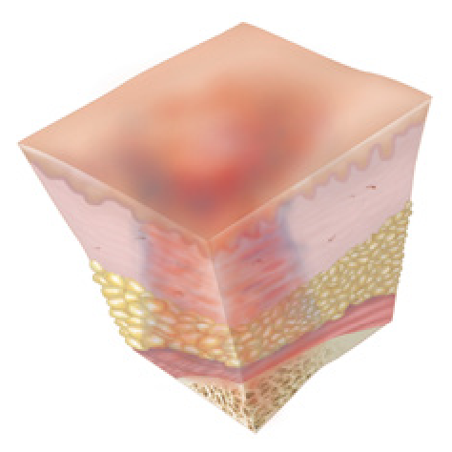
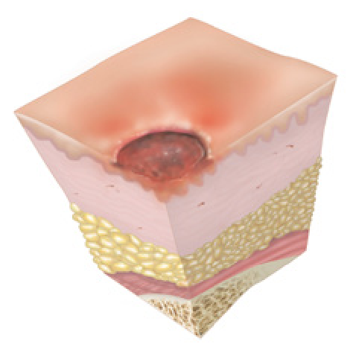
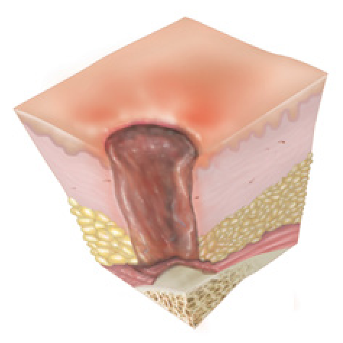
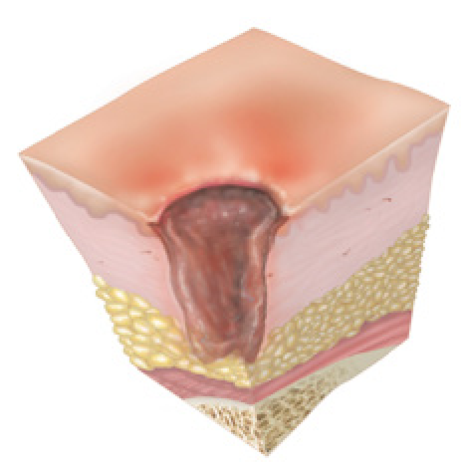
Unstageable – Deep wound covered by necrotic or slough; unable to see how deep it is. At least a category III or IV.
SDTI – Looks like a bruise but over a bone and under the skin. Intact purple area or could be intact blood blister.
Category IV – Full thickness with exposed bone tendon or muscle. Localised over bone.
Category III – Deep wound with yellow (slough) or black (necrotic) tissue. Not down to muscle or bone and depth of wound is visible.
Category II – Closed blister or an open wound. May be painful. Superficial wound. Wound bed will be pink/red. No yellow or purple tissue on the wound bed.
Category I – red skin over bony area that does not go white/blanch when pressed. No blister or break to the skin. Can be painful, warm +/- oedema.

jj

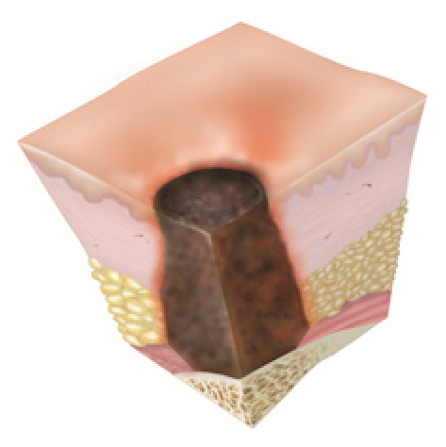

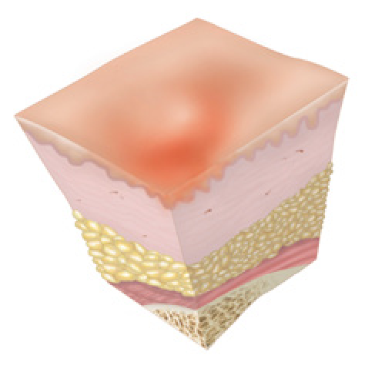

Classification of pressure ulcers: Reproduced with the permission of Dr Joseph Grey, University Hospital of Wales.
Identify five factors that increase an individual’s risk of developing pressure damage and five interventions that can reduce this.
(ACc 7.3, 7.4 ACn 7.3, 7.4).

Factors which increase an individual’s risk of developing pressure damage | Interventions to reduce the risk of pressure damage
1. | 1.
2. | 2.
3. | 3.
4. | 4.
5. | 5.

Know the importance of diet, nutrition and hydration
Identify national and local initiatives which have been introduced to support nutrition and hydration for individuals receiving health and care in your work setting (ACc 8.1, ACn 8.1).

Identify five factors that affect nutrition and hydration (ACc 8.2, ACn 8.2):

Describe how to provide support for a person with swallowing difficulties (ACc 8.4, ACn 8.4)?

Fluid balance
Provide three symptoms of dehydration (ACc 8.2, ACn 8.2):

Provide three routes of (ACc 8.2, ACn 8.2):
Fluid intake | Fluid loss
1. | 1.
2. | 2.
3. | 3.

What documentation should be completed to support nutrition and hydration (ACc 8.3, ACn 8.3)?

Completing a Fluid Balance Chart (ACc 8.3, ACn 8.3)
Ms Louise Evans has been admitted to your clinical area having suffered diarrhoea and vomiting for the last 72 hours. She is looking pale and weak.
Her past medical history includes:
- Type 2 Diabetes well controlled
- She has rheumatoid arthritis
- Mobilises with a Zimmer frame having previously fractured her hip 2 years ago
On Admittance to the ward the medical team has reviewed 22.00 hours and asked the ward to monitor her fluid input and output over the next 24 hours. She has not at present been prescribed any Intravenous fluids. The fluid chart commences at midnight (note different areas start fluid balance charts at different times, namely 00:00 or 06:00)
This is her fluid intake/output for the next 24 hours:
00:00 Vomit (250ml)
02:00 3 sips of water (All-Wales guidance notes a sip as 5ml)
06:00 Went to the toilet (100ml urine)
06.30 300ml Diarrhoea
07:00 half cup of tea (100ml)
08:00 75ml of urine passed
10:00 Went to toilet passed urine forgot to measure
12:00 Cup of tea
15:00 Half a cup of water
15:45 120ml urine passed
16:00 Reviewed by team – continue monitoring
17:00 Vomit 100ml
18:00 Half bowl of soup (170ml) and 100ml of tea
20:00 Cup of tea
22:00 250ml Diarrhoea

Complete the Fluid Balance Chart below: (Clinical setting)
What is the balance over 24 hours (ACc 8.3, ACn 8.3)?
DAILY  INTAKE-OUTPUT CHART  (record MUST be recorded on Weekly Chart)  24 HRS FROM…………..ON………….TO…………ON…………. | ADDRESSOGRAPH
WARD | ADDRESSOGRAPH
ALL INSTRUCTIONS FOR 24 HOURS – All intravenous/enteral fluid therapy and drugs must be administered as prescribed on the ALL-WALES PRESCRIPTION CHART. The “Type” heading below refers to the particular fluid prescribed
INSTRUCTIONS FOR 24 HOURS

 | INTAKE |  |  |  |  |  | OUTPUT
Time | Intravenous/Enteral Fluids |  |  |  | Oral |  | Urine |  | Gastric |  | Wound drainage | Bowel
 | Type  Intravenous/Enteral | Vol.Set up | IV Vol.Given | E Vol.Given | Vol. | Type | Vol. | Running total | Vol. | Running total | Vol. | Type
c/f
12 Hr Total
12 Hr Total
24 Hr Total
TOTAL INPUT:…………………………..mls FLUID BALANCE +/-:………………………mls
TOTAL OUTPUT:……………………….mls

Completing an All-Wales Food Record Chart (ACc 8.3, ACn 8.3)
Ms Louise Evans (89) has been transferred to your clinical area for rehabilitation having recently overcome a period of norovirus. She is still feeling unwell and appears weak. Her past medical history includes:
• Type 2 Diabetes well controlled
• She has rheumatoid arthritis and struggles to use cutlery
On admission to your ward, the dietetic team has reviewed her dietary intake. They are concerned by her nutritional score and therefore require her food intake until review. Please record the following onto the food chart.
Note: Cups/glasses = 200ml
 | Food | Portion served | Amount eaten
Breakfast  08:00 | Toast  Porridge  Tea | 2x 800g slices of white bread with butter  1 medium bowl  1 cup | 1 slice with butter  ½ bowl  200ml
Mid-morning  10:30 | Tea  Digestive Biscuits  Fortisip compact | 1 cup  2 biscuits  125ml | 200ml  0 biscuits  ½ (60ml approx.)
Lunch  12:30 | Cottage pie  Mixed vegetables  Ice cream  Squash | 1 large portion  1 portion (80g)  1 portion (80ml)  1 cup (200ml) | ¼ portion  ½ portion - 40g  ½ portion – 40ml  ½ - 100ml
Mid-afternoon  14:30 | Tea  Digestive Biscuits  Fortisip compact | 1 cup  2 biscuits  125 ml | 200ml  ½ of a biscuit  80ml
Dinner  17:30 | Tea  Ham sandwich  Ice cream | 1 cup  1 (2x 800g slices of bread)  1 portion (80ml) | 200ml  ½ sandwich  80ml
Supper  21:00 | Horlicks  Digestive Biscuits | 1 cup  2 biscuits | ½ - 100ml  ½ of a biscuit

Chart No: 1 2 3 4 5 (Please circle)

All Wales Food Record Chart
Please records all Food, Nutritional Supplements and nourishing Drinks consumed
If NONE consumed please specify the reason on the chart
- Record all food and drink consumed throughout the day
- Describe the type of food served e.g. beef, bread, creamed potato
- Specify the quantity and meal size actually eaten e.g. ½ a small bowl of soup

Remember to:
Addressograph |  | Ward: |  |  |  | Nursing:  Dietitian:  Other:
 |  | Food chart requested by: |  |  |  | Nursing:  Dietitian:  Other:
 |  | Body Wt kgs:  Date: | Actual weight (kg):  Reported weight ( kg):  Weight reported by patient  Weight reported by carer |  |  | Date:  Days:  Ongoing:
Meal/Snack | Foods/nutritional supplements/nourishing drinks offered/special diets e.g. pureed | AMOUNT TAKEN  Must be reported to and countersigned by registered nurse (RN) twice daily
Meal/Snack |  | Portion  Served  (S,M,L) |  | Amount  Eaten  (none, ¼, ½, ¾, All) | Signed |  | Countersigned by RN
Breakfast
Cereal
Milk/sugar
Cooked Item
Bread / toast
Spread
Drinks
Mid-morning
Snacks
Drinks
Lunch
Soup
Main item
Potato/rice
Vegetables
Pudding
Drinks
Mid-afternoon
Snacks
Drinks
Dinner
Soup
Main item
Potato/rice
Vegetables
Pudding
Drinks
Supper
Snacks
Drinks
Therapeutic Intake e.g. oral intake trails for swallow rehabilitation such as yoghurt etc. Include amount given e.g. 3 teaspoons (refer to care plan)

Know how to support individuals to maintain continence while preserving their dignity
Define the term continence (ACc 9.1, ACn 9.1):

Identify three factors that affect continence (ACc 9.2, ACn 9.2):

Identify three tools which support continence (ACc 9.3, ACn 9.3):

Identify how to maintain dignity for those in your care who need continence support (ACc 9.4, ACn 9.4):

Identify how to record bladder and bowel movements (ACc 9.5, ACn 9.5):

Understand how to support the wellbeing of individuals in a health and care setting
Identify specific factors that can impact the wellbeing of individuals in your work area
(ACc 10.1, ACn 10.1):
Physical wellbeing | Mental wellbeing
1. | 1.
2. | 2.
3. | 3.

Know how to support oral care
Identify why oral care is important (ACc 11.1, ACn 11.1):

Give three examples of how you would support an individual with their oral care needs
(ACc 11.2, ACn 11.2):

Give three examples of when an individual may require additional support to meet their oral care needs (ACc 11.3, ACn 11.3):

Know how to support foot care
Identify why foot care is important (ACc 12.1, ACn 12.1):

Give three examples of how you would support an individual with their foot care needs
(ACc 12.2, ACn 12.2):

Give three examples of when an individual may require additional support to meet their foot care needs (ACc 12.3, ACn 12.3):

Understand the needs of individuals who have a cognitive impairment
Define the term cognitive impairment (ACc 13.1, ACn 13.1):

List three signs and symptoms that may indicate an individual has a cognitive impairment (ACc 13.2 ACn 13.2):

Describe three ways you could support an individual in your work area who has a cognitive impairment (ACc 13.3, ACn 13.3):

Understand the needs of individuals who have a learning disability
Define the term learning disability (ACc 14.1, ACn 14.1):

Identify three examples of underlying health conditions that may affect individuals with a learning disability (ACc 14.2, ACn 14.2):

Identify communication challenges a patient with learning disabilities may encounter
(ACc 14.3, ACn 14.3)
Barrier to communication | Ways to address them
1. | 1.
2. | 2.
3. | 3.

Explain three ways you can support an individual with a learning disability
(ACc 14.4, ACn 14.4):

Understand the needs of individuals with a mental health condition
Complete the table below (ACc 15.1, 15.2, 15.3, ACn 15.1, 15.2, 15.3):
- Identify three mental health conditions
- Outline three signs and symptoms you may observe in an individual
- Identify three ways to support an individual with a mental health condition

Mental Health Condition | Signs | Symptoms | Support

Know how to support individuals with sensory loss
In the table below list the five senses.
Identify one cause of a loss of each sense, ensure you include both congenital and acquired reasons in your table.
Identify a method or tool which could support an individual who has the named sensory loss (ACc 16.1, 16.2, 16.3, ACn 16.1, 16.2, 16.3)
Sense | Cause | Tools to support
1.

2.

3.

4.

5.

Understand the signs of a deteriorating patient
Identify the signs and symptoms of a deteriorating patient and their significance (ACn 17.1):
 | Sign/symptom | Significance
Airway

Breathing

Circulation

Disability

Exposure

Describe key actions and considerations to take when you identify a deteriorating patient (ACn 17.2)

Know the factors that may affect physiological measurements
There are many factors that can affect physiological measurements. Complete the table below to identify three factors which can alter physiological measurements, both internal and external (ACn 18.1).
Physiological measurement | Internal affecting factors | External affecting factors
Blood pressure


Respiratory rate
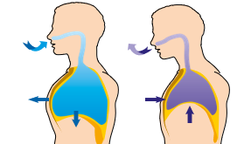

Pulse


Temperature
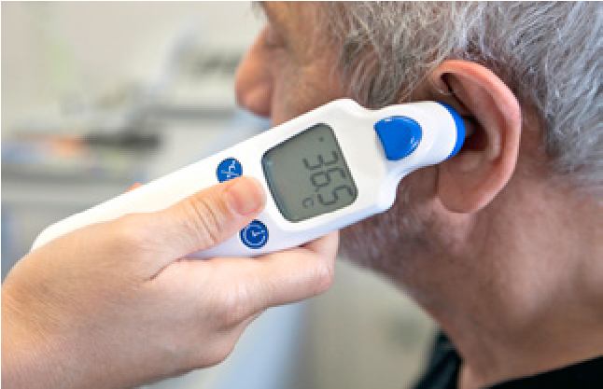

Oxygen saturation
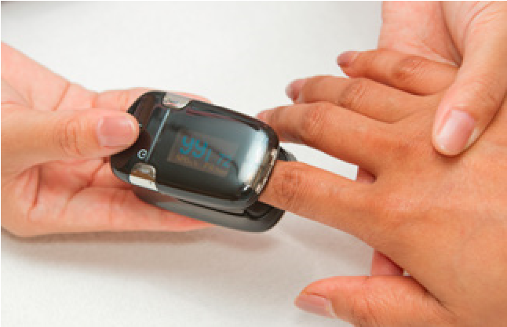

Be able to take physiological measurements - Learner Assessment Record Sheet

Criteria covered  Undertaking physiological measurements | Practitioner sign and date when demonstrated | Date & sign  Assessment 1 | Date & sign  Assessment 2 | Date & sign  Assessment 3 | Date & sign  Assessment 4 | Date & sign  Assessment 5
Correctly carry out hand washing and hand hygiene prior and after clinical task and identify correct PPE to carry out the activity
Explain procedure and reasons for undertaking all physiological measurements, Answer any concerns client may have and reassure before and during observation
Confirm clients identify obtain consent from patient.
Select correct manual blood pressure equipment’s to undertake task
Adjust any clothing as required correctly
Identify correct cuff size used for the client and correctly
Correctly use mechanical device to undertake. Pulse, Blood pressure
Record oxygen saturation with correct equipment and undertake Clients respirations correctly and document correctly on chart
Correct use and recording of a temperature using a tympanic thermometer and document correctly on chart
Correctly undertake respirations.
Correctly undertake Manual pules
Correctly undertake manual Blood pressure where posable (can be role play)
Correctly undertake and completed NEWS Chart
Correctly document all vital signs on all relevant and correct documents

Discussion To be carried out by assessors | Name & signature | Date
Discussed with assessor her accountability when undertaking / and recording vital signs
Discuss the procedures when unable to obtain or read physiological measurements and Identify issues outside your responsibility and refer to reverent colleagues
Discuss what are the normal ranges of the vital signs undertaken and what they should do if they are outside the normal range
Discuss the importance of NEWS and why they should think of sepsis at a NEWS score of 3 or above
Discuss or carry out the correct procedure for reporting faulty and labeling the equipment as per policy

Feedback & Discussion to be completed by person who has observed HCA

Please complete the candidate’s feedback on their observation ensuring you give a full explanation of how they carried out the task.
Feedback on Observations
Assessors name  if Registered nurse | Feedback | Initials | Signature | Date

Must be completed by all HCSW within BCUHB where they come in contacted with patient using Oxygen. You must also ensure that you are competent in carrying out the bellow.

Oxygen Cylinder Safety Competencies- Health Care Assistants –All Wards & Departments

Subject practice or discussion | Observation
Can identify where Oxygen Cylinders are kept within the department/Ward area.
Can demonstrate Safe storage of oxygen cylinders within department/Ward area. Ensuring empty cylinders are not stored with cylinders that are currently in use.
Awareness of BOC Medical Oxygen Cylinder guidance leaflet and understands content
Reflect content back to assessor
Preparation and Use: All Ward Staff must completed a demonstration
NB: Registered Nurse: Professional accountability in relation to the assessment of patient suitability for transfer lies with the Registered Nurse- Discussion can only be used if not in day to day contacted with oxygen
HCSW can demonstrate or discuss how to:
- Check with the registered nurse the correct medical gas is being used and expiry date of the cylinder
- Check the amount of oxygen in the cylinder before use
- Remove all Anti Tamper plastic seals prior to use
- Connect the delivery tube to the cylinder
- Ensure there is enough oxygen in the cylinder to last as long as required
- Ensure the registered nurse has turned the cylinder on and ensured that oxygen is flowing and being delivered to the patient at the correct flow. Connection of mask and tubing
- Apply mask/nasal cannula
- Check for leaks and know what to do if a leak is detected
- If non re-breathing face mask is to be used RGN to apply
During Use:
Can demonstrate or discuss how to:
- Correctly fit a mask or nasal cannula on to the patient. RGN to provide the appropriate flow rate for the device.
- Understand the need for RGN to check pulse oximetry prior to transfer
- Check the valve at regular intervals to ensure sufficient gas
- Visually observe the patient for signs of reduced Oxygen levels (agitation/restlessness/blue peripheries, breathlessness). Escalate to appropriate personnel in the event of these signs
Always ensure patient is never left unattended during the transfer and whilst in the receiving department

After Use:
Can demonstrate or discuss how to:
- Remove the mask or cannula from the patient
- The importance of alerting RGN that patient needs connecting to their usual oxygen supply
- Turn off the cylinder and disconnect equipment
- Replace outlet cover
- Return cylinder to storage point

Understands that empty or near-empty cylinders need to be replaced immediately and the correct process for replacement of cylinders.

Learners Signature………………………………………………..Date……………………………………

Assessor/Observer Signature…………………………………………………Date……………………………………

Once you have completed all competencies and have been certificated for undertaking physiological measurements – you must give a copy of these competencies, certificated to your manager, and ensure that you have updated your qualifications on your ESR learning recorded .

Understand how to support the hygiene needs of individuals
Give three examples of how you can protect the privacy and dignity of individuals while providing support with hygiene needs (ACn 20.1):

Describe how you would support an individual with their hygiene (ACn 20.2):

Know about death and dying
Identify cultural and religious differences associated with death and dying (ACn 21.1)

Describe how you would care for an individual in their last days of life (ACn 21.2):

Identify how to care for an individual after death (ACn 21.3):

Identify how the personal belongings of an individual are managed after death (ACn 21.4):

Describe how these items of jewellery would be handled and stored in line with workplace policy (ACn 21.4):

yellow metal ring with white stones on shoulders and green oval stone centrally.

white metal chain with tear drop shape pendant with white central stone, surrounded by white stones.

Identify support that is available to you whilst you are supporting individuals through death, dying and bereavement (ACn 21.5):

Know how clinical specimens are taken

Describe how the clinical specimen is taken (ACn 22.1)
Midstream Specimen of Urine (MSU)
Catheter Specimen of Urine (CSU)
Stool Sample
MRSA Screening
Sputum Specimen

Identify how to label clinical specimens (ACn 22.2):

23. Be able to use reflection in a health and care setting
Describe a model of reflection to use in a health and care setting (ACc 17.1, ACn 23.1):

Learning from practice – Template 1
Please use the following templates to reflect on two experiences from the list below (ACc 17.2, ACn 24.2. Choose either/or both templates – whichever best suits your learning style.
- Your training programme
- Your shadow shifts
- An interaction with another individual (e.g. patient, carer, colleague)
This is a template of the Reflective Model by Rolfe et al. (2001). You can use this template or transfer the headings to a new document; this will help you to achieve your reflective practice.
WHAT?
This is the description and self-awareness level and all questions start with the word what.
What I did? What did I do well? What could I do better? What have I learnt?

SO WHAT?
This is the level of analysis and evaluation when we look deeper at what was behind the experience.
What could I have changed? How did it make you feel?

NOW WHAT?
This is the level of synthesis. Here we build on the previous levels these questions to enable us to consider alternative courses of action and choose what we are going to do next.
Now what can I do? Now what do I need to do? Now what is my action plan to improve this

Date of activity:

Learning from Practice – Template 2
This is a template for a reflective review, based on the Reflective Model by Gibbs (1988). You can use this template or transfer the headings to a new document; this will help you to achieve your reflective practice.
DESCRIPTION
What happened? Describe the situation you are reflecting upon as though you were communicating to someone who wasn’t there.
Brief explanation of the situation you are reflecting upon (What happened? Where were you? Why were you there?):

Who was present / involved (include yourself in the list)?:

Briefly explain your specific role:

Briefly explain the role of others who were present:

FEELINGS
What were you thinking and feeling?
What did you feel confident about when just before and during the situation?

What were you nervous or less confident about just before and during the situation?

What were your feelings immediately afterwards, what made you feel that way?

What do you think other people involved in the situation were feeling during and after the action?

EVALUATION
This section is reflecting on what was good or bad about the situation. It might help to think about both your reactions and the response of other people involved during the situation
What went well in the situation?

How do you know this was a good outcome? (think about the response of others, or how well you met the objectives)

What didn’t go so well / what could be improved?

How did you identify this as an area for improvement? (think about the response of others, or how well you met the objectives)

What were the consequences of your actions for the other people involved in the situation?

ANALYSIS
What sense can you make of the situation? Things that helped and things that hindered
What did you learn from this situation? Why did things go well? Why didn’t things go so well?

Was there anything you did not know?

CONCLUSION
What else could you have done or what could have been done differently?
If the same situation happened again, what could you do differently to ensure a more positive outcome? Are there any skills which you could developed?

CALL TO ACTION!
How can you ensure a different outcome next time?
What do you need to do to ensure the actions you identified in the CONCLUSION get implemented and not just forgotten? Is there something you could do to make sure you were more prepared? Do you think you need to ask for help or further training to enable you to handle the situation better?

Date of activity:

Curriculum Details

An up-to-date curriculum can be accessed by either the clicking the links below or scanning the QR code.

All-Wales Induction Health and Care Workers (Core)
Unit (agored.cymru)


All-Wales Induction Health and Care Workers (Nursing)
Unit (agored.cymru)


