Health Board  18th November 2021 |  | 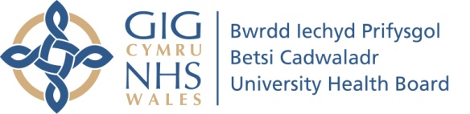  To improve health and provide excellent care
Chair’s Report

Name of Committee: | Targeted Intervention Improvement Framework (TIIF) Steering Group
Meeting date: | 29.9.21
Name of Chair: | Gill Harris, Deputy Chief Executive/ Executive Director of Nursing & Midwifery
Responsible Director: | Gill Harris, Deputy Chief Executive/ Executive Director of Nursing & Midwifery
Summary of business discussed: | - Terms of reference review – membership list to be refreshed in light of individuals’ title and portfolio changes  - Requests for additional resources to support work in the Targeted Improvement domains – a paper seeking additional posts was to be submitted for Executive Team consideration  - Maturity Matrix self-assessment scoring – discussion took place on the scoring method used, taking the mode to indicate the overall level achieved. Feedback on use of the word ‘low’ to indicate progress assessed as being in the first half of a level, rather than the ‘high’ second half indicated that the language could demoralise colleagues who were working hard to progress through the levels. It was therefore agreed to dispense with the word ‘low’, so that eg level 1 progress would now be described as simply ‘1’ or ‘high 1’  - Following self-assessment, maturity scores were agreed for each domain: Mental Health (1), Strategy, Planning & Performance (1), Leadership (1) and Engagement (1)
Key assurances provided at this meeting: | - Governance arrangements are in place to monitor TI progress via Steering Group oversight  - Teams are working to deliver improvements, with target maturity scores being set for the next self-assessment milestone of May 2022
Key risks including mitigating actions and milestones | - There is a risk of insufficient progress on the improvement journey; the oversight of the Steering Group and added scrutiny from IM Links will mitigate this.
TIIF Domain addressed | - All
Issues to be referred to another Committee | -
Matters requiring escalation to the Board: | -
Well-being of Future Generations Act Sustainable Development Principle | Describe how the items of business and the development of any proposals considered by the Committee gave adequate consideration to the sustainable development principles or if not indicate the reasons for this.  1. Balancing short term need with long term planning for the future – covered by the strategy, planning and performance domain.  2. Working together with other partners to deliver objectives – covered by the engagement work  3. Involving those with an interest and seeking their views – covered by the engagement work;  4.Putting resources into preventing problems occurring or getting worse – via WG funding allocation;  5. Considering impact on all well-being goals together and on other bodies – covered by engagement work.
Planned business for the next meeting: | - Updates on progress across the domains; planning for the next Evidence Group meeting.
Date of next meeting: | 6.12.21.

V1.0

