 |  | 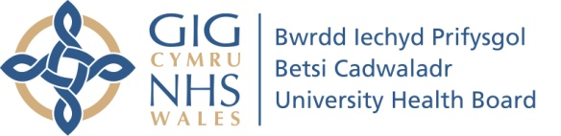
Chair’s Report

Name of Committee: | Targeted Intervention Improvement Framework (TIIF) Steering Group
Meeting date: | 19.12.22 & 03.01.23 (Please note both the December and January meetings were cancelled due to the announcement of an Internal Critical Incident on these dates)
Name of Chair: | Nick Lyons, Deputy Chief Executive / Executive Medical Director
Responsible Director: | Nick Lyons, Deputy Chief Executive / Executive Medical Director
Summary of business discussed: | - The TI Steering Group meetings due to take place on 19.12.22 & 03.01.23 were cancelled due to the announcement of an Internal Critical Incident on these dates and the priority support required to assist.  - The papers due to be discussed at the meeting on 19.12.22 were rolled forward to the meeting due to take place on 03.01.23.  - As the January meeting was cancelled, the agenda bundle was circulated to all members of the Group via email requesting papers / recommendations to be reviewed and comments to be returned by 06.01.23.  - The following recommendations were included:1  - Consider and support the next steps following the TI Working Group Workshop on 29 November 2022.  - Note and consider the first draft of the TI Domain “Plan on a Page” documents and refine these by 10.01023 ready for informal review by Welsh Government from 13.01.23.  - Consider and support the next steps related to the development of the Performance Maturity Matrix.  - Approve the evidence for the YGC Maturity Matrix (Vascular)  - Note the next steps required to refine the Maturity Matrices  - Note the response letter from Gill Harris to Judith Paget.  - Note the next steps required in relation to the ongoing key actions in the update section of the letter from Judith Paget dated 02.12.22.  - The TI Evidence of Outcomes Group is taking place on 12.01.23 where the “Plan on a Page” documents will be shared and the evidence submissions for the YGC Domain (which includes Leadership, Governance and Culture, ED and Vascular) will be approved.
Key assurances provided at this meeting: | - Governance arrangements are in place to monitor TI progress via Steering Group oversight.
Key risks including mitigating actions and milestones | - No risks were raised
TIIF Domain addressed | - All
Issues to be referred to another Committee | - N/A
Matters requiring escalation to the Board: | - None
Well-being of Future Generations Act Sustainable Development Principle | Describe how the items of business and the development of any proposals considered by the Committee gave adequate consideration to the sustainable development principles or if not indicate the reasons for this.  1. Balancing short term need with long term planning for the future – covered by the strategy, planning and performance domain.  2. Working together with other partners to deliver objectives – covered by the engagement work  3. Involving those with an interest and seeking their views – covered by the engagement work;  4.Putting resources into preventing problems occurring or getting worse – via WG funding allocation;  5. Considering impact on all well-being goals together and on other bodies – covered by engagement work.
Planned business for the next meeting:
Date of next meeting: | 07.02.22

V1.0

